Engine GBA
The gameboy advance like engine
by Magnus Oblerion

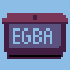

All rights reserved 2024

Describe :
2d game engine made with C, raylib.h and lua.h .
egba = Tic80 api + 32bits upgrade + modern GPU optimization.

It's the synthesis of 7 years of game and framework creation,
which is why (exceptionally) the sources are closed.

Features:
- UI Projet browser (add/delete/load project)
- UI Project (edit/debug/run/export/import)
- UI Sprite viewer (view/save/load-delete palette/load spritesheet)
- UI Script viewer (view)
- locked cartbridge
- Color Theme (white/black/blue/red/green/yellow)
- Run egba and lua in CLI
- Save-state 100 bools, 50 string, 50 number
- Your game can run other local game
- Read other save-state

Spec:
- 100 projets max in browser
- 5 palette color : 32 colors + alpha
- 256 sprite : 16x16
- lua script : 64000 char

Fast start :

Setup new project
- Download palette image .png <= 32 colors lospec.com

- on browser touch ,
it create new.lua and new.png

- click on « new » project, click on and sprite button
- drag and drop palette image to window
- save, quit and rename new .lua/.png with your projet name

Debug (GUI)
- load projet with browser
- press space for start/stop debug

Create EGBA from script/sprite
- After load projet , « -> » button or ctrl + e
- ctrl + l for locked egba (can’t import lua/spr from egba)

Import sprite/script from EGBA
After load projet , « <- » button or ctrl + i

Run EGBA (GUI)
After load projet, press enter for start/stop running EGBA

Debug (CLI)
- open cmd, tape it
egba.exe project.lua
it use .png for load color and sprite

Run (CLI)
- open cmd, tape it
egba.exe project.egba

Load spritesheet
- drag and drop 256x256 img, it to browser→project→spr
- drag and drop 256x257 img, it to browser→project→spr

Lua api :

Main

loop function
function EGBA()
-- your code run 60/seconds
end

log
trace("hi")
-- print hi in console (only string)
local v=2 print("value :",v)
-- lua print function can be used to view variable value in console

palette swap
pal(2)
-- id 0 -> 4, change curant palette
-- for all function after with id color

Graphics

clear screen
cls(0)
-- clear screen with id color 0

print text
text("hello world",23,23,0,16)
-- x 23, y 23, id color 0,font size 16

draw rectangle
rect(23,23,50,50,2)
-- draw fill rectangle in x 23, y 23, width 50, height 50, id color 2
rectb(23,23,50,50,2)
-- draw line rectangle in x 23, y 23, width 50, height 50, id color 2

draw pixel
pix(10,10,2)
-- draw pixel in x 10,y 10, id color 2

draw sprite
spr(1,23,23,2)
-- draw sprite id 1,x 23,y 23,scale 2

Input

keyboard
if btn(0) then
-- if key down is down
elseif btn(1) then
-- if key up is down
end
if btnp(2) then
-- if key left is pressed
elseif btnp(3) then
-- if key right is pressed
end
-- id 0 : up, 1 : down, 2 : left, 3 : right, 4 : x, 5 : c
-- btn -> btn is down
-- btnp -> btn is pressed

mouse
local x,y,btnl,btnm,btnr = mouse()
-- x = x mouse
-- y = y mouse
-- btnl = true/false mouse left button
-- btnm = true/false mouse mid button
-- btnr = true/false mouse right button

Save-state (.sav file)
This is static data, it keep value when quit.

Write save
wsave_numb(id,100)
-- id 0 → 50
wsave_string(id,"name")
-- id 0 → 50, string 35 char
wsave_bool(id,true)
-- id 0 → 100

Read save
local i_num = rsave_numb(id)
-- id 0 → 50
local i_string = rsave_string(id)
-- id 0 → 50
local i_bool = rsave_bool(id)
-- id 0 → 100

Interverse
Run an other game, read extern save.

Run game
run("projet.egba") -- work with .lua

Read extern save
-- if target is projet.sav
local numb = rsave_numb_ext("projet",id)
local nstring = rsave_string_ext("projet",id)
local nbool = rsave_bool_ext("projet",id)

Entry point
Create projet.entry for run (projet.lua / projet.egba) at start.

Music
Load / play .wav .mp3 .ogg

Load directory
music_loaddir("asset") -- load all .wav .mp3 .ogg in dir

Play sound
music_playsound("lazer") -- play lazer.wav

Play music
music_playmusic("music_intro") -- play/resume music_intro.mp3/.ogg

Pause music
music_pausemusic("music_intro") -- pause music_intro.mp3/.ogg

Stop music
music_stopmusic("music_intro") -- stop music_intro.mp3/.ogg

Gamepad
btn(id) -- test gamepad isdown when is plug
btnp(id) -- test gamepad ispressed when is plug

id button map :
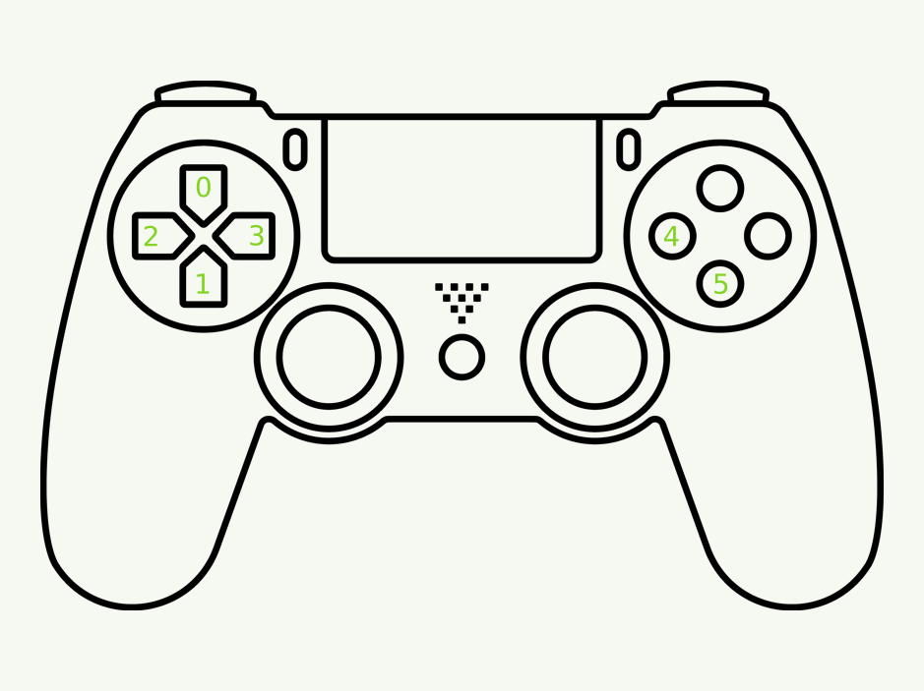

Table index
Describe : 2
Features: 2
Spec: 2
Fast start : 2
Setup new project 2
Debug (GUI) 3
Create EGBA from script/sprite 3
Import sprite/script from EGBA 3
Run EGBA (GUI) 3
Debug (CLI) 3
Run (CLI) 3
Load spritesheet 3
Lua api : 4
Main 4
loop function 4
log 4
palette swap 4
Graphics 4
clear screen 4
print text 4
draw rectangle 4
draw pixel 4
draw sprite 4
Input 5
keyboard 5
mouse 5
Save-state (.sav file) 5
Write save 5
Read save 5
Interverse 6
Run game 6
Read extern save 6
Entry point 6
Music 6
Load directory 6
Play sound 6
Play music 6
Pause music 6
Stop music 6
Gamepad 7

