Elyoko
The 3d game engine for
make your lyoko world

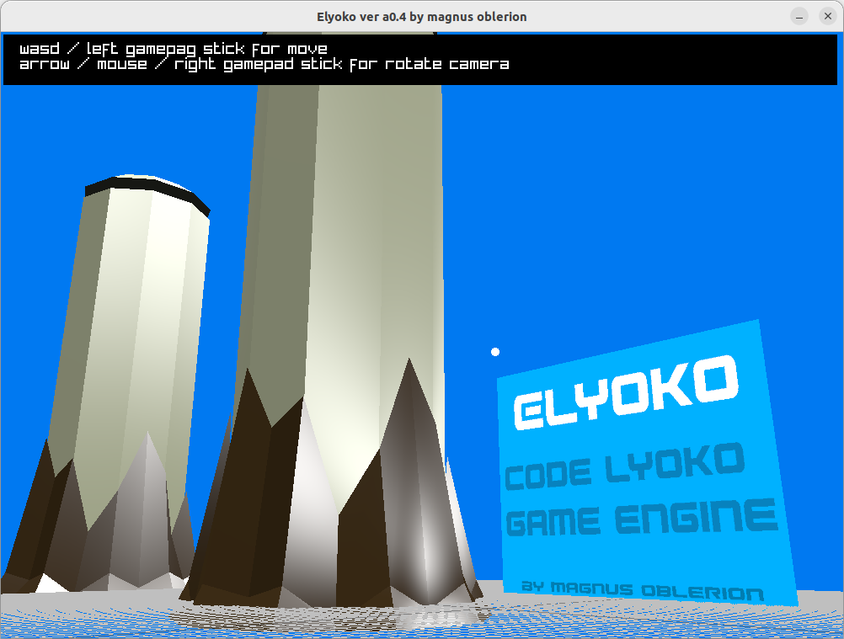
by Magnus Oblerion

Description
The 3d game engine make with C , raylib.h and lua.h.
It is lightweight, powerful and easy to extends (lua script).

Features
- Max 100 preload model
- Max 100 preload texture
- load/draw/unload model (obj,gltf,glb)
- load/draw/unload texture (png,jpg)
- load/draw textured plane from image
- draw 3d primitive (cube,sphere)
- draw 2d primitive (rect,circle,point)
- draw text
- move/rotate camera
- keyboard/mouse input -> camera control
- gamepad input -> camera control

Run script CLI

on window
elyoko.exe main.lua

on linux
./elyoko main.lua

Run projet folder CLI
Projet folder need main.lua.

on window
elyoko.exe folder

on linux
./elyoko folder

Entry point
If you create file project.entry beside of binary,
elyoko will run project.lua at start.
Or run project folder if exist.

Your *.lua/folder and *.entry need same name for work.

API

1) Main loop
function ELYOKO2D()
-- loop 2d
end

function ELYOKO3D()
-- loop 3d
end

2) delta time
local dt = deltatime() -- get time between 2 frame

3) color
local id_color = color(255,0,255,20) -- color r=255,g=0,b=255,a=20
local id_color = color(255,0,200) -- color r=255,g=0,b=200,a=255

4) camera 3d

get camera X
local camx = camerax()

get camera Y
local camy = cameray()

get camera Z
local camz = cameraz()

camera move
cameramove(x, y, z) -- add value to camera position

camera set position
camerasetpos(x, y, z) -- set value to camera position

camera rotate
camerarotate(rotx, roty, rotz) -- rotation in radiant

Camera set target
camerasettarget(x, y, z) -- set points than camera look

camera lock
cameralock(state)
-- state=true player can’t move/rotate camera
-- state=false player can move/rotate camera

5) Asset loading
Outside loop / protect for run once

load model
loadmodel(path) -- path is string

load texture
loadtexture(path) -- path is string

load plane textured
loadplanetexture(texture_name.ext) -- create model plane with loaded texture

6) Input

btn / btnp
if btn(0) then
-- key w is down or gamepad left stick up
elseif btnp(1) then
-- key s is pressed or gamepad left stick down
end
btn(id) : key is down
btnp(id) : key is pressed
id=0 → key w / gamepad left stick up
id=1 → key s / gamepad left stick down
id=2 → key a / gamepad left stick left
id=3 → key d / gamepad left stick right
id=4 → key x / gamepad button x
id=5 → key c / gamepad button a

mouse
local x,y,btnl,btnm,btnr = mouse()
-- x = x mouse
-- y = y mouse
-- btnl = true/false mouse left button
-- btnm = true/false mouse mid button
-- btnr = true/false mouse right button

7) 2d
work only in ELYOKO2D

draw pixel
pix(x, y, color())

draw fill rectangle
rect(x, y, width, height, color())

draw line rectangle
rectb(x, y, width, height, color())

draw fill circle
circle(x, y, radius, color())

draw line circle
circleb(x, y, radius, color())

draw text
text(str, x, y, scale, color())

unload texture
deltexture(name.ext)

draw texture
drawtexture(name.ext, x, y)

8) 3d
work only in ELYOKO3D()

draw cube
cube(x, y, z, width, height, depth, color())

draw sphere
sphere(x, y, z, radius, color())

unload model
delmodel(name.ext) -- name.ext is name without path

draw model
drawmodel(name.ext, x, y, z, rot_x, rot_y, rot_z, scale)
-- rotation in radian
-- scale > 0 , float multiply scale of model

Table of Contents
Description 2
Feature 2
Run script CLI 2
on window 2
on linux 2
Entry point 2
API 3
1) Main loop 3
2) delta time 3
3) color 3
4) camera 3d 3
Get Camera X 3
Get Camera Y 3
Get Camera Z 3
Camera move 3
Camera set position 3
Camera rotate 3
Camera set target 3
Camera lock 4
5) Asset loading 4
load model 4
load texture 4
load plane textured 4
6) Input 4
btn / btnp 4
mouse 4
7) 2d 5
draw pixel 5
draw fill rectangle 5
draw line rectangle 5
draw fill circle 5
draw line circle 5
draw text 5
unload texture 5
draw texture 5
8) 3d 6
draw cube 6
draw sphere 6
unload model 6
draw model 6

