**Please sign in each day you visit the building**

**Point your smart phone camera at the QR code then follow the link**

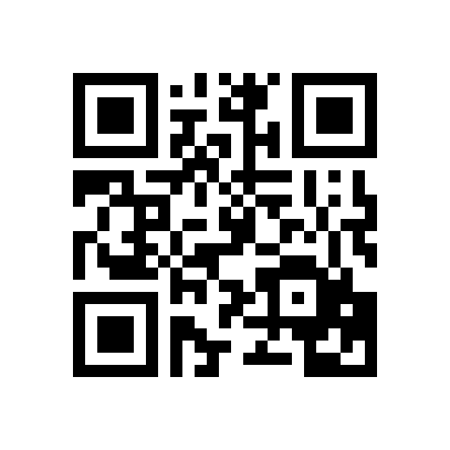

**Or type in the link: http://tiny.cc/3hwusz**