RISK ASSESSMENT DETAILS | DEGREE OF RISK | RISK RATING MATRIX
Other assessments which might also be required, ✓ if needed:  - Manual Handling REF  - COSHH REF  - Personal Protective Equipment (PPE) REF  - Noise REF  - Other REF
  Faculty/School/Service | Mathematics
  Team | Sam Pegler & Onno Bokhove/Maths Fluids Laboratory
  Risk Assessment Title | Wavetanks (one glass screwed on table and one portable Perspex one)
  Risk Assessment Log Reference
  Date | 06-01-2021
  Name of Assessors
  Manager Responsible | 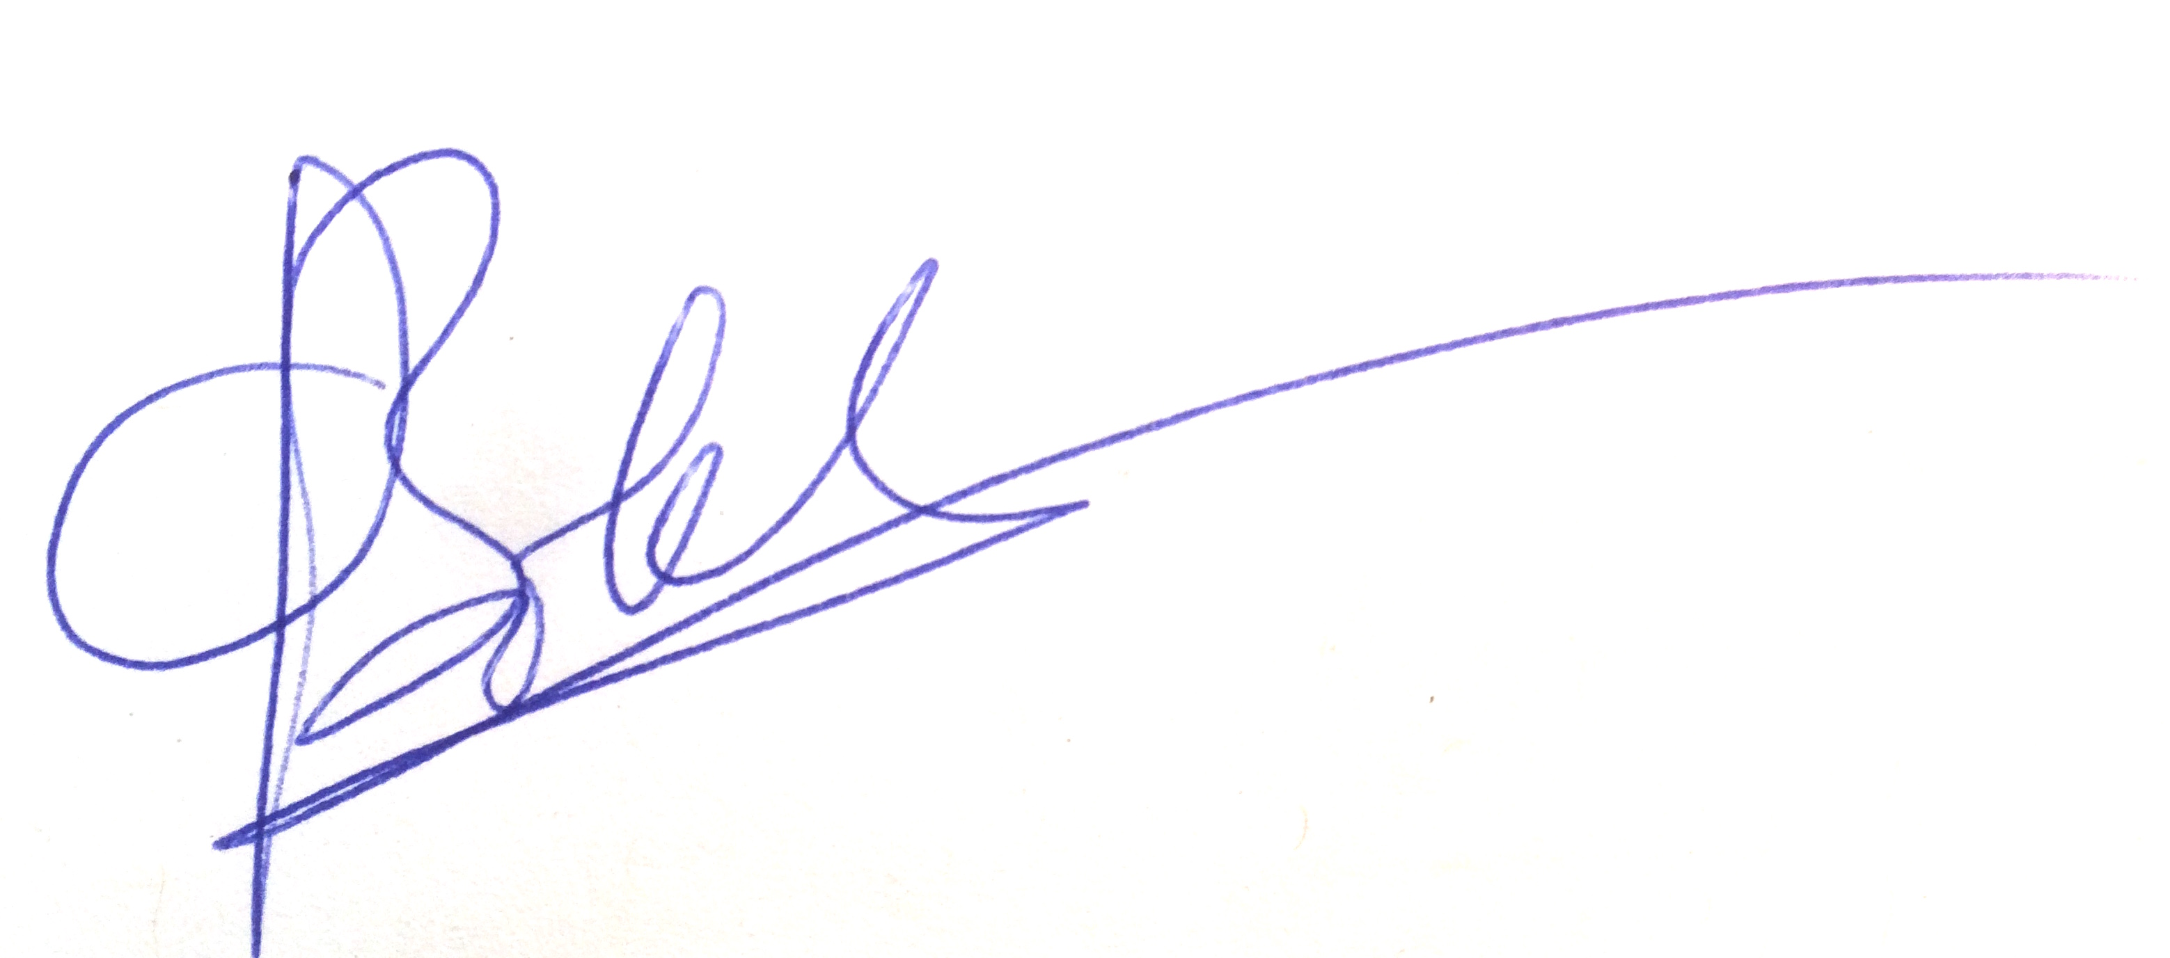
  Location | Chemistry B13
  Details of Activity
  1) Perspex wave tank (~2m length), involves an electrically powered oscillating plate of Perspex to create waves in a layer of water inside the tank.
  for link on 2) see YouTube movie: https://www.youtube.com/watch?v=3yNoy4H2Z-o
  2) A different smaller glass wave tank fixed on table.
  LIKELIHOOD (L)
  5 | Inevitable
  4 | Highly Likely
  3 | Possible
  2 | Unlikely
  1 | Remote Possibility
   |  | SEVERITY
  LIKELIHOOD |  | 1 | 2 | 3 | 4 | 5
  LIKELIHOOD | 1 | 1 | 2 | 3 | 4 | 5
  LIKELIHOOD | 2 | 2 | 4 | 6 | 8 | 10
  LIKELIHOOD | 3 | 3 | 6 | 9 | 12 | 15
  LIKELIHOOD | 4 | 4 | 8 | 12 | 16 | 20
  LIKELIHOOD | 5 | 5 | 10 | 15 | 20 | 25
 |  | PERSONS AT RISK
  SEVERITY (S)
  5 | Very High -Multiple Deaths
  4 | High - Death, serious injury, permanent disability
  3 | Moderate - RIDDOR over 7 days
  2 | Slight - First Aid treatment X
  1 | Nil - Very Minor

PERSONS AT RISK

Employees X

Students X

Clients

Contractors

Members of the public X

Work Experience students

Other Persons

  REVIEW DATES
  RISK RATING SCORE | ACTION
  1 - 4 | Broadly Acceptable - No action required
  5 - 9 | Moderate - Reduce risks if reasonably practicable
  10 -15 | High Risk - Priority Action to be undertaken
  16 -25 | Unacceptable -Action must be taken IMMEDIATELY

HAZARD AND RELATED ACTIVITIES  e.g. trip, falling objects, fire, explosion, noise, violence etc. | PERSONS  AT RISK  e.g. Employees, Customers, Contractors, Members of the public | POSSIBLE OUTCOME | RISK RATING BEFORE CONTROLS (LxS) | EXISTING CONTROLS  e.g. Guards, Safe Systems of Work, Training, Instruction, Authorised Users, Competent Persons, Personal Protective Equipment (PPE) | RISK RATING AFTER CURRENT CONTROLS (LxS) | FURTHER CONTROLS REQUIRED? | RISK RATING AFTER ADDITIONAL CONTROLS (LxS)
Electrocution | All | Death/Injury | 3x4=12 | Cables taped in place.  Socket above tank level so splashed water cannot contact.  Or secured so no one walks between tank and socket (or taped to ground). | 2x4=8
Falling objects (knocking over tanks) | All | Injury from slipping/falling | 3x2=6 | Tank 1) is secured on a table; nearly impossible to knock it off.  Tanks 1) and 2) are heavy when filled due to its own weight so unlikely. | 2x2=4
Tripping on cables | All | Injury from tripping | 2x2=4 | System located near the wall with socket so no cables to run across the room. | 2x2=4
Sharp edges wavemaker | All | Minor injury from cuts | 2x2=4 | First aid box available in case of any minor cuts. | 2x2=4

MANAGEMENT AGREED  ADDITIONAL CONTROL MEASURES REQUIRED |  | ACTIONED BY |  |  | ACTION COMPLETE
 |  | POSITION | NAME | DATE | MANAGER SIG |  | DATE

COMMUNICATION OF RISK ASSESSMENT FINDINGS TO STAFF
REFERENCE OF FORMAL COMMUNICATION TO STAFF | METHOD | YES | DATE | COMMENTS
REFERENCE OF FORMAL COMMUNICATION TO STAFF | Copy of risk assessment issued to staff
REFERENCE OF FORMAL COMMUNICATION TO STAFF | Controls covered in team procedure issued to staff
REFERENCE OF FORMAL COMMUNICATION TO STAFF | Staff Handbook issued to staff
REFERENCE OF FORMAL COMMUNICATION TO STAFF | Other -
ADDITIONAL METHODS OF COMMUNICATION | Induction
ADDITIONAL METHODS OF COMMUNICATION | Toolbox Talk
ADDITIONAL METHODS OF COMMUNICATION | Team Meeting
ADDITIONAL METHODS OF COMMUNICATION | E-mail circulation
ADDITIONAL METHODS OF COMMUNICATION | Other -

COMMENTS AND INFORMATION

(Use this section to record any dynamic risk assessment comments and information)

Do additional controls adequately lower high risk activities to an acceptable level? | YES / NO  If NO explain in comments box above | SIGNATURE OF MANAGER  "The risks identified in this assessment are controlled so far as is reasonably practicable"
 | YES / NO  If NO explain in comments box above | Signature: | Date:

DATE OF REASSESSMENT  (Every two years minimum) | ARE THERE ANY CHANGES TO THE ACTIVITY SINCE THE LAST ASSESSMENT? | SIGNATURE OF MANAGER

LOCATION OF CURRENT SIGNED RISK ASSESSMENT

RISK ASSESSMENT LOG
Directorate: |  |  |  |  |  | Area:
Section/Team | Risk Assessment Title | Version No. | Risk Assessment Category | Code  /Location | Risk Assessor | Manager responsible for signing off risk assessment | Date assessment signed off | Review Due | Review Date | Outstanding Controls/Actions  Yes/No | Comments

