**BIO/CMPSC 300 Introduction to Bioinformatics   
Spring 2016  
Kristen Webb and Janyl Jumadinova***http://cs.allegheny.edu/sites/jjumadinova/300*

Lab Week 6 – Investigation of Influenza Virus StrainsGiven: Friday February 26, 2016  
 Due: Friday March 4 by 2:30pm

**Objectives:**

* **To understand the value of aligning genes and recognize the practical applications of this technique.**
* **To gain familiarity with the use of Web-based alignment tools to explore sequence similarity and understand how to modify their parameters.**
* **To know how the Needleman-Wunsch algorithm optimally aligns any two sequences.**
* **Understand how the Needleman-Wunsch algorithm can be modified to yield other alignments.**

**Reading Assignment:**

**Chapter 3 in Exploring Bioinformatics textbook.**

**Required Deliverables (submitted through your Bitbucket repository):**

1. **An electronic version of the report containing the answers to the lab comprehension questions in red.**
2. **A properly formatted and commented Python program that implements other types of alignments and a snapshot of an output that your program produces.**

**General Guidelines for Labs**

**Work on the Alden Hall computers.** If you want to work on a different machine, be sure to transfer your programs to the Alden machines and re-run them before submitting.

**Keep all of your files!** Don't delete your programs and reports after you hand them in---you might need them again later.

**Back up your files regularly.** Use a flash drive or Google Drive or whatever your favorite backup method is.

**Review the Honor Code policy on the syllabus.** Remember that you may discuss experiments and programs with others, but copying answers or programs is a violation of the Honor Code

**Part I: Pairwise Global Alignment with the Needleman-Wunsch Algorithm**

The genomes of the influenza viruses are divided into eight segments, each representing essentially the coding information for a single protein (Figure 1). Segment 4 contains the gene for hemagglutinin (HA), the viral surface protein essential for the initial interaction between the virus and its host cell. HA is one key determinant of which host(s) a particular virus can infect, because the virus cannot replicate or cause disease without being able to first bind to a host cell. The HAs of one of the major seasonal human viruses circulating before 2009, the 2009 H1N1 pandemic virus, and the 1918 human pandemic virus are all classified as the H1 type, whereas recent outbreaks of severe avian flu are caused by a virus with HA classified as H5. These classifications are based on binding of antibodies of known specificity, but sequence alignment provides much more detailed information about similarities and differences and where changes have occurred.

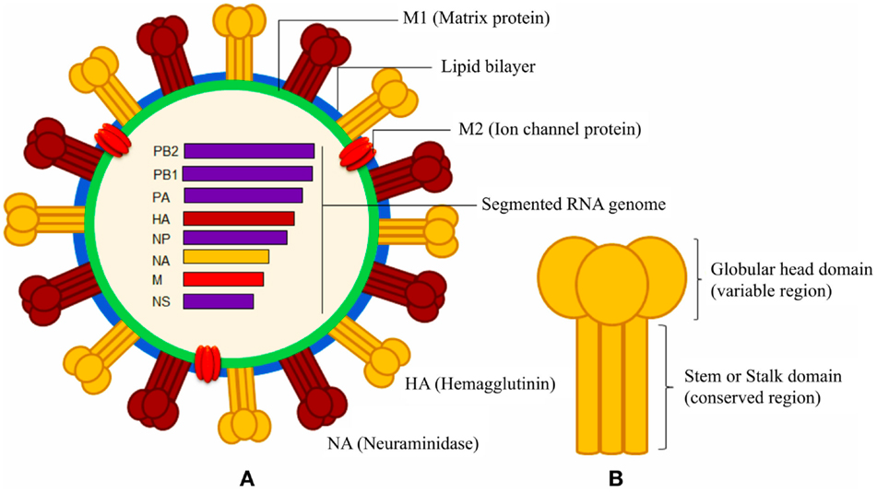

**Figure 1. Schematic diagrams of influenza A virus -** The segmented genome of influenza A virus encodes three envelope proteins (hemagglutinin, neuraminidase, and ion channel M2 protein), and internal nucleoprotein (NP), polymerases (PA, PB1, and PB2), matrix protein 1 (M1), and non-structural proteins (NS). The lipid bilayer is derived from host cell membrane.

We can use the Needleman-Wunsch algorithm to compare influenza virus HA segments. To start, we will compare two 2009 H1N1 virus strains - the reference strain designated A/California/07/2009 (H1N1) and the human seasonal H1N1 virus that was circulating at that time, A/Brisbane/59/2007 (H1N1). The term “reference strain” refers to a common strain of a virus that is selected for the manufacture of the seasonal Influenza vaccines developed by the Centers for Disease Control every year.

1. The files Influenza_A_Brisbane2007(H1N1)segment4.txt and Influenza_A_California2009(pandemicH1N1)segment4.txt have been uploaded to the lab6 directory in the shared repository. These files contain the DNA sequences of segment 4 of the each virus.
2. Go to the EBI-EMBL’s EMBOSS webpageat [www.ebi.ac.uk/Tools/emboss/](http://www.ebi.ac.uk/Tools/emboss/)   
   You should see a list of programs for pairwise alignment. Under the heading “Global Alignment”, the program Needle is an implementation of the Needleman-Wunsch algorithm.
3. From the EMBOSS site, choose the version of Needle that compares nucleotide sequences and then paste the two viral segment 4 DNA sequences into the designated boxes. Leave the parameters set to the defaults and run Needle to align your two sequences.

*Notice that you can set some parameters for comparison, most notably the gap penalty. Needle uses an* ***affine*** *gap penalty, which means it imposes a larger penalty when a new gap is added and a smaller penalty when that gap is extended (our examples on Tuesday and Thursday used a* ***linear*** *gap penalty).*

At the top of your results, you will see parameters such as the gap penalty and two measures of similarity: the number and percentage of matching nucleotides (labeled “Identity”) and an alignment score (based on the scoring matrix, in this case awarding a match bonus of 5). In the alignment itself, matching nucleotides are shown by a | character, mismatches by a dot (.), and gaps by a dash (-).

* 1. How many matching nucleotides are there between the two sequences? What is the alignment score?
  2. How many gaps were needed to align these sequences? Is there any particular pattern to where or how these gaps occur? If so, explain briefly.

Nearly all of segment 4 consists of coding sequence, so we would expect insertions/deletions, aka indels, especially one- or two-nucleotide indels to be mutations with serious consequences for HA proteins. Considering this, perhaps it would be valuable to consider strongly penalizing gaps.

1. Set the gap opening penalty to 50, rather than the default of 10.
   1. When you align the two HA sequences using the higher gap opening penalty, does the percent identity change significantly relative to the previous alignment? How about the number of gaps and their placement or size?
   2. Each of your alignments, the one with higher and the one with the lower gap opening penalties, are optimal alignments (the best alignments given the parameters), and they give quite similar scores. Which alignment do you feel is “better” biologically, and which is your justification? (*Hint: what striking observation did you make when looking at the gaps in the second alignment)*

**Part II: Local Alignment with the Smith-Waterman Algorithm**

Another way to use sequence alignment is to find one sequence within another. The influenza virus M2 gene, for example, is another key player in the biology of the virus: once the virus enters the cell, M2 is involved in the release of the virus genome subunits so they can travel to the nucleus and direct viral replication. Suppose we have sequenced segment 7 from the 2009 H1N1 pandemic virus but are uncertain what part of it represents the actual M2 coding region. To find out, we could align the well-characterized M2 coding sequence from the Brisbane strain with the full segment 7 sequence from the newly sequenced virus.

1. The files Influenza_A_California2009(pandemicH1N1)segment7.txt and Influenza_A_Brisbane2007(H1N1)M2.txt have been uploaded to the lab6 folder in the shared repository. Access these files and align them using Needle with a default gap opening penalty of 10.
   1. How good are the score and percentage of sequence identity for this comparison? Why don’t these statistics tell the full story in this case?
   2. Suppose we only looked at the portion of the 2009 segment that actually aligned with the M2 coding region of the Brisbane strain. How would this change the percent identity? Is this degree of similarity as high as you would expect for these related viruses?

Considering what you know about the Needleman-Wunsch algorithm, you should see why it might not be the best choice for aligning sequences that are so drastically different in length. Because the need to make alignments of this kind arises frequently, in 1981 Smith and Waterman published a modification of the Needleman-Wunsch algorithm that allows for **local** alignments.

A local alignment looks for optimal partial (subsequences) matches. EMBOSS includes an implementation of the Smith-Waterman algorithms called Water.

1. Choose the nucleotide version of the Water method and then set a gap opening penalty of 10 an a gap extension penalty of 0.1 and align the Influenza_A_California2009(pandemicH1N1)segment7.txt and Influenza_A_Brisbane2007(H1N1)M2.txt sequences.
   1. How does this alignment differ from the previous one? Is the percent identity, either for the whole alignment or just for the regions that actually match, significantly better than before?
   2. There is an obvious difference between how the subsequences of the M2 coding region align with the 2009 segment 7 sequence in the local alignment. Can you suggest a hypotheses for why the sequences align this way? (*Hint: Remember that the M2 sequence is the protein coding sequence*) Based on your hypothesis, is the local alignment superior to the global alignment in terms of its ability to help us understand the viruses biologically?

This alignment is very sensitive to the parameters used. Change the gap extension penalty (e.g. from 0.1 to 0.5). Although almost all bioinformatics programs come with default settings that are usable for many common purposes, this illustrates the importance of understanding the algorithm and the meaning of the parameters, as well as the value of considering what kind of alignment would be most appropriate for the sequences aligned.

**Part III: Using Alignment to Investigate Virulence**

Influenza viruses have received a great deal of study, and the ability to compare many strains has lead to significant advances in understanding what allows one strain to cause more severe disease than another. The H5N1 “bird flu” virus makes an interesting case in point. The virus causes severe influenza in birds and has become established in populations of domestic chickens and turkeys. Human cases occur sporadically, mostly in individuals heavily exposed to infected birds, such as poultry farmers, and H5N1 flu is severe for humans as well. Once a human case occurs, however, spread to another human is exceedingly rare, even among family members in close contact with the infected individual.

A 2006 article by van Riel et al. demonstrated that the avian H5N1 virus binds to a form of sialic acid receptor that in humans is only found far down in the lungs and lower respiratory system. Human viruses, in contrast, bind to a form of the receptor common in the upper respiratory tract. Thus, it is difficult for H5N1 to infect humans because our respiratory defenses normally prevent the virus from reaching the lungs. However, a mutant strain in which HA was altered to be able to bind to sialic acid receptors in the upper respiratory tract could be a very dangerous strain indeed.

So far, no such H5N1 strains that infect humans efficiently have been observed. However, we might ask whether the strains that do make it into humans tend to have altered HA genes –if so, that would suggest that either adaptive mutations could be occurring within the human host or that the viruses that cause human infections are subpopulations that are already better adapted. There are many avian H5N1 sequences available and a number of sequences of the H5N1 viruses isolated from infected humans, so we can use sequence alignment to see whether these have essentially the same HA or noticeable differences.

1. The files Influenza_A_Chicken_Vietnam2005(avianH5N1)segment4.txt, Influenza_avianHong_Kong2007(avianH5N1)segment4.txt, and Influenza_A_ChinaGD012006(humanH5N1isolate)segment4.txt have been have been uploaded to the lab6 directory in the shared repository. Perform pairwise comparisons of the three strains using the Needleman-Wunsch algorithm.
   1. What are the scores and sequence identities for the comparison of the two avian viruses? Are the differences between the human isolate and the avian isolates greater than the differences among avian isolates?
   2. Based on your results (which of course are limited –it would be necessary to do many more comparisons in reality), do you believe there is evidence that human adaptation is occurring in H5N1 viruses that might merit concern about human-to-human transmission in the near future?

**Part IV: Implementation of Alignment Techniques**

**Required:**

1. Although global alignments are useful, they don't solve all alignment problems. When you need to find the coding sequence for a gene within a longer DNA sequence, the Needleman-Wunsch algorithm will penalize not only the internal gaps but also the terminal gaps (gaps at the beginning and the end of the alignment). For example, in the alignment shown below, a global alignment finds all of these alignments to be optimal. However, the first alignment would be the best because it only includes terminal gaps used to position the short sequence. The alignment when we eliminate the gap penalty for terminal gaps is called a *semiglobal alignment*.

CGCTATAG CGCTATAG CGCTATAG

- - CTA - - - C - - TA - - - - - C - - TA -

Modify the Needleman-Wunsch program so it implements a semiglobal alignment by eliminating the gap penalty for terminal gaps. Make sure to rename the program as you copy it. (Hint: This requires just a few minor changes in the code given in class. Cosider what parts of the matrix represent the terminal gaps. Focus on what the outside rows and columns of the matrix represent and how they are used.) Test your modified implementation using short sequences from the example above first. Then, run your program on a real-world example using the sequence of 2009 H1N1 pandemic influenza virus segment 7 and the coding sequence for the 2009 H1N1 virus M1 gene (in the lab6 directory). Your program should successfully pick out the M1 coding sequence within the segment 7 sequence.

2. Local alignments solve the problem of finding and aligning conserved regions in otherwise dissimilar sequences by looking for optimal partial or sebsequence matches between the sequences. For example, in the sequences AAAGCTCCGATCTCG and TAAAGCAATTTTGGTTTTTTTCCGA, there are two similar regions AAAGC and TCCFA, separated by other very different regions. A global and semiglobal alignments will find AAAGC alignment but will not correctly align the sequences so that TCCGA sequences also match up. Large gaps are expected when finding subregions of similarity and should not negatively affect the alignment score. This was the basis for Smith-Waterman algorithm, which requires only a few changes to a semi-global alignment problem.  
  
  
Describe a modified algorithm that would find local alignments given two sequences. Include details on how the matrix is initialized, how the scores are calculated, and where the alignment path should start and end.

**Optional:**

1. Make necessary changes to your semiglobal alignment program to implement the local alignment algorithm you described in the previous part. Test your program with the short sequences given in the example above. Then, run your program with the segment 7 sequence for the 2009 H1N1 pandemic influenza virus and the coding region of the M2 gene from the Brisbane seasonal strain and see if your program gives you the same result as the EMBOSS implementation of the Smith-Waterman algorithm.

2. Modify your previous implementations to find all possible optimal alignments.