Name: Key

BIO300/CMPSC300

DNA: The Molecule Worksheet

Spring 2016

|  |  |
| --- | --- |
| **DNA Structure**   1. On the diagram to the right:  * Circle and label a nucleotide. * Place an “s” in the sugar molecules. * Place a “p” in the phosphate molecules. * Label the bases that are not already labeled. * Label a base pair. * Label the sugar-phosphate backbones. * Label the hydrogen bonds |  |

Slide 5: 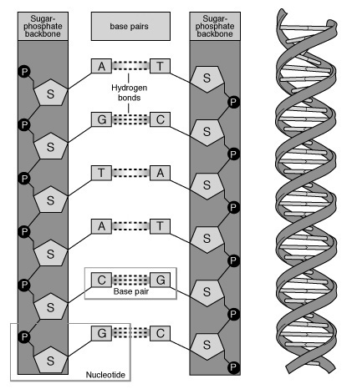

1. A nucleotide is made of three parts: a phosphate group, a five carbon

sugar, and a nitrogenous base. Slide 9

1. In a single strand of DNA, the phosphate group binds to the sugar of the next nucleotide. Slide 5
2. The DNA of any species contains equal amounts of adenine & thymine and also equal amounts of guanine & cytosine. Slides 5, 6
3. In DNA, thymine is complementary to (or pairs with) adenine ; cytosine is complementary to guanine. Slides 5, 6
4. In a strand of DNA, if the percentage of thymine is 30%, what would the percentage of cytosine in the same DNA strand be? 20%. Slides 5, 6
5. James Watson and Francis Crick with, the help of Rosalind Franklin and others, determined

that the shape of the DNA molecule was a double helix. Slide 8

1. A two-ring purine always pairs with a one -ring pyrimindine. Slide 7
2. What type of bonds connect the deoxyribose sugars to the phosphate groups?

Phosphodiester bonds. Slide 10

1. What type of bonds connect the bases to each other? Hydrogen bonds – slides 5, 6, 7

**DNA Replication**

1. Number the steps of DNA replication in the correct order (1, 2, 3):

2 Daughter strands are formed using complementary base pairing.

1 DNA unwinds

3 The DNA of the daughter strands winds with together with its parent strand.

Slide 14

1. Why is DNA replication called “semi-ˇconservative”?

Each new strand contains one parent strand and one daughter strand – slide 15

1. What enzyme unwinds or unzips the parent strand? Helicase – slide 17
2. What enzyme connects joins the new nucleotides during the synthesis of the daughter strand?

DNA polymerase – slide 17

1. Show the complimentary base pairing that would occur in the replication of the short DNA molecule below. Use two different colored pencils (or different pens, markers, etc.) to show which strands are the original and which are newly synthesized.

|  |  |  |  |  |  |  |  |
| --- | --- | --- | --- | --- | --- | --- | --- |
| Original DNA Strand 1 | Original DNA Strand 2 |  | Original DNA Strand 1 | New DNA Strand |  | New DNA Strand | Original DNA Strand 2 |
| A | T | ➔ | A | T | **+** | A | T |
| C | G | ➔ | C | G | **+** | C | G |
| T | A | ➔ | T | A | **+** | T | A |
| T | A | ➔ | T | A | **+** | T | A |
| A | T | ➔ | A | T | **+** | A | T |
| C | G | ➔ | C | G | **+** | C | G |
| G | C | ➔ | G | C | **+** | G | C |
| C | G | ➔ | C | G | **+** | C | G |
| C | G | ➔ | C | G | **+** | C | G |
| G | C | ➔ | G | C | **+** | G | C |
| A | T | ➔ | A | T | **+** | A | T |
| T | A | ➔ | T | A | **+** | T | A |