Key
NAME: _________
DATE: 7 Nov 2020
Bio/CMPSC300

Overlap of Sequence Assembly and Open Reading Frames

1. Suppose two sequence reads give GGCAGCC and GCCCCAGG.
a) What are the possible overlaps? Which one is the largest?

GCCCCAGG ←-largest
GGCAGCC

GCCCCAGG
GGCAGCC

b) Describe an algorithm that finds the largest overlap. Use the legos to help you with the development of the algorithm and with the run through your algorithm, where the first sequence are represented by the rectangles and the second one by squares. A - red, C - yellow/orange, G - blue. Remember that the algorithm is a step-by-step procedure, thus your algorithm should outline the sequence of steps required for finding the largest overlap given two sequences.

First overlay the two sequences at the ends and check for matches.
If they overlap perfectly then that is the best overlap.
If not then repeat the process, overlapping at the other end, repeatedly offsetting by a base.
(Stopping of course when there isn't any overlap left to check)

Ex;
GCCCCAGG
GGCAGCC

GCCCCAGG
GGCAGCC

GCCCCAGG
GGCAGCC

GCCCCAGG
GGCAGCC

GCCCCAGG
GGCAGCC

GCCCCAGG
GGCAGCC

GCCCCAGG
GGCAGCC

GCCCCAGG
GGCAGCC

c) What would be the sequence of the contig produced using your algorithm?

GGCAGCCCCAGG

2. Now suppose you would like your algorithm to account for the possibility that the sequences could come from either strand of the DNA. How would you modify the algorithm to accomplish this? Would the contig resulting from the two sequences in 1 change as a result?

Also check the inverse complement of one of the sequences against the unmodified other sequence. (or simply pipe in the sequences from the DNA manipulation algorithm if the details are actually known by the user)

As you know, the genome is the instruction manual that contains the information to create an organism. Everything from viruses to humans have genomes. In the third week of the course, you evaluated and edited DNA sequence data in the form of chromatograms (Figure 1). These data were generated using dye terminator sequencing and the length of a sequence of this type is typically 600-800 bp. Recent advances in DNA sequencing technology have significantly improved our ability to quickly and efficiently collect DNA sequence data using methods collectively referred to as Next Generation sequencing. However, the length of a given sequence generated using Next Generation sequencing is drastically smaller than the length of a sequence generated using dye terminator sequencing – just 20-500 bp.

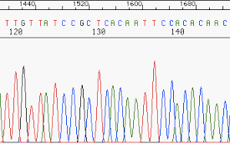
Figure 1 - DNA Sequence Chromatogram

The smallest known genome is that of the Porcine circovirus and is just 1759 bp while the largest known genome belongs to the marbled lungfish with 130,000,000,000 bp. Even the smallest known genome, and clearly the largest known genome, is too big to sequence with a single DNA sequencing read. The solution to this challenge is shown in Figure 2 below. The first step of a genome sequencing project is to isolate many copies of the target genome and then break the large genome into smaller pieces randomly. These smaller pieces are sequenced and then the genome is put back together based on overlapping nucleotides present in each sequence.

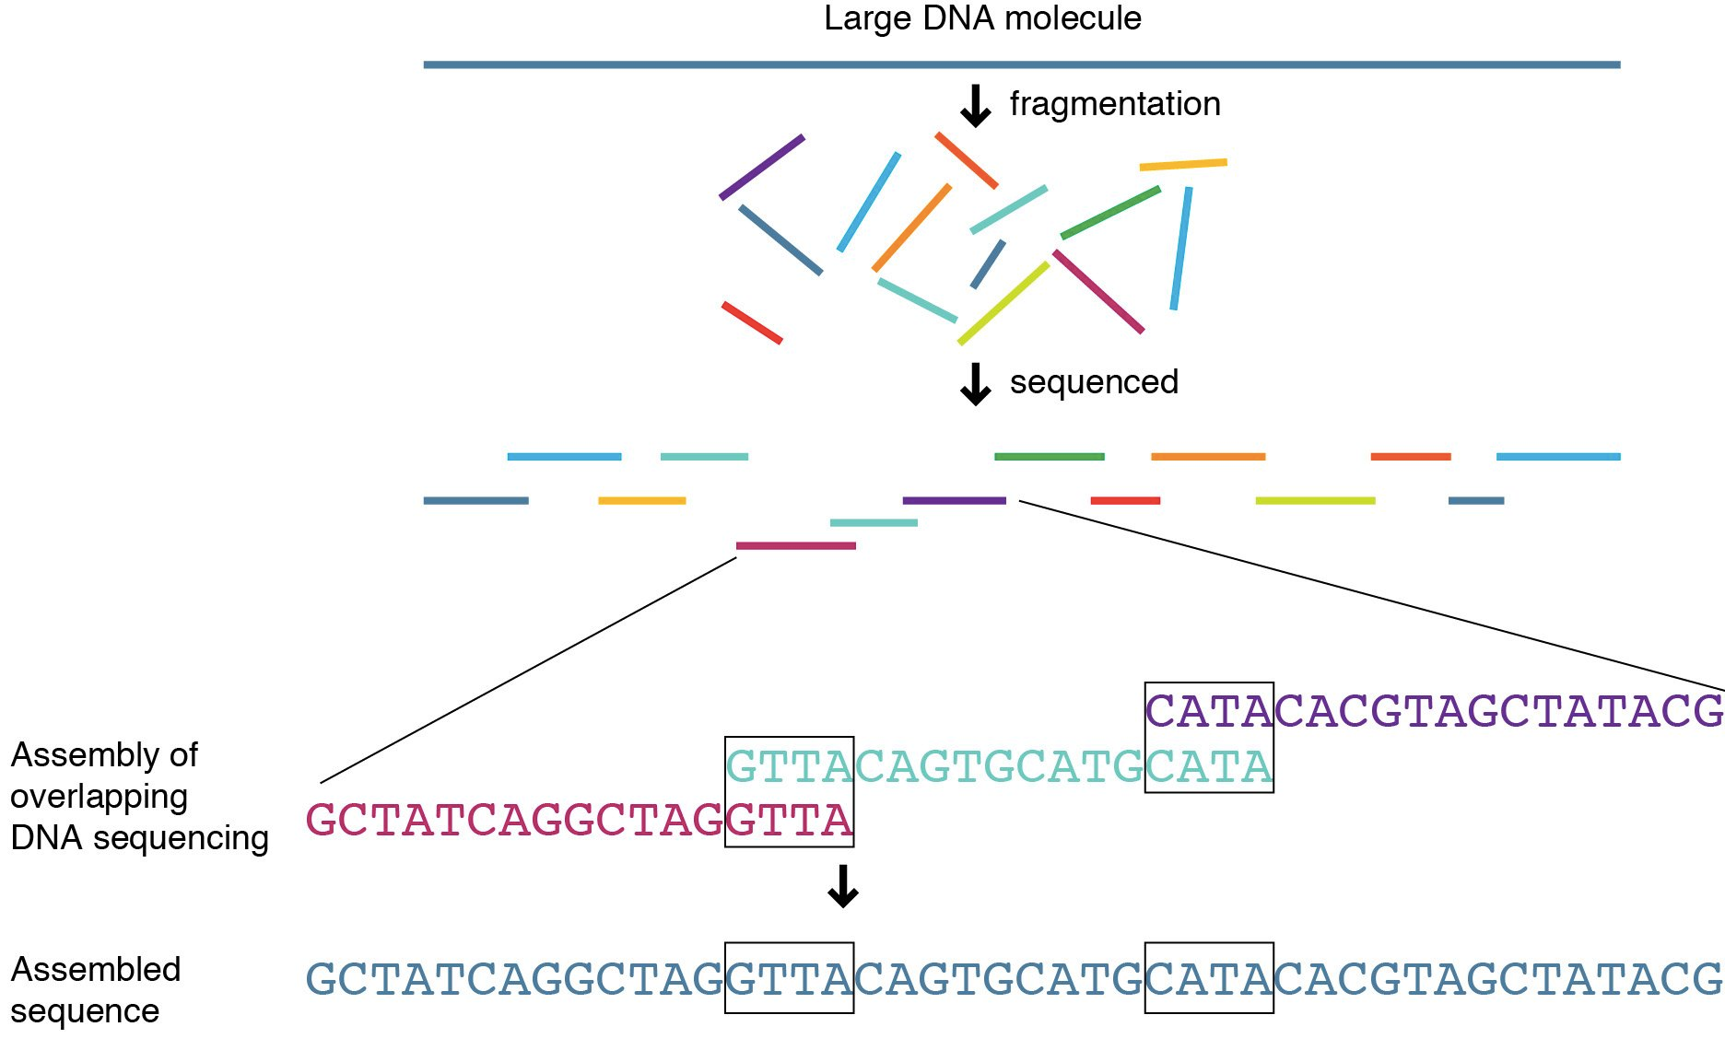
Figure 2 – Genome Sequencing and Assembly

This process has been compared to putting together a jigsaw puzzle or trying to read the New York Times after it has been blown apart into millions of pieces (Figure 3).
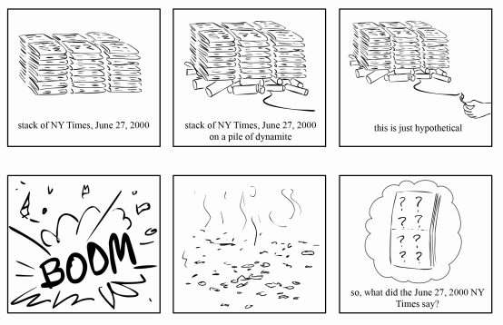

Figure 3 – Exploding newspaper analogy

For today's class activity, you will use EGassembler to assemble the genome sequence of a virus. The raw data you will assemble is contained in a file called reads.txt. This file contains ~2,500 sequences in FASTA format representing the fragmented genome of of an unknown virus. These sequences range in length from 100 to 500 bases and contain between 1 and 10 random substitutions or single-nucleotide deletions each, representing the errors inherent in sequencing data.

- Download the reads.txt file from the shared repository.

- Navigate to the EGassembler website (https://www.genome.jp/tools/egassembler/) and either upload or copy and paste the sequences from the reads.txt file into the input field.

EGassembler includes software to scan for low-quality sequence (e.g. sequences containing many Ns, representing unreadable nucleotides) and remove sequences matching databases of other DNA sources (e.g. organelles (mitochondrial DNA in a human nuclear genome project) as well as highly repetitive sequences.

- For our purposes, turn off the options other than sequencing cleaning and the assembly step itself by unchecking the box next to the word “enable” for repeat masking, vector masking, and organelle masking. Run the program. You should immediately see the results of sequencing cleaning; You can view a .cln file to identify reads that were discarded and then examine these reads in the original sequence file.

In a few minutes, the results should become functional. From the results page, you can view (1) the contig or contigs that resulted from the assembly of your sequence reads; (2) any “singletons”, which are reads that could not be assembled into the contigs or that were not used in creating the contig; and (3) an alignment of the individual sequence reads showing how they led to the generation of the consensus contig sequence.

- Process 1 describes the Sequence Cleaning. Looking at the text on the results page, how many sequence reads were rejected in the sequence cleaning process? Why they were rejected?
2 reads were rejected because they were low-quality

- Download the .contigs file. Use BLAST to compare your contig sequence(s) with known sequences in Genbank. The assembled sequence should match one known sequence with a high degree of similarity. What genome have you just assembled.
The sequences are from the Salivirus A genome

- Because next-generation sequencing produces random short reads, there is no guarantee that even 2,500 reads would be sufficient to completely sequence a particular genome. Did the sequence reads you assembled cover the entire genome or do gaps remain? (Hint – you'll need to click on the genome accession number to determine the length of the previously published genome)
The newly assembled contig was 7982 bases long while the Salivirus A genome is 7989 bases long. The assembly represents most but not all of the genome. A second smaller contig was also generated (209 bp) that also matches the Salivirus A genome but not nearly as well.

- You used the default parameters in your EGassembler run. In a real sequencing project, however, you might want to change variables such as the overlap percent identity cut-off (the minimum percentage of nucleotides that must be identical in the overlapping region of two fragments) By default, the assembler is quite tolerate of sequencing errors (and in fact automatically compensates for some of the common problems of high-throughput sequencing such as as low-quality sequence at the beginnings and ends of fragments). To see how these parameters affect the assembly, in the “Enable Sequence Assembly Process” options, try setting the overlap percent identity cut-off to 100%. What happens to your contig? Does the quality of your alignment change?
Changing the overlap percent identity cut-off to 100% does not change the results. The first resultant contig is still 7982 bases and still aligns very well to the Salivirus A genome. The second contig is also still the same size and aligns to the same sequences as in question 6. This shows that perfect matches are not required when assembling a genome sequence.

Chapter 9 Genome Annotation I
Fall 2019

- Download the Enterococcus faecium resistance plasmid sequence file from the shared repository.

- Use the ORF Finder tool at NCBI (https://www.ncbi.nlm.nih.gov/orffinder/) to annotate the plasmid.

- Briefly (3 sentences) describe what the ORF Finder tool does.
The ORF Finder tool takes a sequence file and searches all six reading frames for the stretches of in-frame sequence beginning with ATG and ending with one of the three stop codons.
- What does changing the “Minimal ORF length” option do?
Changing 100 to 300 increases the minimum length required for a stretch of sequence to be considered an ORF.
- When we click on the ORF174 (for example) we get the box that is displayed in Figure 1. Describe is the CDS, Title Location and Product fields contain?
The CDS: coding sequence, title: Coding sequence title,, location: where in sequence this the DNA of cds is found, and product: gene product name.
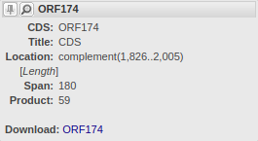
Figure 1: After clicking on the ORF174 annotation, we see this box open.

- Below is a generic pattern matching algorithm. Explain specifically how each step of the algorithm is being used by the NCBI ORF Finder to find ORFs in the Enterococcus faecium resistance plasmid sequence file.

Pattern-Matching Algorithm

        - Initialize parameters of algorithm:

        - Organism: What type of organism are we studying here? bacterial
        - Pattern: What search pattern do we use? ATG
        - SearchedText: What type of genome to be searched for patterns? a plasmid sequence
        - Start: Where is the start location for our search (assumes first character is position 1) position 1
        - Stop:What position is the stop (last) location of our sequence in which to search for patterns? (this represents last location to search from) position three nucleotides from the end (no point in looking at last two)
        - Increment:What is the incrementing value to be used to jump to a new reading frame? (Hint: a negative number for an upstream search and a positive number for a downstream search) 1 (in order to search all three possible reading frames)
        - Threshold:What is the minimum percentage match required? 100%

        - Compare pattern to characters of searchedText starting at position start. If percentage of matching characters is >=threshold, output start position and end algorithm. If not, add increment to start and continue to step 3. In your own words, what is this step doing? Look for ATG in plasmid sequence beginning at base 1. If you find an ATG (perfect match), output “1” as the start position and end algorithm. If not, move on to position 2 and continue to step 3.

        - If increment is positive and start is <=stop, repeat step 2. If not, pattern was not found, end algorithm. In your own words, what is this step doing?
If your progressing left to right and your start position is less than or equal to your stop position, search for ATG again by repeating step two. If statement's not true, start codon wasn't found, end algorithm.

5. Once a start codon is found, how could you modify the algorithm above to find an open reading frame beginning with an identified start codon and ending with a stop codon? Hint: the modification involves changing just two parameters.
Change the pattern to the stop codons – TAA, TAG, or TGA
Change the increment value to three to stay in frame

6. The algorithm above would find an ATG start codon in one of three reading frames by reading a sequence in the 5' to 3' direction, but really we should consider all six possible reading frames: three from the DNA as it was entered and three more on the complementary strand. What changes need to be made to the algorithm above to search for ORFs in the complementary strand? One solution would be to run the algorithm once on the DNA strand as entered, then get the reverse complement of the DNA and run the algorithm again. Or, you could reverse-complement the pattern (so CAT rather than ATG) and do another search with the same DNA string still starting at position 1 and incrementing 1. The former method is probably better in the long run, as the user will be more comfortable with sequences that look like mRNA as output.

- For the below sequence, five of the six reading frames have been listed. What is the sixth reading frame that has been omitted? Explain why this is a reading frame.

5' -TGTCATAGGATAAGCACC -3'

    - TGTCATAGGATAAGCACC
    - GTCATAGGATAAGCA
    - TCATAGGATAAGCAC

    - GGTGCTTATCCTATGACA
    - GTGCTTATCCTATGA
    - TGCTTATCCTATGAC

