Task Crashcourse Modelica

Ottelien Bossuyt, student 2e Master Energie

# Questions

The temperature of the zone after one year is 291.758K. De evolution of the zone temperature can be seen in the figure below.

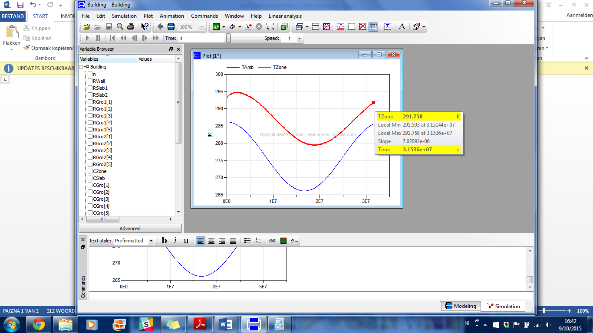

# Modelica code

model Building

type Temperature = Real(unit="K", min=0);

type ThermalResistance = Real(unit="K/W");

type ThermalCapacity = Real(unit="J/K");

type HeatFlow = Real(unit="W");

parameter Integer n=5;

// Thermal Resistances

parameter ThermalResistance RWall = 0.00806;

parameter ThermalResistance RSlab1 = 0.016;

parameter ThermalResistance RSlab2 = 0.016;

parameter ThermalResistance RGro1[5] = {0.033, 0.033, 0.033, 0.033, 0.033};

parameter ThermalResistance RGro2[5] = {0.033, 0.033, 0.033, 0.033, 0.033};

// Thermal Capacities

parameter ThermalCapacity CZone = 2.4096*10^8;

parameter ThermalCapacity  CSlab = 3.36*10^8;

parameter ThermalCapacity CGro[n] = {2.52*10^8, 2.52*10^8, 2.52*10^8, 2.52*10^8, 2.52*10^8};

// Temperatures

parameter Temperature TGroIni = 283.15;

Temperature TGro[n];

Temperature TSlab;

Temperature TZone;

 Temperature TAmb;

//Heat flow

HeatFlow Qsol;

initial equation

for i in 1:5 loop

TGro[i]=283.15;

end for;

TSlab = 293.15;

TZone = 293.15;

equation

  TAmb = 10*cos(2*3.14* time *3*10^(-8))+276.15;

Qsol = floor(cos(2* Modelica.Constants.pi * time /86400)+1)*5000*cos(2* Modelica.Constants.pi * time /86400);

Qsol = (TZone-TAmb)/RWall + CZone * der(TZone) + (TZone-TSlab)/RSlab1;

(TZone-TSlab)/RSlab1 = CSlab * der(TSlab) + (TSlab-TGro[1])/(RSlab2+RGro1[1]);

(TSlab-TGro[1])/(RSlab2+RGro1[1]) = CGro[1]* der(TGro[1])+(TGro[1]-TGro[2])/(RGro2[1]+RGro1[2]);

for i in 2:(n-1) loop

  (TGro[i-1]-TGro[i])/(RGro2[i-1]+RGro1[i]) = CGro[i] * der(TGro[i]) + (TGro[i]-TGro[i+1])/(RGro2[i]+RGro1[i+1]);

end for;

(TGro[end-1]-TGro[end])/(RGro2[end-1]+RGro1[end]) = CGro[end] * der(TGro[end]) + (TGro[end]-TGroIni)/(RGro2[end]);

  annotation (uses(Modelica(version="2.2.2")));

end Building;