Productivity and reproducbility

An example using *palmerpenguins*

Olivia Boven

2023-09-14

# Abstract

Who doesn’t like penguins? Here we look at bill length and depth to demonstrate reproducible science.

# Introduction

This short project focuses on the widely used *palmerpenguins* package (Horst et al., 2022) with the intention of making an entirely reproducible workflow. The penguins near Palmer Station, Antarctica, such as Adelie penguins (*Pygoscelis adeliae*) have been the focus of many studies (Cimino et al., 2023; Nardelli et al., 2021). Since the development of the *palmerpenguins* package, data on these penguins has been used in many coding examples. As such, it was chosen for this demonstration of reproducible research. We will determine whether bill length and depth vary between species.

# Methods

We plotted bill length against bill depth for each species in RStudio using *plot* to visually assess whether bill length and depth varied between species.

# Results

Our results indicate that bill length and depth does vary between species (Figure 1).

# Discussion

Bill length and depth varied between species, possibly because they are different species that have evolved independently, faced different selective pressures, and are optimized for non-identical niches.

# References

Cimino, M. A., Conroy, J. A., Link to external site, this link will open in a new window, Connors, E., Bowman, J., Corso, A., Ducklow, H., Fraser, W., Friedlaender, A., Kim, H. H., Larsen, G. D., Link to external site, this link will open in a new window, Moffat, C., Nichols, R., Pallin, L., Patterson-Fraser, D., Roberts, D., Roberts, M., Steinberg, D. K., … Stammerjohn, S. (2023). Long-term patterns in ecosystem phenology near Palmer Station, Antarctica, from the perspective of the Adélie penguin. *Ecosphere*, *14*(2). <https://doi.org/10.1002/ecs2.4417>

Horst, A. M., Hill, A. P., & Gorman, K. B. (2022). Palmer Archipelago Penguins Data in the palmerpenguins R Package - An Alternative to Anderson’s Irises. *R Journal*, *14*(1), 244–254. <https://doi.org/10.32614/rj-2022-020>

Nardelli, S. C., Cimino, M. A., Conroy, J. A., Fraser, W. R., Steinberg, D. K., & Schofield, O. (2021). Krill availability in adjacent Adélie and gentoo penguin foraging regions near Palmer Station, Antarctica. *Limnology and Oceanography*, *66*(6), 2234–2250. <https://doi.org/10.1002/lno.11750>

# Figure captions

Figure 1. Bill depth versus bill length for Adelie, Chinstrap, and Gentoo penguins.

# Figures

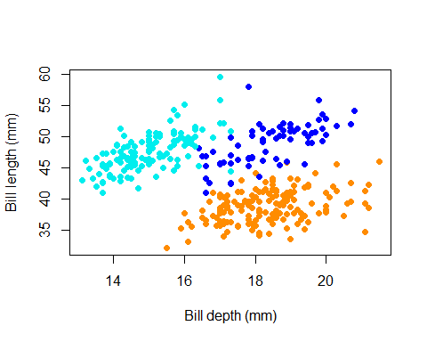

Figure 1.