FINAL REPORT · AI / MACHINE LEARNING COMPONENT
Smart Irrigation System
A soil-moisture forecasting model built with scikit-learn, trained on a synthetic sensor dataset, served live from a Flask backend, and wired to an ESP32 sensor node over HTTP.
PROJECT | MODEL | TASK | CROSS-VAL ACCURACY | STATUS
smart-irrigation | Random Forest classifier | Binary classification | 88.0% ± 1.7% | Stage 6 — complete

Contents
00 Two decision systems, only one of them AI
01 The AI/ML method used, and why it was selected
02 The dataset
03 Preprocessing and cleaning
04 Model development and training
05 Validation procedure and performance
06 Connecting the AI to the ESP32 sensor system
— Limitations and next steps

00 Two decision systems, only one of them AI
The system contains two separate decision-makers, and the distinction matters for everything that follows.
The irrigation controller is rule-based, not AI. The thing that actually switches the pump is a single deterministic comparison in compute_commanded_pump(): if soil moisture is below the active growth stage's threshold, the pump turns on; once moisture reaches the threshold, it turns off. This was a deliberate choice — irrigation is a physical actuator with real consequences, so the control path stays explainable and auditable.
The AI component is a separate predictive layer. It answers a forward-looking question the threshold rule structurally cannot: given everything measured right now, is this plant trending toward needing water soon? It runs alongside the controller every five seconds, writes its output to the ai_predictions table, and surfaces on its own dashboard card. It has no control authority over the pump.
WHY THE SPLIT
Keeping prediction advisory means a model error costs a misleading dashboard card, not a flooded or dried-out plant. It also means the model can be retrained, replaced, or removed entirely without touching the control logic — the app starts and irrigates normally when ml/model.pkl is absent.

01 The AI/ML method used, and why it was selected
Brief: the AI/ML method or model used and why it was selected.

Problem framing
The task is framed as supervised binary classification. Each input is one snapshot of environmental conditions; the target will_need_irrigation is 1 if soil moisture is projected to fall below the active growth stage's threshold, and 0 otherwise.
Classification was chosen over regression deliberately. A predicted moisture value (e.g. “43.7% in one hour”) would carry false precision on a system with no validated soil-physics model behind it. A predicted class with a confidence percentage — “irrigation likely needed soon (84.3%)” — is a claim the system can actually support, and it maps directly onto the decision a grower makes.

Model: RandomForestClassifier
The model is a random forest: an ensemble of 50 shallow decision trees, each trained on a bootstrap sample of the data and a random subset of features, whose votes are averaged into a class probability. Selected for six reasons specific to this project:
REASON | WHAT IT BUYS THIS PROJECT
Explainability | A tree is a chain of readable thresholds — “if moisture < 45 and air temp > 30 and not recently watered, then at risk.” Individual trees can be printed and walked through in a presentation. Feature importances come out for free.
Suits small data | 600 rows. Bagging plus depth-limited trees keeps variance in check where a single deep tree would memorise the training set and a neural network would have nothing to learn from.
Mixed feature types | Handles continuous sensor readings, a binary flag, and one-hot categorical columns in the same model without separate treatment.
No feature scaling | Trees split on ordering, not distance, so raw units mix freely — moisture in %, temperature in °C, humidity in %. This removes an entire class of train/serve bug: no scaler to fit, persist, version, and correctly reapply at inference.
Calibrated-ish probabilities | predict_proba() returns the fraction of trees voting for each class, which drives the confidence percentage on the dashboard. A bare threshold rule has no equivalent output.
Robust to label noise | 5% of training labels are deliberately flipped (see §02). Averaging across 50 bootstrapped trees dilutes noisy labels rather than fitting them.
Table 1. Selection criteria for the model, weighed against the project's constraints.

Alternatives considered
- Logistic regression — simpler still, but assumes a linear decision boundary. The target depends on an interaction (drying pressure is temperature times dryness, offset by recent watering) that a linear model can only capture through hand-built interaction terms.
- A single decision tree — maximally explainable, but unstable: small changes in the training sample redraw the whole tree, and it overfits the 5% flipped labels directly.
- Gradient boosting — likely a point or two more accurate, at the cost of tuning learning rate, tree count, and depth against a 120-row test set. Not a good trade at this data scale.
- Neural network / LSTM — ruled out by the project specification (“do not use deep learning or complicated AI”), and unjustifiable on 600 synthetic rows.

02 The dataset
Brief: source, size, variables, whether it is real or synthetic, and how it was prepared.
REAL OR SYNTHETIC
The training data is entirely synthetic. It is generated in code by generate_training_data() in ml/train_model.py. No real field measurements were used to train the model, because no ESP32 sensor history existed when the model was built. This is stated plainly here because it bounds every performance figure in §05.

Source and size
PROPERTY | VALUE
Source | ml/train_model.py → generate_training_data()
Type | Synthetic, rule-generated with additive label noise
Size | 600 rows
Input variables | 6 (5 numeric, 1 categorical) → 9 columns after encoding
Target | will_need_irrigation — binary, 0 or 1
Class balance | 374 negative (62.3%) / 226 positive (37.7%)
Reproducibility | numpy.random.default_rng(seed=42) — regenerates identically
Missing values | 0 — every field is generated in range
Table 2. Training dataset at a glance.

Variables
VARIABLE | UNIT | TYPE | SAMPLING RANGE | MEAN | SD
soil_moisture | % | Continuous | Uniform 20–90 | 54.88 | 20.59
soil_temperature | °C | Continuous | Uniform 15–35 | 24.82 | 5.79
air_temperature | °C | Continuous | Uniform 15–40 | 27.67 | 7.10
humidity | % | Continuous | Uniform 20–95 | 58.10 | 22.21
growth_stage | — | Categorical | 4 levels, uniform | — | —
previous_watering | 0/1 | Binary | Bernoulli(0.5) | 0.50 | 0.50
`will_need_irrigation` | 0/1 | Target | Derived + 5% noise | 0.38 | 0.48
Table 3. The six input variables and the target, with the sampling range used for each. Ranges were chosen to cover plausible greenhouse and open-field conditions.
The four growth stages sampled almost evenly across 600 rows — Fruiting 166, Vegetative 152, Flowering 147, Seedling 135. Each stage carries its own moisture threshold, which is what makes the stage informative rather than decorative: Seedling 60%, Vegetative 50%, Flowering 45%, Fruiting 40%. These same thresholds are stored in the growth_stages table and drive the live controller, so the model and the controller share one definition of “too dry”.

How the labels are produced
Each row is labelled by a simplified evapotranspiration proxy. Hotter, drier air pulls moisture out of soil faster; recent watering offsets it:
STEP | EXPRESSION
Drying pressure | (air_temperature − 20) × 0.3 + (60 − humidity) × 0.1
Projected moisture | soil_moisture − dry_pressure + (10 if previous_watering else 0)
Label | 1 if projected_moisture < stage_threshold else 0
Noise | with probability 0.05, flip the label
Table 4. The labelling rule, transcribed from ml/train_model.py.
The 5% flip rate is intentional. Without it the mapping from features to label is perfectly deterministic and any competent model reaches 100% accuracy — a number that would say nothing about real conditions. The noise both makes the benchmark honest and forces the ensemble to generalise rather than memorise. It also imposes a ceiling: roughly 95% accuracy is the best any model can achieve against these labels.

The operational dataset
Separately from training, the running system has accumulated a real body of operational data in database.db (SQLite). This was not used to train the model, but it is the data the model has been scored against in production and the natural source for the next retraining round.
SENSOR READINGS | PREDICTIONS LOGGED | PUMP EVENTS | WATER METERED
9,272  one every 5 s | 9,270  ai_predictions | 2,147  ON/OFF with reason | 225.4 L  across 3 days

Of the 9,270 logged predictions, 8,082 were “Moisture OK” (mean confidence 72.4%) and 1,188 were “Irrigation likely needed soon” (mean confidence 65.3%). Six alerts were raised over the run — 3 low-tank, 2 blockage, 1 leak. The lower average confidence on the positive class is consistent with the test-set behaviour in §05: the model is systematically less certain when it calls for water.

03 Preprocessing and cleaning
Brief: data preprocessing/cleaning (if any).
Because the dataset is generated rather than collected, the usual cleaning work — imputing gaps, dropping duplicates, correcting sensor drift, removing outliers — did not apply. There are no missing values, no duplicates, and no out-of-range readings, because every field is drawn from a bounded distribution and rounded at generation time. What the pipeline does instead is transformation:
STEP | STAGE | WHAT HAPPENS
01 | Generate | 600 seeded rows into a pandas DataFrame
02 | Round | Continuous values to 1 dp, matching real sensor resolution
03 | One-hot encode | growth_stage → 4 binary columns
04 | Split | 80/20 train/test, random_state=42
05 | Persist | Model and column order into model.pkl
Table 5. The five transformation steps in ml/train_model.py.

One-hot encoding
growth_stage is the only non-numeric input. It is expanded with pd.get_dummies() into four 0/1 columns — growth_stage_Flowering, growth_stage_Fruiting, growth_stage_Seedling, growth_stage_Vegetative — so the model never sees text. One-hot rather than integer coding matters here: labelling the stages 0–3 would imply an ordering and a spacing the model would happily split on, when the stages are simply four different thresholds.

What was deliberately not done
- No feature scaling or normalisation. Decision trees split on rank order, so a 20–90% moisture range and a 15–40 °C temperature range coexist without distorting the model. Skipping the scaler also removes the risk of an unfitted or mismatched transform at inference time.
- No outlier removal. Every value is inside its generating bounds by construction.
- No class rebalancing. The 62/38 split is mild and reflects the physical reality that soil is more often adequately moist than not. §05 revisits whether this was the right call.
- No dimensionality reduction. Nine features against 600 rows needs none, and PCA would destroy the interpretability that motivated the model choice.

Keeping training and inference consistent
The most common failure mode in a small ML deployment is column drift: the model is handed features in a different order, or with a column missing, than it was trained on. The pipeline defends against this explicitly. The training script pickles a dictionary, not a bare model:
KEY | CONTENTS
model | The fitted RandomForestClassifier
feature_columns | The exact ordered list of the 9 columns the model expects
Table 6. The contents of ml/model.pkl.
At prediction time, predict_irrigation_need() in app.py rebuilds a single row against that stored list: it initialises every column to 0, fills the five numeric fields from the current sensor reading, sets the one matching growth_stage_* column to 1, and reindexes the resulting one-row DataFrame by feature_columns before calling the model. The serving path therefore reproduces the training transform by construction rather than by convention.

04 Model development and training
Brief: algorithm (architecture), important parameters, and software/libraries used.

Architecture
The forest is 50 independent CART decision trees. Each tree is fitted on a bootstrap resample of the 480 training rows and, at every split, considers a random subset of sqrt(9) = 3 of the nine features, choosing the split that most reduces Gini impurity. Growth stops at depth 5. Prediction averages the class-probability estimates of all 50 trees; the argmax is the label and the winning probability is the confidence shown on the dashboard.
PARAMETER | VALUE | EFFECT | SET EXPLICITLY
n_estimators | 50 | Trees in the ensemble. Enough to stabilise the vote at this data size; more adds cost without accuracy. | Yes
max_depth | 5 | The primary regularisation. Caps each tree at 5 questions deep, keeping trees readable and blocking memorisation of the 5% flipped labels. | Yes
random_state | 42 | Fixes bootstrap sampling and feature selection, so training is fully reproducible. | Yes
criterion | gini | Split quality measure. | Default
max_features | sqrt | 3 of 9 features considered per split — the decorrelation that makes a forest outperform its trees. | Default
bootstrap | True | Each tree sees a different resample, the second source of ensemble diversity. | Default
min_samples_split | 2 | Unconstrained; max_depth is doing the regularising. | Default
min_samples_leaf | 1 | As above. | Default
class_weight | None | Both classes weighted equally. See §05 — this is the parameter most worth revisiting. | Default
Table 7. Hyperparameters, read back from the fitted model in ml/model.pkl. Values not set explicitly are scikit-learn defaults, listed here because they materially shape the model.
The fitted forest reaches the depth cap: all 50 trees are exactly 5 levels deep, with 1,040 leaves in total, averaging 20.8 leaves per tree against a theoretical maximum of 32. The model holds 9 input features and 2 classes.

Software and libraries
COMPONENT | VERSION | ROLE IN THE PROJECT
Python | 3.14.6 | Runtime for both the training script and the server
scikit-learn | 1.9.0 | RandomForestClassifier, train_test_split, metrics
pandas | 3.0.5 | Training table, get_dummies() encoding, one-row inference frame
NumPy | 2.5.2 | Seeded random generation; underlies pandas and scikit-learn
Flask | 3.1.3 | Serves the dashboard, the JSON API, and the ESP32 endpoints
SQLite | stdlib | Storage for readings, events, alerts, water usage, predictions
pickle | stdlib | Serialises the model plus its feature-column list
Chart.js | CDN | Dashboard line charts (frontend only)
ArduinoJson | — | JSON encode/decode on the ESP32 firmware side
Table 8. Versions as installed in the project virtual environment at the time of writing.

Training procedure
Training is a single command, python ml/train_model.py, and takes under a second. It regenerates the dataset from seed 42, encodes it, splits it, fits the forest, prints an accuracy and a per-class classification report, and writes ml/model.pkl. Because both the data seed and the model's random_state are fixed, re-running reproduces the identical model — which is what makes every figure in §05 independently checkable.

05 Validation procedure and performance
Brief: training and testing or validation procedure, and the performance evaluation.

Procedure
The primary protocol is a held-out split: train_test_split with test_size=0.2 and random_state=42, giving 480 training rows and 120 test rows. The test rows take no part in fitting.
Because 120 rows is a thin basis for a single accuracy figure, this report adds 5-fold stratified cross-validation over all 600 rows as a second, more stable estimate. The two are reported side by side below, and they disagree in an instructive way.
HELD-OUT ACCURACY | 5-FOLD CV ACCURACY | ROC–AUC | TRAINING ACCURACY
81.7%  98 of 120 correct | 88.0%  ±1.7% across folds | 0.887  ranking quality | 92.7%  11 pts above held-out

The five cross-validation folds scored 85.8%, 90.0%, 86.7%, 90.0% and 87.5% — a tight spread. The single held-out figure of 81.7% sits below all five. Two things explain the gap, and both are worth stating rather than smoothing over:
- The split is not stratified. train_test_split was called without stratify=y, so the test set drew 53 positives out of 120 (44.2%) against a population rate of 37.7%. It is an unusually positive-heavy sample, and the positive class is the harder one.
- 120 rows is small. At that size a single accuracy figure carries a margin of roughly ±7 points. The cross-validated 88.0% ± 1.7%, which scores every row exactly once, is the more trustworthy number and is the one quoted in the summary at the top of this report.
Against the ~95% ceiling imposed by the deliberate label noise, 88% cross-validated means the forest recovers most, but not all, of the underlying labelling rule. The 11-point gap between training and held-out accuracy is mild for an ensemble of this type and indicates the depth cap is doing its job.

Confusion matrix
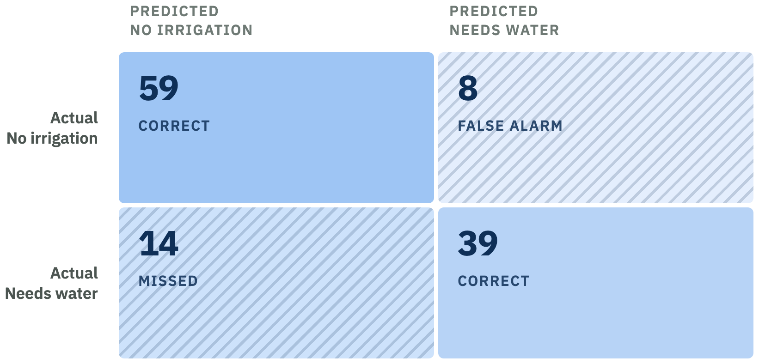
Figure 1. Confusion matrix on the 120 held-out rows: 98 correct, 22 incorrect. Cell shading runs light → dark with the count; misclassified cells carry a diagonal hatch and an explicit label, so the correct/incorrect distinction never rests on colour alone.
The asymmetry is the finding. The model misses 14 of 53 genuine “needs water” cases but raises only 8 false alarms — it errs toward saying the soil is fine.

Per-class metrics
CLASS | PRECISION | RECALL | F1 | SUPPORT
No irrigation needed | 0.808 | 0.881 | 0.843 | 67
Irrigation needed soon | 0.830 | 0.736 | 0.780 | 53
Macro average | 0.819 | 0.808 | 0.811 | 120
Weighted average | 0.818 | 0.817 | 0.815 | 120
Table 9. Precision, recall and F1 on the held-out set. Support is the number of test rows in each class.
THE ERROR THAT MATTERS
Recall on the positive class is 0.736: roughly one in four plants genuinely trending dry is not flagged. For irrigation these two errors are not equally costly — a false alarm wastes a little attention, a missed warning lets a crop dry out. The model's bias runs the wrong way, and it stems from the class_weight=None default combined with the 62/38 class imbalance.
The remedy is cheap and does not require more data: set class_weight="balanced", or lower the decision threshold from 0.50 to around 0.40 on predict_proba(), trading a few extra false alarms for materially better recall. This is the single highest-value change available to the model, and it is left as the first recommendation in §07.

What the model actually learned
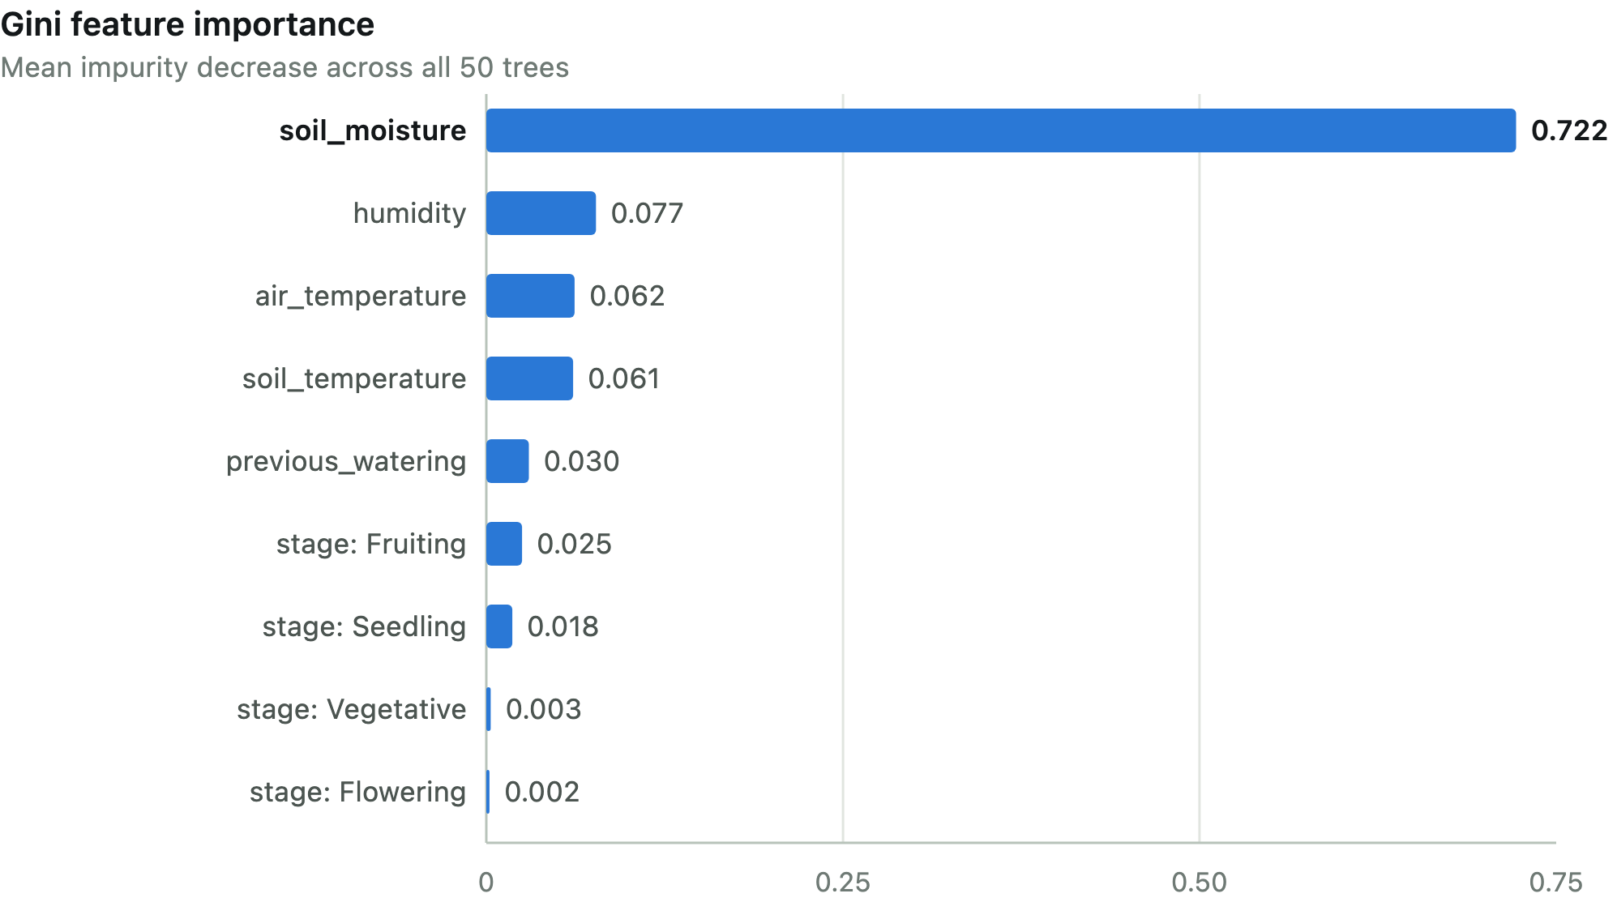
Figure 2. Feature importances, drawn on a true linear scale — the disparity is the result. soil_moisture carries 72.2% of the model's total impurity reduction; the four growth-stage columns together account for 4.9%.
This distribution is a useful sanity check: soil moisture should dominate a soil-moisture forecast, and the fact that the model discovered this without being told is evidence it learned the structure rather than noise. Two observations are less comfortable:
- `previous_watering` scores only 0.030 despite entering the labelling rule with a substantial +10 offset. Its effect is largely absorbed by soil_moisture, which is sampled independently of it in the generator. In real data the two would be correlated, and the importance would likely shift.
- Vegetative (0.003) and Flowering (0.002) are near-zero. Their thresholds (50% and 45%) sit in the middle of the range and are hard to separate from each other; Seedling (60%) and Fruiting (40%) are the extremes and carry the signal. The model effectively learned “extreme stages matter, middling stages don't”.

06 Connecting the AI to the ESP32 sensor system
Brief: how the AI component is integrated with the ESP32/sensor system, including the communication method and data flow.
The governing design decision is that no machine learning runs on the microcontroller. The ESP32 is a sensing and actuation node only: it reads sensors, reports them, and obeys a pump command. All inference happens on the Flask server, which holds the model in memory. This keeps the firmware small enough to be rewritten for whatever sensors are actually wired up, and means the model can be retrained and swapped without reflashing the board.

Communication method
ASPECT | CHOICE
Transport | HTTP/1.1 over 2.4 GHz WiFi — ESP32 as client, Flask as server
Payload | JSON, encoded on the board with ArduinoJson, parsed by Flask's request.get_json()
Direction | ESP32-initiated in both directions — it posts, then polls. The server never opens a connection to the board.
Server bind | 0.0.0.0:5001, reachable from any device on the LAN
Cadence | 5,000 ms, matching SIMULATOR_INTERVAL_SECONDS = 5 on the server
Libraries (board) | WiFi.h, HTTPClient.h (ESP32 core), ArduinoJson
Table 10. The transport between the sensor node and the server.
HTTP polling was chosen over MQTT or WebSockets because it needs no broker, no persistent connection, and no extra service to keep running — the same Flask app that serves the dashboard serves the board. Poll-based control also fails safe: if WiFi drops, the ESP32 simply keeps its last relay state and retries, rather than blocking on a dead socket. The port is 5001 rather than the conventional 5000 because macOS's AirPlay Receiver permanently occupies 5000, which would silently block the board from ever reaching the server.

Data flow
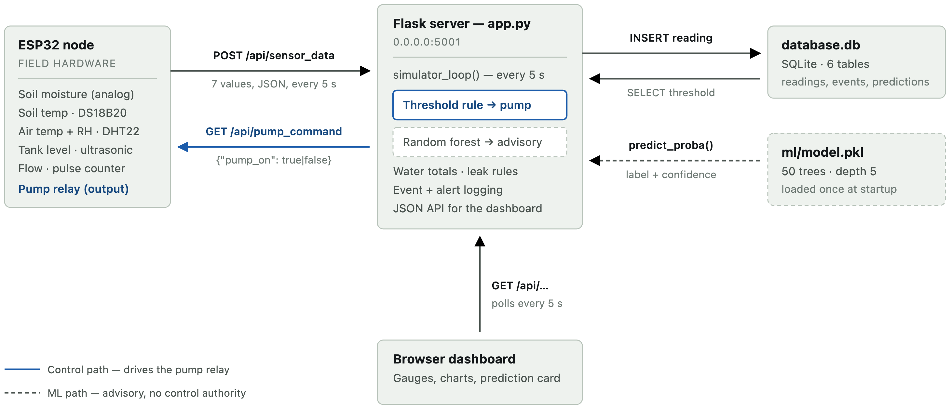
Figure 3. End-to-end data flow. The solid accent path is the only one that can move the pump; the dashed path is the AI component, which reads the same reading and writes a prediction but never reaches the relay.

The cycle, step by step
- Read. The ESP32 samples all six sensors. Flow is derived from an interrupt-driven pulse count divided by the sensor's calibration constant.
- Post. It serialises seven fields — soil_moisture, soil_temperature, air_temperature, humidity, water_tank_level, water_flow, pump_status — and POSTs them to /api/sensor_data. Any missing field returns HTTP 400.
- Cut over. On the first successful POST the server sets simulator_enabled = False. The background simulator stops inventing readings immediately, so real and simulated data can never be interleaved in the same table.
- Store. The reading is stamped with the active growth stage and inserted into sensor_readings.
- Decide. compute_commanded_pump() compares the new moisture value against the stage threshold read from SQLite.
- Poll and actuate. The ESP32 GETs /api/pump_command and drives its relay from {"pump_on": …}. The rule that governed the simulator now governs real hardware, unchanged.
- Infer. On the same 5-second tick, predict_irrigation_need() assembles the nine-column row, calls the forest, and writes label plus confidence to ai_predictions.
- Account. The flow reading becomes litres used, added to today's and the all-time totals; leak, blockage and low-tank rules open or resolve an alert; a pump transition is logged with its reason and the water that cycle consumed.
- Display. The browser polls the JSON API every 5 seconds and repaints gauges, charts, and the AI Prediction card. The source badge flips to “ESP32 (Live)” on its own.

Endpoints
METHOD | PATH | PAYLOAD | PURPOSE
POST | /api/sensor_data | 7 fields, JSON | Real readings arrive; simulator cuts out
GET | /api/pump_command | {"pump_on": bool} | Relay state the board should adopt
GET/POST | /api/data_source | {"simulator_enabled": bool} | Force back to simulator for a hardware-free demo
Table 11. The three endpoints that constitute the hardware contract. The remaining API routes serve the dashboard only.

Hardware map
SIGNAL | ESP32 PIN | PART
Soil moisture | GPIO34 (ADC) | Capacitive soil moisture probe, analog
Pump relay | GPIO26 (out) | 5 V single-channel relay → 12 V pump or solenoid
Flow pulses | GPIO27 (in) | YF-S201 pulse-output flow meter, 450 pulses/L
Soil temperature | — | DS18B20 waterproof probe (OneWire)
Air temp + humidity | — | DHT22
Tank level | — | HC-SR04 ultrasonic, or float switch
Table 12. Pin assignments and parts, as specified in the firmware. Pins are placeholders to be matched to the final wiring.
The pump and relay are powered from their own supply with a common ground to the ESP32; a pump draws far more current than the board's regulator can source.
INTEGRATION STATUS — STATED PLAINLY
The firmware is written and the JSON contract is real and exercised, but the ESP32 has not yet been connected to physical sensors. Only readSoilMoisturePercent() and readWaterFlowLitersPerMinute() perform genuine reads; soil temperature, air temperature, humidity and tank level currently return fixed placeholder constants pending the actual hardware. Every figure in §02's operational dataset therefore came from the software simulator, not from a field deployment.

One timing caveat
The server's control loop ticks every 5 seconds regardless of when data last arrived. If the board posts less often than that, the loop reuses the stale flow reading for intervening ticks and over-counts water usage. Holding SEND_INTERVAL_MS at 5,000 ms keeps the two in step; a longer sensor interval would need the water-accounting to be driven by the POST handler instead of the timer.

— Limitations and next steps

What the accuracy figures do and do not mean
The model was trained on data generated by a rule, so 88% cross-validated accuracy measures how well the forest recovered that rule, not how well it predicts real soil behaviour. The generating rule is a crude linear proxy for evapotranspiration with no soil type, no root depth, no rainfall, no solar radiation and no time dimension. Validating against real measurements is the one step that would turn these numbers into agronomic claims, and it has not been taken.

Three concrete weaknesses
- Missed-warning bias. Positive-class recall of 0.736, driven by class_weight=None against a 62/38 imbalance, in a setting where missed warnings cost more than false alarms.
- Train/serve semantic mismatch on `previous_watering`. In training it means “recently watered” over an unspecified horizon; at inference app.py supplies the pump status from the previous tick — 5 seconds earlier. The model is being fed a narrower notion of “recent” than it learned. A rolling window (was the pump on at any point in the last n minutes) would close the gap.
- Distribution shift. Training rows are independent uniform draws; live readings are a smooth autocorrelated walk in which moisture, temperature and humidity move together. The model is scored in production on a distribution it never saw in training.

Recommended next steps, in priority order
- Rebalance for recall. Set class_weight="balanced" or lower the decision threshold to ~0.40. Cheapest change, largest effect on the error that matters.
- Stratify the split. Add stratify=y so the held-out set matches the population class rate, and report cross-validated accuracy as the headline figure.
- Retrain on real history. The 9,272 rows already in sensor_readings can be labelled retrospectively — look ahead n ticks and check whether moisture actually crossed the threshold. That replaces the synthetic rule with observed outcomes and is the single highest-value improvement available.
- Widen the `previous_watering` window to a rolling interval, aligning training and serving semantics.
- Complete the hardware build. Wire the DS18B20, DHT22 and tank sensor, replace the placeholder reads, and confirm the four currently-constant features vary in the field.
- Add a persistent evaluation loop. Every prediction is already timestamped in ai_predictions and every reading in sensor_readings; joining them a few minutes forward would give a continuously updated real-world accuracy figure, entirely from data the system already collects.

What works
Within its stated scope the AI component does what it was built to do. It is reproducible from seed, explainable feature by feature, correctly separated from the control path, degrades safely when the model file is absent, transforms its inputs identically at training and inference, and has run unattended for 9,270 predictions without intervention. The engineering around the model is, if anything, in better shape than the model's training data — which is the right way round, because the training data is the part that a season of real measurements will fix.

All figures were measured directly from the project source and database.db; the model is reproducible with python ml/train_model.py (data seed 42, random_state=42). Operational counts reflect the database as recorded across a three-day run.

