Homework Assignment 1. Due April 21, 2015

Matthew O'Brien 965010701 matthewo@pdx.edu

Collaborators: Andrew McCann

4/21/2015

Solutions Chapter 1.

1.1:
Estimated development cost is 530,000. How much additional money will be needed for post delivery maintenance of the software?
The post delivery maintenance cost is 3 times that of the development cost. 530,000 times 3 is 1,590,000.

1.6:
Nine months after delivery, a fault is detected in the software of a product that analyzes mRNA using the Stein-Rotgen reagent. The cost of fixing the fault is 18,900. The cause of the fault is an ambiguous sentence in the specification document. Approximately how much would it have cost to correct the fault during the analysis phase?
The cost of detecting and correcting faults during the post delivery maintenance compared to the analysis phase is ~123 to 1. 18,900/123 = 153.66.

1.7:
Suppose that the fault in Problem 1.6 had been detected during the implementation phase. How much would it have cost to fix then?
The comparative cost between the post delivery and implementation phases is ~7 to 1. Or 18,900/7 = 2700.

Chapter 5

5.1:

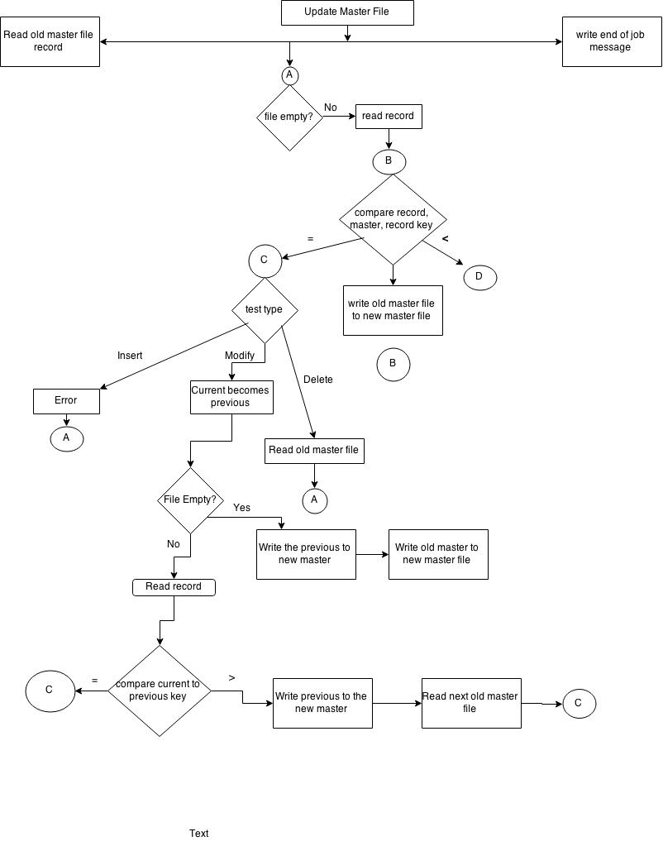

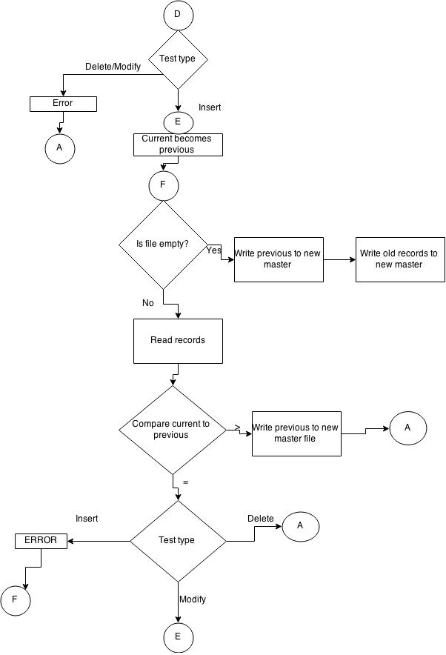

5.2:
Check for modification followed by deletion.
Follow chart works.
5.3
Check for insertion followed by modification.
Follow chart works.
5.4
Check for n insertions modifications, or deletions, n > 2.
Follow chart works.
5.5
Last transactions record has no successor.
Follow chart works.

Chapter 11.

11.23
Perform the requirements workflow for the ATM.

Brief Description:
Customer will be withdrawing funds from ATM.

Step-by-Step Description:
        - Customer inserts the card into ATM
        - Customer inputs pin
        - Verification of the PIN. Incorrect PIN terminates, ATM returns card.
        - Correct PIN. Menu screen appears for customer
        - Customer selects to withdraw funds.
        - Customer selects which account they want to withdraw
        - Customer selects the amount they want to withdraw. Up to 200, increments of 20.
        - ATM verifies amount selected is available. If not, error screen and returned to step 7.
        - Customer receives money from ATM.
        - Software updates the customer's balance.
        - ATM prints the customer's new balance, account number, amount withdrawn, and the date of transaction.
        - ATM returns the card to customer.

Brief Description:
Customer will be depositing funds into the ATM.

Step-by-Step Description:
        - Customer inserts the card into ATM
        - Customer inputs pin
        - Verification of the PIN. Incorrect PIN terminates, ATM returns card.
        - Correct PIN. Menu screen appears for customer.
        - Customer selects to deposit funds.
        - Customer selects account to deposit funds.
        - ATM opens deposit slot, customer places their funds into the slot, and slot closes.
        - Software updates the customer's balance.
        - ATM prints the customer's old balance, account number, amount deposited, and the date of transaction.
        - ATM returns the card to the customer.

Brief Description:
Customer will be transferring funds between their accounts.

Step-by-Step Description:
        - Customer inserts the card into ATM.
        - Customer inputs PIN
        - Verification of the PIN. Incorrect PIN terminates, ATM returns card.
        - Correct PIN. Menu screen appears for the customer.
        - Customer selects to transfer funds between their accounts.
        - Customer selects the account from which to transfer funds out.
        - Customer selects the destination account for the funds.
        - Customer selects the amount of funds for tranfer.
        - ATM verifies amount selected is available. If not, error screen and returned to step 8.
        - The software updates the balances of the two accounts.
        - ATM prints the customer's balance for both accounts, account numbers, amount transferred, and the date of the transaction.
        - ATM returns the card to the customer.

Brief Description:
Customer will be checking their balance of a given account.

Step-by-Step Description:

        - Customer inserts the card into the ATM.
        - Customer inputs PIN.
        - Verification of the PIN. Incorrect PIN terminates, ATM returns card.
        - Correct PIN. Menu screen appears for the customer.
        - Customer selects to view balance.
        - Customer selects which account to view.
        - ATM displays the current balance of the given account.
        - ATM returns the card to the customer.

