# Lab 3 – Git & Bugs

Individually:

* Setup hosted account (github, bitbucket, other)
* Setup local and remote repositories for your coursework
  + Local – ie ITWS4500/.
  + 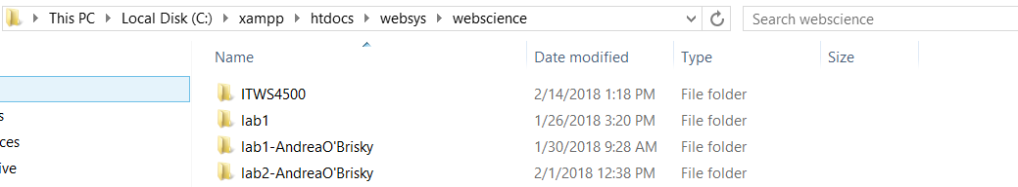

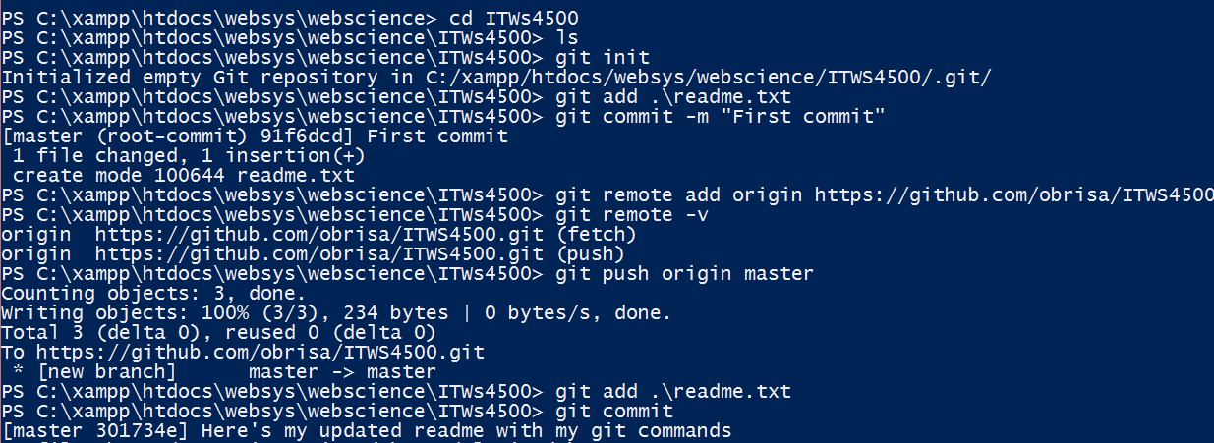

* + Remote – github or bitbucket
* Share the repository with Rahul (rahulprajapati3568) and me – taswegian (pfox@cs.rpi.edu)
* Install Bug Tracking software to your local machines – Show configuration and screenshot when complete.
* Submit links in readme to LMS with Part 2

<https://github.com/obrisa/ITWS4500>

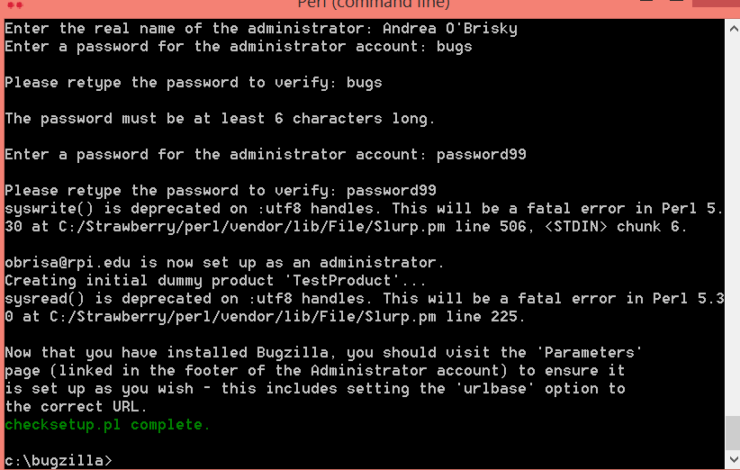

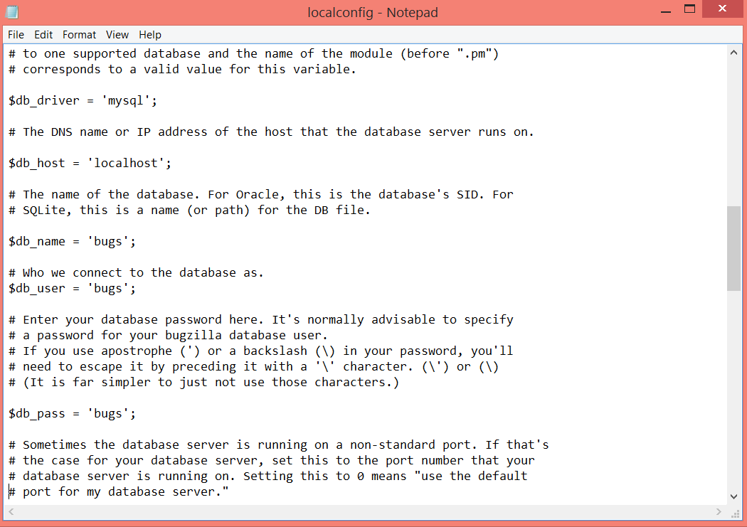

Group

* Setup a server for your projects – <http://hosting.myrpi.org/> or alternative
* Readme should include a description of your project and the repo should contain your proposal

Readme: <https://github.com/fakedestinyck/RPI-WebSysDev-FORMQ/blob/master/README.md>

-Proposal: <https://github.com/fakedestinyck/RPI-WebSysDev-FORMQ/blob/master/Form%20Q%20Project%20Proposal.docx>

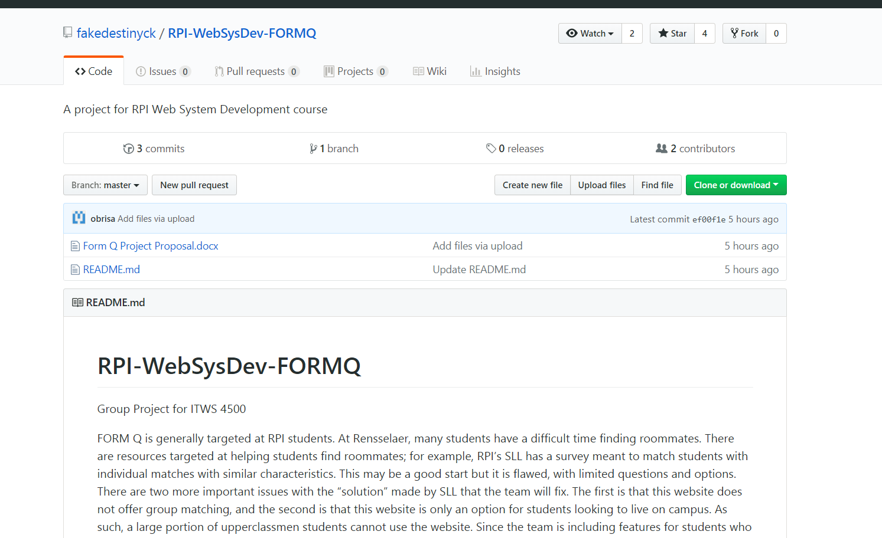

* Setup local and remote repositories
  + Local – each team member



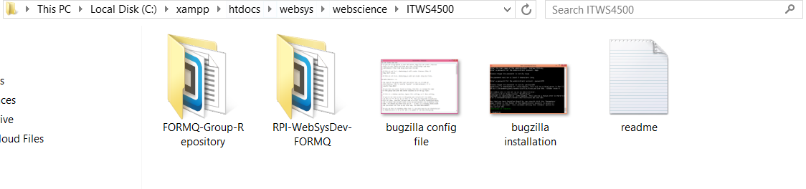

* + Remote – github or bitbucket

https://github.com/fakedestinyck/RPI-WebSysDev-FORMQ

* + Remote – your production server
* Setup a Bug Tracking server for your projects

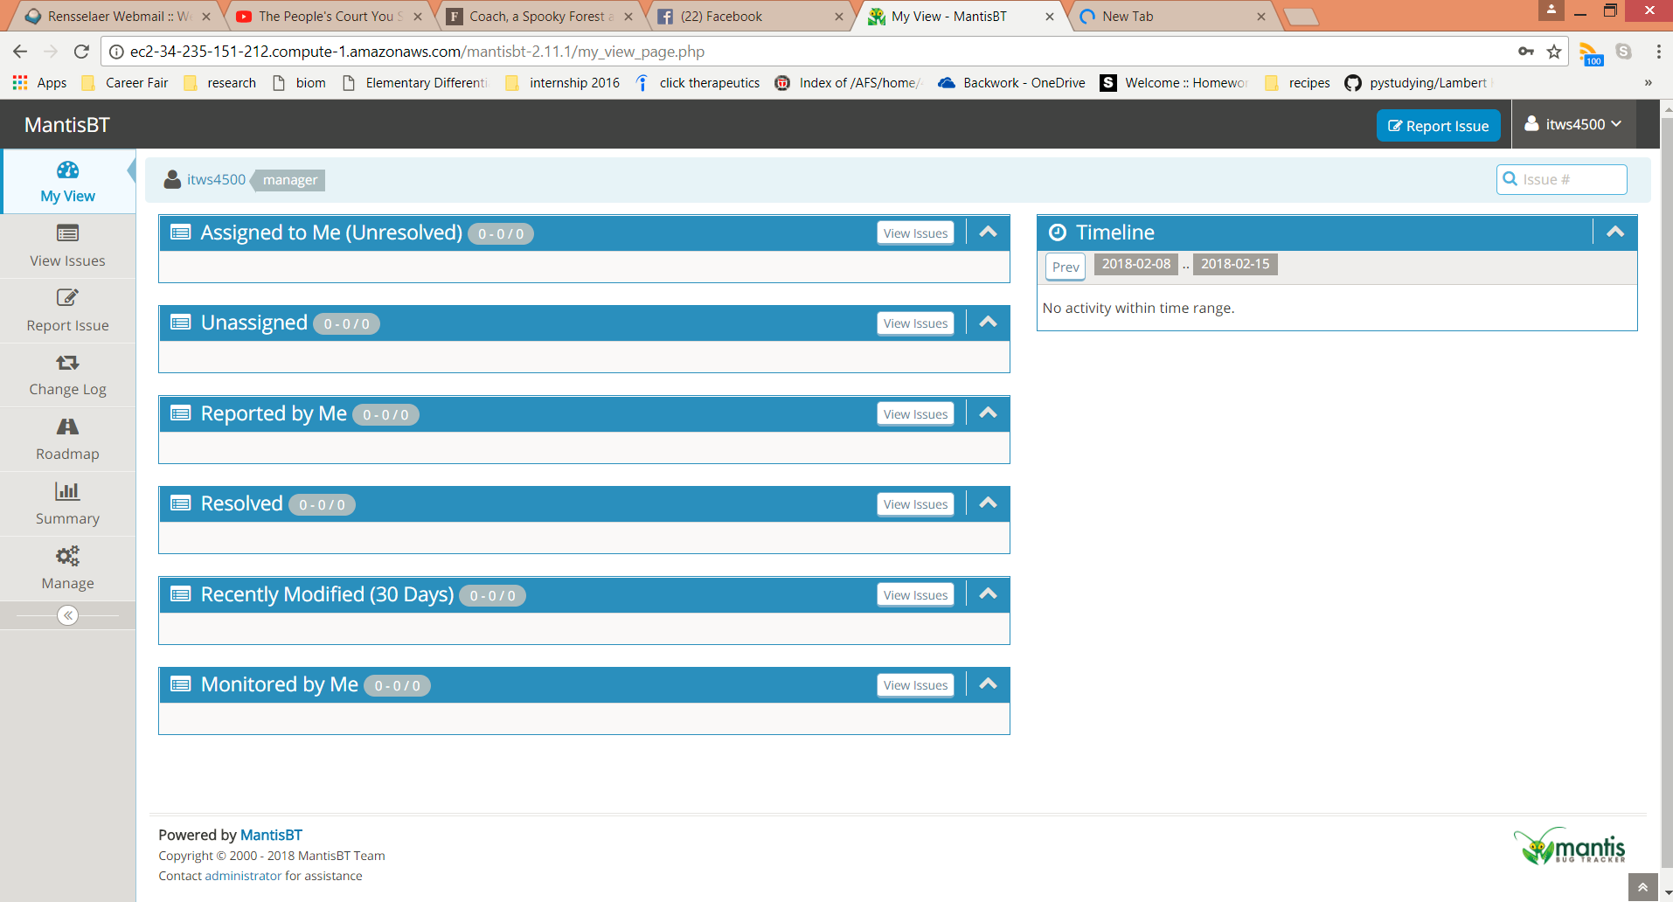

* Give us authority to the server and the repo

run ssh -i "itws4500gp.pem" itws4500@ec2-34-235-151-212.compute-1.amazonaws.com

* Submit links in readme via LMS

References:

<https://guides.github.com/activities/hello-world/>

<https://github.com/features/projects/issues>

<http://www.softwareadvice.com/resources/free-bug-tracking-software/>

<https://www.mantisbt.org/>

<https://www.bugzilla.org/>

You will be graded on the following;

Objective 1 : 20

Objective 2 : 20

Organization of course code : 10

Documentation/Read.me : 10