HMC

**Hamiltonian**

Hamiltonian function:

In motion

H=势能+动能

$$H(x,m)=U(x)+K(p)$$

$x: position$, $p: momentum$

$U:potential energy$, $K:kinetic energy$

$$U=mgh=max$$

$$\frac{∂U}{∂x}=ma$$

$$\frac{dx}{dt}=v$$

$$\frac{dv}{dt}=a$$

So if m=1

$$\frac{∂U}{∂x}=\frac{dv}{dt}$$

Then

$$K=\frac{mv^{2}}{2}$$

$$\frac{∂K}{∂v}=mv$$

If m=1

$$\frac{∂K}{∂v}=v$$

If dropping

$$\frac{dx}{dt}=−v$$

$$−\frac{∂K}{∂v}=\frac{dx}{dt}$$

So

$$\frac{dv}{dt}=\frac{∂U}{∂x}=\frac{∂H}{dx}$$

$$\frac{dx}{dt}=−\frac{∂K}{∂v}=−\frac{∂H}{dv}$$

$$\frac{dH}{dt}=\frac{∂H}{∂x}\frac{dx}{dt}+\frac{∂H}{∂v}\frac{dv}{dt}=−\frac{∂H}{∂x}\frac{∂H}{∂v}+\frac{∂H}{∂v}\frac{∂H}{∂x}=0$$

So H will not change with time

**Discrete** with leapfrog method.

With step size $ε$

$$p(t+\frac{ε}{2})=p(t)−\frac{ε}{2}\frac{∂U(x(t))}{∂x}$$

$$x(t+ε)=x(t)+ε\frac{p(t+\frac{ε}{2})}{m}$$

$$p(t+ε)=p(t)−\frac{ε}{2}\frac{∂U(x(t+ε))}{∂x}$$

**translating the density function for this distribution to a potential energy function**

$$P(x) = \frac{1}{Z}exp(−E(x)/T)$$

P(X): pdf

E(X): some energy function

T=1

Z: normalize

So for H(x,p)

$$P(x,p) = \frac{1}{Z}exp(−H(x,p))$$

$$P(x,p) = \frac{1}{Z}exp(−U(x))exp(−K(p))$$

$$U(x)=−log[π(x)p(x|D)]$$

In parameter space:

$$H(θ,p)=U(θ)+K(p)$$

$$U(θ)=−log[π(θ)p(data|θ)]$$

$π(θ)$:prior

$p(data|θ)$: likelihood

Negative of the log of the un-normalised posterior density (NLP)

NLP space

$$NLP(θ)=−log[π(θ)p(data|θ)]$$

Algorithm

1 initial with $θ^{0}$

2 loop for t=0,1,2...

Generate new momentum p from $N(μ,Σ)$

Solve the for new $θ^{∗}$ and $p^{∗}$ with leapfrog with step size $ε$ and L steps

$$p(t+\frac{ε}{2})=p(t)−\frac{ε}{2}\frac{∂U(θ(t))}{∂θ}$$

$$θ(t+ε)=θ(t)+ε\frac{p(t+\frac{ε}{2})}{m}$$

$$p(t+ε)=p(t)−\frac{ε}{2}\frac{∂U(θ(t+ε))}{∂θ}$$

Repeat the leapfrog for L steps

$$p^{∗}=p(t+Lε)$$

$$θ^{∗}=θ(t+Lε)$$

Accept with

$$α=min[1, exp(U(θ)+K(p)−U(θ^{∗})−K(p^{∗}))]$$

If accept:

$$θ^{1}=θ^{∗}$$

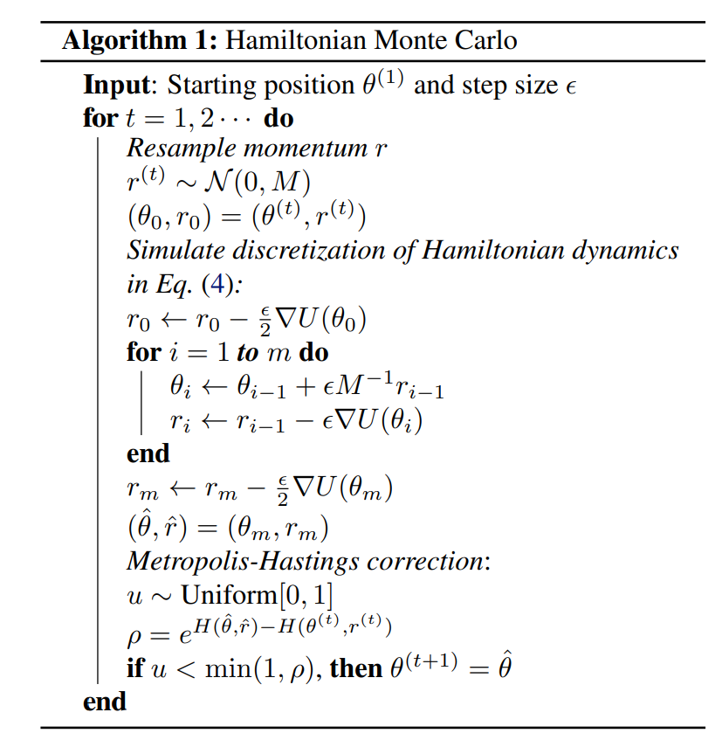

Tianqi Chen, Emily B. Fox, Carlos Guestrin. *Stochastic Gradient Hamiltonian Monte Carlo.* MODE Lab, University of Washington, Seattle, WA.

$$U(θ)=−log[π(θ)p(data|θ)]$$

-log(binormal distribution)

