MCMC

Markov chain

In finding E[X]

We need to do integral over target sample space

Both density and volume can contribute to the integral

In high dimension volume increases fast, but might have lower density

Typical set can balance the volume and density

So we only need to integral typical set

Markov chain is one of the method finding the typical set

A Markov chain is a progression of points in parameter space generated by sequentially applying a random map known as a Markov transition

Markov transition conditional probability density:

Q(q_n+1|q_n)

stochastic matrix

Keep updating q to find the typical set

Once the n is large enough the average of {q_0...q_n} is the E[X]

MCMC should follow Central Limit Theorem:

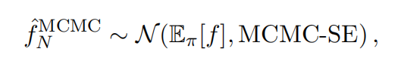

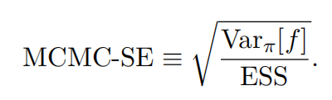

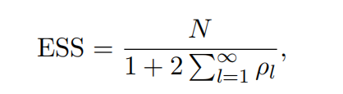

Effective sample size: number of sample needed

Autocorrelation

Finding Q

$π(q)$ Pdf of target distribution on parameter space

$$π(q_n+1)Q(q_n|q_n+1)α(q_n|q_n+1)=π(q_n)Q(q_n+1|q_n)α(q_n+1|q_n)$$

$$α(q_n|q_n+1)=π(q_n)Q(q_n+1|q_n)$$

$$α(q_n+1|q_n)=π(q_n+1)Q(q_n|q_n+1)$$

$α(q_n|q_n+1)$: accept rate

pathological region

Metropolis-Hastings

$$π(q_n+1)Q(q_n|q_n+1)α(q_n|q_n+1)=π(q_n)Q(q_n+1|q_n)α(q_n+1|q_n)$$

$$α(q_n|q_n+1)=min\{1,\frac{π(q_n+1)Q(q_n|q_n+1)}{π(q_n)Q(q_n+1|q_n)}\}$$

Random Walk Metropolis

$$Q(q_n|q_n+1)=Q(q_n+1|q_n)$$

$$α(q_n|q_n+1)=min\{1,\frac{π(q_n+1)}{π(q_n)}\}$$