For the ODE likeand the point

The following method might be work, but some of them do not have very high accuracy.

Froward Euler method  

Backward Euler method 

Trapezoid  

By roughly analyse the method before we could use the following equation to predict the solution numerical.

|  |  |  |
| --- | --- | --- |
|  |  | (1) |

And for each of three method above we will have:

,and

So the Runge Kutta method could be used in derive a higher order of prediction.

We first define an equation about the accuracy of equation 1

Def: If an ODE has a true solution, that

|  |  |  |
| --- | --- | --- |
|  |  | (2) |

Which mean for particular, the accuracy of prediction is.

Then take integral of ODE



To predict The integral is main goal of solving the ODE.

And if we combine it with equation (2)

|  |
| --- |
|  |

So the closer we predict of the integral the more accuracy we will get. Also notice that:is the width fromto

we need use Newton-Cotes formula:

|  |  |  |
| --- | --- | --- |
|  |  | (3) |

Which mean the sum of the product of width and value of the function.

So after we plug integral into equation (3):

|  |  |  |
| --- | --- | --- |
|  |  | (4) |

Is a small number, r is the number of point inside the interval h is the total width.

So apparently the more r we take the more accuracy we will get.

Also for each y point yn need to be predict from all of point above.

If we take r=2, the next y value need to be predict from the previous point, Where



So the equation for r=2 is:





Also the next y value need to predict from k1 and k2, And so on

We finally take (4) into (2), we will get the Ruuge Kutta equation like:

|  |  |  |
| --- | --- | --- |
|  | where | (5) |

Now I will use r=2 for example

So (5) becomes:

|  |  |  |
| --- | --- | --- |
|  | where | (6) |

So in these equations,,andare the unknowns.

To build equations that solve these unknowns we will take Taylor expansion of

|  |  |  |
| --- | --- | --- |
|  |  | (7) |

And we could change to:

|  |  |  |
| --- | --- | --- |
|  |  | (8) |
|  |  | (9) |
|  |  | (10) |

Then we can plug (8),(9) and (10) into (7)

|  |  |  |
| --- | --- | --- |
|  |  | (11) |

The difference of the approximate value and true value is:

|  |  |  |
| --- | --- | --- |
|  |  | (12) |

Also

|  |  |  |
| --- | --- | --- |
|  |  | (13) |

Then combine (12) (13) and (11):

|  |  |  |
| --- | --- | --- |
|  |  | (14) |

After deal with

|  |  |  |
| --- | --- | --- |
|  |  | (15) |

We want R to be smallest so we need the coefficients of f and h to be 0:

So we will get



Since we have 3 equaitons and 4 unknowns we will get infinite number of solution. So in order to make the compute simple, I choose:



Therefore

and 

Then second order R-K method from equation(6) becomes

|  |  |  |
| --- | --- | --- |
|  | where | (16) |

Which is also called modified Euler method.

With the same progress if we take r=3 or r=4, we will get third order and fourth order RK method:RK3



And RK4



Since RK2 has accurate of O(h3), RK3 will be O(h4) and RK4 will be O(h5) of accuracy.

Example:

For the ODE:and point



The true solution is



And if we use the RK3 method:

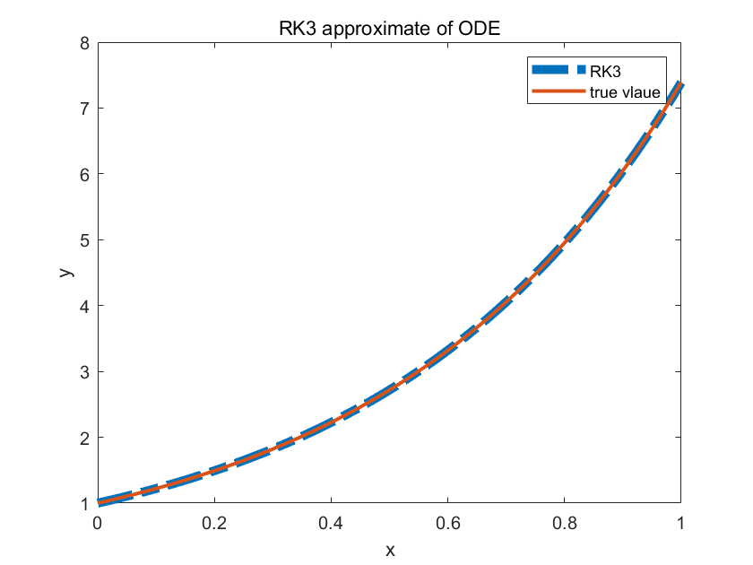

So from the plot the approximate from RK3 has coincide with the true value.

sum(abs(yt(:)-y(:)))%total absolute error.

ans = 1.4003e-04

Also the difference are very small.

Activity:

For the same ODE:





Making a approximate Using RK4 and see if the RK4 has less error than RK3.