

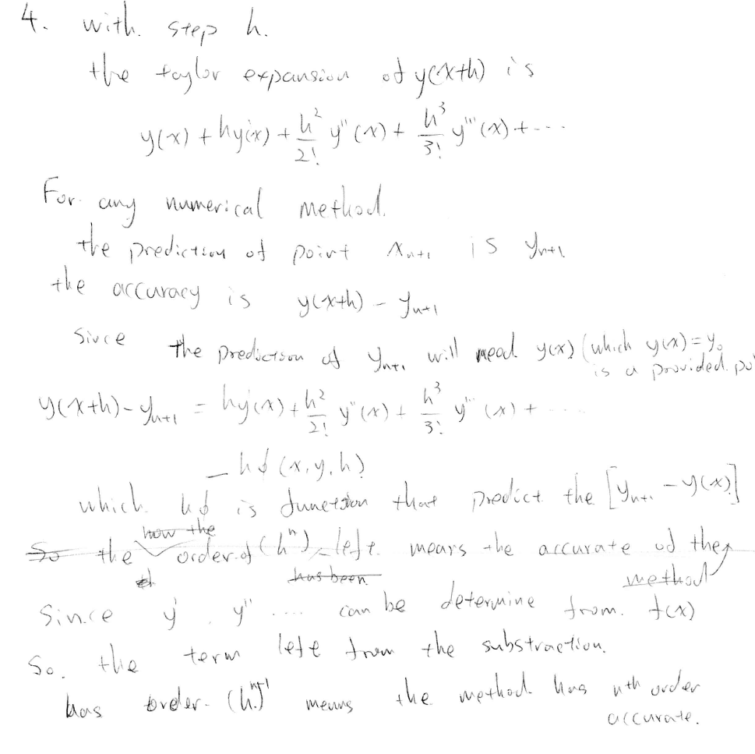



Regularization is the method that helping people choosing data from the noise data. With better Regularization method we could de-noise the data and get better result, reduce the over fit.

Method 1: TSVD

Truncked SVD:

for the problem

F is the things we want

M is the data we have and sigma is the noise

In order to solve m we need

The singular values of a picture or matrix are separated to wide range. The condition number will be huge and it will be hard to do the inverse computation

Set a limitation and ignore the singular value smaller than the limitation, doing the pseudo-inverse instant of inverse, set the inverse of smaller singular value to 0.

Then using the least square method find vector that:



Then vectorwill be the solution

Method: Tikhonov

for the problem

Tikhonov minimize the expression

with

write





