How to install
Kernel-based Virtual Machine (KVM) and libvirt
on a Linux CentOS system.

Example Scripts and Stuff
https://github.com/obscuritysystems/kvm-libvirt

Intended Audience
This guide is written for a medium to novice skilled Linux administrator or hobbyist.
What you need to know
What is Kernel-based Virtual Machine (KVM)?
KVM is a full featured virtualization solution that is free to use. It takes advantage of the Intel VT and AMD-V CPU extensions. The advantage of KVM over other virtualization software is that its free and doesn't require any licensing hoops. KVM is also open source software.
Computer virtualization is the process of using software to substitute hardware to an operating system. It's the same as having an operating system on top of another operating system. The advantage of this is the ability to separate software services into their own environments and reduce down time by having the ability to move virtual machine images to new hardware when old hardware becomes degraded or starts to fail.
What is libvirt / virsh?
Libvirt is a management application programming interface (API). Virsh is a command line utility that uses the libvirt API to manage virtual machines and other virtual host settings.
Skill level required.
Basic knowledge of Linux System and Centos is a must for completing this guide.
You should be comfortable with these Linux commands on a Centos Environment.
- yum
- cd
- grep
- cp
- ls
- ps
- iptables
- ifconfig
- dhclient
You must have knowledge of basic TCP/IP Networking .
- IP addressing and subneting
- Network Address Translation or NAT.
- What a networking bridge is and how it functions.
- DHCP Client Basics.

You need to be familiar with the abstract concepts of computer hardware.
- CPU Processor Basics
- RAM Configuration Basics
- Hard drives configuration basics.
- Networking Interface Cards (NIC's) .
- Display Ports.
- PCI Slots.
Getting Started
To install KVM on CentOS from this guide you need to have access to physical computer hardware. This guide cannot be implemented through a virtual machine using windows or another virtualization system.
Before you begin this procedure you need to have access to a computer system that has a CPU at support virtualization.
The Host system will refer to the operating system and hardware that is providing the virtualization service.
The Guest system will refer to the operating system being virtualized and controlled through kvm and libvirt.
We will begin by testing the CPU architecture.
Testing your Hardware for Virtualization Support.
To begin you must have root access to a Centos System that isn't currently virtualized.
Most modern CPU's have virtualization capabilities, but most desktop system have them disabled by default. Please refer to your motherboard user manual on how to enable these features on your hardware.
You can test to see if you have virtualization enable by installing centos and running this command as root.
egrep '(vmx|svm)' /proc/cpuinfo
If you see output like in Figure 1.1 Then your system is capable of full virtualization and you have virtualization enable.
If you something like Figure 1.2 then you may not have virtualization support enable or your CPU does not support virtualization and you cannot continue.
Please refer to your Computer system manufacture for more information on virtualization support.
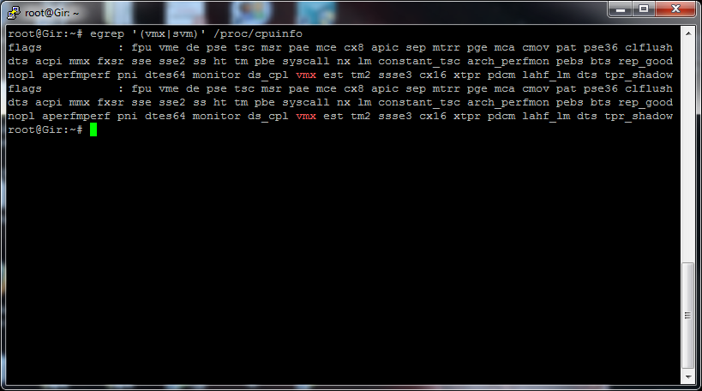Figure 1.1 virtualization support enabled.

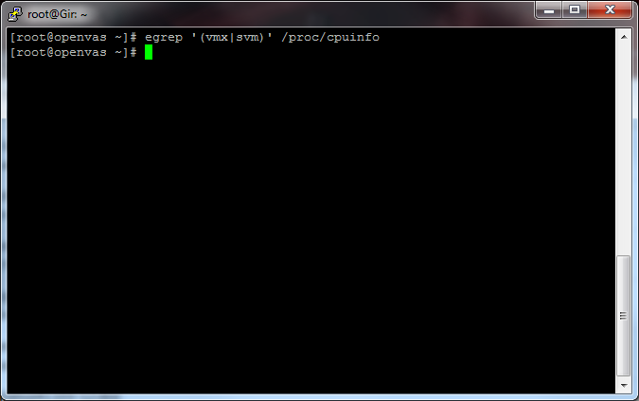Figure 1.2 no virtualization support

Installing KVM Software and libvirt
The easiest way to install KVM and libvirt is through the yum package manager.
Please note before you install kvm and libvirt you might need to have additional repositories enabled on your Centos System. Please refer to www.centos.org for more information.
Execute this command on your system to install kvm and libvirt.
yum install kvm libvirt python-virtinst qemu-kvm
Next start the libvirtd daemon using this command.
/etc/init.d/libvirtd start
or
service libvirtd start
To check if libvirt has been successfully installed run this command
virsh
You should see something like Figure 1.3.
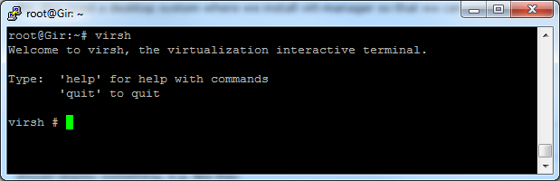Figure 1.3 - Virsh output.
Configuration of Networking support.
We will use the term "outside network" to refer to the physical networking connection our host system is connected to. This guide assumes you have one physical networking connection connected to a local area network that has an out bout route.
Before you begin you will need to install the bridge-utils package. The bridge-utils package allows Linux to run as a virtual switch and bind Ethernet NIC's to this virtual switch
Libvirt by default creates a Network Address Translated Bridge called virbr0 you can use this internal network to hide your virtual machines from the outside physical network and still have internet connectivity for updates.
To view virbr0 configuration information run the command:
ifconfig virbr0
The output of the command should look like figure 1.4. In this you should see that the IP address 192.168.122.1 and the subnet is 255.255.255.0.
If you do a virt-install (explained later) and have your virtual machine on this virtual bridge you can run the command.
dhclient
Once dhclient has finished your virtual machine will get configured with a IP address on the 192.168.122.0/24 network. if your host has internet access your guest will now use the hosts IP address as a NAT IP address and will now have internet connectivity.
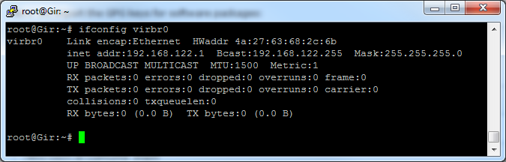Figure 1.4 virbr0 config information.
Next we will setup a bridge connection that our guest machines can use to connect to the physical LAN and appear as a normal machine. The different between this and using virbr0 is the machines will not be hidden behind a network address translation layer.
Bridging eth0 on Centos physical host system
To bridge the hosts Ethernet port eth0 to allow virtual machines unfiltered access to the external network we need to configure a bridge device.
using the vi editor or another editor of your choice.
Modify the following Centos config file.
vi /etc/sysconfig/network-scripts/ifcfg-br0
DEVICE=br0
TYPE=Bridge
BOOTPROTO=static
DNS1=x.x.x.x
GATEWAY=x.x.x.x
IPADDR=x.x.x.x
NETMASK=x.x.x.x
ONBOOT=yes

The value x.x.x.x is the appropriate IP address and subnet (netmask) for your network.

Next we need to tell the Centos that eth0 is part of br0. Open up and edit the file like so.

vi /etc/sysconfig/network-scripts/ifcfg-eth0

# Networking Interface
DEVICE=eth0
#BOOTPROTO=none
#DNS1=4.2.2.1
#GATEWAY=192.168.0.1
HWADDR=00:1e:90:f3:f0:02
#IPADDR=192.168.0.100
#NETMASK=255.255.255.0
ONBOOT=yes
TYPE=Ethernet
IPV6INIT=no
USERCTL=no
BRIDGE=br0

Once you have your networking files configured restart the networking services.
Service networking restart
Once that is done you now have a bridge interface to the outside world that virtual machines can be configured to use. This gives the virtual host the ability to pretend that each of the virtual machines are real machines connected to a physical switched network.
To verify that that the bridge contains a physical interface you can run brctl show.
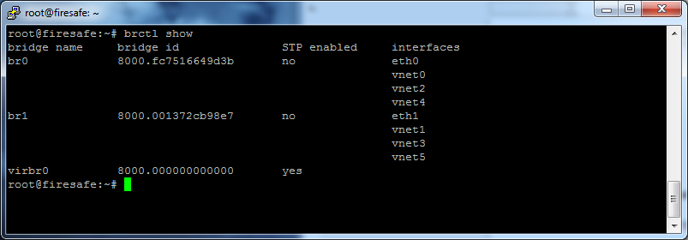
Figure 1.5
Also note if you have virtual machines running you should see there virtual interface attached ot the bridge. Setting up a bridge on the Linux system is the virtual equivalent of putting a switch between multiple computers.
We are now ready to install our first virtual machine.
Installing a virtual machine.
Start by installing the virt-install utility.
You do this by executing the yum command.
yum install virt-install
Next you use the virt-install command to install a virtual machine below is an example. We will go through what each option relates to.
virt-install --nographics --name Moogey --ram 512 --vcpus=1 --os-type linux --hvm -l /opt/CentOS-6.2-x86_64-netinstall.iso -x "console=ttyS0" --network=bridge:br0,model=ne2k_pci --disk path=/opt/kvm/images/Moogey.qcow2,size=16
virt-install options
--nographics
No graphics tells libvirt not to create a VNC service for the virtual machine. This is useful if you want to have a system free of X11 and xwindows.
--name [NAME]
is the name you use to identify the virtual machine in the virsh console.
--ram [RAM SIZE IN MEGABYTES]
This defines how much ram is allocated to your virtual machine.
--vpcus = [Number of cpus]
The --vpcus command defines how many virtual cpus your system will have you can define as many as you want but its recommend to only do as many as cpu cores you have on your physical hardware.
--os-type [LINUX,WINDOWS,FREEBSD,ETC..]
The --os-type command is used to optimize the virtual machine.
--hvm
--hvm forces full virtualization of the virtual machine.
-l /opt/CentOS-6.2-x86_64-netinstall.iso
-l defines the location of the installation media. Here is where you would point to the iso image of the installation cd.
-x "console=ttyS0"
This command enables the console port of the virtual machine this is very important for accessing your virtual machine by the virsh console.
--network=bridge:br0,model=ne2k_pci
Network defines how to create the networking interface for the virtual machine to use virbr0 instead of br0 use --network like this --network network:default . Model defines the type of virtual networking card for more information consult libvirt documentation http://libvirt.org/.
--disk path=/opt/kvm/images/Moogey.qcow2,size=16
path= defines the path of the hard drive image. size = 16 sets the hard drive size to 16 gigabytes. To increase the size in gigabytes you can increase this number.
Modify the virt-install command to suit your needs and then run it. After virt-install creates the virtual machine and initializes it. You will enter the default centos install prompts that you would see from a normal install. This ends the portion of this guide focusing on virtualization setup from here on the install should be exactly the same as a normal graphic free text install.
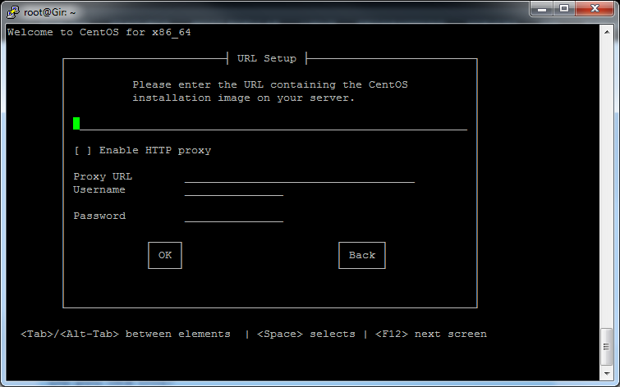Figure 1.6 CenotOS console install.
Figure 1.6 show a console install of centos using the net install cd.

libvirt managing VM's
So once your VM is done installing you can access it via the console.

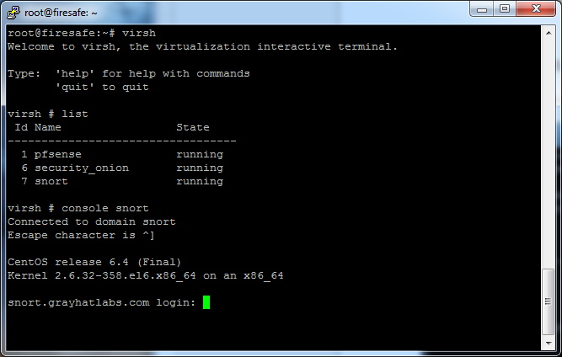
Figure 1.7
To exit out of the console you hold down ctrl + ] (ps this also works in telnet)
The advantage of being able to ssh in and remotely administration the console on servers around the world is powerful. You no long require the need of vmware clients or reconfiguration of firewalls to opening insecure ports.
So now what if you want a GUI for your virtual machine?
Graphical Install and management via SSH tunneling
So lets say you want to run a server with a GUI like windows from M$ or maybe you just want a GUI.
The following command is for a virt-install of a Windows XP Guest.
virt-install --name myWinXP --ram 512 --disk path=/var/lib/libvirt/images/WinXP3.qcow2,format=qcow2 --network bridge=br0 --vnc --os-variant winxp -c /var/lib/libvirt/images/en_winxp_pro_with_sp2.iso
Note some changes here. First we are setting the networking to bridge br0 next we are defining --vnc instead of no-graphics.
What this will do is start a VNC service on the local loopback interface of the virtual host.
The local loop back interface is only accessible via the local machine. So you ask how is this helpful? Well we will take advantage of ssh tunneling to access those VNC display ports.
Below is a diagram of 3 virtual machines listed by virsh (figure 1.8). The first two have vncdisplays that last one does not. To see which virtual machine is running on which vnc display port you use the vndsiplay <hostname> command in virsh.
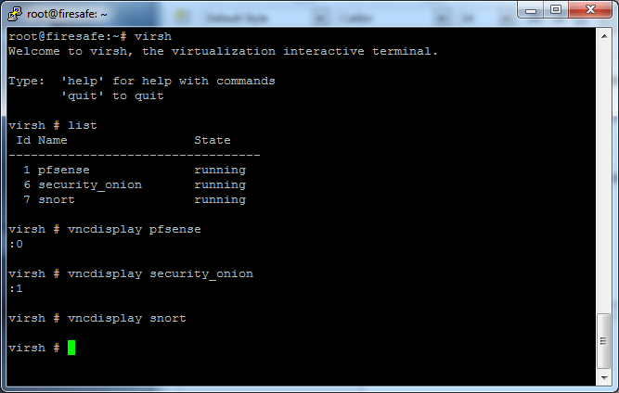
Figure 1.8

So a quick introduction to VNC.
VNC port :0 is tcp port 5900, vnc port:1 is tcp port 5901 VNC port :n is tcp port 590N.
If you run netstat -lptun you can see what ports are open and what process they are bound to. Here we see port 5900 and 5901 are bound to kvm. Which means our VNC display is running on these ports.
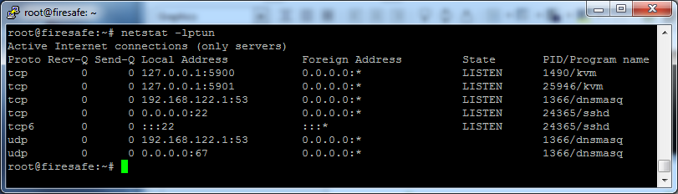
Figure 1.9
Now how do I access the vnc display? Easy via ssh tunneling. Using putty
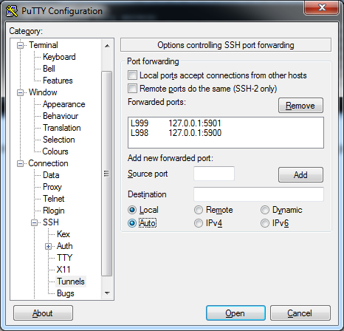

Figure 2.0
In the Figure 2.0 which shows the putty tunnel configuration option we see in Forwarded ports L999 127.0.0.1:5901. L999 references the local port on your machine which is going to be mapped to the remote IP 127.0.0.1 and port 5900 once you log in via ssh.
After have configured your tunnels in putty under ssh and then logged in and you are ready to go. You should now be able to connect via VNC to your localhost port 999.
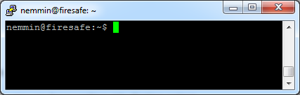

Figure 2.1

In this example we use tight vnc.
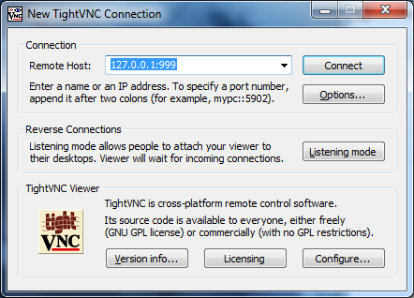

Figure 2.2
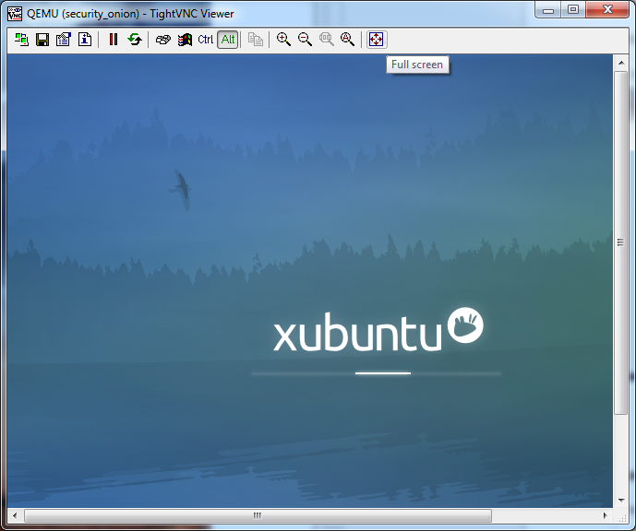
Figure 2.3
Now you have a secure VNC connection tunneled over ssh to your virtual host.
Next lets review virsh.
Useful virsh commands
list –all (displays all available virtual machines.)
destroy <hostname> (hard shutdown of machine equivalent of holding the power button down)
undefine <hostname> (Removes host from virsh config.)
start <hostname> (start the virutal machine.)
edit <hostname> (lets you edit the virtual machine xml config also notee it requires a reboot to take affect.)
Config files
/etc/libvirt# ls
hooks libvirt.conf libvirtd.conf lxc.conf nwfilter qemu qemu.conf storage
Virtual Machine storage
by default libvir stores all virtual machine files in /var/lib/libvirt/images
root@firesafe:/var/lib/libvirt# ls
boot dnsmasq images network qemu sanlock
Conclusion
Congratulations now you have working virtualization system.
For more help run the virsh help command and consult the libvirt documentation at http://libvirt.org/docs.html.

Abbreviations

API Application Programmer Interface
DNS Domain Name Service
DHCP Dynamic Host Configuration Protocol
KVM Kernel Virtual Machine
LAN Local Area Network
IP Internet Protocol
TCP Transmission Control Protocol
NAT Network Address Translation
NIC Network Interface Controller
VNC Virtual Network Computer

Technical Terms
This section defines common virtualization terms.
A computer network, also known as a network, is a collection of hardware components and computers interconnected by communication channels that allow sharing of resources and information.
Dynamic Host Configuration Protocol is a network configuration protocol for hosts on Internet Protocol (IP) networks.
Ethernet is a computer networking technology specification for local area networks (LANs).
Guest System refers to the operating system being virtualized and controlled through KVM and libvirt.
Host System will refer to the operating system and hardware that is providing the virtualization service.
Hypervisor, also known as a virtual machine manager (VMM). The hypervisor provides a guest operating systems a virtual operating platform and manages the execution of the guest operating systems machine instructions.
KVM Kernel Based Virtual Machine is a full virtualization solution for Linux on computer hardware.
LAN A local area network (LAN) is a computer network that interconnects computers close area such as a home or office.
Network Bridge Bridging is a way of forwarding frames between computers.
Network Interface Controller is a computer hardware component that connects a computer system to a TCP/IP network.
Network Address Translation (NAT) is the process of modifying IP address information in IP packet headers while in transit across a traffic routing device. So that the IP address is hidden from the outside IP network.
Router is a device that forwards data packets between computer networks.
Subnet (Netmask) is the number used to define a networking segment define a local area network.
TCP/IP is a communications protocols used for the Internet and other similar networks.
VNC is remote control software which allows you to view and fully interact with one computer desktop.
A Virtual Machine (VM) is a software implementation of a computer system. A VM executes programs instructions exactly like a physical machine.
Virtualization in computing, is the creation of a software model version of a real device, such as a hardware platform, operating system, a storage device or network resources.

