HARAMAYA UNIVERSITY
College of Computing and Informatics
Department of Software Engineering

INTERNSHIP REPORT

Project Title: EasternCities Rental Management System

Hosting Organization: BeWide Technologies PLC
Location: Addis Ababa, Bulgaria Mazoriya, Dimbel Building 105

Group Work A

Name | ID | Section
Rahma Salah | 0886/15 | B
Obse Taresa | 1780/15 | B
Mahlet Mulugeta | 0692/15 | B

Internship Period: February 2026 – June 2026
Course: Full Semester Internship (18 ECTS)
Academic Advisor: ________________________
Date of Submission: ________________________

2. Preliminary Pages

2.1 Declaration and Approval

Declaration
We, the undersigned students of Haramaya University, College of Computing and Informatics, Department of Software Engineering, hereby declare that this internship report is an authentic record of our group work performed at BeWide Technologies PLC from February 2026 to June 2026. This report is submitted in partial fulfillment of the requirements for the degree of Bachelor of Science in Software Engineering. The information and findings presented herein are the result of our own work and observations during this period. We further declare that this report has not been submitted to any other university or institution for the award of any degree or diploma.

Name | Signature | Date
Rahma Salah | _________________ | _________
Obse Taresa | _________________ | _________
Mahlet Mulugeta | _________________ | _________

Approval
Hosting Organization Supervisor: Feysel Seifu
Signature: ________________________
Date: ________________________

Academic Supervisor: ________________________
Signature: ________________________
Date: ________________________

2.2 Acknowledgements
We would like to extend our deepest gratitude to BeWide Technologies PLC for providing us with the platform, resources, and mentorship to carry out our internship. The guidance and encouragement of the entire development team made our experience both productive and enriching. In particular, we wish to express our profound thanks to our company supervisor, Feysel Seifu, whose industry insights, technical expertise, and unwavering support guided us through complex architectural decisions and day-to-day challenges. Feysel's leadership was instrumental in bridging our academic knowledge with practical software engineering practices.
We sincerely thank our industry supervisors for their continuous support, patience, and technical direction throughout the development of the EasternCities Rental Management System.
We are also deeply grateful to the Department of Software Engineering at Haramaya University, College of Computing and Informatics, for equipping us with the foundational theoretical knowledge and practical skills necessary to succeed in a professional software development environment.
Finally, we extend our appreciation to our academic advisor for their oversight and feedback on this report.

2.3 Abbreviations and Acronyms
Abbreviation | Full Form
API | Application Programming Interface
CI/CD | Continuous Integration / Continuous Deployment
CRUD | Create, Read, Update, Delete
CSS | Cascading Style Sheets
DOM | Document Object Model
ERD | Entity Relationship Diagram
HTML | HyperText Markup Language
IDE | Integrated Development Environment
JS | JavaScript
JSX | JavaScript XML
JWT | JSON Web Token
MVP | Minimum Viable Product
OOSAD | Object-Oriented Systems Analysis and Design
ORM | Object-Relational Mapping
REST | Representational State Transfer
SDLC | Software Development Life Cycle
SPA | Single Page Application
SQL | Structured Query Language
UI/UX | User Interface / User Experience
UML | Unified Modeling Language

2.7 Executive Summary
This report documents our four-month group internship experience at BeWide Technologies PLC, an Addis Ababa-based software development startup known for its innovative solutions like the Umrago Umrah travel platform. The internship was undertaken from February to June 2026 under the direct supervision of Feysel Seifu. We were tasked with developing the EasternCities Rental Management System, a comprehensive web-based platform designed to connect renters with item owners across multiple categories including vehicles, electronics, furniture, and real estate.
The project was constructed using a modern, scalable full-stack architecture. The frontend was built with React.js and Vite, utilizing React Query (TanStack v5) for robust state management. The backend was powered by Node.js and Express.js, interfacing with a Neon PostgreSQL cloud database managed through the Prisma ORM. To enhance the platform's capabilities, we integrated several external services, including Google's Gemini AI API for intelligent features, SMTP email services for notifications, and cloud-based file storage for managing listing images.
Our key activities spanned the entire Software Development Life Cycle (SDLC). We began with rigorous requirements analysis and system modeling using UML, progressing to database design, frontend and backend implementation, API development, and rigorous performance optimization. We successfully implemented complex, role-based dashboards catering to renters, owners, system administrators, and super admins. Additionally, we developed a complete advertising request and approval workflow to support platform monetization.
The internship culminated in a fully functional, deployed rental management system. Through this intensive, hands-on experience, we significantly strengthened our technical proficiency in full-stack JavaScript development. We gained invaluable exposure to agile methodologies in a commercial setting and cultivated essential professional soft skills, including teamwork, effective communication, and robust time management, preparing us thoroughly for future careers in software engineering.

3. Introduction

3.1 Background of the Hosting Organization
BeWide Technologies PLC is a prominent and pioneering startup specializing in software development, IT solutions, and branding services that drive digital transformation. Founded and headquartered in Addis Ababa, Ethiopia, the company has established itself as a key player in the local tech ecosystem. BeWide Technologies delivers intelligent web design, custom enterprise systems, and dynamic mobile applications meticulously tailored to meet modern business needs and solve complex operational challenges.
The company has a proven track record of successfully delivering numerous projects and continuously collaborates with diverse stakeholders across multiple sectors. One of its most notable flagship innovations is Umrago. Umrago is a proprietary product and a dedicated Umrah marketplace platform designed to transform and enhance the Umrah travel experience for Ethiopian travelers. It provides a central platform to discover and book packages from certified agencies, offering transparency, verified reviews, and a simplified planning process through smart, user-centered digital solutions.
In addition to commercial software development, BeWide Technologies is actively involved in technology capacity building. The company offers comprehensive training programs aimed at empowering youth and professionals with highly sought-after practical digital skills. Demonstrating strong corporate social responsibility, BeWide Technologies contributes significantly to community development initiatives and actively supports technology-driven social impact projects across Ethiopia.

Core Products and Services:
- Custom web and mobile application development (including frameworks like React, Node.js, and Flutter)
- Enterprise software systems and scalable backend architectures
- IT consulting, branding services, and digital strategy formulation
- Digital skills training programs and internships
- Umrago (Comprehensive Umrah travel and booking platform)

Target Customers:
BeWide Technologies caters to a diverse clientele, including mid-to-large enterprises, government institutions, non-governmental organizations (NGOs), and individual entrepreneurs actively seeking modern, robust digital transformation solutions.

3.2 Internship Overview
The primary purpose of this internship was to effectively apply theoretical Software Engineering concepts—such as Object-Oriented Systems Analysis and Design (OOSAD), database normalization, and algorithm design—learned in the academic environment to a tangible, real-world commercial software project. Our group of three software engineering students was integrated into the Software Development department at BeWide Technologies PLC.
Under the expert guidance of our supervisor, Feysel Seifu, we were assigned the ambitious task of designing, architecting, and building the EasternCities Rental Management System from the ground up. This involved navigating complex business logic, ensuring high performance, and maintaining strict security standards.
Internship Duration: February 2026 – June 2026 (4 months)
Department: Software Development Team
Project: EasternCities Rental Management System

3.3 Objectives of the Internship
General Objectives:
- To meticulously bridge the gap between academic, theoretical learning and practical, fast-paced industry software development practices.
- To actively experience and contribute to the full Software Development Life Cycle (SDLC) within a professional, commercial setting.
- To develop and refine technical, interpersonal, and professional skills deemed essential for a successful, long-term career in software engineering.

Specific Objectives:
- To architect, design, and implement a highly scalable, secure, and performant full-stack rental management web platform.
- To rigorously apply Object-Oriented Systems Analysis and Design (OOSAD) principles, extensively utilizing UML modeling to communicate system architecture.
- To gain mastery over modern development tools and frameworks, specifically React.js, Node.js, Express.js, Prisma ORM, and Neon PostgreSQL.
- To practice and internalize agile software development methodologies (Scrum, Sprints, Daily Stand-ups) in a collaborative team environment.

3.4 Scope of Work
Our extensive responsibilities encompassed the entire, end-to-end development lifecycle of the EasternCities platform. This required a multidisciplinary approach:
- Requirements Gathering and Analysis: Engaging in stakeholder discussions, conducting market research, and translating business needs into technical specifications.
- System Modeling: Creating detailed UML diagrams including use-case, entity-relationship (ERD), sequence, activity, component, and deployment diagrams to visually document the system architecture.
- Database Design: Architecting the relational database schema, ensuring proper normalization, and implementing it using Prisma ORM on a Neon PostgreSQL cloud instance.
- Frontend Development: Crafting responsive, highly interactive, and accessible user interfaces utilizing React.js, Vite, and modern CSS paradigms like glassmorphism.
- Backend Development: Engineering secure, RESTful APIs using Node.js and Express.js to handle complex business logic, authentication, and authorization.
- Integration of External Services: Seamlessly connecting the platform with third-party APIs including Google Gemini AI for advanced features, SMTP for reliable email delivery, and secure cloud solutions for handling large file uploads.
- Performance Optimization: Implementing advanced client-side caching, data synchronization, and state management using React Query (TanStack v5) to ensure optimal application speed and responsiveness.
- Testing and Debugging: Conducting rigorous manual UI/UX testing, performing comprehensive API endpoint validation using Postman, and utilizing browser developer tools for deep code profiling.

4. Internship Activities and Technical Experience

4.1 Working Environment and Team Structure
Our group was fully immersed in an agile, cross-functional development environment at BeWide Technologies. This professional setting was designed to simulate high-performance industry standards. The team structure was meticulously organized to ensure clear responsibilities and smooth workflows:
Role | Responsibility
Project Manager | Oversaw Sprint planning, facilitated task assignment, managed timelines, and handled critical stakeholder communication.
Supervisor / Senior Dev | Feysel Seifu provided high-level architecture decisions, conducted thorough code reviews, and offered invaluable daily mentorship.
UI/UX Designer | Responsible for initial wireframing, establishing visual design language, and conducting user research for intuitive navigation.
Frontend Developers (Interns) | Engineered complex React components, applied styling, managed client/server state, and ensured cross-browser compatibility.
Backend Developers (Interns) | Developed robust API routes, managed database schema migrations, and implemented strict security and authentication protocols.
QA Engineer | Executed testing protocols, maintained bug tracking systems, and ensured overall software quality assurance before deployments.
Development Workflow: We strictly adhered to an Agile Scrum methodology. Our work was structured into two-week sprints. Each sprint commenced with a detailed planning session to estimate and assign tasks. Daily stand-up meetings were held to discuss immediate progress, identify blockers, and align daily goals. At the conclusion of each sprint, we participated in code reviews, sprint demonstrations, and retrospectives to foster a culture of continuous integration and continuous improvement (CI/CD).

4.2 Tools, Technologies, and Platforms Used
To ensure the EasternCities platform was built to modern, scalable standards, we utilized a comprehensive suite of cutting-edge technologies:
Category | Tools and Technologies
Programming Languages | JavaScript (ES6+), HTML5, CSS3, SQL
Frontend Framework | React.js 18, Vite (for rapid bundling)
State Management | React Query (TanStack v5) for server state, React Context API for UI state
UI Libraries & Styling | Bootstrap Icons, Custom CSS utilizing modern Glassmorphism aesthetics
Backend Framework | Node.js (Runtime), Express.js (Web Framework)
ORM (Object-Relational Mapper) | Prisma (for type-safe database queries and schema migrations)
Database | Neon PostgreSQL (Serverless Cloud SQL Database)
Authentication & Security | JWT (JSON Web Tokens), bcrypt (for secure password hashing)
AI Integration | Google Gemini API (for smart listing descriptions and analysis)
Email Service | SMTP protocol utilizing Nodemailer for automated system notifications
File Uploads | Cloud-based file storage integration for secure image hosting
IDE & Editors | Visual Studio Code with ESLint and Prettier configurations
Version Control | Git (local versioning), GitHub (remote repository hosting and collaboration)
API Testing | Postman (for rigorous endpoint testing and payload validation)

4.3 System Architecture and Design

System Architecture Diagram
The EasternCities Rental Management System was engineered following a highly decoupled, modern three-tier architecture to ensure maximum scalability and maintainability. The Presentation Layer (Frontend) operates as a Single Page Application (SPA) built with React.js and bundled with Vite. It relies heavily on React Query for efficient server state management. The Business Logic Layer (Backend) is driven by Node.js and Express.js, utilizing Prisma ORM to interact with the data layer. The Data Layer is firmly grounded in a Neon PostgreSQL serverless database. Crucially, the system extends its functionality by interfacing with External Services, including Google Gemini AI, SMTP email servers, and cloud file storage.
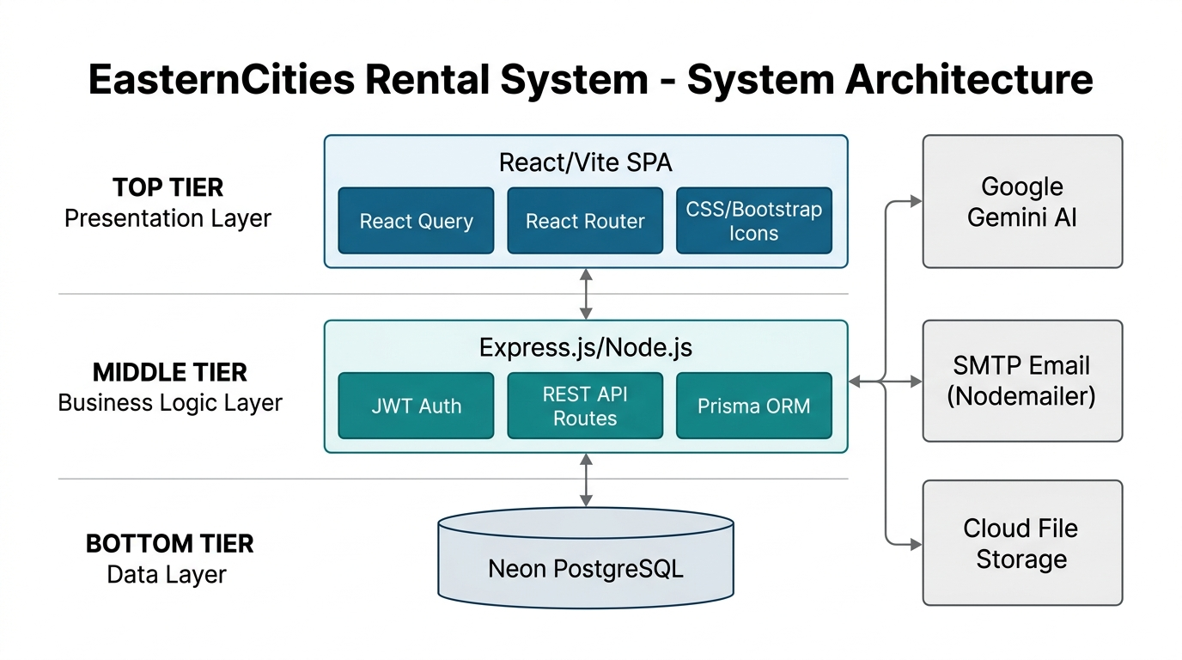
Figure 1: System Architecture Diagram

Use-Case Diagram
Comprehensive requirements analysis identified five primary actors interacting within the system boundaries: Renter, Owner, Admin, Super Admin, and External Advertiser. The Use-Case diagram maps the diverse capabilities available to each actor, from basic browsing and booking requests by renters, to complex listing management by owners, and overarching system configuration and ad request processing handled by the administrative tiers.
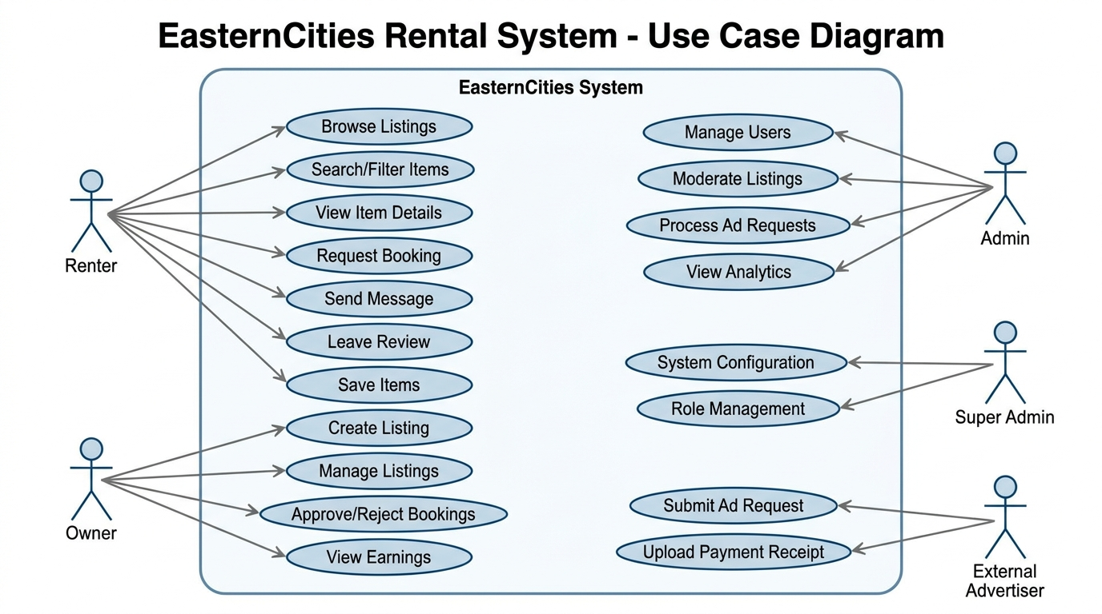
Figure 2: Use-Case Diagram

Entity-Relationship Diagram (ERD)
Data integrity and relational mapping are core to the system's stability. The database schema is carefully normalized and consists of nine heavily interconnected core entities. The Users table is central, linking to Listings, Bookings, Messages, Reviews, and AdvertisingRequests. The ERD visually represents these tables, detailing primary keys, foreign keys, constraints, and the strict cardinality rules (1:N, M:N) that govern the data relationships.
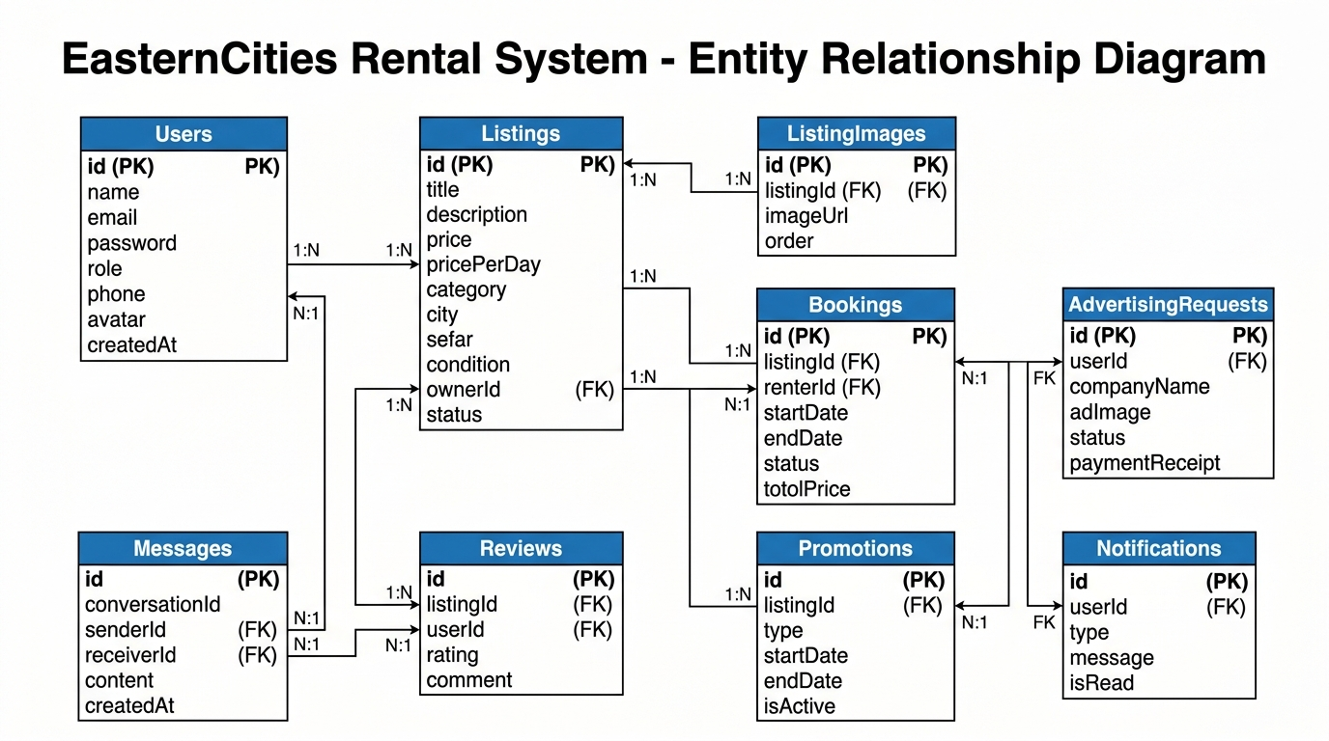
Figure 3: Entity-Relationship Diagram

Activity Diagram – Rental Listing to Booking Flow
The core business value of the platform is the rental transaction. This Activity Diagram provides a detailed flowchart of the user journey. It begins with an owner successfully publishing a listing. It traces the renter's path through browsing, evaluating item details, and submitting a booking request. The flow highlights critical decision nodes, specifically the owner's review and subsequent approval or rejection of the booking, culminating in the rental period execution and final review submission.
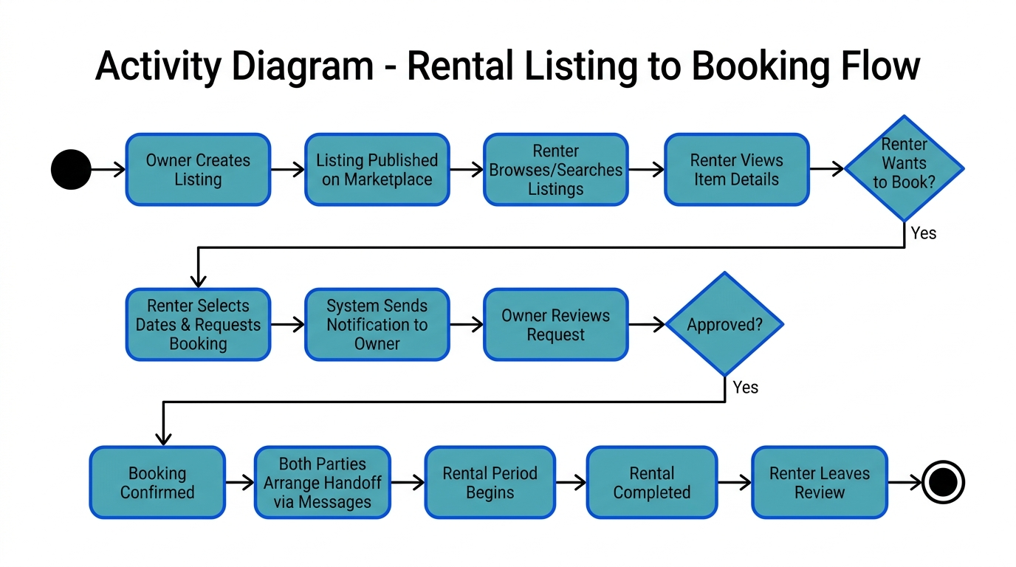
Figure 4: Activity Diagram – Rental Listing to Booking Flow

Sequence Diagram – Login and Role-Based Dashboard Routing
Security and user experience are paramount during authentication. This Sequence Diagram details the exact chronological flow of messages across the system lifelines (User, Frontend, API, Database) during a login event. It illustrates credential submission, the critical backend validation using bcrypt hashing, the secure generation and transmission of a JWT token, and the frontend's logic to decode the token's payload to dynamically route the user to their specific, role-based dashboard.
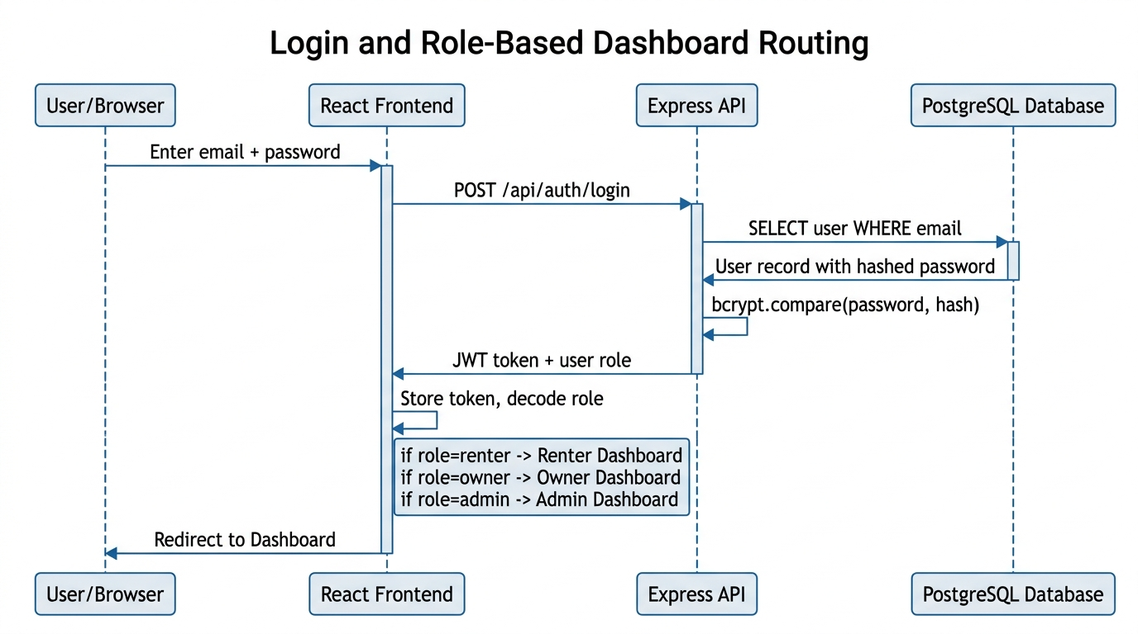
Figure 5: Sequence Diagram – Login and Role-Based Routing

Sequence Diagram – Advertising Request Flow
To support platform monetization, an external advertising module was implemented. This Sequence Diagram maps the multi-step, asynchronous workflow required to process an ad request. It details the initial submission by the advertiser, the notification and review process by the Admin, the subsequent pricing reply, the advertiser's upload of a payment receipt, the final admin verification, and the ultimate automated display of the advertisement on the public homepage.
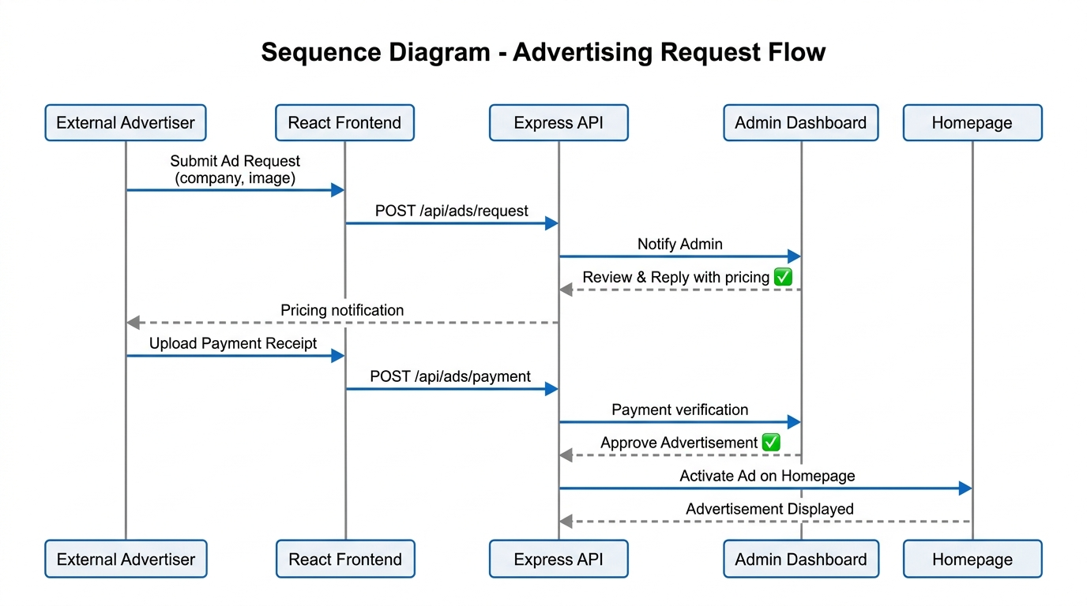
Figure 6: Sequence Diagram – Advertising Request Flow

Component Diagram
To ensure modularity and separation of concerns, the system's software components are logically grouped. The Component Diagram visualizes the high-level architecture packages: The Frontend Package encapsulates the Public Website and the diverse User/Admin Dashboards. The Backend Package contains the modular REST API routes handling authentication, listings, bookings, and messaging. The Data Package illustrates the Database and ORM integration. Dependency arrows clearly show how the frontend relies on the backend API, which in turn depends on the data layer and external services.
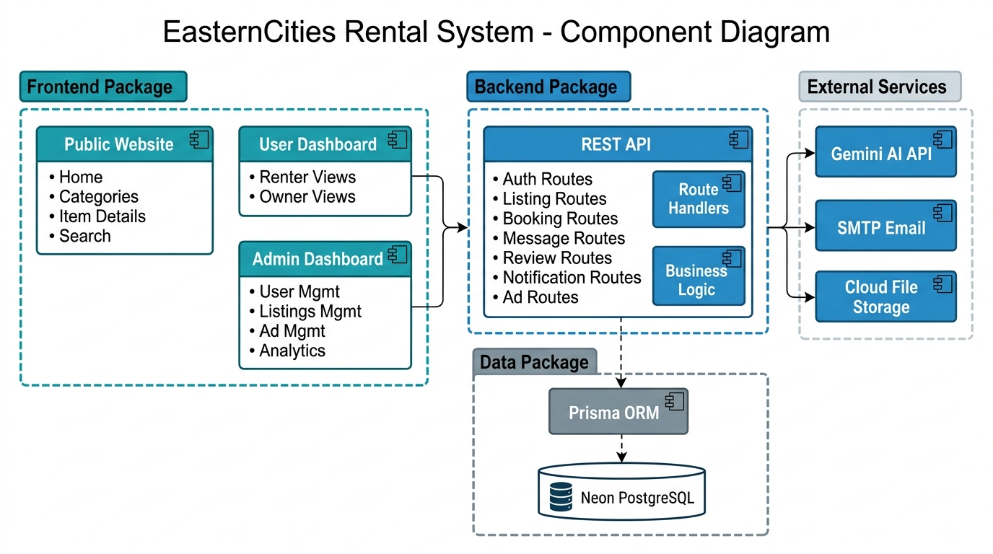
Figure 7: Component Diagram

4.4 Tasks and Responsibilities Performed
Our group collaboratively executed a wide array of technical tasks, distributing responsibilities to leverage individual strengths while ensuring everyone gained full-stack experience. Below is an exhaustive breakdown of the tasks performed:
Frontend Architecture & UI Development:
- Engineered highly responsive, premium-styled user interfaces utilizing React.js, applying advanced CSS techniques to achieve a modern 'glassmorphism' aesthetic that elevated the user experience.
- Constructed complex, data-rich pages including the dynamic Home Page featuring a hero slider and category grids, and the intricate Item Details Page which incorporated an advanced image gallery with navigational arrows, thumbnail previews, a sticky booking sidebar, and integrated user reviews.
- Developed the central Items Listing Page, implementing sophisticated client-side search, multi-parameter filtering, and responsive grid displays.
- Architected secure, role-based dashboard layouts tailored specifically for Renters (managing bookings and saved items), Owners (managing active listings and earnings), and Admins (handling user moderation and analytics).
- Executed a major refactor to optimize data fetching, caching, and state synchronization using React Query v5. This included implementing data prefetching on hover events to create an 'instantaneous' navigation feel, drastically reducing perceived load times.

Backend Engineering & API Design:
- Constructed highly secure RESTful API endpoints dedicated to user authentication, encompassing registration, login, and robust JWT (JSON Web Token) generation and verification workflows.
- Built comprehensive CRUD (Create, Read, Update, Delete) API architectures to manage the core data models: listings, bookings, user reviews, real-time messages, system notifications, and advertising requests.
- Implemented strict role-based access control (RBAC) middleware to ensure that sensitive endpoints were only accessible to authorized user roles (e.g., preventing renters from modifying owner listings).

Database Management & Optimization:
- Meticulously designed the relational database schema, ensuring strict adherence to database normalization principles to eliminate data redundancy and ensure data integrity.
- Leveraged Prisma ORM to create, execute, and manage complex database migrations on the Neon PostgreSQL cloud infrastructure.

4.5 Software Development Methodologies
Throughout the internship, we strictly adhered to industry-standard software development methodologies. We utilized an Agile Scrum SDLC model, organized into rigorous two-week sprint cycles. These cycles included formal sprint planning, daily stand-up meetings to unblock progress, and comprehensive sprint reviews and retrospectives to foster continuous team improvement.
Source code was meticulously managed utilizing Git and GitHub. We employed a professional feature-branch workflow, requiring peer-reviewed pull requests before merging code into the main production branch. Quality assurance was maintained through extensive manual UI/UX checks, rigorous API contract testing using Postman, and deep debugging sessions utilizing React DevTools and browser profiling tools.

4.6 Performance Analysis and Key Achievements
Our dedicated efforts culminated in the successful delivery of a fully functional Minimum Viable Product (MVP) for the EasternCities platform. We are proud of several major technical achievements:
- End-to-End Platform Delivery: We successfully engineered the complete rental workflow, seamlessly connecting listing creation, browsing, booking, messaging, and review submission.
- Robust Role-Based Architecture: We implemented a secure, four-tier user role system (renter, owner, admin, super admin) with distinct, tightly controlled access levels and customized dashboard experiences.
- Exceptional Performance Optimization: The strategic integration of React Query completely eliminated redundant API calls, significantly reduced server load, and enabled near-instant page transitions, resulting in a highly performant application.
- Monetization Engine: We successfully developed and integrated a complete advertising module, enabling external businesses to submit, pay for, and track advertisements on the platform.

4.7 Challenges Encountered
The development process was not without its hurdles. We encountered and navigated several significant challenges:
Technical Challenges:
- A major technical hurdle was migrating the application's state management from React Query v4 to v5. This version update introduced breaking API changes (requiring strict object syntax), causing widespread runtime errors that necessitated a systematic, file-by-file refactoring effort.
- Managing complex, deeply nested state across multiple interactive dashboard views while ensuring UI consistency proved conceptually challenging.
- The Vite build system, while incredibly fast, enforced strict import/export rules that frequently caused build failures if circular dependencies or incorrect pathing were introduced.

Organizational Challenges:
- Coordinating the development timelines of frontend and backend tasks across three team members occasionally led to blocking dependencies and complex Git merge conflicts.

4.8 Solutions and Lessons Learned
Measures Taken:
- To overcome the React Query migration, we dedicated time to deeply study the official TanStack migration documentation, creating a standardized conversion strategy before refactoring the codebase.
- We mitigated integration issues by establishing clear, documented API contracts (request/response JSON structures) between the frontend and backend developers before writing code.
- We drastically reduced Git merge conflicts by enforcing a policy of daily, granular commits and structuring our code into highly modular, decoupled components.

Lessons Learned:
- Software Architecture is foundational: We learned firsthand that a well-designed, modular component architecture is not just theoretical; it significantly reduces debugging time and makes the codebase immensely easier to maintain and extend.
- State Management defines performance: Properly distinguishing between server state (data from the DB) and client state (UI toggles) is critical for building performant React applications.

5. Skills and Professional Development Gained

5.1 Technical Skills
The internship provided a profound enhancement of our technical capabilities, elevating us from theoretical students to practical software developers. We gained deep, hands-on proficiency in Full-Stack JavaScript Development, specifically mastering the intricate interactions between React.js on the client side and Node.js/Express.js on the server side. We developed a strong command of Modern Frontend Techniques, including the advanced use of React hooks, complex component composition, and sophisticated caching strategies using React Query. Furthermore, we solidified our understanding of Backend and API Design, successfully architecting RESTful services, implementing secure JWT authentication flows, and utilizing Prisma ORM. Finally, our grasp of Database Design was significantly improved as we actively modeled relational schemas, applied normalization rules, and managed a live Neon PostgreSQL cloud database.

5.2 Soft Skills and Professional Skills
Beyond technical code execution, the professional environment at BeWide Technologies fostered critical soft skills. We vastly improved our Communication and Teamwork abilities, learning how to succinctly present technical progress during daily stand-ups, articulate complex blocking issues, and gracefully accept constructive criticism during code reviews. We developed robust Time Management skills, learning to accurately estimate task durations, prioritize critical path features within strict two-week sprint deadlines, and balance our rigorous internship commitments with ongoing academic requirements. Above all, we internalized a sense of Professional Responsibility, understanding the importance of delivering reliable, production-quality code and taking full ownership of our assigned modules.

5.3 Ethics, Work Culture, and Entrepreneurship
Immersing ourselves in a dynamic tech startup provided invaluable lessons in professional conduct and business acumen. We strictly adhered to Workplace Ethics, maintaining high standards of punctuality, professional communication, and collaborative respect. Working with sensitive authentication systems deeply ingrained the critical importance of Data Privacy and Confidentiality; we learned the ethical and technical imperatives of securing user data through proper hashing (bcrypt) and secure token management (JWT). Finally, our time at BeWide Technologies offered incredible Exposure to Innovation and Entrepreneurship. Witnessing the strategic development and market positioning of products like Umrago provided us with a first-hand understanding of product ideation, user-centric design, and the business strategies that drive successful software companies in Ethiopia.

6. Conclusion and Recommendations

6.1 Conclusion
The four-month internship at BeWide Technologies PLC was a profoundly transformative experience in our educational and professional journey. It provided the vital bridge between the theoretical concepts taught in our Software Engineering curriculum at Haramaya University and the rigorous, fast-paced realities of commercial software development. We successfully applied core principles—including Object-Oriented Systems Analysis and Design (OOSAD), complex relational database design, and scalable software architecture—to architect and build a robust, production-grade web application.
The successful deployment of the EasternCities Rental Management System stands as tangible evidence of our comprehensive learning outcomes. We delivered a fully functional, highly performant platform featuring secure user authentication, distinct role-based dashboards, an intuitive rental marketplace equipped with advanced search and filtering, end-to-end booking management, real-time messaging, user reviews, and a complete advertising workflow. All general and specific internship objectives were unequivocally met. We have emerged from this experience with a deepened technical expertise in full-stack JavaScript development, a practical mastery of agile methodologies, and the professional maturity required for a successful career in the software industry.

6.2 Recommendations
For the Hosting Organization (BeWide Technologies):
- We highly recommend the implementation of automated CI/CD (Continuous Integration / Continuous Deployment) pipelines using tools like GitHub Actions to facilitate faster, more reliable, and automated deployments to staging and production environments.
- To further enhance software reliability, we suggest adopting comprehensive unit and integration testing frameworks, such as Jest or Cypress, to programmatically catch regressions early in the development cycle before manual QA.

For Future Interns:
- We strongly advise future interns to heavily familiarize themselves with Git version control, core React concepts, and basic Node.js architecture prior to beginning their placement to ensure a rapid and smooth onboarding process.
- Maintain a detailed daily work log from day one. Documenting daily tasks, bugs fixed, and concepts learned makes compiling the final comprehensive internship report significantly easier and more accurate.

For Haramaya University:
- We recommend incorporating more intensive, project-based courses utilizing current industry-standard technologies (such as React, modern Node.js, and cloud-based databases) directly into the core curriculum to better align academic training with immediate industry demands.
- Establishing stronger, continuous feedback loops between academic advisors and hosting organizations throughout the internship period would help ensure students are consistently meeting both academic and industry expectations.

7. References
1. BeWide Technologies PLC. (2026). Company Profile and Internal Technical Documentation. Addis Ababa, Ethiopia.
2. Meta Platforms, Inc. (2026). React Official Documentation. Retrieved from https://react.dev/
3. TanStack. (2026). TanStack Query v5 Official Documentation. Retrieved from https://tanstack.com/query/latest
4. Prisma Data, Inc. (2026). Prisma ORM Official Documentation. Retrieved from https://www.prisma.io/docs/
5. Evan You & Vite Contributors. (2026). Vite Official Documentation. Retrieved from https://vitejs.dev/
6. OpenJS Foundation. (2026). Node.js Official Documentation. Retrieved from https://nodejs.org/docs/
7. OpenJS Foundation. (2026). Express.js Official Documentation. Retrieved from https://expressjs.com/
8. Neon, Inc. (2026). Neon Serverless PostgreSQL Documentation. Retrieved from https://neon.tech/docs/
9. Sommerville, I. (2015). Software Engineering (10th ed.). Pearson Education.
10. Pressman, R. S., & Maxim, B. R. (2014). Software Engineering: A Practitioner's Approach (8th ed.). McGraw-Hill Education.

8. Appendices

Appendix A: Weekly Reports and Monthly Logbooks
[Insert your weekly reports and monthly logbooks here. This should include detailed breakdowns of hours worked, tasks completed, and supervisor signatures.]

Appendix B: Screenshots of Key Completed Interfaces
The following screenshots demonstrate the UI/UX design and functionality of the completed EasternCities platform.
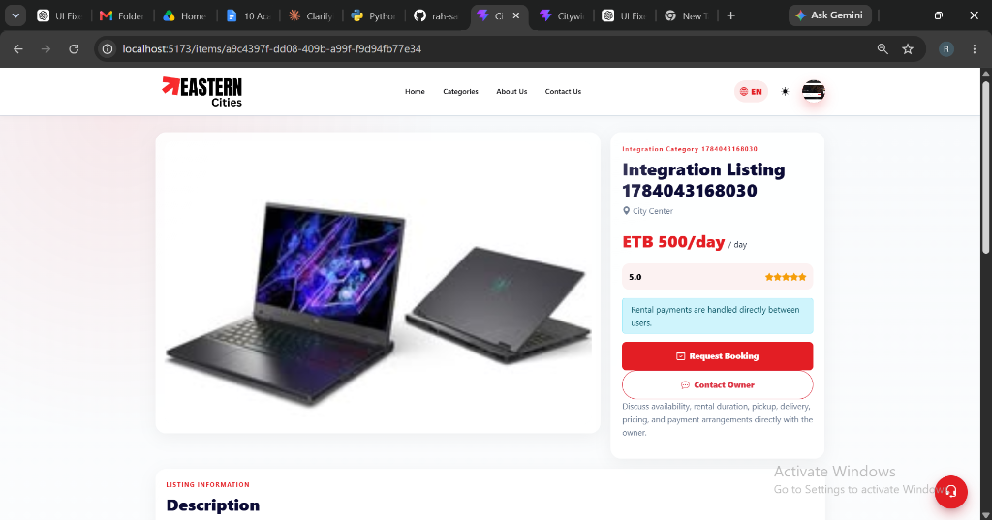
Figure 8: Sample User Interface Screenshot
[Insert additional screenshots of the Homepage, Item Details, Owner Dashboard, Admin Dashboard, Messaging, and Advertising screens here]

Appendix C: Sample Code Snippets
[Insert representative code snippets showcasing your work (e.g., a React component, an Express API route, or a Prisma schema definition) if permitted by BeWide Technologies.]

