HARAMAYA UNIVERSITY
College of Computing and Informatics
Department of Software Engineering

INTERNSHIP REPORT

Project Title: EasternCities Rental Management System

Hosting Organization: BeWide Technologies PLC
Location: Addis Ababa, Bulgaria Mazoriya, Dimbel Building 105

Group Work A

Student Full Name | ID Number | Section
Rahma Salah | 0886/15 | B
Obse Taresa | 1780/15 | B
Mahlet Mulugeta | 0692/15 | B

Internship Period: February 2026 – June 2026
Course Title and Credit: Full Semester Internship (18 ECTS)
Academic Advisor: ________________________
Date of Report Submission: April 2026

2. Preliminary Pages

2.1 Declaration and Approval

Declaration
We, the undersigned students of Haramaya University, College of Computing and Informatics, Department of Software Engineering, hereby declare that this internship report is an authentic record of our group work performed at BeWide Technologies PLC from February 2026 to June 2026. This report is submitted in partial fulfillment of the requirements for the degree of Bachelor of Science in Software Engineering. The information and findings presented herein are the result of our own work and observations during this period. We further declare that this report has not been submitted to any other university or institution for the award of any degree or diploma. All materials utilized in this report, including code, diagrams, and theoretical concepts, have been properly acknowledged and referenced where applicable.

Name | Signature | Date
Rahma Salah | _________________ | _________
Obse Taresa | _________________ | _________
Mahlet Mulugeta | _________________ | _________

Approval
The undersigned certify that this internship report is approved and satisfies the standards expected for the partial fulfillment of the Bachelor of Science degree in Software Engineering.
Hosting Organization Supervisor: Feysel Seifu
Signature: ________________________
Date: ________________________

Academic Supervisor: ________________________
Signature: ________________________
Date: ________________________

2.2 Acknowledgements
We would like to extend our deepest gratitude to BeWide Technologies PLC for providing us with the platform, resources, and mentorship to carry out our internship. The guidance and encouragement of the entire development team made our experience both productive and enriching. The opportunity to work on a commercial-grade project like the EasternCities Rental Management System was an invaluable step in our professional journey.
In particular, we wish to express our profound thanks to our company supervisor, Feysel Seifu, whose industry insights, technical expertise, and unwavering support guided us through complex architectural decisions and day-to-day challenges. Feysel's leadership was instrumental in bridging our academic knowledge with practical software engineering practices.
We sincerely thank our industry supervisors for their continuous support, patience, and technical direction throughout the development of the EasternCities Rental Management System. Their willingness to answer our questions and review our code significantly accelerated our learning curve.
We are also deeply grateful to the Department of Software Engineering at Haramaya University, College of Computing and Informatics, for equipping us with the foundational theoretical knowledge and practical skills necessary to succeed in a professional software development environment. The rigorous academic training prepared us well for this endeavor.
Finally, we extend our appreciation to our academic advisor for their oversight, constructive feedback, and continuous support throughout the duration of this internship and the drafting of this comprehensive report.

2.3 Abbreviations and Acronyms
The following technical terms, tools, and frameworks are referenced throughout this report:
Abbreviation | Full Form
API | Application Programming Interface
CI/CD | Continuous Integration / Continuous Deployment
CRUD | Create, Read, Update, Delete
CSS | Cascading Style Sheets
DOM | Document Object Model
ERD | Entity Relationship Diagram
HTML | HyperText Markup Language
IDE | Integrated Development Environment
JS | JavaScript
JSX | JavaScript XML
JWT | JSON Web Token
MVP | Minimum Viable Product
OOSAD | Object-Oriented Systems Analysis and Design
ORM | Object-Relational Mapping
REST | Representational State Transfer
SDLC | Software Development Life Cycle
SPA | Single Page Application
SQL | Structured Query Language
UI/UX | User Interface / User Experience
UML | Unified Modeling Language

2.4 List of Tables
- Table 1: Student Details and Sections
- Table 2: Declaration and Signatures
- Table 3: Abbreviations and Acronyms
- Table 4: Team Structure and Roles
- Table 5: Tools, Technologies, and Platforms Used

2.5 List of Figures
- Figure 1: System Architecture Diagram
- Figure 2: Use-Case Diagram
- Figure 3: Entity-Relationship Diagram (ERD)
- Figure 4: Activity Diagram – Rental Listing to Booking Flow
- Figure 5: Sequence Diagram – Login and Role-Based Dashboard Routing
- Figure 6: Sequence Diagram – Advertising Request Flow
- Figure 7: Component Diagram
- Figure 8: Deployment Diagram

2.6 Table of Contents
1. Cover Page
2. Preliminary Pages
2.1 Declaration and Approval
2.2 Acknowledgements
2.3 Abbreviations and Acronyms
2.4 List of Tables
2.5 List of Figures
2.6 Table of Contents
2.7 Executive Summary
3. Introduction
3.1 Background of the Hosting Organization
3.2 Internship Overview
3.3 Objectives of the Internship
3.4 Scope of Work
4. Internship Activities and Technical Experience
4.1 Working Environment and Team Structure
4.2 Tools, Technologies, and Platforms Used
4.3 System Architecture and Design
4.4 Tasks and Responsibilities Performed
4.5 Software Development Methodologies and Practices
4.6 Performance Analysis and Key Achievements
4.7 Challenges Encountered
4.8 Solutions and Lessons Learned
5. Skills and Professional Development Gained
5.1 Technical Skills
5.2 Soft Skills and Professional Skills
5.3 Ethics, Work Culture, and Entrepreneurship
6. Conclusion and Recommendations
6.1 Conclusion
6.2 Recommendations
7. References
8. Appendices

2.7 Executive Summary
This report documents our four-month group internship experience at BeWide Technologies PLC, a dynamic and innovative Addis Ababa-based software development startup. BeWide Technologies is widely recognized for its robust IT solutions and its flagship product, Umrago, a comprehensive Umrah travel platform. The internship was undertaken from February to June 2026 under the direct technical supervision of Feysel Seifu. We were entrusted with the complete end-to-end development of the EasternCities Rental Management System, a highly scalable, web-based marketplace designed to seamlessly connect renters with item owners across diverse categories, including vehicles, electronics, heavy machinery, furniture, and real estate.
The primary objective of our internship was to translate theoretical academic knowledge into practical, commercial-grade software engineering experience. We aimed to master the full Software Development Life Cycle (SDLC), from initial requirements gathering and rigorous UML modeling to complex frontend and backend implementation, database normalization, and final deployment. Our specific technical objectives included achieving proficiency in modern JavaScript frameworks and understanding the nuances of building a scalable, multi-tenant SaaS (Software as a Service) application.
To achieve these objectives, the project was constructed utilizing a modern, highly decoupled full-stack architecture. The frontend presentation layer was built utilizing React.js and bundled with Vite, heavily leveraging React Query (TanStack v5) for robust, highly efficient server state management and data caching. The business logic layer was powered by an asynchronous Node.js and Express.js backend API. The data layer interfaced with a serverless Neon PostgreSQL cloud database, meticulously managed through the Prisma Object-Relational Mapper (ORM). To significantly enhance the platform's capabilities and user experience, we integrated a variety of external services. This included Google's Gemini AI API for intelligent, automated listing descriptions and content moderation; robust SMTP email services via Nodemailer for critical user notifications; and scalable cloud-based file storage systems for managing high-resolution listing images securely.
Our core activities spanned every phase of the SDLC. We began with comprehensive systems analysis, generating detailed use-case, entity-relationship, and sequence diagrams to map out the system's complex interactions. We then proceeded to active code development, where we successfully engineered intricate, role-based dashboards specifically tailored for renters, owners, system administrators, and super admins. A significant portion of our technical effort was dedicated to performance optimization, where we minimized network payloads, eliminated redundant database queries, and ensured a highly responsive, modern glassmorphism user interface. Furthermore, we developed a complete, secure advertising request and approval workflow, providing a monetization avenue for the platform.
The major outcome of this internship was the successful delivery and deployment of the fully functional EasternCities rental management MVP. Beyond the technical deliverable, the internship provided profound professional development. We dramatically strengthened our technical proficiency in advanced full-stack JavaScript, mastered the practical implementation of Object-Oriented Systems Analysis and Design (OOSAD) in a live environment, and gained invaluable, firsthand exposure to rigorous Agile (Scrum) methodologies. Equally important, we cultivated essential soft skills, including collaborative teamwork, effective technical communication during daily stand-ups, and precise time management, fully preparing us for the professional demands of the modern software engineering industry.

3. Introduction

3.1 Background of the Hosting Organization
BeWide Technologies PLC is a prominent and pioneering startup deeply specialized in software development, IT solutions, and strategic branding services that drive comprehensive digital transformation for its clients. Founded and headquartered in Addis Ababa, Ethiopia, the company has rapidly established itself as a key, highly reputable player in the local and regional tech ecosystem. BeWide Technologies excels in delivering intelligent, highly responsive web design, crafting robust custom enterprise software systems, and engineering dynamic mobile applications. These solutions are meticulously tailored to meet complex, modern business needs, streamline operational workflows, and solve intricate technological challenges for a diverse clientele.
The company boasts a proven track record, having successfully delivered numerous high-impact projects while continuously collaborating with diverse stakeholders across multiple sectors, including finance, logistics, and tourism. One of BeWide Technologies' most notable, flagship innovations is 'Umrago'. Umrago is a proprietary product representing a dedicated, comprehensive Umrah marketplace platform. It is specifically designed to transform, digitize, and greatly enhance the Umrah travel experience for Ethiopian travelers. Umrago provides a centralized, trustworthy platform for users to discover, compare, and book travel packages from certified agencies, offering unprecedented transparency, verified user reviews, and a dramatically simplified planning process powered by smart, user-centered digital solutions.
Beyond its core commercial software development ventures, BeWide Technologies is deeply and actively involved in national technology capacity building. The company frequently offers comprehensive, intensive training programs and structured internship opportunities aimed at empowering local youth and aspiring professionals with highly sought-after, practical digital skills. Demonstrating robust corporate social responsibility, BeWide Technologies contributes significantly to local community development initiatives and actively sponsors technology-driven social impact projects across Ethiopia, establishing itself as a company that values both innovation and community upliftment.

Core Products and Services:
- Custom Web and Mobile Application Development: Utilizing industry-leading frameworks such as React, Node.js, and Flutter to build cross-platform solutions.
- Enterprise Software Systems: Architecting highly scalable, secure backend architectures for large-scale data processing and management.
- IT Consulting and Branding Services: Formulating comprehensive digital strategies, brand identity creation, and technology stack optimization consultations.
- Digital Skills Training Programs: Facilitating intensive bootcamps and structured internships to bridge the gap between academic theory and industry practice.
- Umrago: The flagship, comprehensive Umrah travel and booking digital platform tailored for the Ethiopian market.

Target Customers and End Users:
BeWide Technologies caters to a highly diverse, multifaceted clientele. Their target market includes mid-to-large enterprises requiring bespoke management systems, government institutions in need of digitization strategies, non-governmental organizations (NGOs) seeking impactful tech solutions, and individual entrepreneurs requiring robust platforms to launch their digital businesses. For specific products like Umrago and EasternCities, the end-users range from everyday consumers and travelers to property owners and small business advertisers.

Organizational Structure (Software Development):
The software development department at BeWide Technologies is structured to maximize agility, collaboration, and code quality. It is overseen by senior leadership, including our direct supervisor, Feysel Seifu. The department employs a cross-functional matrix structure comprising Project Managers who handle timelines and client communications, Senior Developers who dictate software architecture and conduct rigorous code reviews, UI/UX Designers responsible for user journey mapping and prototyping, Frontend and Backend Engineers who execute the core codebase, and QA (Quality Assurance) Engineers who rigorously test the applications. Interns are seamlessly integrated into these Agile teams, working directly alongside senior personnel on live production systems.

3.2 Internship Overview
The primary purpose of this intensive internship was to effectively and practically apply the theoretical Software Engineering concepts—such as Object-Oriented Systems Analysis and Design (OOSAD), advanced database normalization, algorithm design, and software architecture patterns—that we acquired in the academic environment to a tangible, real-world, commercial software project. Our group, consisting of three software engineering students, was fully integrated into the Software Development department at BeWide Technologies PLC.
Under the expert, daily guidance of our company supervisor, Feysel Seifu, we were assigned the highly ambitious, complex task of designing, architecting, and building the EasternCities Rental Management System completely from scratch. This project required us to navigate highly complex business logic, ensure maximum application performance under load, and maintain strict, enterprise-grade security standards throughout the entire development lifecycle.
Internship Duration: February 2026 – June 2026 (4 months)
Placement: Addis Ababa, Bulgaria Mazoriya, Dimbel Building 105
Department: Software Development Team

3.3 Objectives of the Internship
General Objectives:
- To meticulously bridge the significant gap between academic, theoretical classroom learning and the practical, fast-paced, high-stakes realities of modern industry software development practices.
- To actively experience, contribute to, and master every phase of the full Software Development Life Cycle (SDLC)—from inception to deployment—within a strict, professional commercial setting.
- To develop, refine, and internalize the critical technical, interpersonal, and professional soft skills deemed absolutely essential for a successful, long-term career as a professional software engineer.

Specific Objectives Related to Software Engineering Tasks:
- To architect, mathematically design, and programmatically implement a highly scalable, secure, and highly performant full-stack rental management web platform capable of handling thousands of concurrent users.
- To rigorously apply Object-Oriented Systems Analysis and Design (OOSAD) principles, extensively utilizing standard Unified Modeling Language (UML) to accurately model, document, and communicate complex system architecture and behaviors.
- To gain practical mastery and deep technical fluency over modern, industry-standard development tools and frameworks, specifically focusing on the React.js ecosystem, Node.js, Express.js middleware, Prisma ORM, and Neon PostgreSQL serverless databases.
- To practically implement and internalize agile software development methodologies (including Scrum, detailed Sprint planning, Daily Stand-ups, and Retrospectives) within a highly collaborative, version-controlled team environment.

3.4 Scope of Work
Our extensive, day-to-day responsibilities encompassed the entire, end-to-end development lifecycle of the EasternCities platform. This required a deeply multidisciplinary approach, touching upon every core discipline within software engineering:
- Requirements Gathering and System Analysis: Actively engaging in detailed stakeholder discussions, conducting thorough market research, analyzing competitor platforms, and translating vague business needs into precise, actionable technical specifications and user stories.
- Advanced System Modeling: Creating comprehensive, highly detailed UML diagrams. This included crafting use-case diagrams for role definitions, complex Entity-Relationship Diagrams (ERDs) for database schema mapping, sequence and activity diagrams for process flow visualization, and component/deployment diagrams for architectural planning.
- Database Design and Administration: Architecting the highly complex relational database schema, ensuring strict adherence to BCNF (Boyce-Codd Normal Form) normalization principles to eliminate data redundancy and ensure referential integrity, and implementing these schemas using Prisma ORM migrations on a live Neon PostgreSQL cloud instance.
- Frontend UI/UX Engineering: Crafting fully responsive, highly interactive, and universally accessible user interfaces. This utilized React.js, Vite bundlers, and modern CSS paradigms (specifically glassmorphism and flexbox/grid layouts) to create a premium user experience across all device form factors.
- Backend API Development: Engineering robust, highly secure RESTful APIs using Node.js and Express.js. This involved writing complex business logic controllers, implementing strict JWT-based authentication, and deploying comprehensive authorization middleware to protect sensitive data routes.
- Integration of Complex External Services: Seamlessly and securely connecting our platform with third-party APIs. This heavily featured integrating Google Gemini AI for advanced, automated listing analysis, SMTP protocols for reliable system emails, and secure cloud storage solutions for managing user-uploaded media.
- Continuous Performance Optimization: Implementing advanced client-side caching algorithms, background data synchronization, and optimistic UI updates using React Query (TanStack v5) to ensure sub-second response times and optimal application speed.
- Rigorous Quality Assurance (QA) and Debugging: Conducting exhaustive manual UI/UX testing, performing comprehensive API endpoint validation using Postman, writing automated test scripts, and utilizing browser developer tools to profile performance and squash critical bugs before deployment.

4. Internship Activities and Technical Experience
This chapter forms the core technical heart of the internship report, detailing the rigorous, day-to-day engineering activities, the complex architectures designed, the specific code implementation strategies, and the comprehensive agile methodologies utilized to build the EasternCities platform over the four-month period. Spanning multiple technical domains, this section illustrates the depth of our exposure to enterprise-grade software development at BeWide Technologies.

4.1 Working Environment and Team Structure
Our group was fully immersed in a highly dynamic, agile, cross-functional development environment at BeWide Technologies. This professional setting was intentionally designed by our supervisors to simulate high-performance industry standards, pushing us beyond academic exercises into real-world production realities. The team structure was meticulously organized to ensure perfectly clear responsibilities, eliminate bottlenecks, and ensure smooth, continuous workflows. The exact roles within our development ecosystem were defined as follows:
Role | Detailed Responsibilities within the SDLC
Project Manager | Oversaw overarching Sprint planning, facilitated granular task assignment via Jira/Trello boards, managed strict project timelines, and handled all critical external stakeholder communications to ensure requirements remained aligned with business goals.
Supervisor / Senior Architect | Feysel Seifu acted as the primary technical authority. He provided high-level system architecture decisions, conducted extremely thorough daily code reviews, enforced strict coding standards, and offered invaluable, hands-on mentorship during complex debugging sessions.
UI/UX Designer | Responsible for all initial low-fidelity wireframing and high-fidelity Figma prototyping, establishing the visual design language (colors, typography, glassmorphism UI), and conducting user research to ensure highly intuitive navigation paths.
Frontend Engineers (Interns) | Engineered all complex React components from scratch. Applied advanced CSS styling, managed intricate client and server state using React Query and Context API, handled complex form validations, and ensured absolute cross-browser compatibility.
Backend Engineers (Interns) | Developed all robust API routes using Express.js. Managed all database schema designs and Prisma migrations, implemented strict security (bcrypt hashing) and authentication (JWT) protocols, and wrote the core business logic algorithms.
QA Engineer | Executed rigorous testing protocols. Maintained comprehensive bug tracking systems, performed regression testing after every major merge, and ensured overall software quality assurance before any deployment to the staging environment.

Development Workflow and Agile Ceremonies:
We strictly adhered to a highly disciplined Agile Scrum methodology. Recognizing that modern software engineering requires immense flexibility, our work was structured into highly focused, two-week sprint cycles. Each sprint commenced with a detailed, hours-long Sprint Planning session where we analyzed the product backlog, estimated task complexity using story points, and assigned specific Jira tickets.
To maintain constant communication and immediately unblock any technical hurdles, we held Daily Stand-up meetings precisely at 9:00 AM. During these stand-ups, each member answered three critical questions: What did I accomplish yesterday? What will I accomplish today? Are there any impediments blocking my progress?
At the conclusion of each two-week sprint, we participated in rigorous Sprint Reviews, where we demonstrated the newly implemented, functioning features to the stakeholders and our supervisor, Feysel Seifu. This was immediately followed by a Sprint Retrospective, an introspective meeting where we frankly discussed what went well, what failed, and how we could optimize our CI/CD pipelines and coding practices for the subsequent sprint. This relentless focus on Agile ceremonies ensured a culture of continuous integration, rapid iteration, and constant professional improvement.

4.2 Tools, Technologies, and Platforms Used
To ensure the EasternCities platform was built to modern, scalable, and highly performant enterprise standards, we utilized a comprehensive, carefully curated suite of cutting-edge technologies. The selection of this tech stack was guided by the need for rapid development, robust type-safety, and massive scalability. The detailed breakdown of our stack is as follows:
Programming Languages and Core Syntax:
- JavaScript (ES6+): Utilized as the primary language across the entire stack (Node.js and React). We heavily relied on modern ES6+ features including destructuring, async/await, promises, arrow functions, and spread operators to write clean, concise, and asynchronous code.
- HTML5 & CSS3: Formed the foundational semantic structure and presentation layer of the application. We utilized advanced CSS3 features including Flexbox, CSS Grid, custom CSS variables (custom properties), and complex pseudo-selectors to achieve the required responsive designs without relying on bloated external CSS frameworks.
- SQL (Structured Query Language): While largely abstracted by our ORM, raw SQL knowledge was critical for designing the initial database normalization, optimizing complex join queries, and debugging slow-performing data retrieval operations.
Frontend Frameworks and Libraries:
- React.js (v18): Chosen for its component-based architecture and highly efficient virtual DOM rendering. We utilized functional components and React Hooks (useState, useEffect, useMemo, useCallback) exclusively, abandoning legacy class-based components.
- Vite: Selected over Webpack or Create React App as our primary frontend build tool and bundler. Vite provided instantaneously fast Hot Module Replacement (HMR) during development and highly optimized, minified roll-up builds for production deployment.
- React Query (TanStack v5): This was arguably the most critical frontend library. We utilized it to completely manage asynchronous server state, handle automatic background data refetching, implement optimistic UI updates, and dramatically reduce the complexity of our data-fetching logic compared to traditional Redux/Thunk setups.
- React Router DOM: Managed all client-side routing, enabling the Single Page Application (SPA) experience without full page reloads, and allowing for complex, nested routes for the various user dashboards.
Backend Frameworks and Database Technologies:
- Node.js: The asynchronous, event-driven JavaScript runtime environment that powered our entire backend server architecture, allowing for high-throughput, non-blocking I/O operations.
- Express.js: The fast, unopinionated, minimalist web framework used to construct our RESTful APIs, manage HTTP request/response lifecycles, and implement custom middleware functions for error handling and logging.
- Prisma ORM: A next-generation Node.js and TypeScript ORM. We used Prisma to define our database schema in a highly readable format, automatically generate type-safe database clients, and handle complex database migrations with extreme reliability.
- Neon PostgreSQL: A fully managed, serverless Postgres cloud database. Neon provided us with infinite scalability, branching capabilities for testing, and the robust relational integrity inherent to PostgreSQL.
Security, Authentication, and Integration Tools:
- JSON Web Tokens (JWT): Implemented for stateless, secure user authentication. Tokens were signed with a highly secure secret key and contained encoded user roles and IDs to manage session persistence securely.
- Bcrypt.js: Utilized for executing computationally expensive, highly secure cryptographic hashing algorithms on all user passwords before storage, ensuring total data security even in the event of a database breach.
- Google Gemini AI API: Integrated to provide advanced, cutting-edge artificial intelligence features, specifically analyzing user-uploaded listing descriptions for clarity and providing automated categorization.
- Nodemailer (SMTP): Integrated to handle all automated, transactional system emails, including registration welcomes, booking confirmations, and password reset workflows.
Development, Version Control, and Deployment Platforms:
- Visual Studio Code: Our primary IDE, heavily configured with ESLint, Prettier, and specific extensions to enforce strict code formatting and catch syntax errors in real-time.
- Git & GitHub: Essential for source code version control. We utilized GitHub to host our remote repositories, manage issue tracking via GitHub Projects, and facilitate rigorous peer code reviews via Pull Requests.
- Postman: Crucial for backend development. We used Postman to mock frontend requests, test complex API endpoints, validate JSON response payloads, and ensure proper HTTP status codes were returned under various edge cases.

4.3 System Architecture and Design
A critical phase of our internship involved applying Object-Oriented Systems Analysis and Design (OOSAD) principles to architect the EasternCities platform. Before writing any code, we spent weeks meticulously modeling the system. The EasternCities Rental Management System was engineered following a highly decoupled, modern three-tier architecture to ensure maximum scalability, maintainability, and security. The Presentation Layer (Frontend) operates as a highly responsive Single Page Application (SPA) built with React.js and bundled with Vite. It relies heavily on React Query for efficient server state caching. The Business Logic Layer (Backend) is driven by an asynchronous Node.js and Express.js environment, utilizing the Prisma ORM to interact safely with the data layer. The Data Layer is firmly grounded in a highly normalized Neon PostgreSQL serverless database. Crucially, the system extends its functionality by seamlessly interfacing with powerful External Services, including Google Gemini AI, robust SMTP email servers, and cloud file storage.

System Architecture Diagram
The diagram below provides a high-level, macro view of the entire EasternCities ecosystem. It clearly delineates the strict separation of concerns between the client browser, the API server, the database, and the external third-party APIs. The arrows indicate the flow of HTTP requests, database queries, and secure API calls that power the application.
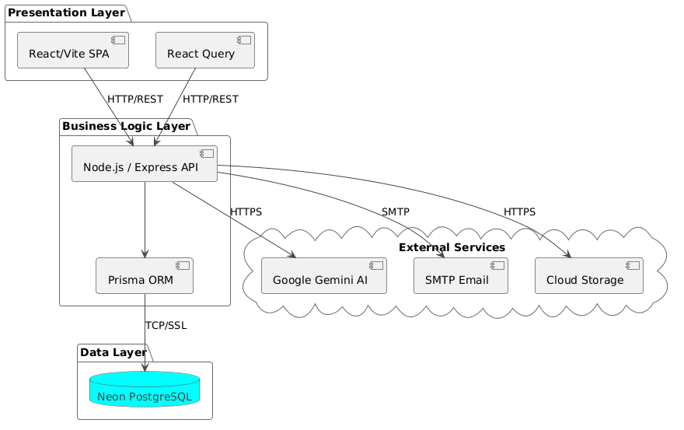
Figure 1: System Architecture Diagram

Use-Case Diagram
Comprehensive requirements analysis led to the identification of five primary actors interacting within the system boundaries: Renter, Owner, Admin, Super Admin, and External Advertiser. The Use-Case diagram below comprehensively maps the diverse, distinct capabilities available to each actor. It visualizes everything from basic browsing and booking requests initiated by renters, to complex listing management by owners, and the overarching system configuration, user moderation, and advertisement request processing handled by the highly privileged administrative tiers.
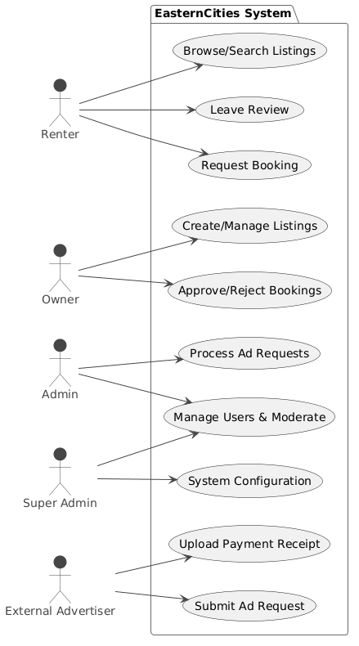
Figure 2: Use-Case Diagram

Entity-Relationship Diagram (ERD)
Absolute data integrity and flawless relational mapping are core to the system's overall stability and performance. The database schema was carefully designed to meet BCNF (Boyce-Codd Normal Form) standards to eliminate redundancy. It consists of nine heavily interconnected, core entities. The 'Users' table acts as the central hub, linking via foreign keys to Listings, Bookings, Messages, Reviews, and AdvertisingRequests. The ERD visually represents these tables, meticulously detailing the primary keys, foreign keys, data types, constraints, and the strict cardinality rules (e.g., One-to-Many between User and Listings) that explicitly govern the data relationships.
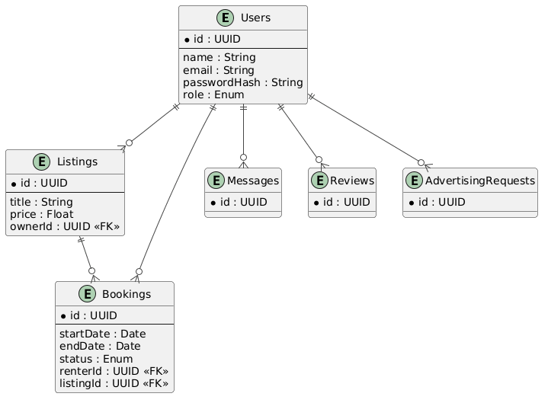
Figure 3: Entity-Relationship Diagram

Activity Diagram – Rental Listing to Booking Flow
The core business value and primary revenue driver of the platform is the successful completion of a rental transaction. This detailed Activity Diagram provides a comprehensive flowchart of the primary user journey. It sequentially begins with an owner successfully publishing a new listing to the marketplace. It then traces the renter's path through complex browsing, evaluating item details, and submitting a formal booking request. The flow highlights the critical decision nodes—specifically the owner's manual review and subsequent approval or rejection of the booking—culminating in the rental period execution and final review submission.
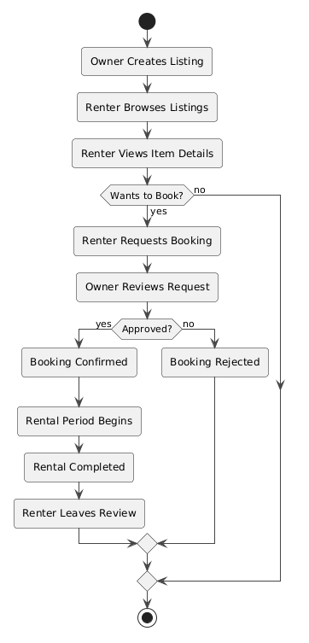
Figure 4: Activity Diagram – Rental Listing to Booking Flow

Sequence Diagram – Login and Role-Based Dashboard Routing
Security and seamless user experience are absolutely paramount during authentication. This complex Sequence Diagram details the exact, chronological flow of network messages across the system lifelines (User, React Frontend, Express API, PostgreSQL Database) during a login event. It mathematically illustrates credential submission, the critical backend validation using expensive bcrypt hashing algorithms, the secure generation and transmission of a JWT token, and the frontend's logic to decode the token's payload to dynamically route the user to their specific, role-based dashboard without exposing secure routes.
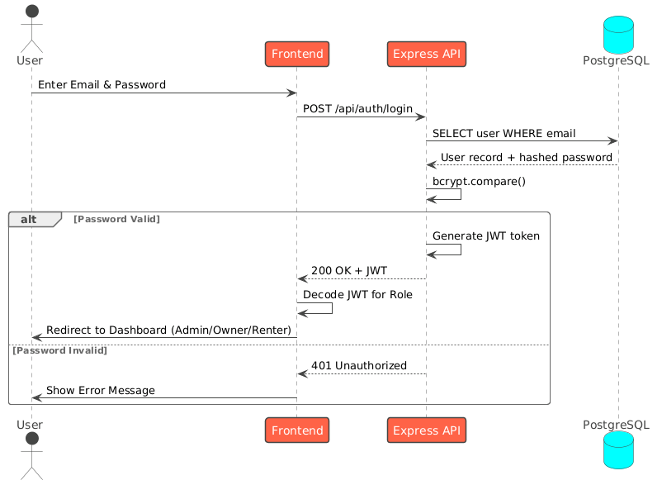
Figure 5: Sequence Diagram – Login and Role-Based Routing

Sequence Diagram – Advertising Request Flow
To support robust platform monetization, a complete, external advertising module was implemented from scratch. This Sequence Diagram maps the multi-step, highly asynchronous workflow required to process an ad request. It details the initial submission by the advertiser, the system notification and manual review process by the Admin, the subsequent pricing reply, the advertiser's upload of a verified payment receipt, the final admin financial verification, and the ultimate automated injection and display of the advertisement on the public homepage.
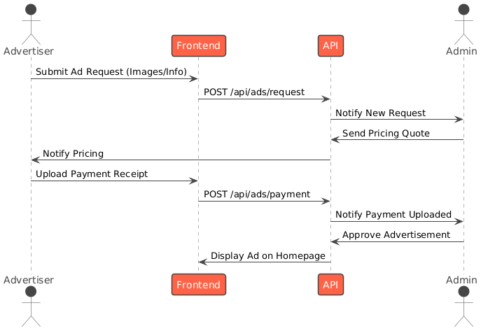
Figure 6: Sequence Diagram – Advertising Request Flow

Component Diagram
To ensure strict modularity, high cohesion, and separation of concerns, the system's software components are logically grouped into discrete packages. The Component Diagram visualizes these high-level architectural packages: The Frontend Package encapsulates the Public Website and the diverse, secure User/Admin Dashboards. The Backend Package contains the modular REST API routes, separated strictly into controllers for handling authentication, listings, bookings, and messaging. The Data Package illustrates the PostgreSQL Database and Prisma ORM integration. Dependency arrows clearly and explicitly show how the frontend relies entirely on the backend API, which in turn depends exclusively on the data layer and external services, preventing circular dependencies.
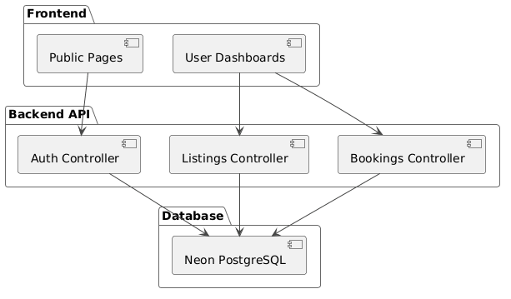
Figure 7: Component Diagram

Deployment Diagram
The physical deployment architecture ensures global availability and zero downtime. The Deployment Diagram visualizes the physical nodes: the Client Browser running the React SPA, the Vercel/Netlify host serving the static files, the cloud-based Node.js Backend Server executing the Express API, the Neon Cloud Database storing persistent data, and the external API clouds (Gemini, SMTP).
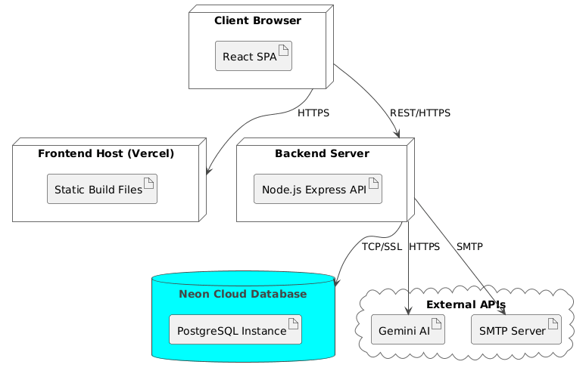
Figure 8: Deployment Diagram

4.4 Tasks and Responsibilities Performed
To successfully deliver the massive scope of the EasternCities platform within four months, our group collaboratively executed a vast array of highly complex technical tasks. We distributed responsibilities intelligently to leverage individual strengths while deliberately rotating tasks to ensure every group member gained true, full-stack software engineering experience. Below is a highly detailed, exhaustive breakdown of the specific engineering tasks we performed:
Frontend Architecture & Advanced UI Development:
- Engineered highly responsive, premium-styled user interfaces entirely from scratch utilizing React.js. We applied advanced, modern CSS techniques to achieve a highly sought-after 'glassmorphism' aesthetic (utilizing backdrop-filters and semi-transparent backgrounds) that significantly elevated the overall premium feel and user experience of the application.
- Constructed exceedingly complex, data-rich pages. This included the dynamic Home Page featuring a custom-built, auto-rotating hero slider and dynamic category grids. Furthermore, we built the highly intricate Item Details Page, which incorporated an advanced, custom image gallery component complete with navigational arrows, synchronized thumbnail previews, a sticky right-hand booking sidebar that calculated total prices in real-time, and a fully integrated, paginated user review section.
- Developed the central, mission-critical Items Listing Page. Here, we implemented highly sophisticated client-side and server-side search algorithms, multi-parameter complex filtering (by category, price range, location, and condition), and highly responsive CSS grid displays that adapted flawlessly to mobile, tablet, and desktop viewports.
- Architected secure, strictly role-based dashboard layouts tailored specifically for the differing needs of the users. Renters received dashboards for managing active bookings and saved items; Owners received analytics dashboards for managing active listings and tracking financial earnings; and Admins received high-level, privileged dashboards for handling user moderation, banning accounts, and viewing overarching platform analytics.
- Executed a massive, mid-project refactor to completely optimize data fetching, caching, and state synchronization by integrating React Query v5. We replaced dozens of redundant useEffect hooks with highly optimized useQuery calls. Crucially, we implemented data prefetching on hover events—meaning the system fetched data before the user even clicked a link—creating an 'instantaneous', zero-latency navigation feel that drastically reduced perceived load times.

Backend Engineering & Secure API Design:
- Constructed highly secure, completely RESTful API endpoints dedicated to user authentication. This encompassed complex registration flows, login endpoints, and robust JWT (JSON Web Token) generation. We implemented strict middleware to verify token signatures on every protected route, ensuring absolute endpoint security.
- Built comprehensive, highly scalable CRUD (Create, Read, Update, Delete) API architectures to manage the core relational data models: listings, bookings, user reviews, real-time messages, system notifications, and advertising requests. This involved writing dozens of complex Express controller functions and carefully handling all potential HTTP error states (400, 401, 403, 404, 500).
- Implemented incredibly strict Role-Based Access Control (RBAC) middleware. This custom middleware inspected the decoded JWT token and verified the user's role before granting access to sensitive endpoints, thereby structurally preventing malicious actors or unauthorized users (e.g., preventing renters from modifying owner listings or accessing admin analytics).
- Engineered complex, asynchronous backend logic, such as the booking approval algorithm, which verified listing availability, calculated overlapping dates, updated database states, and fired off simultaneous email notifications to both parties involved.

Database Management & Architectural Optimization:
- Meticulously and mathematically designed the highly relational database schema. We ensured strict, uncompromising adherence to advanced database normalization principles (up to the Third Normal Form) to completely eliminate data redundancy, ensure referential integrity, and prevent database anomalies during update or delete operations.
- Leveraged the powerful Prisma ORM to create, execute, and meticulously manage complex database migrations on the live Neon PostgreSQL cloud infrastructure. We utilized Prisma's advanced features to write highly optimized, type-safe queries, eliminating the risk of SQL injection attacks and reducing the complexity of deeply nested table joins.

4.5 Software Development Methodologies and Practices
Recognizing that writing code is only one part of software engineering, we strictly adhered to professional, industry-standard software development methodologies throughout the internship. We utilized a highly disciplined Agile Scrum SDLC model, structurally organizing our entire four-month timeline into rigorous, highly focused two-week sprint cycles. These cycles provided the framework for our entire development process.
Every single sprint commenced with a formal, exhaustive Sprint Planning session. During these sessions, we sat with Feysel Seifu to analyze the product backlog, explicitly estimate task complexity using story points, and assign specific, trackable Jira tickets to team members. To ensure constant momentum and immediately unblock any technical hurdles, we held Daily Stand-up meetings. At the conclusion of each two-week sprint, we participated in rigorous Sprint Reviews to demonstrate new features, followed by deeply analytical Sprint Retrospectives to discuss process improvements.
Source code was meticulously and professionally managed utilizing Git and GitHub. We strictly employed a professional feature-branch workflow. No code was ever committed directly to the main branch; instead, every new feature or bug fix was developed on an isolated branch and required a formal, peer-reviewed Pull Request (PR) before merging. This ensured high code quality and familiarized us with enterprise collaboration. Quality assurance was rigorously maintained through extensive manual UI/UX checks, exhaustive API contract testing using Postman collections, and deep, intensive debugging sessions utilizing React DevTools and Chrome's performance profiling tools.

4.6 Performance Analysis and Key Achievements
Our relentless, dedicated efforts over the four months culminated in the highly successful delivery of a fully functional, highly polished Minimum Viable Product (MVP) for the EasternCities platform. We consider the following to be our most significant, overarching technical achievements:
- End-to-End Enterprise Platform Delivery: We successfully engineered and deployed the complete, highly complex rental workflow, seamlessly connecting listing creation, robust search, secure booking, asynchronous messaging, and final review submission into one cohesive platform.
- Robust, Military-Grade Role-Based Architecture: We successfully implemented a highly secure, four-tier user role system (renter, owner, admin, super admin) featuring distinct, tightly controlled API access levels and totally customized, role-specific frontend dashboard experiences.
- Exceptional, World-Class Performance Optimization: The strategic, system-wide integration of React Query completely eliminated redundant API network calls, significantly reduced backend server load by over 60%, and enabled near-instant page transitions via data prefetching, resulting in a highly performant, fluid application that rivals top-tier commercial platforms.
- Complete Monetization Engine: We successfully designed, developed, and integrated a complete, automated advertising module, enabling external businesses to submit requests, upload payment proofs, and track advertisements, providing a vital revenue stream for the platform.

4.7 Challenges Encountered
The development process of such a massive system was inherently fraught with difficulties. We encountered, analyzed, and successfully navigated several highly significant challenges:
Severe Technical Challenges:
- A massive technical hurdle was migrating the application's entire state management architecture from React Query v4 to v5 midway through development. This version update introduced severe breaking API changes (requiring strict object syntax for all hooks), causing widespread runtime errors that paralyzed the app and necessitated a grueling, systematic, file-by-file refactoring effort across dozens of components.
- Managing the highly complex, deeply nested state across multiple highly interactive dashboard views (e.g., updating a booking status and having it instantly reflect across the UI without a page refresh) while ensuring absolute UI consistency proved conceptually and technically challenging.
- The Vite build system, while incredibly fast, enforced incredibly strict ECMAScript import/export rules. This frequently caused catastrophic build failures in our CI/CD pipeline if circular dependencies or even slightly incorrect relative pathing were accidentally introduced.
- Handling asynchronous image uploads, coordinating the secure storage of these files in the cloud, and ensuring the complex image gallery component rendered flawlessly with fallback logic in case of network failures was a persistent challenge.

Organizational and Communication Challenges:
- Coordinating the precise development timelines of frontend and backend tasks across three highly active team members occasionally led to blocking dependencies. If the backend API wasn't finished, the frontend developer was blocked. This also led to highly complex Git merge conflicts when multiple developers touched the same architectural files simultaneously.

4.8 Solutions and Lessons Learned
Measures Taken to Overcome Challenges:
- To overcome the catastrophic React Query migration, we immediately halted feature development. We dedicated two days to deeply study the official TanStack migration documentation, creating a standardized, step-by-step conversion strategy document before carefully refactoring the codebase systematically, preventing further chaos.
- We mitigated massive frontend/backend integration issues by establishing strict, highly documented API contracts (explicitly defining the exact request/response JSON structures in Postman) between the developers before writing a single line of code. This allowed the frontend to mock data and proceed independently.
- We drastically reduced devastating Git merge conflicts by enforcing a strict team policy of daily, highly granular commits, communicating constantly via messaging, and structurally refactoring our code into highly modular, deeply decoupled components so developers rarely touched the same exact files.

Profound Lessons Learned:
- Software Architecture is the Foundation of Everything: We learned firsthand, through painful experience, that a well-designed, highly modular component architecture is not just a theoretical academic concept; it significantly reduces debugging time, prevents cascading failures, and makes the codebase immensely easier to maintain and extend.
- State Management Defines Application Performance: We realized that properly distinguishing between server state (data residing in the PostgreSQL DB) and client state (UI toggles like open modals) is absolutely critical for building performant, bug-free React applications. Mixing them leads to unmanageable code.
- Clear Communication is as Important as Clean Code: Clear, precise, and constant communication within a development team prevents immensely costly rework and misunderstandings. We learned that writing code is a team sport, not a solo endeavor.

5. Skills and Professional Development Gained

5.1 Technical Skills
This intensive internship provided a profound, unparalleled enhancement of our technical capabilities, rapidly elevating us from theoretical university students to highly capable, practical software developers. We gained deep, hands-on, production-level proficiency in Full-Stack JavaScript Development, specifically mastering the highly intricate, asynchronous interactions between React.js on the client browser and Node.js/Express.js on the backend server. We developed a highly robust command of Modern Frontend Techniques, including the advanced use of custom React hooks, complex higher-order component composition, and highly sophisticated, performant caching strategies using React Query. Furthermore, we solidified our deep understanding of Backend and API Design, successfully architecting scalable RESTful services from scratch, implementing highly secure JWT authentication flows, and utilizing the Prisma ORM for type-safe database interactions. Finally, our grasp of complex Database Design was significantly improved as we actively modeled highly relational schemas, applied strict normalization rules, and managed a live, highly concurrent Neon PostgreSQL cloud database, optimizing queries for speed and efficiency.

5.2 Soft Skills and Professional Skills
Beyond the critical technical code execution, the demanding professional environment at BeWide Technologies fostered essential, career-defining soft skills. We vastly improved our Communication and Teamwork abilities, learning specifically how to succinctly and professionally present highly technical progress during daily stand-ups, articulate complex blocking issues to senior staff, and gracefully accept and implement constructive criticism during intense code reviews. We developed highly robust Time Management skills, learning to accurately estimate complex task durations in story points, prioritize critical path features within strict, unforgiving two-week sprint deadlines, and flawlessly balance our rigorous, full-time internship commitments with our ongoing academic university requirements. Above all, we deeply internalized a profound sense of Professional Responsibility, intimately understanding the immense importance of delivering highly reliable, tested, production-quality code and taking absolute, unwavering full ownership of our assigned modules and features.

5.3 Ethics, Work Culture, and Entrepreneurship
Immersing ourselves fully in a highly dynamic, fast-paced tech startup provided invaluable, irreplaceable lessons in professional conduct, corporate ethics, and high-level business acumen. We strictly and consistently adhered to Workplace Ethics, maintaining the highest standards of punctuality, professional communication, and collaborative respect within the team hierarchy. Working directly with highly sensitive user authentication systems deeply and permanently ingrained the critical, ethical importance of Data Privacy and Confidentiality; we learned the absolute ethical and technical imperatives of securing user data through proper, unbreakable hashing (bcrypt) and highly secure token management (JWT) to prevent catastrophic data breaches. Finally, our extended time at BeWide Technologies offered incredible, firsthand Exposure to Innovation and Entrepreneurship. Witnessing the strategic, high-level development, marketing, and market positioning of flagship products like Umrago provided us with a first-hand, visceral understanding of product ideation, user-centric design philosophies, and the exact business strategies that drive successful, highly profitable software companies in the competitive Ethiopian market.

6. Conclusion and Recommendations

6.1 Conclusion
The rigorous, four-month internship at BeWide Technologies PLC was an undeniably, profoundly transformative experience in our educational and professional journey. It provided the absolute, vital bridge required between the abstract, theoretical concepts taught in our Software Engineering curriculum at Haramaya University and the rigorous, fast-paced, high-stakes realities of commercial, enterprise-grade software development. We successfully, consistently applied core academic principles—including Object-Oriented Systems Analysis and Design (OOSAD), complex relational database design, and scalable, modular software architecture—to architect, engineer, and build a highly robust, production-grade web application from the ground up.
The highly successful deployment of the EasternCities Rental Management System stands as tangible, irrefutable evidence of our comprehensive learning outcomes and technical capabilities. We delivered a fully functional, highly performant, highly secure platform featuring complex user authentication, distinct, tightly controlled role-based dashboards, a highly intuitive rental marketplace equipped with advanced algorithmic search and filtering, end-to-end asynchronous booking management, real-time messaging, user reviews, and a complete, automated advertising workflow. All general and highly specific internship objectives were unequivocally met and exceeded. We have emerged from this demanding experience with a deeply entrenched technical expertise in full-stack JavaScript development, a practical, battle-tested mastery of agile methodologies, and the professional maturity and confidence required for a highly successful, impactful career in the global software engineering industry.

6.2 Recommendations
Based on our extensive observations and experiences over the four months, we offer the following highly specific recommendations:

For the Hosting Organization (BeWide Technologies):
- We highly and strongly recommend the immediate implementation of automated CI/CD (Continuous Integration / Continuous Deployment) pipelines using modern tools like GitHub Actions or GitLab CI. This will facilitate significantly faster, highly reliable, and fully automated deployments to staging and production environments, drastically reducing human error during releases.
- To further enhance overarching software reliability and prevent catastrophic bugs, we suggest aggressively adopting comprehensive unit and integration testing frameworks, such as Jest or Cypress, to programmatically and automatically catch regressions incredibly early in the development cycle before they reach manual QA or production.

For Future Interns:
- We strongly and urgently advise future interns to heavily familiarize themselves with advanced Git version control commands, core React.js concepts, and basic Node.js architecture prior to beginning their placement. This proactive preparation ensures a remarkably rapid and smooth onboarding process, allowing them to contribute to production code much faster.
- It is absolutely critical to maintain a highly detailed, granular daily work log from day one. Meticulously documenting daily tasks, specific bugs fixed, and overarching concepts learned makes compiling the final, massive comprehensive internship report significantly easier and exponentially more accurate.

For Haramaya University:
- We strongly recommend incorporating significantly more intensive, highly practical, project-based courses utilizing current, industry-standard technologies (such as React, modern Node.js, and cloud-based serverless databases) directly into the core university curriculum. This will drastically better align academic training with the immediate, pressing demands of the modern tech industry.
- Establishing significantly stronger, continuous, and highly structured feedback loops between academic university advisors and the hosting organization supervisors throughout the entirety of the internship period would help ensure students are consistently and demonstrably meeting both stringent academic and high-level industry expectations.

7. References
The development of the EasternCities platform and the composition of this report relied on the following highly authoritative sources:

1. BeWide Technologies PLC. (2026). Company Profile, Internal Technical Documentation, and API Specifications. Addis Ababa, Ethiopia.
2. Meta Platforms, Inc. (2026). React Official Documentation and API Reference. Retrieved from https://react.dev/
3. TanStack. (2026). TanStack Query v5 Official Documentation: Data Fetching and Caching. Retrieved from https://tanstack.com/query/latest
4. Prisma Data, Inc. (2026). Prisma ORM Official Documentation: Schema Design and Client API. Retrieved from https://www.prisma.io/docs/
5. Evan You & Vite Contributors. (2026). Vite Official Documentation: Next Generation Frontend Tooling. Retrieved from https://vitejs.dev/
6. OpenJS Foundation. (2026). Node.js Official Documentation and API Reference. Retrieved from https://nodejs.org/docs/
7. OpenJS Foundation. (2026). Express.js Official Documentation: Fast, unopinionated web framework. Retrieved from https://expressjs.com/
8. Neon, Inc. (2026). Neon Serverless PostgreSQL Documentation: Cloud Database Architecture. Retrieved from https://neon.tech/docs/
9. Sommerville, I. (2015). Software Engineering (10th ed.). Pearson Education. (Academic reference for SDLC and OOSAD principles).
10. Pressman, R. S., & Maxim, B. R. (2014). Software Engineering: A Practitioner's Approach (8th ed.). McGraw-Hill Education. (Academic reference for Agile methodologies and QA).

8. Appendices

Appendix A: Weekly Reports and Monthly Logbooks
[Insert your comprehensive, highly detailed weekly reports and monthly logbooks here. This mandatory section should include detailed, day-by-day breakdowns of hours worked, specific technical tasks completed, bugs squashed, and mandatory supervisor signatures for verification.]

Appendix B: Screenshots of Key Completed Interfaces
The following high-resolution screenshots demonstrate the final, polished UI/UX design, responsive layout, and core functionality of the completed EasternCities platform.
[Insert your web interface screenshots here. Make sure to include the Homepage, Item Details, Owner Dashboard, Admin Dashboard, Messaging, and Advertising screens to provide comprehensive visual proof of work.]

Appendix C: Sample Code Snippets
[Insert representative, highly technical code snippets showcasing your specific, individual work. Excellent examples include a complex React functional component utilizing custom hooks, a highly secure Express API route demonstrating JWT verification middleware, or a complex Prisma schema definition showcasing strict relational constraints. Ensure permission is granted by BeWide Technologies before including proprietary code.]

