
HARAMAYA UNIVERSITY
COLLEGE OF COMPUTING AND INFORMATICS
DEPARTMENT OF SOFTWARE ENGINEERING
FULL SEMESTER INTERNSHIP REPORT
EASTERN CITIES RENTAL MANAGEMENT SYSTEM
Prepared as partial fulfillment of the requirements for the Degree of Bachelor of Science in Software Engineering
Student Name | ID No. | Section
Rahma Salah | 0886/15 | B
Obse Taresa | 1780/15 | B
Mahlet Mulugeta | 0692/15 | B

Hosting Organization: Bewide Technologies PLC
Address: Addis Ababa, Bulgaria Mazoriya, Dimbel Building 105
Internship Period: April 2026 - ____________________
Academic Advisor: ________________________________
Organization Supervisor: _________________________
Date of Submission: ______________________________

Internship Host Organization
Hosting Organization: Bewide Technologies PLC
Address: Addis Ababa, Bulgaria Mazoriya, Dimbel Building 105
Internship Duration: April 2026 - ____________________
Organization Supervisor(s): ______________________________________________
Position/Title: __________________________________________________________
Telephone: ______________________________________________________________
In-Campus Advisor: ______________________________________________________
Report Submission Date: _________________________________________________
This page records the official internship placement details. Blank fields are intentionally retained for signatures, final supervision information, and dates that will be supplied at submission time.

Declaration
We, Rahma Salah, Obse Taresa, and Mahlet Mulugeta, declare that this internship report is our original group work. It was prepared from the work carried out during our placement at Bewide Technologies PLC and from our documented contribution to the Eastern Cities Rental Management System. Any ideas, publications, and software documentation consulted have been acknowledged in the references.
Student signatures: Rahma Salah ____________________ Obse Taresa ____________________ Mahlet Mulugeta ____________________

Approval
This internship report has been reviewed and approved for submission.
Hosting Organization Supervisor: ___________________________ Signature: ______________ Date: ______________
Academic Supervisor: ______________________________________ Signature: ______________ Date: ______________

Acknowledgements
We sincerely thank Bewide Technologies PLC for providing an environment in which we could apply software engineering knowledge to a practical marketplace system. We are grateful to the company team for guidance, technical feedback, and exposure to real development practices. We also thank the Department of Software Engineering at Haramaya University, our instructors, classmates, and families for their support throughout the internship.

Abbreviations and Acronyms
Acronym | Meaning
API | Application Programming Interface
DBMS | Database Management System
ERD | Entity Relationship Diagram
JWT | JSON Web Token
ORM | Object Relational Mapping
PLC | Private Limited Company
SDLC | Software Development Life Cycle
UI/UX | User Interface/User Experience

Table of Contents
Executive Summary ........................................................................................................
Chapter One: Introduction ........................................................................................................
Chapter Two: Internship Activities and Technical Experience ........................................................................................................
Chapter Three: Skills and Professional Development Gained ........................................................................................................
Chapter Four: Conclusion and Recommendations ........................................................................................................
References ........................................................................................................
Appendices ........................................................................................................

List of Figures
Figure 1: Eastern Cities system architecture
Figure 2: Listing and booking lifecycle
Figure 3: Advertising request and payment workflow
Figure 4: Core marketplace data model

List of Tables
Table 1: Group members
Table 2: Technologies and platforms
Table 3: Responsibilities and contributions
Table 4: Challenges and solutions

Executive Summary
This report presents the group internship experience of Rahma Salah, Obse Taresa, and Mahlet Mulugeta at Bewide Technologies PLC. The placement focused on the design, implementation, testing, and refinement of the Eastern Cities Rental Management System, a web-based rental marketplace serving Jigjiga, Dire Dawa, and Harar. The system connects renters with owners, supports rental listings, booking communication, verification, administration, advertisements, promotions, and role-specific dashboards.
The project was developed using React and Vite for the frontend, Node.js and Express for the backend, Prisma ORM, and PostgreSQL hosted through Neon. The team worked with role-based authentication, responsive interface design, API integration, database-backed listing data, image galleries, messaging, and email notification features. The internship strengthened the group’s practical understanding of full-stack architecture, version control, collaborative development, debugging, user experience, and professional responsibility.

CHAPTER ONE: INTRODUCTION OF THE INTERNSHIP REPORT

1.1 Background of the Hosting Organization
Bewide Technologies PLC is a startup specializing in software development, IT solutions, and branding services that support digital transformation. Its services include intelligent web design, custom enterprise systems, and dynamic mobile applications tailored to modern business needs. The organization collaborates with stakeholders in multiple sectors and also offers technology capacity-building programs for youth and professionals.
The organization’s product portfolio includes Umrago, a digital platform intended to improve the Umrah travel experience through user-centered technology. The official Umrago platform identifies Bewide Technologies as its technology provider. Bewide Technologies also contributes to community-focused initiatives by using technology to support practical social impact.

1.2 Project Overview
The internship was conducted as group work at Bewide Technologies PLC, Addis Ababa, Bulgaria Mazoriya, Dimbel Building 105. The placement provided an opportunity to contribute to a marketplace application under realistic software-development constraints: evolving requirements, shared source control, database availability, third-party integrations, responsive design, and the need to protect user roles and data.

1.3 Internship Activities
The internship activities progressed from environment setup and project familiarization to implementation, integration, testing, documentation, and presentation. During the first phase, the group reviewed the repository, installed frontend and backend dependencies, examined the database schema, and understood the relationship between the React client, Express server, Prisma ORM, and Neon PostgreSQL. This foundation was essential before adding features because the project contains several connected user roles and workflows.
The next phases focused on public pages and account flows, listing and category modules, dashboard functions, bookings and messages, verification, promotion and advertising features, quality assurance, and documentation. The sequence was iterative rather than strictly linear. New requirements and defects were revisited after browser testing, database checks, and team discussion.

1.4 Main Customers or End-Users
The system serves renters, owners/listing providers, administrators, super administrators, and external advertisers. Renters discover available items, inspect item details, communicate with owners, save listings, and manage bookings. Owners publish and manage rental inventory, respond to messages, and can request promotions. Administrators moderate users, listings, categories, verification requests, reports, advertisements, and receipts. Super administrators are responsible for higher-level administration and system oversight. External businesses submit advertising requests that are reviewed and activated only after the appropriate payment and approval process.

1.5 Overall Objective of the Internship Task
The overall objective was to gain sustained practical experience in the development of a full-stack, database-backed web system while working as a coordinated group. The work combined software design, implementation, testing, maintenance, documentation, and professional collaboration. The project was selected because a rental marketplace requires many software engineering concepts at once: multiple actors, authorization, persistent data, user interaction, media handling, notification, and administrative control.

1.6 Specific Objectives of the Internship
- Apply software engineering theory to a complete web application.
- Develop practical competency in full-stack web development and database integration.
- Practice collaborative version control, task ownership, testing, debugging, and documentation.
- Design an accessible, responsive marketplace experience for users and administrators.

1.7 Scope of Work
The work covered the public marketplace, authentication, user/admin/super-admin dashboards, listing and category management, booking and messaging flows, verification, promotions, advertising requests, receipt uploads, notification and email services, AI assistance, and mobile responsiveness. The work did not include commercial deployment, live payment-gateway settlement, or legal certification of the platform.

CHAPTER TWO: OVERALL INTERNSHIP EXPERIENCE AND SPECIFIC WORK

2.1 Working Environment and Team Structure
The group worked in a collaborative Git-based environment. Responsibilities were divided according to frontend, backend, integration, user-experience, and quality-assurance needs, while important changes were reviewed through testing and shared discussion. Development followed an iterative Agile-inspired workflow: identifying a feature or defect, implementing a small change, testing it locally, reviewing the result, and refining it based on observed behavior.

2.2 Tools, Technologies, and Platforms Used
Area | Technologies / Practices
Frontend | React, Vite, JavaScript, CSS, responsive layouts
Backend | Node.js, Express, RESTful API design
Database | PostgreSQL, Prisma ORM, Neon hosted database
Security | JWT, password hashing, role-based route protection
Collaboration | Git, GitHub, branches, commits, pull/merge workflow
Integrations | Google sign-in, Gemini assistant, SMTP email, media uploads
Quality Assurance | Manual browser testing, API checks, error handling, responsive testing

2.3 System Architecture and Design
Eastern Cities uses a layered web architecture. The React client presents marketplace and dashboard interfaces. The Express API centralizes business rules, authorization, validation, communication features, and integrations. Prisma provides a typed persistence boundary to PostgreSQL. This separation helps the system remain maintainable because UI changes, API changes, and database operations have defined responsibilities.
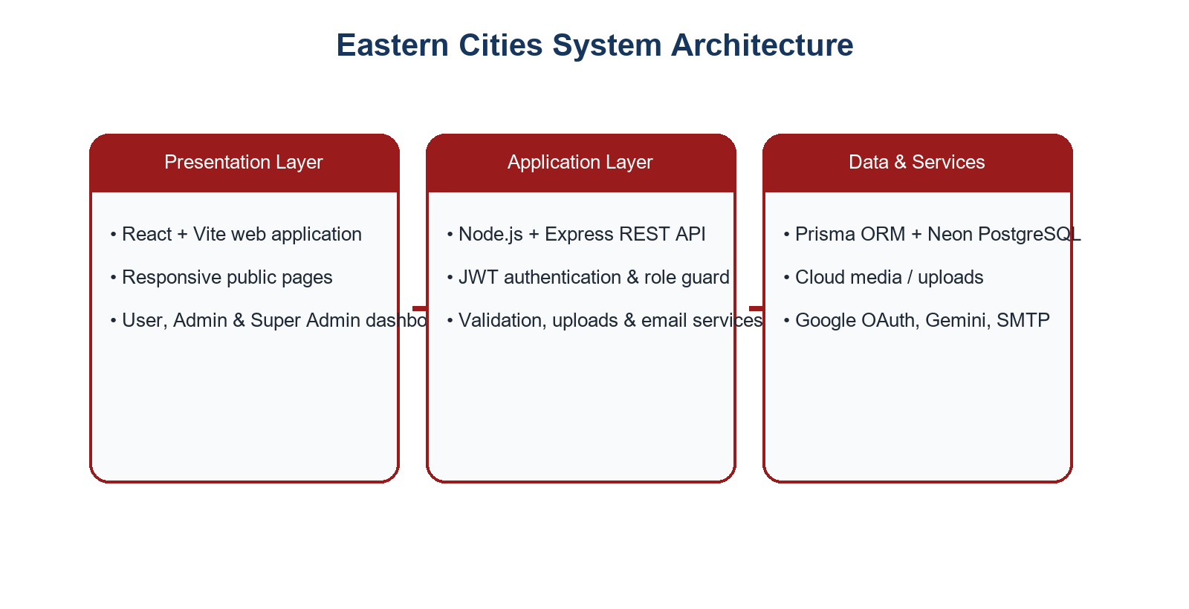
Figure 1: Eastern Cities system architecture.

2.4 Tasks and Responsibilities Performed
Member | Primary contribution areas
Rahma Salah | Backend foundation; Neon/PostgreSQL migration; user verification and integration work; dashboard UI refinement and mobile responsiveness.
Obse Taresa | React/Vite foundation; authentication and administrative functions; listings, bookings, messages, dashboards, language support, AI and integration work.
Mahlet Mulugeta | Listing promotions and uploads; booking/review relations; frontend-backend integration; authentication, dashboard, promotion, messaging, saved-item and category issue fixes.

The allocation above describes the principal contribution areas evidenced by the team project history. All members participated in integration, discussion, defect resolution, interface review, and testing.

2.5 Marketplace Workflows
The listing workflow starts with an owner creating a listing and uploading item images. Administrative review controls whether the listing becomes visible. Renters can browse categories, inspect a gallery, contact an owner, and submit booking-related communication. Reviews and notifications support the post-rental experience.
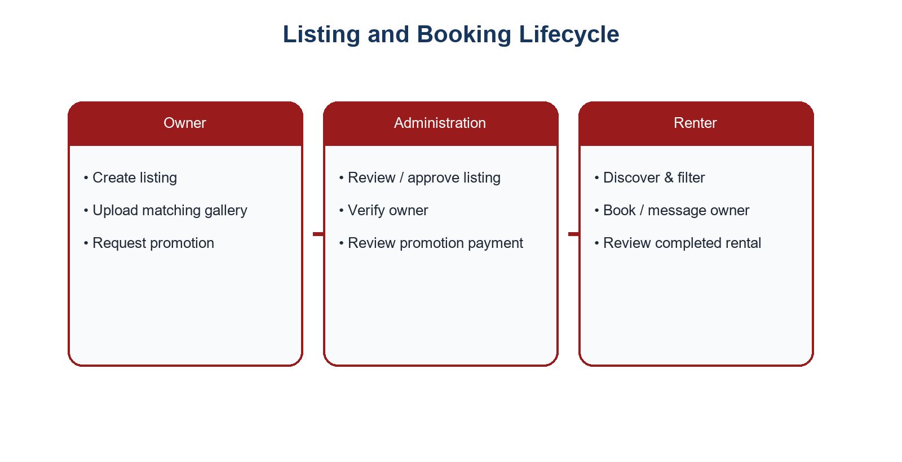
Figure 2: Listing and booking lifecycle.

2.6 Advertising and Payment Workflow
A separate advertising workflow was designed for external organizations. An advertiser submits a campaign request. An administrator reviews the request and replies with payment instructions and the requested amount. The advertiser opens the dedicated payment-receipt page, uploads a Telebirr or CBE Birr receipt, and the administrator verifies it. Only after approval does the banner become active according to its schedule. This prevents unreviewed advertisements from appearing on the public home page.
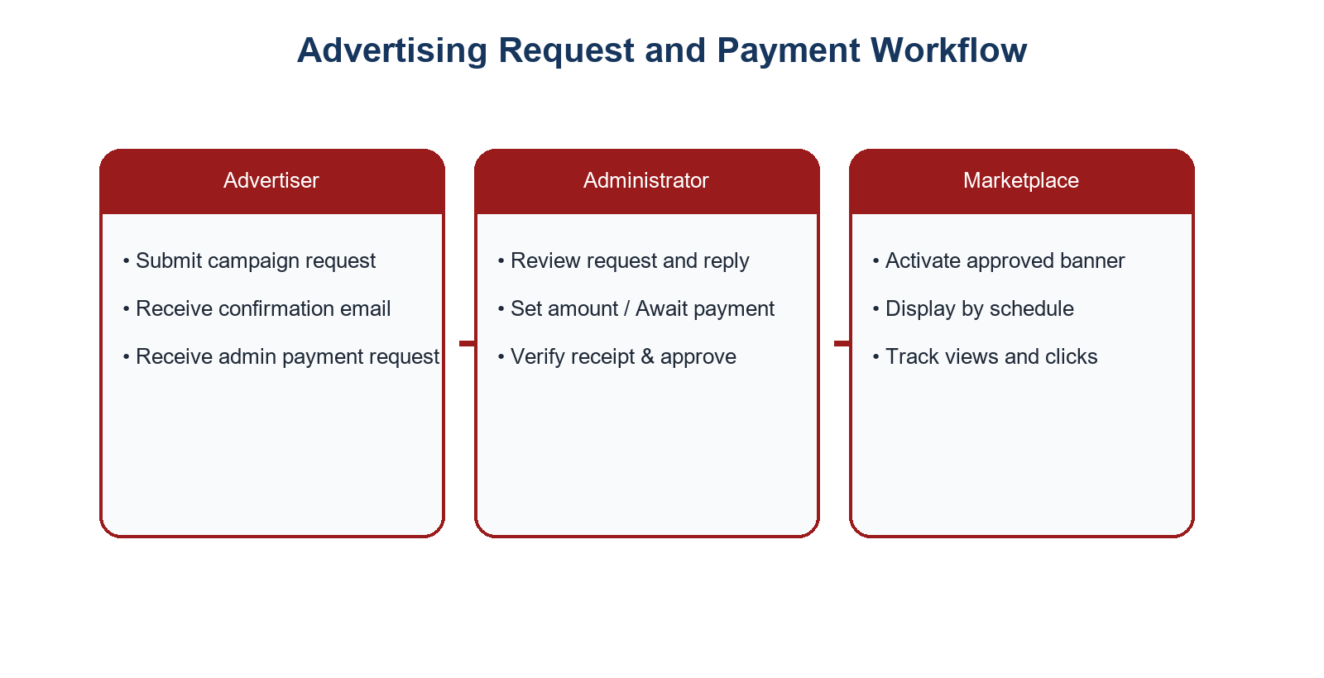
Figure 3: Advertising request and payment workflow.

2.7 Data Design
The core data model links users to their listings, booking activity, messages, notifications, reviews, verification records, promotions, and advertising requests. Listings are related to categories and multiple listing images. This design supports a gallery instead of a single picture and enables better representation of rental items.
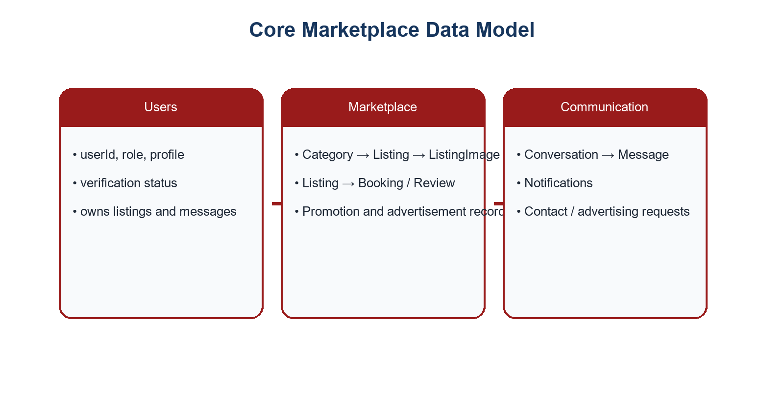
Figure 4: Core marketplace data model.

2.8 Software Development Methodologies and Practices
The group applied a lightweight iterative approach. Features were divided into manageable tasks; changes were recorded in Git; tests were carried out through browser scenarios and API responses; and defects were revisited when feedback exposed an issue. The process emphasized small, testable changes, especially for authentication, navigation, database migrations, and responsive layout work.

2.9 Performance Analysis and Key Achievements
- Implemented a database-backed marketplace with role-specific dashboards.
- Strengthened direct role-based routing so users, administrators, and super administrators reach the appropriate dashboard.
- Introduced a structured advertising request, payment receipt, approval, and banner publication workflow.
- Improved responsiveness and theme consistency across core screens.
- Improved listing-gallery handling and recognized image-to-item quality as a data-governance requirement.

2.10 Challenges Encountered and Solutions
Challenge | Response / lesson learned
Database connection and Prisma client issues | Validated environment variables, regenerated Prisma client when possible, checked schema/database alignment, and restarted the relevant service safely.
Conflicting changes in shared worktree | Inspected Git history and avoided overwriting teammates’ work; isolated changes and tested integrations.
Incorrect listing images | Established the need for title-aware, category-aware galleries and visual verification rather than relying only on scripts.
Mobile dashboard overflow | Used responsive constraints, collapsible navigation behavior, content wrapping, and scoped table scrolling.
Email and external service limits | Used server-side environment variables, clear fallback messaging, and kept credentials out of the client application.

2.11 Frontend Development Experience
The frontend was treated as more than a collection of pages. It is the public face of a trust-based rental marketplace, so the team focused on readable navigation, a consistent visual language, responsive behavior, and clear calls to action. The public home page introduces the marketplace, supports searching and filtering, displays selected listings, and provides space for independently managed external advertisements. Category and item-detail pages are responsible for helping a renter understand an item before contacting its owner.
A major frontend concern was ensuring that card images, prices, owner information, city, category, and actions remain usable at different viewport sizes. The group improved dashboard layouts by maintaining the sidebar on desktop, enabling a mobile navigation pattern on smaller screens, constraining tables inside scrollable regions when necessary, and avoiding full-page horizontal overflow. Light and dark themes were reviewed as two complete interface states rather than as simple color inversion.
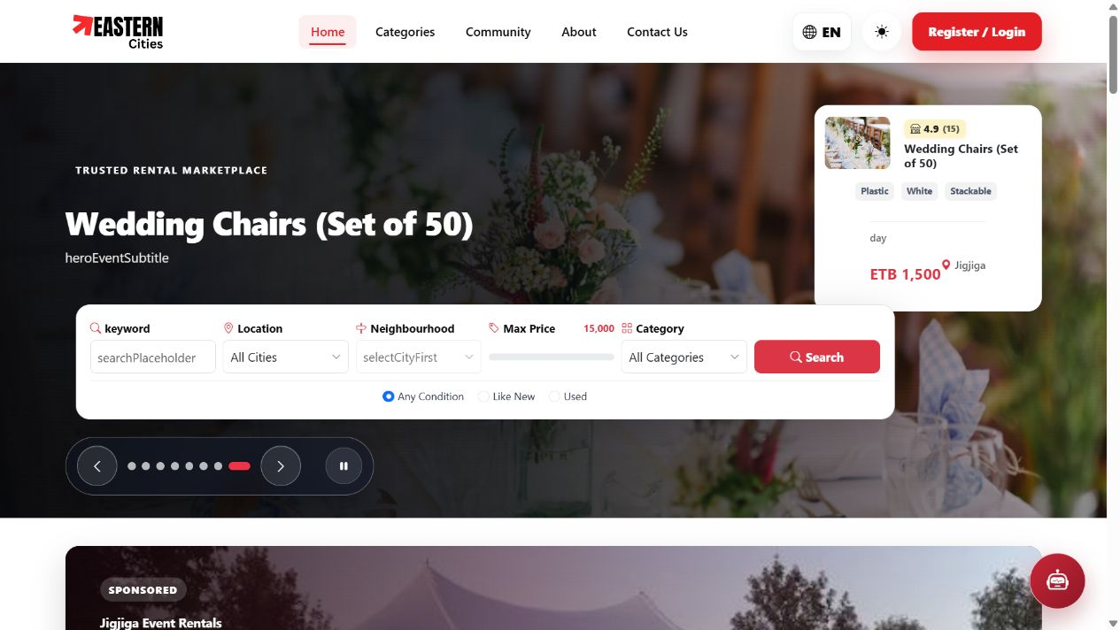
Figure 5: Eastern Cities public home page - homepage search and featured hero area.

2.12 Backend and Database Development Experience
The backend uses service and controller layers to separate HTTP handling from reusable business logic. Controllers interpret request data, return appropriate response statuses, and delegate work to services. Services perform tasks such as authentication, listing creation, booking actions, advertisement processing, email sending, and communication. Prisma maps application objects to PostgreSQL records while keeping database access centralized and more consistent.
The database design was especially important because marketplace data is relational. A user may own multiple listings, renters may create multiple booking inquiries, a listing may contain multiple images, and a conversation may contain several messages. Rather than presenting all data as locally hardcoded content, the project aims to fetch categories, listings, images, reviews, bookings, promotions, and notifications through the database-backed API. This arrangement also enables administrative moderation and supports future auditing.

2.13 Authentication, Authorization, and Security
Authentication was designed around account registration, credential validation, token-based sessions, password recovery, and optional Google sign-in. Authorization is distinct from authentication: after a user is authenticated, the application determines the account role and routes the user to the correct interface. Normal users are directed to the user dashboard, administrators to the admin dashboard, and super administrators to the super-admin dashboard. Attempts to reach unauthorized dashboard pages are redirected to the appropriate permitted destination.
The team learned important operational security practices. API keys must never be placed in frontend source code because every browser user can inspect client assets. Sensitive credentials such as database URLs, mail configuration, and AI-provider keys should be stored in server-side environment variables. Payment receipts and verification records should be protected by access controls, and development logs should avoid exposing passwords, tokens, or raw credentials.

2.14 Testing and Quality Assurance Practices
Testing was performed through progressive validation. At the API level, the team checked request payloads, authorization requirements, database response behavior, and error messages. At the interface level, the team checked the complete user journey: registration, login, dashboard routing, listing creation, browsing, item details, communication, promotion requests, administrative review, payment receipt upload, and banner publication. Browser inspection was especially useful for identifying visual defects that cannot be discovered through code review alone.
Quality assurance also required data quality checks. For rental listings, an image must represent the actual item named in the title and belong to the correct category. A gallery should contain several views of the same item, not random photographs from an unrelated category. This requirement became a practical lesson in the difference between application correctness and marketplace credibility: a database record can be technically valid while still creating poor user trust if its media is misleading.

2.15 Detailed Group Contribution Narrative
Rahma Salah contributed strongly to the application foundation and integration effort. Her work included backend initialization, migration toward a Neon-backed PostgreSQL environment, user verification functionality, frontend-backend integration, and user-interface improvements. She also contributed to dashboard layout refinement, theme consistency, and mobile responsiveness. These contributions were important because marketplace users must be able to move from public discovery to account actions without facing inconsistent interfaces.
Obse Taresa contributed across the React/Vite application foundation, authentication and role-aware routing, administrative views, and feature integration. His work covered parts of listing, booking, messaging, language support, dashboard, and AI-assistant functionality. The breadth of these contributions supports the system’s central workflow: users identify items, contact owners, administer listings, and receive appropriate notifications without being exposed to pages outside their role.
Mahlet Mulugeta focused on promotion and upload capabilities, booking and review relationships, integration work, and issue resolution across authentication, dashboards, promotions, messaging, saved items, categories, and related interfaces. Her contribution demonstrates the value of maintaining relationships between features: an item promotion, a booking review, and a user’s saved item should not operate as isolated screens but as connected parts of a rental experience.

2.16 Work Plan and Milestones
Phase | Main activities | Output
Planning and setup | Repository review, environment setup, schema and route review | Shared development baseline
Core marketplace | Listings, categories, galleries, search and item details | Public rental discovery experience
Accounts and dashboards | Authentication, roles, verification and dashboards | Role-specific user journeys
Transactions and communication | Bookings, messages, reviews, notifications | Owner-renter interaction support
Revenue features | Promotions, advertising requests, receipts and banner scheduling | Controlled advertising workflow
Quality and documentation | Responsive testing, bug fixes, report preparation | Improved usability and evidence

2.17 Lessons from Collaboration
The source-control history showed why communication is as important as programming skill. A shared branch can contain unrelated changes, incomplete merges, or overlapping modifications. Before applying a change, the team must inspect the relevant file, understand active changes, keep the scope narrow, and test the result. When a conflict occurs, the correct response is not to discard another person’s work; it is to compare requirements, preserve valid changes, and resolve the integration deliberately.
The internship also reinforced the importance of documenting technical decisions. Examples include recording why a database environment variable is required, why a banner is not activated until payment receipt approval, why a role guard redirects a user, and why an image gallery must be title-aware. These small explanations reduce repeated troubleshooting and make the project easier for the next developer or intern to maintain.

2.18 Public Marketplace and Search Experience
The public marketplace is designed to reduce the effort required to find rental items. A visitor can begin from the home page, select a category, use keyword and location filters, and open a listing detail page. Each listing card presents a concise summary, while the detail page is intended to provide a fuller description, price, location, gallery, owner context, rental requirements, and a way to initiate communication. This progressive disclosure prevents the home page from becoming crowded while still supporting informed rental decisions.
Search and category design require reliable backend filtering. A category page should not show a static count that differs from the listings returned by the API. Similarly, a listing must appear only in a category that represents its rental type. The team therefore treated category metadata and listing data as related data owned by the database rather than as separate mocked interface values. This makes it easier to add categories, change descriptions, moderate content, and provide consistent discovery across the home page and detail views.
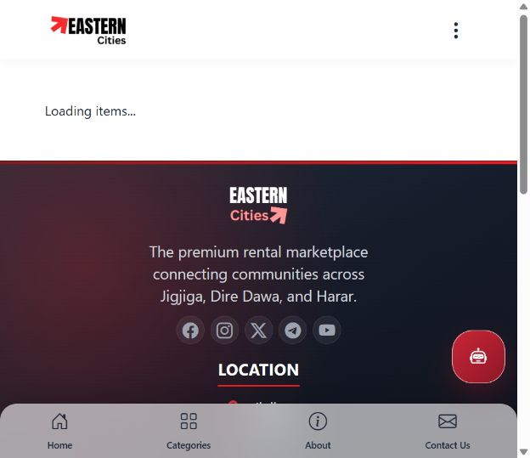
Figure 6: Eastern Cities marketplace listing view captured during local verification.

2.19 Listing Management and Image-Gallery Quality
Listing management combines owner convenience with marketplace moderation. Owners need an understandable form for title, description, price, location, category, availability, and images. Administrators need to review submissions before public display. The project supports multiple listing images so that a renter can inspect an item from more than one angle. For example, a vehicle gallery may contain exterior views and interior views; an electronics gallery may contain the front, side, accessory, and working context of the same device.
The team encountered a real data-quality challenge: media can be stored successfully even when it does not represent the item described by the listing. To address this, the proposed quality standard requires that each gallery contain three or four images of the same product or product type; that the primary image match the title; that images not be reused as unrelated placeholders; and that mismatches be visually checked in the live user interface. The lesson is broadly applicable to any marketplace: content accuracy is part of system quality, not merely an aesthetic issue.

2.20 Booking, Messaging, and Owner Contact
The marketplace has to support the social side of rental transactions. A renter may need to ask about availability, pickup place, duration, price, deposit, or delivery. The messaging feature is therefore associated with users and listing context so that the recipient understands which rental is being discussed. Conversations preserve a history within the session and can be reflected in dashboard notification areas. The owner can respond without exposing unrelated user data to other people.
The booking flow is intentionally separated from a direct payment gateway. This is appropriate while the marketplace is being developed and local rental terms are still negotiated between owners and renters. A booking request captures the renter’s intention and relevant time period, while communication gives both parties space to agree on practical arrangements. Administrative tools can later use booking information for monitoring, dispute handling, reports, and analytics.

2.21 Administrative Dashboard Experience
Administrative dashboards organize functions that are intentionally not visible to ordinary users. They include user management, listing moderation, category management, booking oversight, payments and revenue pages, promotion management, advertising management, verification center, reports, support, contact messages, notifications, analytics, and settings. The dashboard experience needs good hierarchy because it contains a larger number of actions than the public marketplace.
The interface refinement work focused on using consistent cards, readable tables, appropriate action-button hierarchy, responsive layout, premium but restrained brand colors, and accessible contrast. In dark mode, cards and tables should remain readable without turning every panel into a saturated burgundy surface. In light mode, brand red remains an accent rather than a dominant background. The goal is an enterprise-style management system that can be used for long periods without visual fatigue.

2.22 Notification and Email Design
System emails and notifications are part of user experience because they continue a workflow outside the browser. The group worked toward branded HTML emails for registration, verification, password reset, advertising request confirmations, campaign approvals or rejections, promotions, listings, bookings, payments, and messages. A consistent template uses the Eastern Cities brand, concise heading, supporting explanation, primary action button, and a footer containing support contact information.
A technically correct email may still be ineffective if it does not state what the recipient should do next. For this reason, advertising messages should distinguish between an initial confirmation and an administrator’s payment request. The advertiser should not be asked to upload a payment receipt when the form is first submitted. The payment link should be sent only after an administrator replies, specifies payment instructions, and changes the campaign to an await-payment state.

2.23 AI Assistant and Language Support
The project includes an AI-assistant experience that is constrained to helpful platform topics such as rentals, listings, verification, accounts, dashboards, categories, contacting owners, and policies. The service key is handled on the server rather than exposed in the browser. When an AI service is unavailable or reaches a usage limit, the application must provide a clear fallback message instead of leaving the user with an unexplained failure.
Language support is another usability requirement. The assistant greeting and responses are expected to respect the website’s selected language. More broadly, navigation labels, buttons, notifications, and empty states benefit from a consistent localization strategy. This is especially relevant to a marketplace serving communities with different language preferences and varying levels of digital familiarity.

2.24 Deployment and Operational Readiness
The application can run locally using separate frontend and backend development servers. The frontend is served through Vite, while the backend is served by Node.js/Express with environment variables loaded from a local .env file. In production, the same secrets must be provided by the hosting platform instead of being stored in the source repository. Database migrations and Prisma-client generation should be included in a documented deployment checklist.
Operational readiness also includes failure handling. If the Neon database is paused, misconfigured, or temporarily unreachable, the backend should return a useful service error and developers should verify the active DATABASE_URL. If Prisma reports a mismatch between the schema and actual database tables, the correct migration or introspection action should be taken before attempting to treat the symptom as a frontend problem. These experiences improved the group’s ability to separate infrastructure faults from application-code faults.

CHAPTER THREE: SKILLS AND PROFESSIONAL DEVELOPMENT GAINED

3.1 Technical Skills
The internship improved our ability to translate requirements into software components. We strengthened frontend component design, state and API integration, Express controller/service structure, relational database modeling, Prisma usage, authentication flow design, route protection, and responsive CSS. We also gained a clearer understanding that a feature is incomplete until it has been tested in the actual user journey.

3.2 Soft Skills and Professional Skills
Group work required active communication, task coordination, respectful handling of conflicting changes, and time management. We learned to document assumptions, reproduce errors clearly, request missing information, and balance fast iteration with the need to preserve existing functionality. These habits are essential in professional software teams.

3.3 Ethics, Work Culture, and Entrepreneurship
The placement highlighted responsible handling of user data, passwords, API keys, payment receipts, and personal contact details. We learned that keys must be stored only in server-side environment variables and that public interfaces need clear status communication. The internship also exposed us to entrepreneurship: a marketplace must balance user experience, revenue features, trust, moderation, and maintainable engineering.

CHAPTER FOUR: CONCLUSION AND RECOMMENDATIONS

4.1 Conclusion
The internship at Bewide Technologies PLC provided a valuable bridge between academic software engineering and practical product development. Through the Eastern Cities Rental Management System, the group applied design, programming, testing, database, UI/UX, and collaboration skills to a meaningful regional marketplace context. The project demonstrated the importance of clear roles, reliable data, quality assurance, and user-centered workflows.

4.2 Recommendations to Bewide Technologies PLC
- Maintain a documented staging and deployment checklist for environment variables, database migrations, email configuration, and third-party integrations.
- Create a curated listing-image policy and owner-upload review process to ensure every gallery accurately represents the rental item.
- Add automated API, role-routing, and responsive-interface tests to complement manual browser verification.
- Track performance indicators such as API latency, image size, database availability, and page load experience.

4.3 Recommendations to Future Interns
- Read the existing codebase and Git history before changing shared modules.
- Test each feature as the intended role, not only as a developer with broad access.
- Keep secrets out of source code and use environment variables from the start.
- Document completed work, blockers, decisions, and lessons in a weekly log.

4.4 Recommendations to the Internship Program
The department can further strengthen the internship program by providing an early orientation on report expectations, supervisor communication, security practices, and version-control collaboration. Regular review checkpoints would help students connect technical deliverables with documentation evidence while the work is still fresh.

References
Bewide Technologies / Umrago. (2026). Umrago: Your Journey Deserves Excellence. Available at: https://umrago.et/ (Accessed: 7 August 2026).
Haramaya University, College of Computing and Informatics, Department of Software Engineering. (2026). Department of Software Engineering: Outline for an Internship Report. Unpublished departmental guideline.
Prisma. (2026). Prisma ORM Documentation. Available at: https://www.prisma.io/docs/.
React. (2026). React Documentation. Available at: https://react.dev/.
Node.js. (2026). Node.js Documentation. Available at: https://nodejs.org/docs/.
Project source repository: Eastern Cities Rental Management System. Internal project documentation and version-control history, consulted during internship report preparation.

Appendix A: Proposed Weekly Activity Log
Week | Representative activities
1 | Orientation, review of requirements, repository structure, and development environment.
2 | Authentication, user roles, dashboard navigation, and API integration review.
3 | Listing/category features, database relationships, image-gallery investigation.
4 | Booking, messaging, review, and notification workflows.
5 | Administrative dashboards, verification and content-management refinement.
6 | Promotion, advertising request, payment-receipt, and email workflow work.
7 | Mobile responsiveness, dark/light theme consistency, defect testing.
8 | Integration testing, documentation, report preparation, and lessons learned.

Appendix B: Evidence Checklist
- Insert approved screenshots of the home page, item details, user dashboard, admin dashboard, and advertising workflow if permitted by the host organization.
- Attach signed weekly reports and monthly logbooks when available.
- Attach supervisor feedback or acceptance evidence where applicable.

