**Intermediate English Class - Halloween**

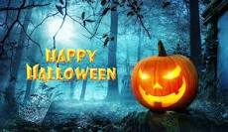

**What we will learn today:**

* Learn the basic vocabulary relating to Halloween
* Discuss Halloween traditions in the Western world
* Reflect on your own cultural celebrations similar to Halloween

**Label the pictures with the words below.**

a bonfire, costumes, a full moon, a ghost, a Jack O’Lantern, a skeleton, a skull, trick-or-treating

A B C  D E 

F 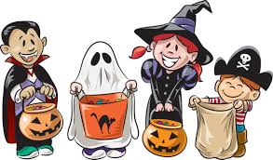 G 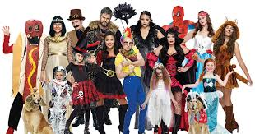H 

**A brief history of Halloween and Chinese traditions similar.**

Halloween originated from the traditional holiday of **Celts** in Great Britain who believed that the last day of October was “the day of the dead” or “the ghost day” when ghosts crossed over the **boundary** between the living and the dead. It evolved into a day of fun and parties for most people. However, in English speaking countries such as America and Britain, many take the day seriously as a special day for religious prayers or **witchcraft**.

The Chinese days of the dead are a part of the religion of the common people. A greater percentage of Chinese than Westerners really believe that on these days there is more of a bridge between the dead and the living, and so they must take **precautions** or honour the dead.

**Read the above text and match the below words to the correct meaning.**

**Celts (kelt), Boundary,** **originated, Witchcraft, Precautions**

1. a line which marks the limits of an area; a dividing line.
2. a person belonging to a people from western Europe who came to live in ancient Britain before the Romans
3. to prevent something dangerous, unpleasant, or inconvenient from happening.
4. the practice of magic, the use of spells.
5. to come from a particular place, time, situation

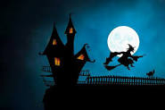

**Answer the questions below.**

1. Which object from the pictures is used to keep away evil spirits?
2. Do you have any full moon traditions in your country?
3. Which Halloween traditions do you take part in?
4. Is Halloween getting more or less popular in your country?

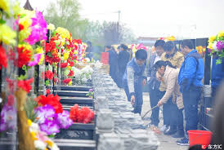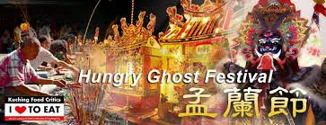

**Can you describe the below Chinese celebrations and festivals?**

1. The Hungry Ghost Festival:
2. The seventh month of the Chinese lunar calendar
3. The Qing Ming Festival:
4. The Chinese Spring Festival: