线性方程组AX=B的数值计算方法实现

姓名：王旋宇

学号：2012049010022

班级：数理基科班

老师：赖生建

#### 实验目的

1. 掌握高斯消元法和选主元策略，会编程实现算法。
2. 掌握三角分解法，将矩阵进行LU分解并求解。会编程实现矩阵的LU分解及求解。
3. 了解雅可比迭代。掌握高斯-赛德尔迭代，并会编程实现且求解。

#### 实验原理

1. 高斯消去法和选主元
2. 定理1（初等变换） 下面三种变换可是一个线性方程组变换成另一个等价的线性方程组：

* Interchange（交换）变换：对调方程组的两行。
* Scaling（比例）变换：用非零数乘以方程组的某一行。
* Replacement（置换）变换：将方程组的某一行乘以一个非零常数，再加到另一行上。

1. 定理2（初等行变换） 对增广矩阵进行如下变换可得到一个等价的线性方程组。

* Interchange（交换）变换：对调矩阵的两行。
* Scaling（比例）变换：用非零数乘以矩阵的某一行的所有元素。
* Replacement（置换）变换：将矩阵的某一行的所有元素乘以一个非零常数，再加到另一行对应的元素上，即：

${row}_{r}={row}_{r}-m_{rp}×{row}_{p}$

1. 定义1 系数矩阵A中的元素 $a_{rr}$ 用来消去 $a_{kr}$，其中 $k=r+1,r+2,⋯,N$，这里称 $a_{rr}$ 为第r个主元，第r行被称为主元行。
2. 高斯消元法。高斯消元法就是将矩阵反复进行行初等变换，将矩阵变为行阶梯型矩阵，即将矩阵变为上三角矩阵。之后利用回代法求解。
3. 偏序选主元策略。在高斯消元法消元的消元过程中，如果出现约化主元 $a_{pp}^{(p)}$ 为0的情况，消元过程将无法进行。有时即使约化主元不为零，但其绝对值很小也会导致计算数据的增长或舍入误差扩散。这时候有必要寻找更合适的第k行的 $a_{kp}^{(p)}$，然后交换第k行和第p行。选择行的判定条件称为选主元策略。偏序选主元策略是最常用的选主元策略。

偏序选主元策略首先检查位于主对角线或主对角线下方第p列的所有元素，确定行k，它的元素的绝对值最大。如果K>p，则交换第k行和第p行。这样保证了消元后的矩阵和初始系数矩阵的对应元素的相对大小一致。

1. 三角分解法
2. 定义2 如果非奇异矩阵A可表示为下三角矩阵L和上三角矩阵U的乘积：

$A=LU$

则A 存在一个三角分解。

1. 设线性方程组 $AX=B$ 的系数矩阵A存在三角分解，则线性方程组可表示为

$LUX=B$

而方程组的解可通过定义 $Y=UX$ 并求解 $LY=B和UX=Y$ 得到X。

1. LU矩阵的求法。设需要将矩阵A进行LU分解，A满足在求解过程中无行交换过程。那么在第i 行进行消元的时候，同时将消元倍数放在一个单位矩阵的对应位置。在A消元结束之后，单位矩阵就变成了L，同时A就变成了U。

拓展的LU矩阵求法。在上面的LU求法中要求A无需进行行变换，这样有可能使得一个非奇异矩阵A不能直接分解为 $A=LU$，于是有如下定理。

定理3 如果A是非奇异矩阵，则存在一个置换矩阵P，使得PA存在三角分解。

1. 求解线性方程组的迭代法。
2. 雅可比迭代。

$x_{j}^{(k+1)}=\frac{b_{j}-a_{j1}x_{1}^{\left(k\right)}-⋯-a_{jj-1}x_{j-1}^{\left(k\right)}-a_{jj+1}x_{j+1}^{\left(k\right)}-⋯-a_{jN}x_{N}^{\left(k\right)}}{a_{jj}},j=1,2,⋯,N$

其中，矩阵为 $N×N$ 维矩阵。

1. 高斯-赛德尔迭代。

$x_{j}^{(k+1)}=\frac{b_{j}-a_{j1}x_{1}^{\left(k+1\right)}-⋯-a_{jj-1}x_{j-1}^{\left(k+1\right)}-a_{jj+1}x_{j+1}^{\left(k\right)}-⋯-a_{jN}x_{N}^{\left(k\right)}}{a_{jj}},j=1,2,⋯,N$

其中，矩阵为 $N×N$ 维矩阵。

1. 定义3 设有 $N×N$ 维矩阵A，如果

$\left|a_{kk}\right|>\sum_{\begin{aligned}j=1 \\ j≠k\end{aligned}}^{N}{\left|a_{kj}\right|},k=1,2,⋯,N$

则称A具有严格对角优势。

1. 定理4（雅可比迭代和高斯-赛德尔迭代） 设矩阵A具有严格对角优势，则 $AX=B$ 有为一解 $X=P$。利用迭代式可产生一个向量序列 $\left\{P_{k}\right\}$，而且对于任意初始向量 $P_{0}$，向量序列都将收敛到 $P$。
2. 定义4 定义范数 ${\left\|*\right\|}_{1}$ 为：

${\left\|X\right\|}_{1}=\sum_{j=1}^{N}{\left|x_{j}\right|}$。

这个范数又称为列和范数。可以用来比较两个向量之间的差距，相比欧几里得距离具有计算量小的优点。可以用来判断向量序列的收敛。

#### 实验内容

1. P108 1. 许多科学应用包含的矩阵带有很多零，在实际情况中很重要的三角型线性方程组有如下形式：



构造一个程序求解三角型线性方程组。可假定不需要行变换，而且可用第k行消去第k+1行的 $x_{k}$。

1. P120 1. 使用程序3.3求解线性方程组 $AX=B$。其中

 

使用MATLAB中的[L,U,P]=lu(A)命令检查得到的答案。

1. P120 2. 使用程序3.3求解线性方程组 $AX=B$，其中 $A={\left[a_{ij}\right]}_{N×N},a_{ij}=i^{j-1}$；而且 $B={\left[b_{ij}\right]}_{N×1},b_{11}=1,当i≥2时，b_{1j}=(i^{j}-1)/(i-1)$。对 $N=3,7,11$ 的情况分别求解。精确解为 $X=[1 1 ⋯1 1]'$。对得到的结果与精确解的差异进行解释。
2. P120 3. 修改程序3.3，使得它可以通过重复求解N个线性方程组

$AC_{j}=E_{j},其中j=1,2,⋯,N$

来得到 $A^{-1}$,

则

$A\left[C_{1} C_{2} ⋯ C_{N}\right]=[E_{1} E_{2} {⋯ E}_{N}]$

而且

$A^{-1}=\left[C_{1} C_{2} ⋯ C_{N}\right]$

保证对LU分解只计算一次！

1. P129 3. 设有如下三角线性方程组，而且系数矩阵具有严格对角优势：



* + 1. 根据方程组（9）、式（10）和式（11），设计一个算法来求解上述方程组。算法必须有效的利用系数矩阵的稀疏性。
    2. 根据i)中设计的算法构造一个MATLAB程序，并求解下列三角线性方程组。

1. 
2. 
3. P130 4. 利用高斯-赛德尔迭代法求解下列带状方程。



#### 实验分析

1. P108 1. 观察矩阵可以知道只要从第一行开始，用每一行来消去下一行的首元，这样得到的就是矩阵中只剩下 $a_{kk}与a_{kk+1}$ 两个元素（除了最后一行只有 $x_{N}$ 项）。这时可以采用从最后一行向上消元的办法来解方程组。不过也可以采用回代法解方程组。本道题目中采取回代法来解方程组。程序使用C语言编写。
2. P120 1. 本道题目采用带选主元的三角分解法，不过采用C语言实现不使用程序3.3。首先使用偏序选主元策略得到一个置换矩阵P，然后对置换后的矩阵A进行LU分解，

通过定义 $Y=UX$ 并求解 $LY=B和UX=Y$ 得到X。

1. P120 2. 这道题的求解思路和上题一样，只是在初始化矩阵的时候改变一下初始化函数即可。
2. P120 3. 这道题采用第二题的程序。先构造一个N阶单位矩阵。然后对于单位矩阵的每一列都复制给一个 $N×1$ 的列向量，即第二题中的B，然后按照第二题所示方法求得解之后把解复制到单位矩阵的对应列即可。
3. P129 3. 采用高斯-赛德尔迭代方法计算。不过在计算式（）中的分子中的被减项的和的时候，利用三角线性方程组的系数特征，只计算 $a_{ii-1}∙x_{i-1},a_{ii}∙x_{i},a_{ii+1}∙x_{i+1}$ 三项的和，如果某个系数不存在就略去不计算。这样在每一迭代中需要计算 $(N-1)×N$ 次乘积，现在变为了只用计算 $3×\left(N-2\right)+4$ 次乘积。其余的按照普通的高斯-赛德尔迭代算法计算即可。
4. P130 4. 本题目采用高斯-赛德尔迭代方法计算。仅仅按照普通的高斯-赛德尔迭代算法计算即可。并没有利用带状矩阵的系数特征。

#### 实验结果

1. P108 1. 以解如下两个线性方程为例。
2. 

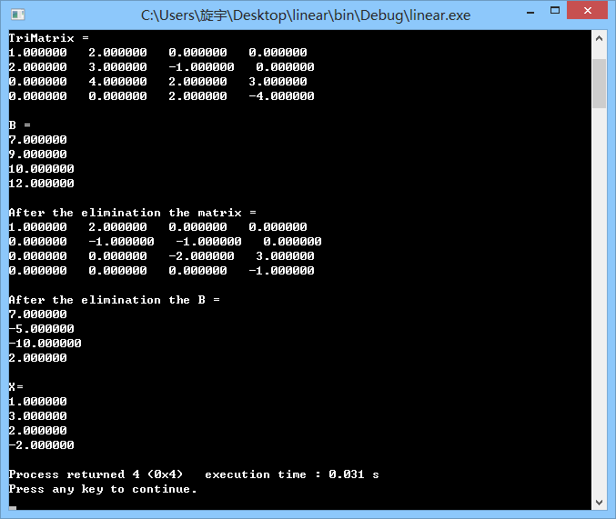

图1. P108 1.题目测试数据第一组计算结果

1. 

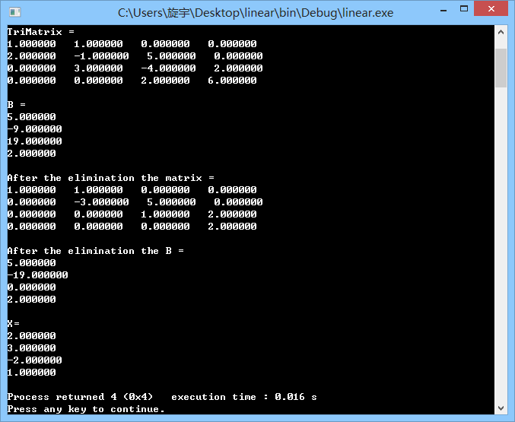

图2. P108 1.题目测试数据第一组计算结果

1. P120 1.

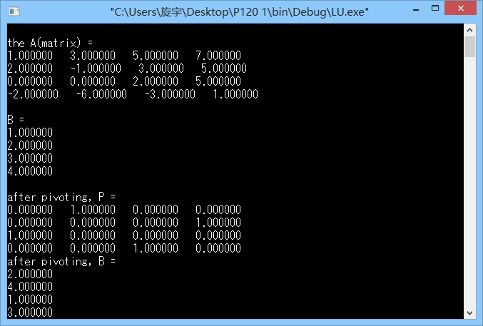

图3. P120 1. 题目计算结果1

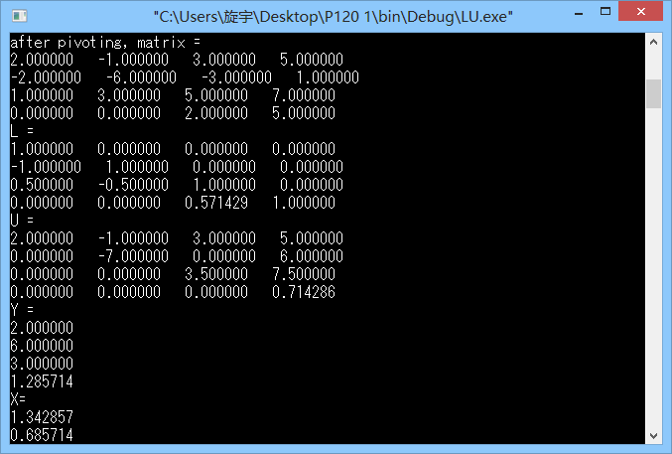

图4. P120 1. 题目计算结果2

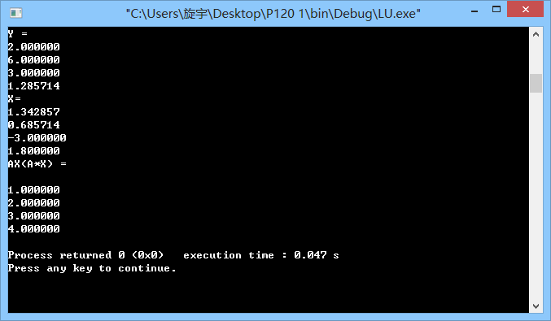图5. P120 1. 题目计算结果3

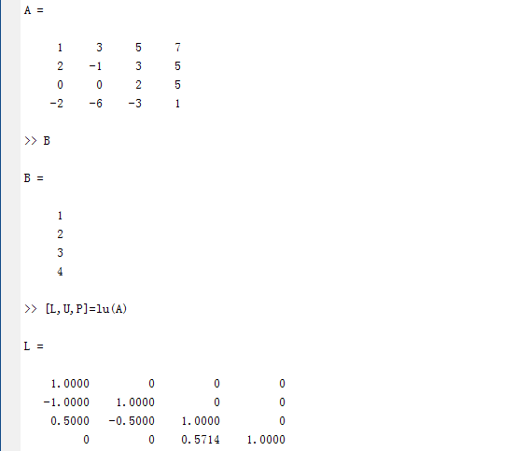

图6. P120 1. 题目计算结果MATLAB验证1

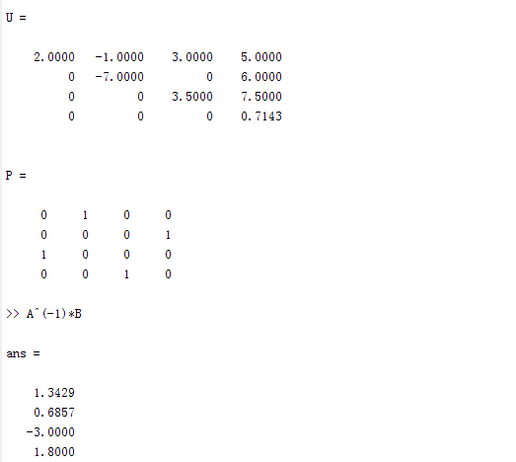

图7. P120 1. 题目计算结果MATLAB验证2

1. P120 2.

* 当N=3时程序运行结果

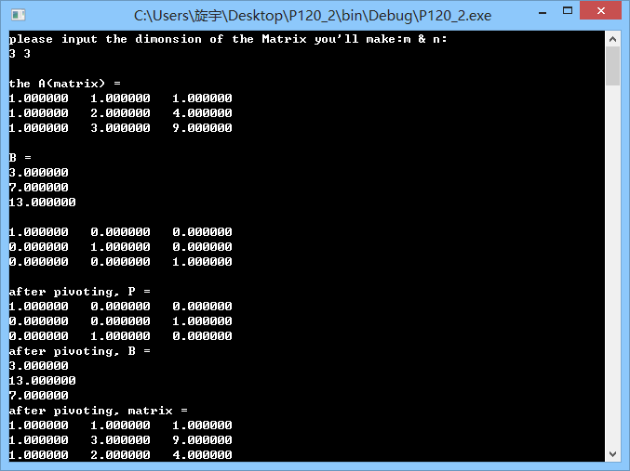

图8. P120 2. N=3计算结果图1

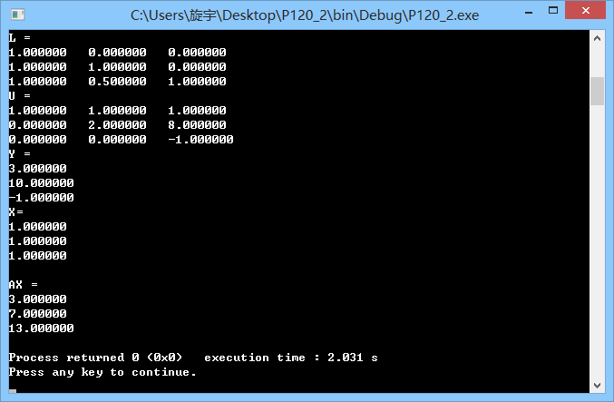

图9. P120 2. N=3计算结果图2

* 当N=7时程序运行结果

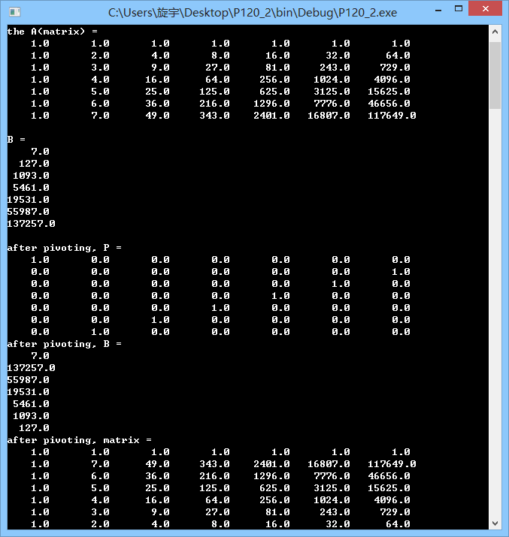

图10. P120 2. N=7计算结果图1

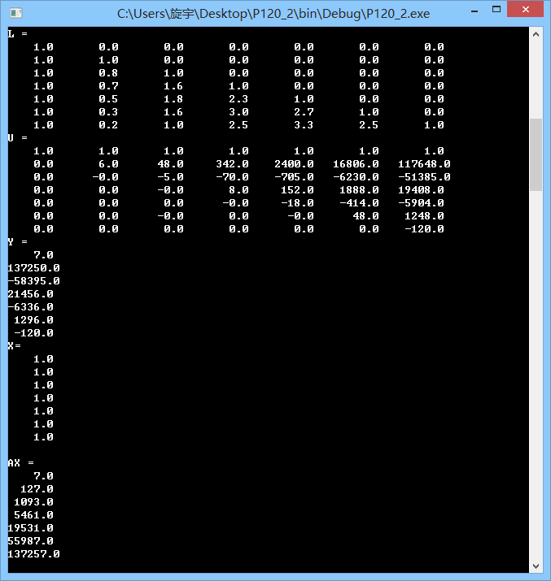

图11. P120 2. N=7计算结果图2

* 当N=11时候的程序运行结果

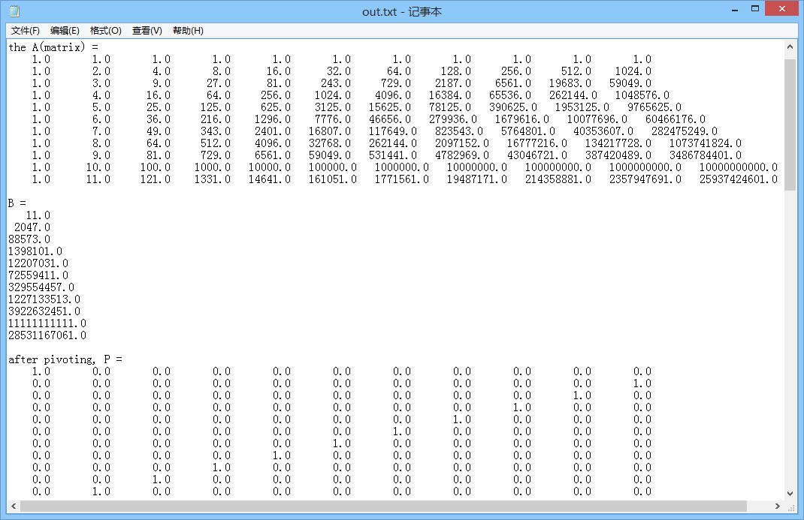

图12. P120 2. N=11计算结果图1

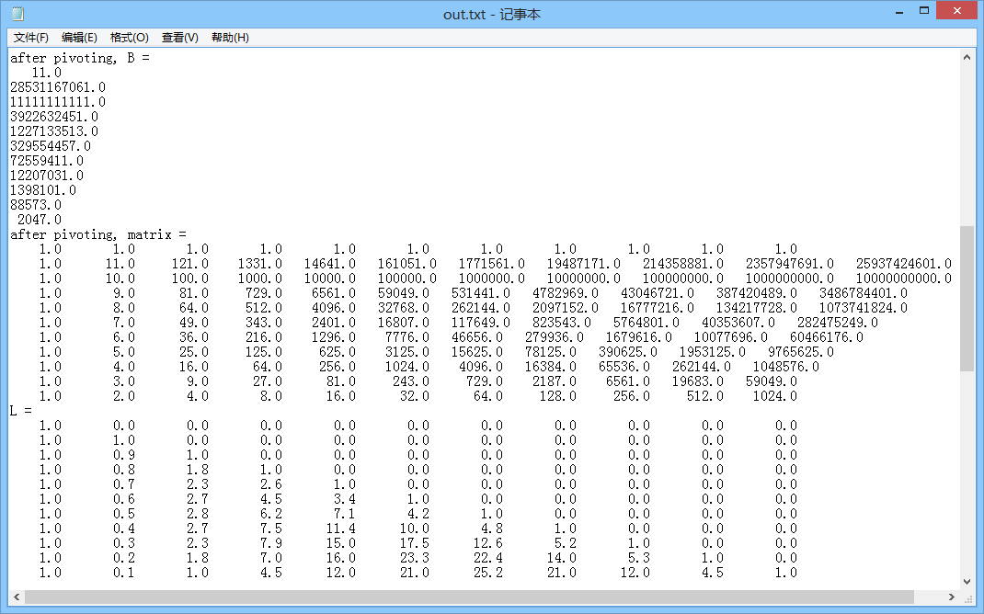

图13. P120 2. N=11计算结果图2

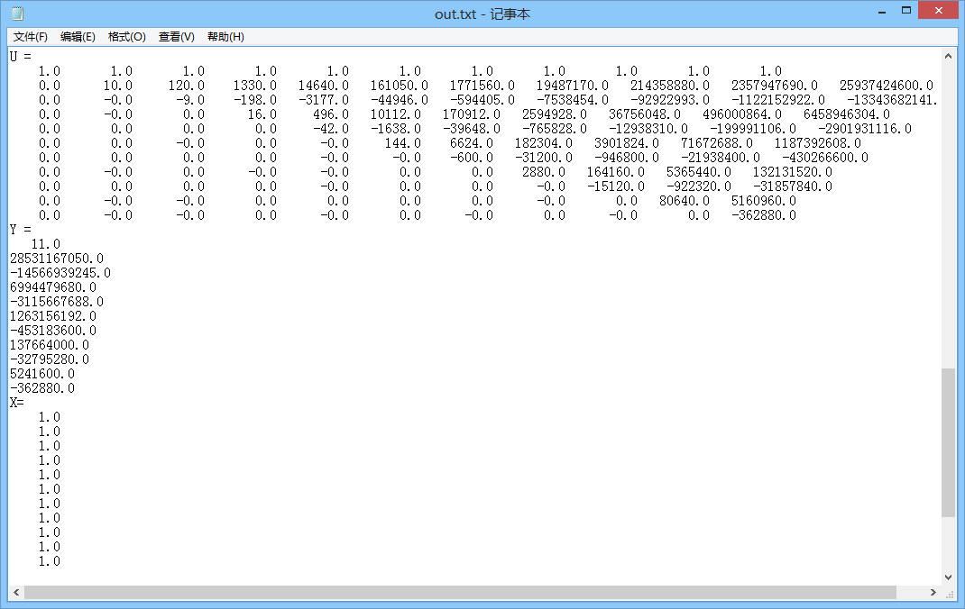

图14. P120 2. N=11计算结果图3

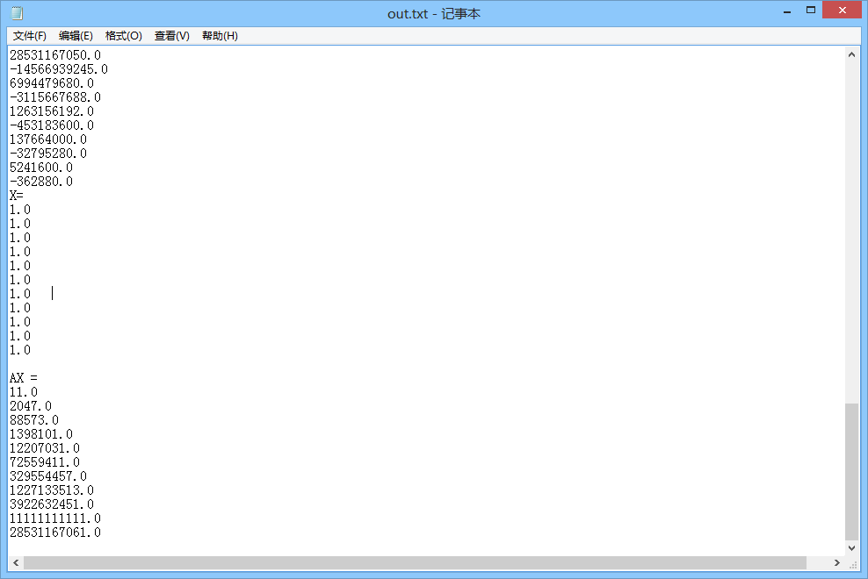

图15. P120 2. N=11计算结果图4

1. P120 3.

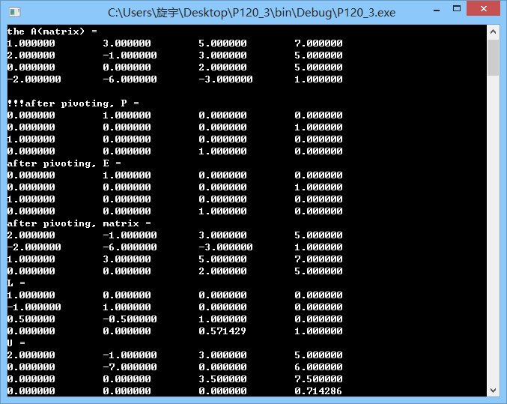图15. P120 3. 矩阵分解计算结果

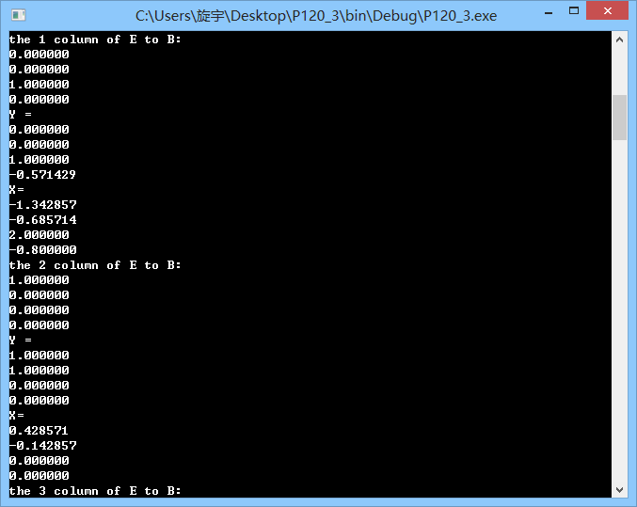图16. P120 3. $AC_{1}=E_{1}，AC_{2}=E_{2}$ 计算结果

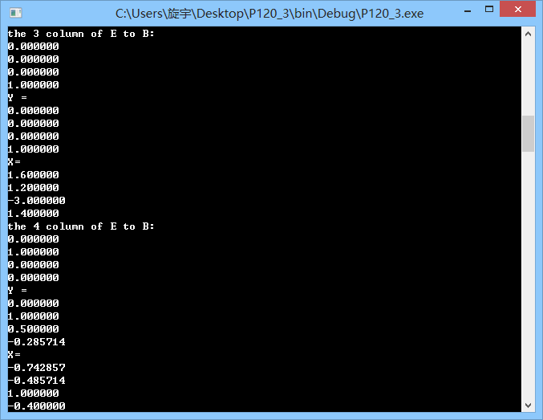图17. P120 3. $AC_{3}=E_{4}，AC_{4}=E_{4}$ 计算结果

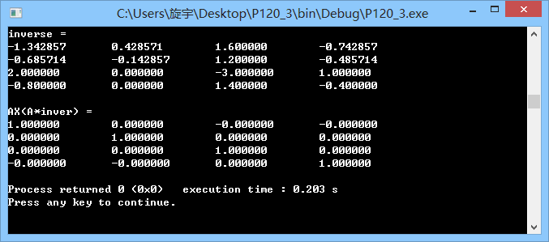图18. P120 3. $A$ 矩阵的逆的计算结果及其验证

1. P129 3.

|  |  |  |
| --- | --- | --- |
|  | 对于方程组（a）解为X = | 对于方程组（b）解为X = |
| 1 | 0.633975 | 0.133975 |
| 2 | 0.464102 | 0.464102 |
| 3 | 0.509619 | 0.009619 |
| 4 | 0.497423 | 0.497423 |
| 5 | 0.500691 | 0.000691 |
| 6 | 0.499815 | 0.499815 |
| 7 | 0.500050 | 0.000050 |
| 8 | 0.499987 | 0.499987 |
| 9 | 0.500004 | 0.000004 |
| 10 | 0.499999 | 0.499999 |
| 11 | 0.500000 | 0.000000 |
| 12 | 0.500000 | 0.500000 |
| 13 | 0.500000 | 0.000000 |
| 14 | 0.500000 | 0.500000 |
| 15 | 0.500000 | 0.000000 |
| 16 | 0.500000 | 0.500000 |
| 17 | 0.500000 | 0.000000 |
| 18 | 0.500000 | 0.500000 |
| 19 | 0.500000 | 0.000000 |
| 20 | 0.500000 | 0.500000 |
| 21 | 0.500000 | 0.000000 |
| 22 | 0.500000 | 0.500000 |
| 23 | 0.500000 | 0.000000 |
| 24 | 0.500000 | 0.500000 |
| 25 | 0.500000 | 0.000000 |
| 26 | 0.500000 | 0.500000 |
| 27 | 0.500000 | 0.000000 |
| 28 | 0.500000 | 0.500000 |
| 29 | 0.500000 | 0.000000 |
| 30 | 0.500000 | 0.500000 |
| 31 | 0.500000 | 0.000000 |
| 32 | 0.500000 | 0.500000 |
| 33 | 0.500000 | 0.000000 |
| 34 | 0.500000 | 0.500000 |
| 35 | 0.500000 | 0.000000 |
| 36 | 0.500000 | 0.500000 |
| 37 | 0.500000 | 0.000000 |
| 38 | 0.500000 | 0.500000 |
| 39 | 0.500000 | 0.000000 |
| 40 | 0.500000 | 0.500000 |
| 41 | 0.499999 | 0.000000 |
| 42 | 0.500004 | 0.500000 |
| 43 | 0.499987 | 0.000000 |
| 44 | 0.500050 | 0.500000 |
| 45 | 0.499815 | 0.000000 |
| 46 | 0.500691 | 0.500000 |
| 47 | 0.497423 | 0.000000 |
| 48 | 0.509619 | 0.500000 |
| 49 | 0.464102 | 0.000000 |
| 50 | 0.633975 | 0.500000 |

表1. 两个方程组的解

1. P130 4.

|  |  |  |  |  |
| --- | --- | --- | --- | --- |
|  | （误差限度为0.000001时）X = | 验证结果（A*X） | （误差限度为0.00001时）X = | 验证结果（A*X） |
| 1 | 0.463796 | 5.000000 | 0.463796 | 5.000000 |
| 2 | 0.537285 | 5.000000 | 0.537285 | 5.000000 |
| 3 | 0.509023 | 5.000000 | 0.509023 | 5.000000 |
| 4 | 0.498222 | 5.000000 | 0.498222 | 5.000000 |
| 5 | 0.498942 | 5.000000 | 0.498942 | 5.000000 |
| 6 | 0.499985 | 5.000000 | 0.499985 | 5.000000 |
| 7 | 0.500089 | 5.000000 | 0.500089 | 5.000000 |
| 8 | 0.500015 | 5.000000 | 0.500015 | 5.000000 |
| 9 | 0.499995 | 5.000000 | 0.499995 | 5.000000 |
| 10 | 0.499998 | 5.000000 | 0.499998 | 5.000000 |
| 11 | 0.500000 | 5.000000 | 0.500000 | 5.000000 |
| 12 | 0.500000 | 5.000000 | 0.500000 | 5.000000 |
| 13 | 0.500000 | 5.000000 | 0.500000 | 5.000000 |
| 14 | 0.500000 | 5.000000 | 0.500000 | 5.000000 |
| 15 | 0.500000 | 5.000000 | 0.500000 | 5.000000 |
| 16 | 0.500000 | 5.000000 | 0.500000 | 5.000000 |
| 17 | 0.500000 | 5.000000 | 0.500000 | 5.000000 |
| 18 | 0.500000 | 5.000000 | 0.500000 | 5.000000 |
| 19 | 0.500000 | 5.000000 | 0.500000 | 5.000000 |
| 20 | 0.500000 | 5.000000 | 0.500000 | 5.000000 |
| 21 | 0.500000 | 5.000000 | 0.500000 | 5.000000 |
| 22 | 0.500000 | 5.000000 | 0.500000 | 5.000000 |
| 23 | 0.500000 | 5.000000 | 0.500000 | 5.000000 |
| 24 | 0.500000 | 5.000000 | 0.500000 | 5.000000 |
| 25 | 0.500000 | 5.000000 | 0.500000 | 5.000000 |
| 26 | 0.500000 | 5.000000 | 0.500000 | 5.000000 |
| 27 | 0.500000 | 5.000000 | 0.500000 | 5.000000 |
| 28 | 0.500000 | 5.000000 | 0.500000 | 5.000000 |
| 29 | 0.500000 | 5.000000 | 0.500000 | 5.000000 |
| 30 | 0.500000 | 5.000000 | 0.500000 | 5.000000 |
| 31 | 0.500000 | 5.000000 | 0.500000 | 5.000000 |
| 32 | 0.500000 | 5.000000 | 0.500000 | 5.000000 |
| 33 | 0.500000 | 5.000000 | 0.500000 | 5.000000 |
| 34 | 0.500000 | 5.000000 | 0.500000 | 5.000000 |
| 35 | 0.500000 | 5.000000 | 0.500000 | 5.000000 |
| 36 | 0.500000 | 5.000000 | 0.500000 | 5.000000 |
| 37 | 0.500000 | 5.000000 | 0.500000 | 5.000001 |
| 38 | 0.500000 | 5.000000 | 0.500000 | 4.999997 |
| 39 | 0.500000 | 5.000000 | 0.500001 | 5.000006 |
| 40 | 0.500000 | 5.000000 | 0.500000 | 4.999995 |
| 41 | 0.499998 | 5.000000 | 0.499998 | 5.000000 |
| 42 | 0.499995 | 5.000000 | 0.499995 | 5.000003 |
| 43 | 0.500015 | 5.000000 | 0.500015 | 4.999999 |
| 44 | 0.500089 | 5.000000 | 0.500089 | 4.999999 |
| 45 | 0.499985 | 5.000000 | 0.499985 | 5.000000 |
| 46 | 0.498942 | 5.000000 | 0.498942 | 5.000000 |
| 47 | 0.498222 | 5.000000 | 0.498222 | 5.000000 |
| 48 | 0.509023 | 5.000000 | 0.509023 | 5.000000 |
| 49 | 0.537285 | 5.000000 | 0.537285 | 5.000000 |
| 50 | 0.463796 | 5.000000 | 0.463796 | 5.000000 |

表2. 不同误差限度方程组的解及其验证

#### 实验结论及分析

1. 三角分解法的确可以用来解方程组。同时，在对需要行变换的非奇异矩阵进行三角分解的时候，在求转置矩阵P的时候不必在每一次交换行之后进行置换变换，而得到的结果也不会变化。至于为什么是这样的还需要进一步探索证明。
2. 对于P120 2.题，我们可以看出A矩阵是严重病态的矩阵，当N为3时其∞-条件数为104, 当N为11时其∞-条件数为3.9237e+07，当N为11时其∞-条件数为1.8758e+14，但是在用偏序选主元策略计算解得时候还是能得到精确的解。证明偏序选主元策略是极其有效的解方程组的方法。一般求解情况下还是用一下。实验内容中要求解释所得结果和精确结果的差，但是发现没有误差。
3. 高斯-赛德尔迭代中，向量的1-范数可以有效地衡量两个向量的距离，在本题迭代中，误差限度为0.00001时结果的精度就在5位，但是误差限速为0.000001时结果的精度就达到了小数点后6位。
4. 对于一些特殊的矩阵，利用矩阵的特征可以有效地减小计算次数。

#### 实验代码

说明：代码比较多。每一道题的代码都由main.c以及allmatrix.h两部分组成。allmatrix.h包含了这次实验所需的所有矩阵操作，每一道小题的allmatrix.h文件都相同。所以allmatrix.h文件代码只在最后展示一次。

1. <allmatrix.h>

#ifndef ALLMATRIX_H_INCLUDED

#define ALLMATRIX_H_INCLUDED

/***********************************************************

Module Name: allmatrix.h

Module Date: 10/22/2014

Module Auth: Xuanyu Wang

Description: The operation of matrix would be used in this experiment.

Revision History: matrix.h

***********************************************************/

/*----------------Includes---------------*/

//the head files that were included

//#include <stdio.h>

//#include <stdlib.h>

/*---------Structures and Typedefs-------*/

/*None

*/

/*---------------Defines-----------------*/

#define a_mn (i * n_column + j +1)//a(m,n) is the true serial number of the element

#define a_jk ((j+1)*n_column+i+k)//the i+(j-i+1) line, i+k column element. i.e.

/*----------extern variables-------------*/

//the variables that were defined in other modules

//None

/*-----External Function Prototypes------*/

//the functions that were implemented in other modules

//None

#include <stdio.h>

#include <stdlib.h>

double* InitMatrix(int n_row,int n_column,double *matrix, int special);

double* SetMatrix(int n_row, int n_column, double* matrix);

void PrintMatrix(int n_row,int n_column,double *matrix);

void SolveAXB(int n_row, int n_column, double *A, double *X, double *B);

void TridiagEliminate(int n_row,int n_column,double *matrix, double *B);

double* TridiagMatrix(int n_row,int n_column,double *matrix);

double* AB(int n_row, int n_column, int single, double *A, double *B);

void CopyToColumn(int n_row, int n_column, double *matrix, int j, double *B);

void CopyToMatrix(int n_row, int n_column, double *X, int j,double *matrix);

void BackSub4Y(int n_row, int n_column, double *L, double *Y, double *B);

void BackSub4X(int n_row, int n_column, double *U, double *X, double *Y);

void LUFact(int n_row,int n_column,double *matrix, double *idmatrix);

double* InitIdMatrix(int n_row,int n_column,double *idmatrix);

void Pivoting(int n_row,int n_column,double *matrix,double *P);

void GSIter4tri(int n_row, int n_column, double *A, double *B, double *X);

void GSIter4all(int n_row, int n_column, double *A, double *B, double *X);

double* InitX(int n_row,int n_column,double *matrix);

double* QuintudiagMatrix(int n_row,int n_column,double *matrix);

double* InitBMatrix(int n_row,double *B);

/***********************************************************

Function Name: InitMatrix

Function Description: Produce a matrix which dimension had been input in main().

And the matrix's member is all 0.

Inputs: Three argument are required. The first is the number of row. It should be a positive int.

The second is the number of the column and it should be positive int,too. The third

is the point of the matrix and it should be double.

Outputs: Return a point of the matrix.

Notes:The module is individual

************************************************************/

double* InitMatrix(int n_row,int n_column,double *matrix,int special)

{

if(special == 0){

int i,j;//counting the row and column

matrix = (double *)malloc((n_row*n_column)*sizeof(double));//allocate the space for the matrix

double value = 0;//define the matrix's value

for(i = 0;i < n_row;i++){//for row

for(j = 0;j < n_column;j++){//for column

*(matrix + i* n_column + j ) = value;//give a(i+1,j+i) a value

}

}

return (matrix);//return a one-dimension double array

}

else{

int i,j;//counting the row and column

matrix = (double *)malloc((n_row*n_column)*sizeof(double));//allocate the space for the matrix

//int count = 0;//initialize the matrix's value

for(i = 0; i < n_row; i++){//for row

for(j = 0; j < n_column;j++){//for column

*(matrix + a_mn - 1 ) = pow((double)(i+1),(double)(j));//give a(i+1,j+i) a value

}

}

return (matrix);

}

}

/***********************************************************

Function Name: PrintMatrix

Function Description: The function display the matrix on the screen. The member of

each row is equal to the number of column.

Inputs: Three argument are asked. The first is the number of row. It should be a positive int.

The second is the number of the column and it should be positive int,too. The third

is the point of the matrix and it should be double.

Outputs: There are no argument need to be return.

Notes:The matrix should be initialized.

************************************************************/

void PrintMatrix(int n_row,int n_column,double *matrix)

{

printf("\n");

int i,j;//for counting

//display every member of the matrix

for(i = 0;i < n_row;i++){

for(j = 0;j < n_column;j++){

printf("%f ",*(matrix + i * n_column + j));//attention:the format should adjust when you need

}

printf("\n");

}

}

/***********************************************************

Function Name: ChangeMatrix

Function Description: Produce a matrix which dimension had been input in main().

And the member's value is decided by user.

Inputs: Three argument are asked. The first is the number of row. It should be a positive int.

The second is the number of the column and it should be positive int,too. The third

is the point of the matrix and it should be double.

Outputs: Return a point of the matrix.

Notes:The matrix should be initialized.

************************************************************/

double* SetMatrix(int n_row, int n_column, double* matrix)

{

int i,j;//counting the row and column

//matrix = (double *)malloc((n_row*n_column)*sizeof(double));//allocate the space for the matrix

for(i = 0; i < n_row; i++){//for row

printf("the %d line is waiting for your:\n", i + 1);

for(j = 0; j < n_column; j++){//for column

printf("the a(%d,%d) = ", i + 1, j + 1);

scanf("%lf", (matrix + a_mn - 1 ));//give a(i+1,j+i) a value

}

}

return (matrix);

}

/***********************************************************

Function Name: TridiagMatrix

Function Description: Produce a matrix which is a tridiagonal matrix.

Inputs: Three argument are asked. The first is the number of row. It should be a positive int.

The second is the number of the column and it should be positive int,too. The third

is the point of the matrix and it should be double.

Outputs: Return a point of the matrix.

Notes: The matrix should be initialized.

************************************************************/

double* TridiagMatrix(int n_row,int n_column,double *matrix)

{

int i;//i is for counting

for(i = 0;i < n_row;i++){

//for the first row, we need two coefficients

if((i + 1) == 1){

printf("first row:input the coefficient of the a(%d,%d) & a(%d,%d):\n",1,1,1,2);

scanf("%lf %lf",matrix,(matrix+1));

}

//for the last row, we need two coefficients

else if((i + 1) == n_row){

printf("input the coefficient of the a(%d,%d) & a(%d,%d):\n",n_row,n_row-1,n_row,n_row);

scanf("%lf %lf",matrix+n_row*n_column-2,matrix+n_row*n_column-1);

}

//for each row except first and last need three coefficient

else{

printf("input the coefficient of the a(%d,%d) & a(%d,%d) & a(%d,%d):\n",i+1,i,i+1,i+1,i+1,i+2);

scanf("%lf %lf %lf",matrix+i*n_column+i-1,matrix+i*n_column+i,matrix+i*n_column+i+1);

}

}

return (matrix);//return the point of one-dimension array

}

/***********************************************************

Function Name: QuintudiagMatrix

Function Description: Produce a matrix which is a tridiagonal system.

Inputs: Three argument are asked. The first is the number of row. It should be a positive int.

The second is the number of the column and it should be positive int,too. The third

is the point of the matrix and it should be double.

Outputs: Return a point of the matrix.

Notes: This function is depended on InitMatrix. Before you use this function, you should

built a matrix.

************************************************************/

double* QuintudiagMatrix(int n_row,int n_column,double *matrix)

{

int i;

for(i = 0;i < n_row;i++){

//printf("\ni+1=%d\n",i+1);

if((i + 1) == 1){

//printf("first row:input the coefficient of the a(%d,%d) & a(%d,%d) & a(%d,%d):\n",1,1,1,2,1,3);

scanf("%lf %lf %lf",matrix,(matrix+1),(matrix + 2));

//printf("a(1,1)=%f\ta(1,2)=%f\n",*matrix,*(matrix+1));//for testing

}

else if((i + 1) == 2){

//printf("first row:input the coefficient of the a(%d,%d) & a(%d,%d) & a(%d,%d) & a(%d,%d):\n",2,1,2,2,2,3,2,4);

scanf("%lf %lf %lf %lf",matrix+n_column,(matrix+1+n_column),(matrix + 2+n_column),(matrix + 3+n_column));

}

else if((i + 1) == n_row-1){

//printf("input the coefficient of the a(%d,%d) & a(%d,%d) & a(%d,%d) & a(%d,%d):\n",n_row-1,n_row-3,n_row-1,n_row-2,n_row-1,n_row-1,n_row-1,n_row);

scanf("%lf %lf %lf %lf",matrix+(n_row-1)*n_column-4,matrix+(n_row-1)*n_column-3,matrix+(n_row-1)*n_column-2,matrix+(n_row-1)*n_column-1);

}

else if((i + 1) == n_row){

//printf("input the coefficient of the a(%d,%d) & a(%d,%d) & a(%d,%d):\n",n_row,n_row-2,n_row,n_row-1,n_row,n_row);

scanf("%lf %lf %lf",matrix+n_row*n_column-3,matrix+n_row*n_column-2,matrix+n_row*n_column-1);

//printf("a(%d,%d)=%f\ta(%d,%d)=%f",n_row,n_row-1,*(matrix+n_row*n_column-2),n_row,n_row,*(matrix+n_row*n_column-1));//for testing

}

else{

//printf("input the coefficient of the a(%d,%d) & a(%d,%d) & a(%d,%d):\n",i+1,i,i+1,i+1,i+1,i+2);

scanf("%lf %lf %lf %lf %lf",matrix+i*n_column+i-2,matrix+i*n_column+i-1,matrix+i*n_column+i,matrix+i*n_column+i+1,matrix+i*n_column+i+2);

//printf("a(%d,%d)=%f & a(%d,%d)=%f & a(%d,%d) =%f\n",i+1,i,*(matrix+i*n_row+i-1),i+1,i+1,*(matrix+i*n_row+i),i+1,i+2,*(matrix+i*n_row+i+1));

}

}

return matrix;

}

/***********************************************************

Function Name: TridiagEliminate

Function Description: Use the Frobenius matrix to eliminate the tridiagonal matrix.

Inputs: The n_row is the number of "matrix"'s rows. It's a positive int.

The n_column is the number of the column and it's positive int,too.

matrix plus B to produce a argumented matrix. The B are n_row*1 matrixs.

Outputs: None

Notes:The matrix should be initialized and is a tridiagonal matrix.

************************************************************/

void TridiagEliminate(int n_row,int n_column,double *matrix, double *B)

{

int i = 0;

double coe;

for(i = 0;i < n_row - 1 ;i++){

//calculate the coefficient to eliminate the next row

coe = -(*(matrix + i * n_column + i + n_column) / (*(matrix + i * n_column + i)) );

// printf("coe = %lf\n",coe);//for testing

//the operation of eliminate. The B need one step, and the matrix need two steps

*(matrix + i * n_column + i + n_column) = 0;

*(B + i * 1 + 1) = *(B + i*1)*coe+*(B + i * 1 + 1);

*(matrix + i * n_column + i + n_column + 1) = *(matrix + i * n_column + i + 1) * coe + (*(matrix + i * n_column + i + n_column + 1));

}

}

/***********************************************************

Function Name: SolveAXB

Function Description: Solve the matrix A*X=B.

Inputs: The n_row is the number of A's rows. It's a positive int.

The n_column is the number of the column and it's positive int,too. The third

is the point of the A. The X & B are n_row*1 matrixs.

Outputs: Display the matrix of the X(solution).

Notes:The function need PrintMatrix function. And in this project,

A and B had been eliminated.

************************************************************/

void SolveAXB(int n_row, int n_column, double *A, double *X, double *B)

{

int i = 0, j = 0;//for counting

//'sum' is the sum of i line of A timed with X, then reduce the a(i,i)*X(i)

double sum = 0;

//from the last row to solve the equation

for(i = n_row - 1; i >= 0; i--){

//for the last row we solve the unknown x_n directly

if(i == n_row - 1){

//display the operation for debug

//x_n = b_n / d_n

//printf("\ni = %d, %lf = %lf / %lf", i, *(B + i) / *(A + i*n_column + i), *(B + i), *(A + i*n_column + i));

*(X + i) = *(B + i) / *(A + i*n_column + i);

}

//for the other rows we need the [B(i)-sum]/a(i,i) to calculate the x(n)

else{

sum = *(X + i + 1) * (*(A + i*n_column + i + 1));

//display the operation to debug

//printf("\nsum = %lf",sum);

//printf("\ni = %d, %lf = (%lf - %lf) / %lf", i, (*(B + i) - sum)/ *(A + i*n_column + i), *(B + i),sum, *(A + i*n_column + i));

*(X + i) = (*(B + i) - sum)/ *(A + i*n_column + i);

}

sum = 0;

}

//display the solution of A*X = B

printf("\nX= ");

PrintMatrix(n_row, 1, X);

}

/***********************************************************

Function Name: AB

Function Description: to calculate the result of A times B

Inputs: The first is the number of A's row. It should be a positive int.

The second is the number of the A's column and it should be positive int,too. The third

is the number of the B's column. The forth is matrix A and the fifth is matrix B

Outputs: Return the result of A*B.

Notes:The function assume A's column is equal with B's row.

************************************************************/

double* AB(int n_row, int n_column, int single, double *A, double *B)

{

printf("\n");

double *result;//the cache to save the A*B

result = InitIdMatrix(n_row,n_column,result);//initialize the result

int i,j,k;//for counting

double sum = 0;//the sum of a(i,)*b(,j)

for(i = 0; i < n_row; i++){

for(j = 0; j < single; j++){

//calculate the value of ab(i,j)

for(k = 0; k < n_column; k++){

sum += (*(A + i*n_row + k)) * (*(B + k*single + j));

}

*(result + i*single + j) = sum;//assign the value to ab(i,j)

//printf("result = %lf\n\n",*(result + i*single + j));

sum = 0;//reset the sum for next calculating

}

}

return result;

}

/***********************************************************

Function Name: CopyToColumn

Function Description: copy one column of a matrix to a vector.

Inputs:The first is the number of row. It should be a positive int.

The second is the number of the column and it should be positive int,too.

the matrix is a matrix. the j is matrix's j column will be copied to B.

Outputs: There are no argument need to be return.

Notes:

************************************************************/

void CopyToColumn(int n_row, int n_column, double *matrix, int j, double *B)

{

int i;

//for each row, find the jth number.

for(i = 0; i < n_row; i++){

*(B+i) = *(matrix + i*n_row + j);

}

}

/***********************************************************

Function Name: CopyToMatrix

Function Description: copy one column of a matrix to a vector.

Inputs:The first is the number of row. It should be a positive int.

The second is the number of the column and it should be positive int,too.

the matrix is a matrix. the j is matrix's j column will be assigned from B.

Outputs: There are no argument need to be return.

Notes:

************************************************************/

void CopyToMatrix(int n_row, int n_column, double *X, int j,double *matrix)

{

int i;

//for each row, change the jth element.

for(i = 0; i < n_row; i++){

*(matrix + i*n_row + j) = *(X+i);

}

}

/***********************************************************

Function Name: BackSub4Y

Function Description: solve the Y in LY=B.

Inputs:The first is the number of row. It should be a positive int.

The second is the number of the column and it should be positive int,too.

Outputs: There are no argument need to be return.

Notes:

************************************************************/

void BackSub4Y(int n_row, int n_column, double *L, double *Y, double *B)

{

int i = 0, j = 0;

double sum_0i = 0;//the sum of l(i,j)*y(j), j is from 0 to i.

for(i = 0; i < n_column; i++){

//get the sum

for(j = 0; j < i; j++){

sum_0i += *(L + a_mn - 1) * (*(Y+ j));

}

//solve the Y(i)

*(Y + i) = (*(B + i) - sum_0i) / *(L + i*n_column + i);//calculate the solution of Y_i

sum_0i = 0;//reset the sum for next calculation

}

printf("Y = ");

PrintMatrix(n_row, 1, Y);

}

/***********************************************************

Function Name: BackSub4X

Function Description: solve the X in UX=Y.

Inputs:The first is the number of row. It should be a positive int.

The second is the number of the column and it should be positive int,too.

Outputs: There are no argument need to be return.

Notes:

************************************************************/

void BackSub4X(int n_row, int n_column, double *U, double *X, double *Y)

{

int i = 0, j = 0;

double sum_iend = 0;//the sum of u(i,j)*x(j), j is from end to i.

for(i = n_row - 1; i >= 0; i--){

//calculate the sum

for(j = n_column - 1; j > i; j--){

sum_iend += *(U + a_mn - 1) * (*(X+ j));

}

//calculate the X(i)

*(X + i) = (*(Y + i) - sum_iend) / *(U + i*n_column + i);//calculate the solution of Y_i

sum_iend = 0;//reset the sum for next calculation

}

printf("X= ");

PrintMatrix(n_row, 1, X);

}

/***********************************************************

Function Name: InitIdMatrix

Function Description: Produce a matrix which dimension is n_row*n_column

and the diagonal element is 1 and other elements are 0.

Inputs: Three argument are asked. The first is the number of row. It should be a positive int.

The second is the number of the column and it should be positive int,too. The third

is the point of the matrix and it should be double.

Outputs: Return the point of the matrix.

Notes:

************************************************************/

double* InitIdMatrix(int n_row,int n_column,double *idmatrix)

{

int i,j;//counting the row and column

idmatrix = (double *)malloc((n_row*n_column)*sizeof(double));//allocate the space for the matrix

int ii = 1;//when the element in diagonal line, assign the element ii

int ij = 0;//when the element isn't in diagonal line, assign the element ij

for(i = 0; i < n_row; i++){//for row

for(j = 0; j < n_column;j++){//for column

if(i+1 == j+1){

*(idmatrix + a_mn - 1 ) = ii;//give a(i+1,j+i) a value

}

else{

*(idmatrix + a_mn - 1 ) = ij;

}

}

}

return (idmatrix);

}

/***********************************************************

Function Name: LUFact

Function Description: The function to find the L and U with triangular factorization

Inputs:The first is the number of row. It should be a positive int.

The second is the number of the column and it should be positive int,too. The third

is the point of the matrix and it should be double and it will be U. The idmatrix is a

identical matrix.

Outputs: There are no argument need to be return.

Notes:

************************************************************/

void LUFact(int n_row,int n_column,double *matrix, double *idmatrix)

{

int i = 0, j = 0,k = 0;

double coe;//the coefficient to eliminate

for(i = 0;i < n_row - 1 ;i++){

//if the matrix is a 1*1 dimension matrix. There are no need to be factorized.

if(n_row == 1){

return;

}

//if the matrix need to be factorized.

for(j = i; j < n_row - 1; j++){

//find the coefficient for interchange

coe = -(*(matrix + i + (j+1)*n_column) / (*(matrix + i * n_column + i)) );

//printf("coe = %lf\n",coe);

for(k = 0; k + i < n_column; k++){

//interchange the matrix and identical matrix to get the U and P

*(matrix + a_jk) = *(matrix + i * n_column +i + k) * coe + (*(matrix + a_jk));

*(idmatrix + a_jk) = *(idmatrix + i * n_column + i + k) * (-coe) + (*(idmatrix + a_jk));

}

}

}

}

/***********************************************************

Function Name: Pivoting

Function Description: To find the interchange matrix of matrix with using partial pivoting.

Inputs: The n_row is the number of "matrix"'s rows. It's a positive int.

The n_column is the number of the column and it's positive int,too.

the matrix is which would be pivoted. The P is the interchange matrix.

Outputs: None

Notes:

************************************************************/

void Pivoting(int n_row,int n_column,double *matrix,double *P)

{

double maxium = 0;

double *temp;//save the row would be changed

temp = (double*)malloc(n_column*sizeof(double));

int i, j;//for counting

int mark;//save the line which will interchange with current line.

int fc;//just for interchange two lines of a matrix

for(i = 0; i < n_column; i++){

//**************************************************************************************

//for each row,you'll find the most max element of i column

//in this section, the max will be founded and the line will be marked

maxium = *(matrix + i*n_column + i);

mark = i;

for(j = i+1; j < n_row; j++){//from i line to row-1 line

if(fabs(maxium) < fabs(*(matrix+j*n_row+i))){//if the max is samller than a(j,i)

//printf("j = %d\t maxium = %lf\t*(matrix+j*n_row+i) = %lf\n",j,maxium,*(matrix+j*n_row+i));

maxium = *(matrix+j*n_row+i);//assign the max from a(j,i)

mark = j;//the j line will be marked

}

}

//printf("\nmax = %lf\n",maxium);

//printf("\nthe %d line need to interchange with %d line\n",i+1,mark+1);

//there are need to interchange with itself.

if(mark == i){

continue;

}

//*********************************************************************

//then, you need interchange the i line with "mark" line

for(fc = 0; fc < n_column; fc++){

*(temp+fc) = *(matrix+mark*n_row+fc);//put a(mk,fc) in cache t(fc)

*(matrix+mark*n_row+fc) = *(matrix+i*n_row+fc);//a(mk,fc) = a(i,fc)

*(matrix+i*n_row+fc) = *(temp +fc);//a(i,fc)=t(fc)

}

//To make the P.

for(fc = 0; fc < n_column; fc++){

*(temp+fc) = *(P+mark*n_row+fc);//put a(mk,fc) in cache t(fc)

*(P+mark*n_row+fc) = *(P+i*n_row+fc);//a(mk,fc) = a(i,fc)

*(P+i*n_row+fc) = *(temp +fc);//a(i,fc)=t(fc)

}

//PrintMatrix(n_row,n_column,matrix);

//*********************************************************************

}

}

/***********************************************************

Function Name: GSIter

Function Description: Use the Gauss-Seidel iteration to solve the matrix euqation.

Inputs: Three argument are asked. The first is the number of row. It should be a positive int.

The second is the number of the column and it should be positive int,too. The third

is the point of the matrix and it should be double. Generally, the matrix is a

n*n matrix and the X and B are n*1 matrix.

Outputs: Print the solution X.

Notes:

************************************************************/

void GSIter4tri(int n_row, int n_column, double *A, double *B, double *X)

{

int i,j,k,single = 1;

double sum,tol = 0.000000001,err;

double *te;//cache for the older solution

double a[5]={0};

PrintMatrix(n_row,n_column,A);

te = InitX(n_row,single,te);

//the circle will be ended while the error<tolerance

do{

for(k = 0;k < n_column;k++){

*(te+k) = *(X+k);

}

//calculate the sum

for(i = 0; i < n_row; i++){

for(j = i-1; j < i+2; j++){

if((j>=0)&&(j<n_column)&&(j != i) ){

sum += *(X + j) * (*(A + i*n_column + j));

}

}

//calculate the X(i)

*(X + i) = ((*(B + i)) - sum) / (*(A + i*n_column + i));

sum = 0;

}

err = 0;

//calculate the error

for(k = 0;k < n_column;k++){

err += fabs(*(X+k)-*(te+k));

}

}while(err > tol);

printf("X = ");

PrintMatrix(n_row, 1, X);

}

/***********************************************************

Function Name: GSIter

Function Description: Use the Gauss-Seidel iteration to solve the matrix euqation.

Inputs: Three argument are asked. The first is the number of row. It should be a positive int.

The second is the number of the column and it should be positive int,too. The third

is the point of the matrix and it should be double. Generally, the matrix is a

n*n matrix and the X and B are n*1 matrix.

Outputs: Print the solution X.

Notes:

************************************************************/

void GSIter4all(int n_row, int n_column, double *A, double *B, double *X)

{

int i,j,k,single = 1;

double sum,tol = 0.00001,err;

double *te;

double a[5]={0};

PrintMatrix(n_row,n_column,A);

te = InitX(n_row,single,te);

do{

for(k = 0;k < n_column;k++){

*(te+k) = *(X+k);

}

for(i = 0; i < n_row; i++){

for(j = 0; j < n_column; j++){

if(j != i){

sum += *(X + j) * (*(A + i*n_column + j));

}

}

*(X + i) = ((*(B + i)) - sum) / (*(A + i*n_column + i));

sum = 0;

}

err = 0;

for(k = 0;k < n_column;k++){

err += fabs(*(X+k)-*(te+k));

}

}while(err > tol);

printf("X = ");

PrintMatrix(n_row, 1, X);

}

/***********************************************************

Function Name: InitX

Function Description: Produce a matrix which dimension had been input in main().

And the matrix's member is all 0.

Inputs: Three argument are asked. The first is the number of row. It should be a positive int.

The second is the number of the column and it should be positive int,too. The third

is the point of the matrix and it should be double.

Outputs: Return a point of the matrix.

Notes:

************************************************************/

double* InitX(int n_row,int n_column,double *matrix)

{

int i,j;//counting the row and column

matrix = (double *)malloc((n_row*n_column)*sizeof(double));//allocate the space for the matrix

double coun = 0.49;//initialize the matrix's value

for(i = 0;i < n_row;i++){//for row

for(j = 0;j < n_column;j++){//for column

*(matrix + i* n_column + j ) = coun;//give a(i+1,j+i) a value

}

}

return (matrix);

}

/***********************************************************

Function Name: InitBMatrix

Function Description: Produce a vector B.

Inputs: The first is the number of row. It should be a positive int.

Outputs: Return the point of B.

Notes:

************************************************************/

double* InitBMatrix(int n_row,double *B)

{

int i,j;//counting the row and column

int n_column=1;

B = (double *)malloc(n_row*sizeof(double));//allocate the space for the matrix

//int count = 0;//initialize the matrix's value

*(B+0) = (double)(n_row);

for(i = 1; i < n_row; i++){//for row

*(B + i ) = (pow((double)(i+1), n_row) - 1) / (i);//give a(i+1,1) a value

}

return (B);

}

#endif // ALLMATRIX_H_INCLUDED

1. P108 1.

<main.c>

#include <stdio.h>

#include <stdlib.h>

#include "allmatrix.h"

int main()

{

freopen("in2.txt","r",stdin);//for testing, load data from a file

double *matrix, *X, *B;//matrix*X = B;matrix is the tridiagonal matrix.

int n_row,n_column;//the number of matrix's row and column

int single = 1;//the number of X and B's column

//printf("please input the dimonsion of the Matrix you'll make:m & n:\n");

scanf("%d%d",&n_row,&n_column);//Get the dimension of the matrix

matrix = InitMatrix(n_row,n_column,matrix,0);//produce a matrix, all elements are 0

X = InitMatrix(n_row, single, X,0);//produce a X, all elements are 0

B = InitMatrix(n_row, single, B,0);//produce a B, all elements are 0

matrix = TridiagMatrix(n_row,n_column,matrix);//change the matrix into a tridiagonal matrix

B = SetMatrix(n_row, 1, B);//set the B

//display the matrix

printf("\nTriMatrix = ");

PrintMatrix(n_row,n_column,matrix);//display the matrix

//display the B

printf("\nB = ");

PrintMatrix(n_row, 1, B);//display the matrix

//eliminate the matrix's elements

TridiagEliminate(n_row,n_column,matrix,B);

//display the matrix after elimination

printf("\nAfter the elimination the matrix = ");

PrintMatrix(n_row,n_column,matrix);

//display the matrix after elimination with matrix

printf("\nAfter the elimination the B = ");

PrintMatrix(n_row,1,B);

//solve the equation matrix*X = B

SolveAXB(n_row, n_column, matrix, X, B);

}

1. P120 1.

<main.c>

//Notes:All the Printf() or PrintMatrix() which had been hidden are for testing

#include <stdio.h>

#include <stdlib.h>

#include "allmatrix.h"

int main()

{

freopen("in.txt","r",stdin);

//freopen("out.txt","w",stdout);

//matrix*X = B;matrix2=matrix. inver is the inverse of matrix.P*matrix=LU.

double *matrix, *matrix2, *U, *P, *inver;

//E & idmatrix are identity matrix.

double *E, *L, *idmatrix;

//UX=Y,LY=B

double *B, *X, *Y;

int n_row,n_column;//the dimension of the matrix.

int j;//for counting

//To get the dimension of the matrix

printf("please input the dimonsion of the Matrix you'll make:m & n:\n");

scanf("%d %d",&n_row,&n_column);

/*--intialize the matrix--*/

matrix = InitMatrix(n_row, n_column, matrix,0);

matrix2 = InitMatrix(n_row, n_column, matrix2,0);

//inver = InitMatrix(n_row, n_column, inver);

//E = InitIdMatrix(n_row, n_column, E);

P = InitIdMatrix(n_row, n_column, P);

idmatrix = InitIdMatrix(n_row, n_column, idmatrix);

/*--assign the value of each matrix's element--*/

matrix = SetMatrix(n_row, n_column, matrix);

matrix2 = SetMatrix(n_row, n_column, matrix2);

/*--show the matrixs--*/

printf("\nthe A(matrix) = ");

PrintMatrix(n_row, n_column, matrix);

//PrintMatrix(n_row, n_column, E);

/*--To intialize the matrix, and assign the value of each matrix's element--*/

B = InitMatrix(n_row, 1, B,0);

B = SetMatrix(n_row, 1, B);

printf("\nB = ");

PrintMatrix(n_row, 1, B);

/*--pivote the matrix--*/

Pivoting(n_row, n_column, matrix,P);

//change the B accordingly

B = AB(n_row,n_column,1,P,B);

printf("after pivoting, P = ");

PrintMatrix(n_row,n_column,P);

printf("after pivoting, B = ");

PrintMatrix(n_row,1,B);

printf("after pivoting, matrix = ");

PrintMatrix(n_row,n_column,matrix);

/*--Using the triangular factorization to factorize the matrix--*/

//matrix had been changed

LUFact(n_row, n_column, matrix, idmatrix);

/*--show the result of the matrix had been factorized--*/

printf("L = ");//show the lower-triangular matrix

L = idmatrix;

PrintMatrix(n_row, n_column, L);

printf("U = ");//show the upper-triangular matrix

U = matrix;

PrintMatrix(n_row, n_column, U);

X = InitMatrix(n_row, 1, X,0);

Y = InitMatrix(n_row, 1, Y,0);

//printf("check the B will use:");

//PrintMatrix(n_row,1,B);

/*for(j = 0; j < n_column; j++){

CopyToColumn(n_row,n_column,E,j,B);

printf("the %d column of E to B:",j+1);

PrintMatrix(n_row, 1,B);

BackSub4Y(n_row, n_column, L, Y, B);

BackSub4X(n_row, n_column, U, X, Y);

CopyToMatrix(n_row,n_column,X,j,inver);

}

printf("inverse = ");

PrintMatrix(n_row,n_column,inver);*/

/*printf("X = ");

PrintMatrix(n_row, 1, X);

B=AB(n_row,n_column,1,U,X);

printf("UX = ");

PrintMatrix(n_row, 1, B);

B=AB(n_row,n_column,1,L,B);

printf("LUX = ");

PrintMatrix(n_row, 1, B);

printf("A=");

PrintMatrix(n_row,n_column,matrix2);*/

/*--use back sub to calculate X and Y--*/

BackSub4Y(n_row, n_column, L, Y, B);

BackSub4X(n_row, n_column, U, X, Y);

printf("AX(A*X) = ");

B = AB(n_row,n_column,1,matrix2,X);

PrintMatrix(n_row,1,B);

return 0;

}

1. P120 2.

<main.c>

#include <stdio.h>

#include <stdlib.h>

#include "allmatrix.h"

int main()

{

//freopen("in.txt","r",stdin);

//freopen("out.txt","w",stdout);

double *matrix, *U, *P;

double *idmatrix, *L;

double *B, *X, *Y;

int n_row,n_column;

int i;

printf("please input the dimonsion of the Matrix you'll make:m & n:\n");

scanf("%d %d",&n_row,&n_column);

/*--intialize the matrix which would be triangular factorize and the identity matrix--*/

matrix = InitMatrix(n_row, n_column, matrix,1);

double *matrix2;

matrix2 = InitMatrix(n_row, n_column, matrix2,1);

idmatrix = InitIdMatrix(n_row, n_column, idmatrix);

P = InitIdMatrix(n_row, n_column, P);

/*--show the matrixs--*/

printf("\nthe A(matrix) = ");

PrintMatrix(n_row, n_column, matrix);

//PrintMatrix(n_row, n_column, idmatrix);

B = InitBMatrix(n_row, B);

printf("\nB = ");

PrintMatrix(n_row, 1, B);

//pivoting the matrix

Pivoting(n_row, n_column, matrix,P);

B = AB(n_row,n_column,1,P,B);

printf("after pivoting, P = ");

PrintMatrix(n_row,n_column,P);

printf("after pivoting, B = ");

PrintMatrix(n_row,1,B);

printf("after pivoting, matrix = ");

PrintMatrix(n_row,n_column,matrix);

/*--Using the triangular factorization to factorize the matrix--*/

//matrix had been changed

LUFact(n_row, n_column, matrix, idmatrix);

/*--show the result of the matrix had been factorized--*/

printf("L = ");//show the lower-triangular matrix

L = idmatrix;

PrintMatrix(n_row, n_column, L);

printf("U = ");//show the upper-triangular matrix

U = matrix;

PrintMatrix(n_row, n_column, U);

X = InitMatrix(n_row, 1, X,0);

Y = InitMatrix(n_row, 1, Y,0);

//printf("check the B will used:");

//PrintMatrix(n_row,1,B);

/*--use back sub to calculate X and Y--*/

BackSub4Y(n_row, n_column, L, Y, B);

BackSub4X(n_row, n_column, U, X, Y);

/*printf("X = ");

PrintMatrix(n_row, 1, X);

B=AB(n_row,n_column,1,U,X);

printf("UX = ");

PrintMatrix(n_row, 1, B);

B=AB(n_row,n_column,1,L,B);

printf("LUX = ");

PrintMatrix(n_row, 1, B);

printf("A=");

PrintMatrix(n_row,n_column,matrix2);*/

//verify the answer

B = AB(n_row,n_column,1,matrix2,X);

printf("AX = ");

PrintMatrix(n_row,1,B);

return 0;

}

1. P120 3.

<main.c>

#include <stdio.h>

#include <stdlib.h>

#include "allmatrix.h"

int main()

{

freopen("in.txt","r",stdin);

//freopen("out.txt","w",stdout);

double *matrix, *matrix2, *U, *P, *inver;

double *E, *L, *idmatrix;

double *B, *X, *Y;

int n_row,n_column;

int j;

printf("please input the dimonsion of the Matrix you'll make:m & n:\n");

scanf("%d %d",&n_row,&n_column);

/*--intialize the matrix which would be triangular factorize and the identity matrix--*/

matrix = InitMatrix(n_row, n_column, matrix,0);

matrix2 = InitMatrix(n_row, n_column, matrix2,0);

inver = InitMatrix(n_row, n_column, inver,0);

E = InitIdMatrix(n_row, n_column, E);

P = InitIdMatrix(n_row, n_column, P);

idmatrix = InitIdMatrix(n_row, n_column, idmatrix);

/*--assign the value of each matrix's element--*/

matrix = SetMatrix(n_row, n_column, matrix);

matrix2 = SetMatrix(n_row, n_column, matrix2);

/*--show the matrixs--*/

printf("\nthe A(matrix) = ");

PrintMatrix(n_row, n_column, matrix);

//PrintMatrix(n_row, n_column, E);

B = InitMatrix(n_row, 1, B,0);

//B = SetMatrix(n_row, 1, B);

//printf("\nB = ");

//PrintMatrix(n_row, 1, B);

//pivoting the matrix

Pivoting(n_row, n_column, matrix,P);

E = AB(n_row,n_column,n_column,P,E);

printf("!!!after pivoting, P = ");

PrintMatrix(n_row,n_column,P);

printf("after pivoting, E = ");

PrintMatrix(n_row,n_column,E);

printf("after pivoting, matrix = ");

PrintMatrix(n_row,n_column,matrix);

/*--Using the triangular factorization to factorize the matrix--*/

//matrix had been changed

LUFact(n_row, n_column, matrix, idmatrix);

/*--show the result of the matrix had been factorized--*/

printf("L = ");//show the lower-triangular matrix

L = idmatrix;

PrintMatrix(n_row, n_column, L);

printf("U = ");//show the upper-triangular matrix

U = matrix;

PrintMatrix(n_row, n_column, U);

X = InitMatrix(n_row, 1, X,0);

Y = InitMatrix(n_row, 1, Y,0);

//printf("check the B will used:");

//PrintMatrix(n_row,1,B);

//for each column,calculate the solution of it

for(j = 0; j < n_column; j++){

//get a column

CopyToColumn(n_row,n_column,E,j,B);

printf("the %d column of E to B:",j+1);

PrintMatrix(n_row, 1,B);

//solve it

BackSub4Y(n_row, n_column, L, Y, B);

BackSub4X(n_row, n_column, U, X, Y);

CopyToMatrix(n_row,n_column,X,j,inver);

}

//display the result of [C]

printf("inverse = ");

PrintMatrix(n_row,n_column,inver);

/*printf("X = ");

PrintMatrix(n_row, 1, X);

B=AB(n_row,n_column,1,U,X);

printf("UX = ");

PrintMatrix(n_row, 1, B);

B=AB(n_row,n_column,1,L,B);

printf("LUX = ");

PrintMatrix(n_row, 1, B);

printf("A=");

PrintMatrix(n_row,n_column,matrix2);*/

E = AB(n_row,n_column,n_column,matrix2,inver);

//verify the result

printf("AX(A*inver) = ");

PrintMatrix(n_row,n_column,E);

return 0;

}

1. P129 3.

<main.c>

#include <stdio.h>

#include <stdlib.h>

#include "allmatrix.h"

int main()

{

freopen("in1.txt","r",stdin);

//freopen("out.txt","w",stdout);

double *matrix, *X, *B ,*result;

int n_row,n_column;

int single = 1;

printf("please input the dimonsion of the Matrix you'll make:m & n:\n");

scanf("%d%d",&n_row,&n_column);//Get the dimension of the matrix

matrix = InitMatrix(n_row,n_column,matrix,0);//produce a matrix

X = InitX(n_row, single, X);

B = InitMatrix(n_row, single, B,0);

result = InitMatrix(n_row,single,result,0);

//printf("Matrix = ");

//PrintMatrix(n_row,n_column,matrix);//display the matrix

//printf("\nX = ");

//PrintMatrix(n_row, single, X);

//printf("\nB = ");

//PrintMatrix(n_row, single, B);*/

//printf("\nresult = ");

//PrintMatrix(n_row, single, result);

matrix = TridiagMatrix(n_row,n_column,matrix);//change the matrix into a tridiagonal matrix

B = SetMatrix(n_row, 1, B);

printf("\nTriMatrix = ");

PrintMatrix(n_row,n_column,matrix);//display the matrix

printf("\nB = ");

PrintMatrix(n_row, 1, B);//display the matrix

GSIter(n_row, n_column,matrix, B, X);

result = AB(n_row,n_column,single,matrix,X);

PrintMatrix(n_row,single,result);

}

1. P129 4.

<main.c>

#include <stdio.h>

#include <stdlib.h>

#include "allmatrix.h"

int main()

{

freopen("in.txt","r",stdin);

//freopen("out.txt","w",stdout);

double *matrix, *X, *B ,*result;

int n_row,n_column;

int single = 1;

printf("please input the dimonsion of the Matrix you'll make:m & n:\n");

scanf("%d%d",&n_row,&n_column);//Get the dimension of the matrix

/*--To intialize the matrix, and assign the value of each matrix's element--*/

matrix = InitMatrix(n_row,n_column,matrix,0);//produce a matrix

X = InitX(n_row, single, X);

B = InitMatrix(n_row, single, B,0);

result = InitMatrix(n_row,single,result,0);

//printf("Matrix = ");

//PrintMatrix(n_row,n_column,matrix);//display the matrix

//printf("\nX = ");

//PrintMatrix(n_row, single, X);

//printf("\nB = ");

//PrintMatrix(n_row, single, B);*/

//printf("\nresult = ");

//PrintMatrix(n_row, single, result);

/*--To intialize the matrix, and assign the value of each matrix's element--*/

matrix = QuintudiagMatrix(n_row,n_column,matrix);//change the matrix into a tridiagonal matrix

B = SetMatrix(n_row, 1, B);

printf("\nTriMatrix = ");

PrintMatrix(n_row,n_column,matrix);//display the matrix

printf("\nB = ");

PrintMatrix(n_row, 1, B);//display the matrix

/*--use Gauss-seidal iteration to solve--*/

GSIter4all(n_row, n_column,matrix, B, X);

result = AB(n_row,n_column,single,matrix,X);

PrintMatrix(n_row,single,result);

}