## Erlang

由于RabbitMQ是采用Erlang编写的，因此我们需要先安装该语言库，以便运行代理（Rabbit）服务器。

### 安装

双击下图中的otp_win64_19.1.exe进行安装

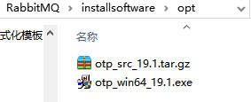

### 环境变量配置

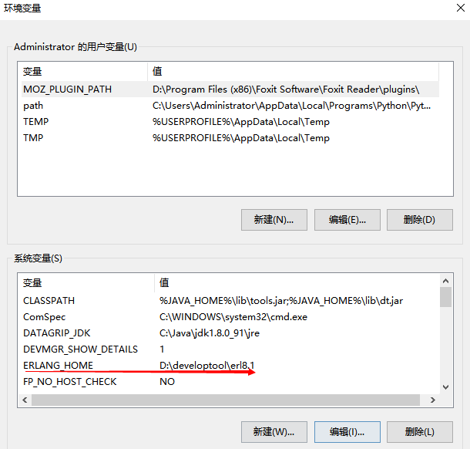

## RabbitMQ

### 安装

解压rabbitmq-server-windows-3.6.6.zip到适当目录下

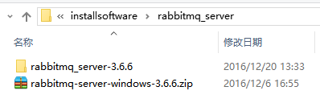

### 环境变量配置

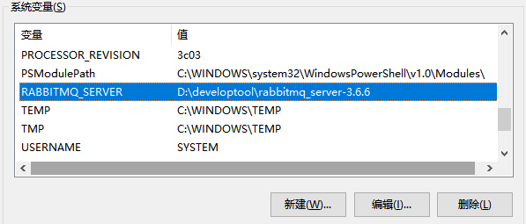

## 配置PATH

将RabbitMQ环境变量加入到PATH环境变量中

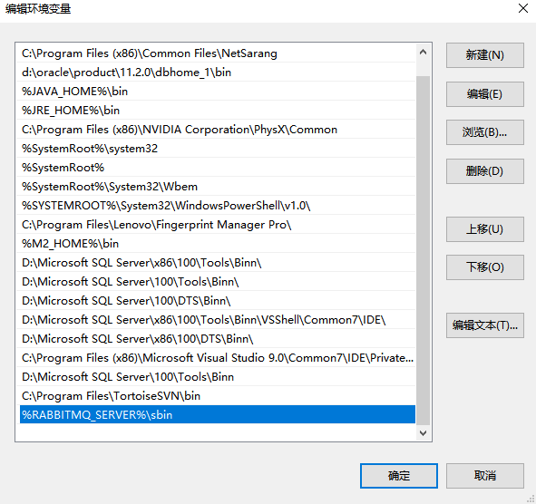

## 命令行脚本和应用数据

### 命令行

在%RABBITMQ_SERVER%\sbin目录中有一些脚本，通过它们运行命令来控制RabbitMQ服务器。

RabbitMQ服务器可以作为应用程序或服务运行。

* [**rabbitmq-server.bat**](http://www.rabbitmq.com/man/rabbitmq-server.1.man.html) starts the broker as an application.
* [**rabbitmq-service.bat**](http://www.rabbitmq.com/man/rabbitmq-service.man.html) manages the service and starts the broker.
* [**rabbitmqctl.bat**](http://www.rabbitmq.com/man/rabbitmqctl.1.man.html) manages a running broker.

Log in as an administrator. To see the output, run these from a [**Command Prompt**](http://windows.microsoft.com/en-GB/windows7/Command-Prompt-frequently-asked-questions)（命令提示符） in the sbin directory.

Note:On Windows Vista (and later) you will need to [**elevate privilege**](http://windows.microsoft.com/en-GB/windows7/Command-Prompt-frequently-asked-questions) (e.g. right-click on the icon to select Run as Administrator).

### 同步Erlang Cookie

当RabbitMQ以手动安装的windows服务方式运行时，需要同步Erlang Cookie。

Erlang Security Cookies used by the service account and the user running rabbitmqctl.bat must be synchronised for rabbitmqctl.bat to function.

(要正常运行 rabbitmqctl.bat，cookie需同步).

To ensure Erlang cookie files contain the same string, copy the .erlang.cookie file from the Windows directory (normallyC:\WINDOWS\.erlang.cookie) to replace the user .erlang.cookie. The user cookie will be in the user's home directory (%HOMEDRIVE%%HOMEPATH%), e.g.

C:\Documents and Settings\%USERNAME%\.erlang.cookie or C:\Users\%USERNAME%\.erlang.cookie(Windows Vista and later).

## 应用数据位置

默认，the RabbitMQ日志存放在

C:\Documents and Settings\%USERNAME%\Application Data or C:\Users\%USERNAME%\AppData\Roaming (Windows Vista and later).

在命令提示符窗口执行 echo %APPDATA% 可以找到该目录

## Running RabbitMQ Server as an Application

### 后台方式启动与关闭

启动 RabbitMQ Server(后台方式):

rabbitmq-server -detached

停止RabbitMQ应用，关闭节点

rabbitmqctl stop

### 非后台方式

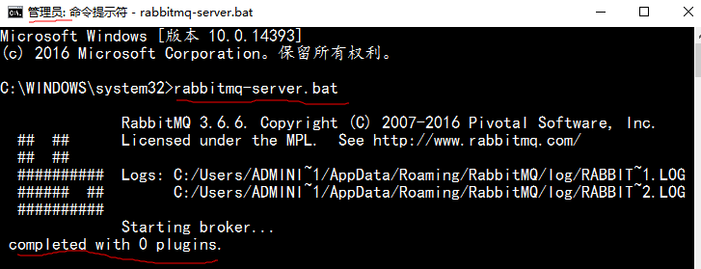

If you start by double-clicking, a Command Prompt window opens, displays a short banner message, concluding with the message "completed with [n] plugins.", indicating that the RabbitMQ broker has been started successfully.

(出现消息"completed with [n] plugins."，表示RabbitMQ启动成功).

If you started without the -detached option, e.g. by double-clicking, you will need a second Command Prompt window to control the application cleanly. *Note:* Closing the original Command Prompt window will forcefully shut down a server started this way.

(如果启动时以非后台方式，则需要新开一个命令提示符窗口进行其他应用操作，关闭启动窗口则关闭了rabbitmq服务)

## . Running RabbitMQ Server as a Service

这通常更适合于在生产环境使用。 RabbitMQ服务不应作为服务和应用程序同时运行。

Install the service by running

rabbitmq-service install

A service with the name defined by RABBITMQ_SERVICENAME should now appear in the Windows Services control panel (Start > Run services.msc).

安装RabbitMQ为windows服务如下图：

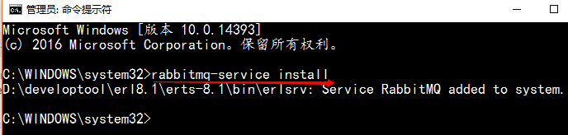

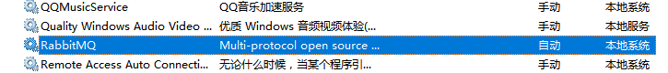

To start the broker, execute

rabbitmq-service start

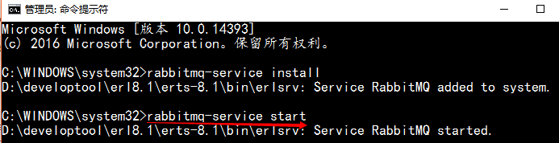

To manage the service (install, remove, start, stop, enable, disable), use [**rabbitmq-service.bat**](http://www.rabbitmq.com/man/rabbitmq-service.man.html)commands. You can also use the Windows Services panel (services.msc) to perform some of the same functions as the service script.

## Port Access(端口访问)

防火墙和其他安全工具可能会阻止RabbitMQ绑定到端口。

确保可以打开以下端口：

* 4369 (epmd)
* 5672, 5671 (AMQP 0-9-1 and 1.0 without and with TLS)
* 25672. This port used by Erlang distribution for inter-node and CLI tools communication and is allocated from a dynamic range (limited to a single port by default, computed as AMQP port + 20000).
* 15672 (if management plugin is enabled)
* 61613, 61614 (if STOMP is enabled)
* 1883, 8883 (if MQTT is enabled)

It is possible to [**configure RabbitMQ**](http://www.rabbitmq.com/configure.html) to use different ports.

## 默认用户访问

每一个RabbitMQ服务器都能创建虚拟消息服务器，我们称之为虚拟主机(vhost).

vhost之于Rabbit就像虚拟机之于物理服务器一样：它们通过在各个实例间提供逻辑上的分离。

vhost是AMQP的基础，你必须在连接时进行指定。由于RabbitMQ包含了开箱即用的默认vhost: “/”,因此使用起来非常简单。如果你不需要多个vhost的话，使用默认的即可。

缺省的guest用户名和密码guest就可以访问默认vhost.

See the documentation on [**access control**](http://www.rabbitmq.com/access-control.html) for information on how to create more users, delete the guestuser, or allow remote access to the guest user.

## 管理RabbitMQ

Stopping the Broker

Use rabbitmqctl stop.

Checking the Broker Status

Use rabbitmqctl status. All rabbitmqctl commands will report the node absence if no broker is running

当rabbitmq服务以application方式启动时，rabbitmqctl status可以正常执行。

## Logging

Output from the server is sent to a RABBITMQ_NODENAME.log file in the RABBITMQ_LOG_BASE directory. Additional log data is written to RABBITMQ_NODENAME-sasl.log.

The broker always appends to the log files, so a complete log history is retained.You can rotate logs using rabbitmqctl rotate_logs(轮流日志设定).

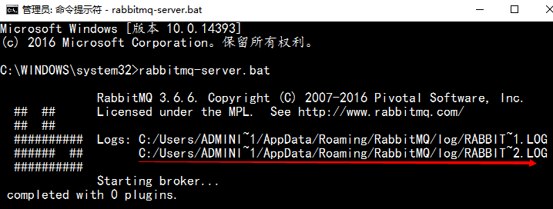

## RabbitMQ作为服务运行时的疑难解答

在Erlang VM崩溃，而RabbitMQ作为服务运行的情况下，erl_crash.dump文件被写入RabbitMQ服务器的基本目录中.

基本目录由RABBITMQ_BASE环境变量设置，默认为

％APPDATA ％\％RABBITMQ_SERVICENAME％ - 通常为％APPDATA％\ RabbitMQ .