similar to Buddhism and Hinduism when it comes to the types of deities they acknowledge.

They Sacrifice Animals!
Wiccans actually respect all living creatures, since the religion is based on nature. They do make offerings and sacrifices yes, but it’s usually inanimate objects such as fruit, flowers, and bread, and oftentimes they wish only good for animals. They aren’t allowed to make blood sacrifices, and it’s nonsense if stated otherwise.

They Have an Evil Bible
They don’t even have a bible. Some Wiccans might make a “Book of Shadows” which is used as a generalized spell book or compilation of spells, but that’s literally it. It’s a reference book, just like any old textbook.
Some Wiccans call it a grimoire, magical diary, or a book of spells, and really, it’s just an informational text, and it does have some myths, spells, various rituals and ceremonies, prayers and affirmations, as well as the herbs and lore behind them, or even personal records they find.
It’s not an evil bible. It’s a reference book. It’s not made to hurt others, it’s just there so they don’t have to write down twenty times to use a certain crystal when working on a practice.

It’s just a Weird Cult!
Nope. There are obviously “weird” Wiccans just like every other religion, but for the most part, it’s incredibly individualized and personal to yourself.

Again, some people can practice in covens if they want, but oftentimes it’s easier to practice alone, which is totally fine.

Wicca is a legitimate religion and an interesting practice, and you learned here a little bit about it, along with the truth of Wicca, and what it really entails.
Chapter 2: A history of Wicca
Wicca actually has a rich history that’s worth learning about. Here, I’ll take you through the historical aspects of Wicca, and why they matter. Wiccan history isn’t as old as you may think it is, although it does have ties to ancient practices, and we’ll highlight as well some of those beliefs, and the importance of them.
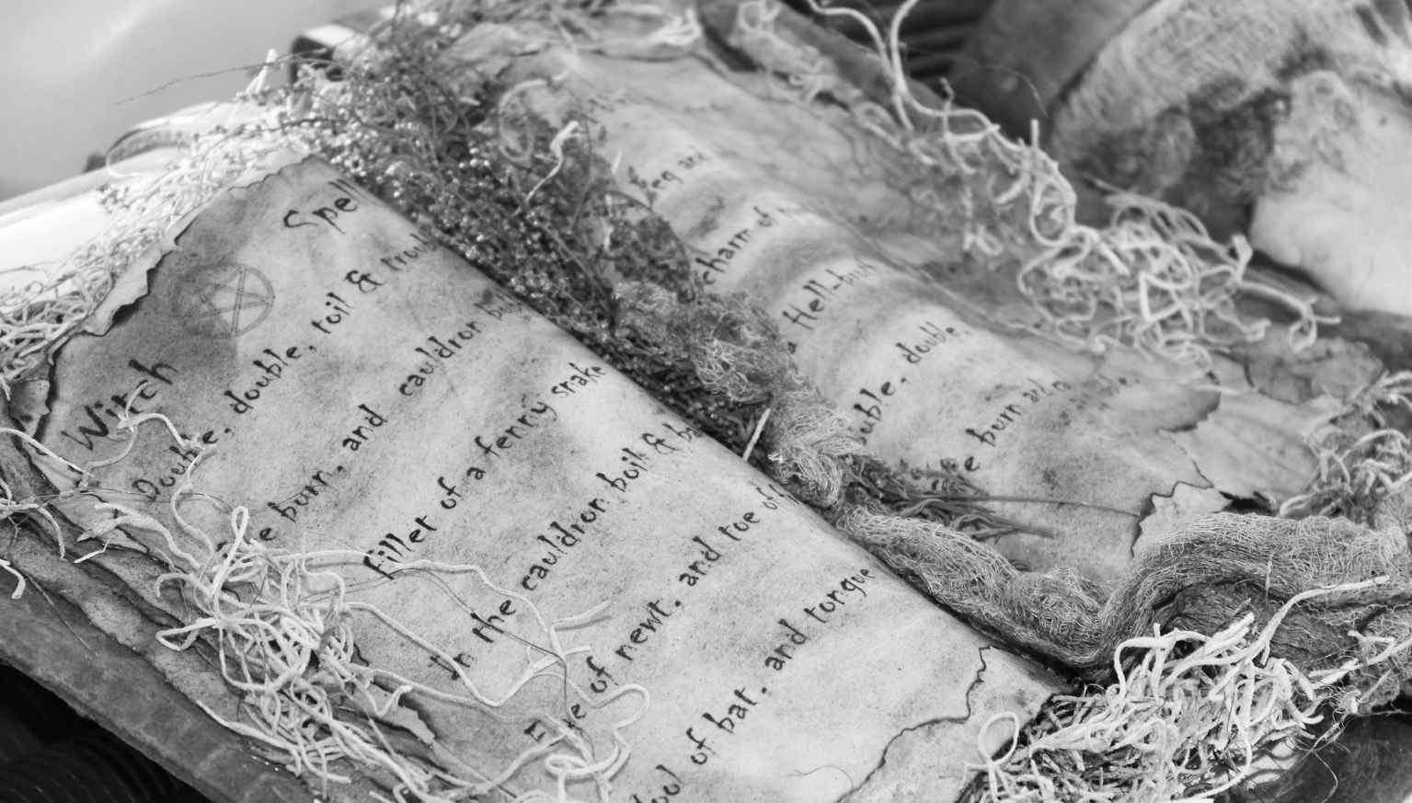

The origination of Wicca
As we’ve said, it’s not an old religion. It’s actually very new. Like less than a century old.
The origins of it were dated all the way back to 1954, which was when it was originally developed. It came forth in England during then, and Gerald
Gardner was the first to bring it forth, talking about the diversity of it, and how it has many different ritualized practices.
There were a couple of other prevent Wiccans at the time, such as Gardner and Doreen Valiente, who both published works on these teachings and arts of the practice. However, the core structured was varied immensely, and it grew over time, and there are many different denominations and sects of it.
The type of Wicca that was practiced initially was called British Traditional Wicca, which followed the initiation elements of Gardner, and it is usually just the application of the older traditions.
So, there is an old-form of Wiccan tradition, which was the type of beliefs that were purported originally.
However, old Wiccans didn’t call it Wicca at all, but it had similar practices. It was later during the 1960s that the name originally came about.
Some do believe it was the hidden lore that was passed during the Dark Ages when the pagans were persecuted, only to come about during modern times, which may be a theory, but it only takes from that in a very generalized sense.
The influences of Wicca are older however, so there is the argument there that Wicca was one of the old religions.

But Who was Gerald Gardner?
He was a man who was originally a civil servant who became interested in folklore, anthropology, the occult, and spiritualism. He was a part of the Rosicrucians who were around in the 1930s. He met some friends at that point, and it was revealed that they were a group of witches. And from there, he was initiated in 1939 to them.
He did travel a lot, and while ancient paganism was stamped out due to Christianity, it was still practiced in secret groups, and they were called a “witch cult,” which asserted that those who were surviving were actually part of these covens. Gardner met with these people, and he was convinced they were part of a pre-Christian religion, and he wanted to make sure this
survived well into the 20th century, hence how this was born.
Gardner founded his own little coven called Bricket Wood, and he drew inspiration from the previous covens he had heard about. He teamed up with Allister Crowley and Cecil Williamson, and from there, the core values of Wiccan were born, such as the worship of a god and goddess in your own way. But of course, they didn’t really adopt the name Wicca until almost a decade later, when it spread.
There were other important figures who came about with this, including other occultists. Some do believe Gardner revived it, but there were others who played a key role in the revival of it, such as Margaret Murray, who wrote many books on it, and was a first-wave feminist who wrote about this religion all the way back in 1921.
But, with the rise of feminism in the 1970s, Wicca grew in power, and we’ll dive into how this plays a part in modern society today.

Wicca and Feminism
Feminism did play a part in Wicca becoming popular, especially during the 1970s, and this was due to women who were attracted to this, because of the female deity, but oftentimes were limited because of restrictions women had in other patriarchal religions. Wicca also became more magic-based, especially since it was a spiritual movement. Wicca still has heavy

