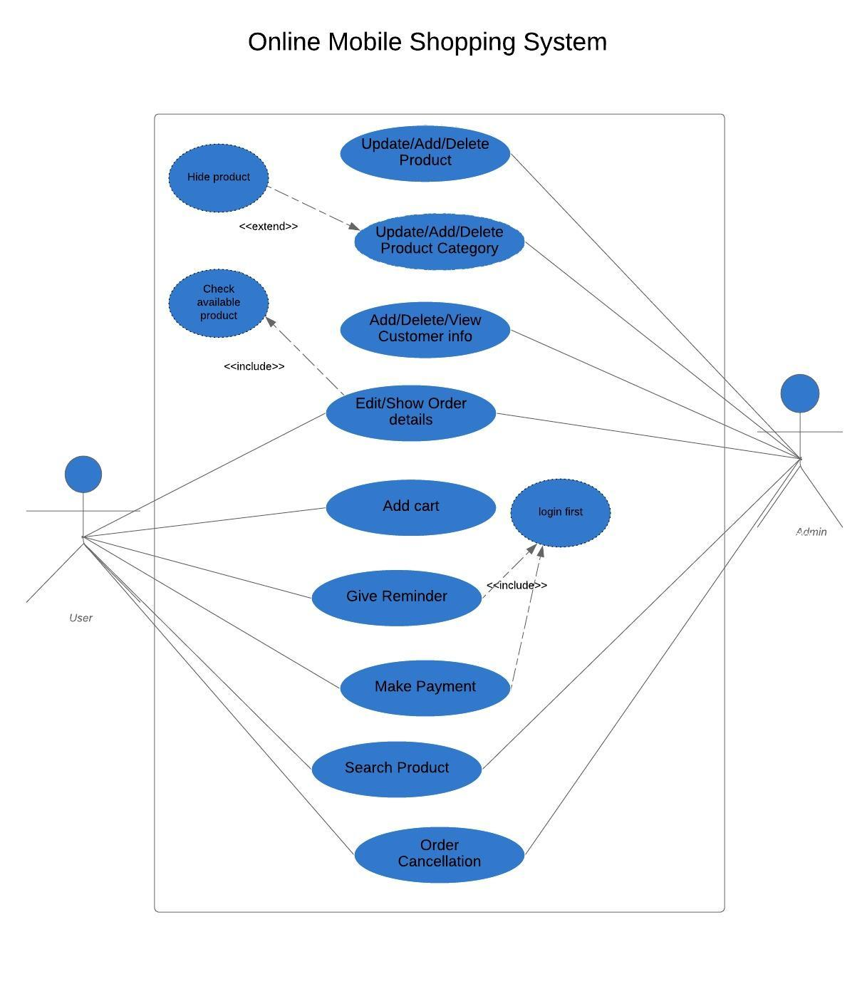

Figure: Use case diagram

USE CASE DEATAILS:

1 Use Case title: Update/Add/Delete Product

Actor: Admin

Scenario: User needs to see available product (mobile) in the web application, so we have to implement proper Update/Add/Delete information into our website for particular products.

Pre-Condition: There should be an authenticate admin login into the system, otherwise product Update/Add/Delete can’t implement, other users can’t perform in product update.

Post- Condition: After authenticate admin login, admin can Update/Add/Delete the data, maybe add product price, add discount and so on.

Exception: Mainly this use case is used to implement the available update which is needed for another user interface in our particular web application.

2 Use Case title: Update/Add/Delete Product Category

Actor: Admin

Scenario: User needs to see the available product in our web application. User can see photos of the product and can check the company level and the packaging.

Pre-Condition: There should be an authenticate admin login into the system, they will provide all available product.

Post- Condition: After authenticate admin login, admin will able to Update/Add/Delete product photos, specifications, prices and other information

Exception: We expect a nice user view for our available products, so our users can view all the available information and can comparative between different products, which helps him/her to find the best product with particular price and specifications.

3. Use Case title: Add/Delete/View Customer info

Actor: Admin

Scenario: Admins have to collect and arrange the information about all customers

Pre-Condition: There should be an authenticate admin login into the system, also included proper user registrations.

Post- Condition: After authenticate admin login, admin will able to see the information about users like: name, address, selected products, contact information etc.

Exception: For a proper online shopping, user have to aware about their customer’s information as that will helpful for shipping procedure or contact with the customers properly.

4 Use Case title: Edit/Show Order details

Actor: Admin, User

Scenario: Admin want to check the user’s order selected product, model, quantity for shipping and other processes.

Pre-Condition: There should be an authenticate admin login into the system.

Post- Condition: After authenticate admin login, admin will able to see the information about the user’s order info like product model, product price, product’s offer and quantity.

Exception: It gives a clear view for particular customers’ ordering, that will enable the shipping and other procedure properly. User can distribute the ordering data properly.

5 Use Case title: Add cart

Actor: User

Scenario: Users want to add product, so that they can buy product.

Pre-Condition: There should be an authenticate user login with proper user name and password into the system.

Post- Condition: After authenticate user login, user can see specification, prices, delivery fee, VAT about the products and can select them for buying, also apply promo code if available, can select quantity.

Exception: This is nothing but giving user a proper interface for completing his/her online order to place.

6. Use Case title: Give Reminder

Actor: User

Scenario: Users get the reminder about the product delivery via email, SMS or phone call.

Pre-Condition: There should be a user order into the online shopping, the reminder should be particular for separate products. There maybe many orders, the reminder will be done according by the order times.

Post- Condition: By reminder, user will get a SMS or email or a phone call from the delivery boy.

Exception: This will ensure the customer about his/her particular product’s delivery information properly.

7. Use Case title: Order Cancellation

Actor: User , admin

Scenario: Sometimes user want to cancel his/her order for unavailable circumstance.

Pre-Condition: Authentication login with proper info (user name, password) and there should be placed order(s).

Post- Condition: After login, by selecting certain placed order, one customer can cancel his/ her orders easily.

Exception: That will give customers to make a perfect shopping

8. Use Case title: Search Product

Actor: User , admin

Scenario: User want to search a particular product according to his/her own choice

Pre-Condition: Authentication login with proper info (user name, password) by user.

Post- Condition: After login, our customers can search products by name, by brand name, by price, by category or by QR code ( if available ).

Exception: This searching option will more flexible for our customer to find his/her desire product with particular specifications and prizes. They can view all the available products into our website.

9. Use Case title: Make Payment

Actor: User

Scenario: After getting the delivery, user have to pay for the product.

Pre-Condition: User places a product, get the product by the delivery boy.

Post- Condition: After getting the product user have to pay. The payment maybe cash in delivery or maybe by the master card; also, it maybe done by bkash, rocket or other party.

Exception: This will be the final part of the e-commerce shopping by making the payment by the customers and implementation of payment status by the delivery boy properly.