Volunteer Management System Project
Software Design Specification
Version 1.4

Team Quartz

Aaron Bourne, Owen Burnett, and Travis McMichael

Revisions
Version | Primary Author(s) | Description of Version | Date Completed
1.0 | Owen Burnett | Assigned sections of this document to group members and added project specific notes | 11-01-2012
1.1 | Owen Burnett | Starting Work on sections 1.1, 1.2, 1.3, 3.2.1, 7 | 11-03-2012
1.2 | Owen Burnett | Worked on sections 1.1, 1.3, 3.1, and 4.2 | 11-11-2012
1.3 | Travis McMichael | Started work on 3.2.4, 3.2.5, and 6.1. Finished 6.1 and 6.2. | 11-17-2012
1.4 | Owen Burnett | Working on sections 1, 2.1, 3.1, 3.2.2, 3.2.7, 4.1, 5, 7, and 8. Checking for completeness and correctness. | 11-20-2012
Contents
1 Introduction 1
1.1 System Overview 1
1.2 Supporting Materials 1
1.3 Definitions and Acronyms 1
2 Design Considerations 2
2.1 Assumptions 2
2.2 Constraints 2
2.3 Goals and Guidelines 2
2.4 System Environment 2
2.5 Development Environment 2
3 Architecture 3
3.1 Overview 3
3.2 Strategies 3
3.2.1 Standards 3
3.2.2 Technical Environment 3
3.2.3 System Integration 3
3.2.4 Maintainability 3
3.2.5 Performance
3.2.6 Software Specification
3.2.7 Hardware Specification
4 High Level Design 4
4.1 Hierarchy Chart Of Components 4
4.2 Sequence Diagrams And Descriptions 4
5 Low Level Design 5
5.1 Component C1 5
5.1.1 Class D1 Of Component C1 5
5.2 Component C2 5
6 User Interface Design 6
6.1 User Interface Design Overview 6
6.2 User Interface Navigation Hierarchy 6
7 Requirements Traceability Matrix 7
8 Appendices 8

Introduction
The purpose of this document is to provide readers with an overview of the Volunteer Management System, design consideration information, a description of the system architecture, an understanding of the high level and low level design of the system, a description of the user interface design, and a reference to information on the requirements traceability of the system.
Section 1 of this document “Introduction” provides an overview of the system, references to other system related documents, and definitions of design related terms and acronyms. Section 2 “Design Considerations” contains information on the design assumptions and constraints, as well as a description of the design goals. Section 3 “Architecture” helps readers to understand the system architecture, including the standards, technical environment, system integration, maintainability, performance, software specification, and hardware specification.
Section 4 “High Level Design” provides information about the responsibilities of the system, a description of the subsystem decomposition, subsystem responsibilities and interactions, a description of the interaction behavior between classes for each use case, and references to the sequence diagrams which illustrate this behavior. Section 5 “Low Level Design” contains information on how the subsystems were further divided into subcomponents, relationships and interactions between the subcomponents, class diagrams depicting the set of classes for each subsystem with a description of the class hierarchy for each subsystem, and class diagrams for each class of each subsystem with a description of relevant characteristics of the classes.
Section 6 “User Interface Design” contains a high level description of the user interface, systems requirements associated with each of the user interfaces, and a description and diagram of the navigation hierarchy. Section 7 “Requirements Traceability Matrix” contains a reference to the location of the requirements traceability matrix that indicates traceability from the software requirements document to the design elements documented.
The intended audience of this document includes the project manager, the system architects, and the developers who design and implement each subsystem.

System Overview
The Volunteer Management System software product is a web-based multi-tier system that was designed to assist with managing events for which volunteers are needed and to help interested persons become volunteers by allowing them to register for events they want to participate in.
The following general functionality is provided by the system: user registration, user account deletion, user authentication, the editing of user information, event registration, event participation cancellation, the posting of events, event cancellation, volunteer assignment by stakeholders, event information modification, the pairing of volunteers with events, the sending of volunteer position assignment notifications to volunteers, volunteer participation confirmation, the sending of event reminders to volunteers and stakeholders, the removing of inactive volunteers from the list of volunteers eligible for new event notifications, and functionality to allow volunteers to request a different volunteer position at an event.
The Volunteer Management System was decomposed into a hierarchy of subsystems. The hierarchy contains a set of layers ordered by the number of dependencies on other subsystems. The subsystem decomposition was performed ensuring minimal coupling between subsystems and the highest level of cohesion possible between the classes within each subsystem. Each subsystem identified in the original subsystem decomposition was further decomposed until each subsystem had a level of complexity that was low enough to be dealt with by only one developer during the implementation phase.
Design patterns were used to resolve frequently occurring problems, to increase the extensibility and flexibility of the system design and implementation, to form larger structures from objects, to give attention to the responsibilities which objects are assigned and algorithms, and to encapsulate complex object creation. Structural, behavioral, and creational design patterns were used in the detailed design of the system including the façade, proxy, observer, bridge, strategy, abstract factory, command, builder, composite, and template design patterns. These design patterns are demonstrated in the object design class diagrams shown in section 5 “Low Level Design”.

1.2 Supporting Materials
Refer to “TeamQuartz.doc” for information about the Volunteer Management System functional requirements and nonfunctional requirements. See “TeamQuartzCodingConvention.docx” for information about the following items related to the implementation of the system: file names, file organization, comments, declarations, statements, white space, naming conventions, and programming practices.

1.3 Definitions and Acronyms
Term | Description
application server | Coordinates the request flow between sources of messages and applications which run transactions for each request received.
behavioral design pattern | A design pattern which focuses on which objects have which responsibilities and algorithms.
CASE tool | Computer Aided Software Engineering tool - a tool used to design and automatically generate code for a system.
client | Subsystem instance which interacts with a system user.
component | An interface compliant replaceable part of the system.
creational design pattern | A design pattern which focuses on the encapsulation of complex object creation.
database | A grouping of related data.
database server | A program which provides database storage and retrieval services to other programs or clients.
end user | A role assumed by individuals who will perform tasks using the system after it is delivered.
event | Activity in which people participate to help others or achieve a goal.
hardware | Electronic computerized equipment which enables the software of the system to run.
layer | A collection of subsystems which supply interconnected services.
multi-tier architecture | A type of software architecture which includes a client, web server, application server, and database server.
PHP | PHP: Hypertext Preprocessor - an open source scripting language allowing for dynamically generated Web pages to be written in a short span of time. The code generated by this scripting language can be embedded in HTML pages with minimal difficulty.
request | Message defining a task for the system to execute.
software architecture | A group of items needed to understand and make decisions based on the system. This group includes the way in which boundary conditions are dealt with, the ways by which subsystems communicate, global control flow, and the decomposition of the system.
stakeholder | End user role representing people who interact with the system to manage events.
structural design pattern | A design pattern which focuses on producing larger structures from objects, supplying extensibility and flexibility, and the realization of new functionality through old functionality.
subsystem | A software component that supplies services that other subsystems need and that is well-defined.
system | A group of components, models, and elements which communicate and are designed to accomplish a common goal.
user interface | The parts of the system that users interact with.
volunteer | End user role representing people who interact with the system to register for events.
web browser | Software used to download and display the Web pages of the Web site.
web server | Program executing on a Web site that handles requests made by end users using Web browsers.

Design Considerations

Assumptions
We assume that Apache technology can be used to best facilitate the application logic of the system.
We assume that stakeholders and volunteers are the only two types of users that the system must support. Other user types may need to be added in the future. It is possible that the system may allow stakeholders to assign registered volunteers to various volunteer positions based on the skills possessed by the volunteers.

Constraints
Users must have both a username and password. The Web, application, and database servers will be limited by the processing and memory capacity of the laptop the system is deployed on. The system must be compatible with major browsers used by end users, such as Internet Explorer, Mozilla Firefox, and Google Chrome.

Goals and Guidelines
Priorities:
- Speed, ease of use, and stability.
Speed: Speed is important in this system in that if the system responds and works quickly then it will be used more frequently than a system that works slowly.
Ease of use: This feature is important due to the fact that the easier the system is to use then the more a user will want to use the system. If the system was hard to use then a user may not be inclined to utilize that system.
Stability: A stable system is vital for the same reason as the ease of use priority. The system needs to be up and running in order for it to actually be used so a stable system is a good system.
- System should be extensible and modifiable. We can keep the system up to date without having to re-write code.
- System should be portable. The system should be implemented using a universal style, not a system specific style.
- Readability - Code should be well written. Some basic guidelines would be the standards set forth in relation to class names, indentation, and other principal guidelines of code writing.
- Utility - Testing should be thorough and as complete as possible. Testing typically occurs during implementation, but the system can be designed so that testing is easier.
- Usability - Make easy to use, keep simple, make sure it works.
- Response time - Efficient error checking. May want to mention efficient database queries. Explain how this effects throughput of system.
- Availability - Available at all times, or as close to at all times given a certain maintenance schedule can be reached.
- Security - Protect from unauthorized access. Send and receive messages in a secure way.

Architecture

Overview
The application software will run on a laptop computer. The web, application, and database logical servers will all three run on the laptop computer. The server must be connected to the Internet so that clients can access it and use its services. The system will be accessed by client desktop and laptop computers.
The application software will include the volunteer interface subsystem, stakeholder interface subsystem, database subsystem, storage subsystem, notification subsystem, event management subsystem, event registration subsystem, user management subsystem, and volunteer matcher subsystem.
The storage subsystem was created to prevent the need for changes to all subsystems which use services of the database subsystem, whenever the database subsystem interface changes. This reduces the coupling between the database subsystem and all subsystems which need to store information in the database, retrieve information from the database, or run a query on the database. Changes will need to be made only in the storage subsystem when the interface of the database subsystem changes.
The functionality that allows users to send messages to other users will be built in to the system as opposed to using an external e-mail system for this purpose. This will help keep the response time of the system low as the system will not have to communicate with an external e-mail system. This will eliminate the need for modifications in the design and implementation that are necessary when changing external e-mail systems. This eliminates the dependency of the system on an external e-mail system.
The system will be based on the model/view/controller and client/server architectural styles.
The client/server architectural style will be realized when some subsystems act as clients and some act as servers as the system is used to perform different functions. For example, when a volunteer is registering for an event using the system and they click the submit button after all of their information is entered the volunteer interface subsystem acts as a client which interacts with the user. This subsystem issues a request for the StoreInfoService service to the storage subsystem. The storage subsystem has no knowledge of the volunteer interface client subsystem. The storage subsystem issues transactions on the database to store the information entered on the event registration form by the volunteer.
The model/view/controller architectural style will be realized by the system any time a user issues a command using a controller subsystem that calls for a change in the information stored by the system. When this happens, the storage subsystem which manages the database subsystem will issue transactions on the database. The central data structure, which is the database, is maintained by the database subsystem. The database subsystem is a model subsystem. The database subsystem will run the transaction issued by the storage subsystem and will notify the view subsystems after the transaction has completed. The view subsystems that have subscribed to receive notifications from the database will modify the view displayed to the users. The view subsystems are the volunteer interface subsystem and the stakeholder interface subsystem.

Strategies

Standards
Unified Modeling Language (UML) - All system design diagrams will adhere to the unified modeling language standards. UML is used to represent models using a standard set of notations.

Technical Environment
A multi-tier system architecture must be employed as per the business requirements. The system must be implemented with Web technology. PHP will be used to serve requests. The system must have a client, Web server, application server, and database server.
MySQL will be used to build and maintain the database. The database will store persistent information, such as user and event information.
The system code consistency will be maintained with Microsoft Visual Sourcesafe 2005, a version control system. Unit tests and integration tests will be performed with the JUnit software testing tool. JUnit will be used throughout implementation and formal testing. Rational Rose will be used to generate skeleton code during implementation. Various IDEs such as NetBeans and Eclipse which support the Java programming language may be used to complete the system code.
One physical server will be needed to host the Web server, application server, and database server. Apache technology will be used to provide the HTML pages of the website and to execute the application logic using PHP pages.
We do not know at this time how many users the system will have or how many of those users will use the system simultaneously. The system hardware can be scaled after the system is deployed depending on the number of total users within a given time period and the average number of simultaneous users.

System Integration
The system we’re creating doesn’t need to be integrated with other systems, as it will be a stand-alone program. Thus, the priority for system integration is a low one so it will be not be focused on, initially.

Maintainability
There are no foreseen business changes that would change the core function of the system. Depending on customer response and number of users, the system could be updated to allow for much greater customization of the abilities in the volunteer profiles, which would allow for greater customization of the skills needed for events and the event search function.

Performance
The system is designed to be simple and fast. It keeps the minimal amount of data on each user and each event needed to perform the functions required. Keeping this in mind, the system should respond to the user within 1 second of receiving user input and should be operational and error-free 99% of the time.

Software Specification
The OS we will develop on will be Windows as it is the common factor within the group and can be utilized on campus via the CS computer lab. The latest stable version of PHP and SQL will be used so that we can ensure our system is up-to-date and meets today’s standards. This will help us to update the system as well in that the worry of new features or different methods won’t work because there shouldn’t be drastic changes between versions of this software. The latest JDK will be utilized if we do utilize it (JDK 7).

Hardware Specification
Clients used to access the system include PCs and laptops. The system will not support handheld devices. Clients should be equipped with a mouse or touchpad. Clients must have a keyboard to provide the system with textual and numerical data.
A laptop computer will be used to run the Web server, application server, and database server. Clients utilize the Internet to connect to the system.

High Level Design
The system was originally decomposed into subsystems using the functional requirements. Four main groups of subsystems were identified from the functional requirements: subsystems for the storage of persistent data, subsystems related to the management of notifications, subsystems for handling user interactions, and subsystems for the management of users and events. Included in the storage management group are the database and storage subsystems. The notification management group only contains one subsystem, the notification subsystem. The group for managing events and users contains the event management, event registration, user management, and volunteer matcher subsystems. The group for handling user interaction includes the volunteer interface subsystem and the stakeholder interface subsystem.
The storage subsystem was created to prevent changes to all subsystems which need to use services of the database subsystem when the database subsystem interface changes. This reduces the coupling between the database subsystem and all subsystems which need to store information in the database, retrieve information from the database, or run a query on the database. Changes will need to be made only in the storage subsystem when the interface of the database subsystem changes.
The notification subsystem provides services for allowing users to send notifications to other users. It also provides services for sending automatic notifications as a result of user interactions and the passage of time. The event management subsystem uses the notification subsystem to send reminders and participation confirmation requests to volunteers.
Within the group for managing events and users there must be subsystems which allow stakeholders to manage events; allow volunteers to register for events and cancel their participation in events; allow for the authentication and authorization of users, as well as user account management; and provide a way of pairing volunteers and events.
The volunteer and stakeholder interface subsystems were created for the purpose of handling user interactions.

Hierarchy Chart Of Components
The below hierarchy chart of components groups each component (subsystem) into a layer. The layer at the top of the chart contains the subsystems which use the services of the layers below, but which provide no services to components of the layers below. The layer at the bottom of the chart contains the subsystems which provide services used by the layers above, but which use none of the services provided by the layers above. This chart depicts an open architecture where each layer can use the services provided by any of the lower layers.
Each subsystem must ultimately use the services of the database subsystem to store data in the database, retrieve data from the database, and query the database. The storage subsystem uses the services of the database subsystem and acts as an interface for all other subsystems to the database subsystem. Each subsystem at layers four through seven use the services provided by the notification subsystem.
When a user attempts to log in to the system either the volunteer interface subsystem or the stakeholder interface subsystem uses the authentication service provided by the user management subsystem. As a user attempts to access and modify data either the volunteer interface subsystem or the stakeholder interface subsystem uses the authorization service of the user management subsystem, which allows or denies the access or modification. When a volunteer registers for an event, the volunteer interface subsystem uses the event registration subsystem to complete the registration.
The system could have been designed using a closed architecture in which each layer uses only the services provided by the layer immediately below it. The designers of this system decided a closed system architecture would prevent certain subsystems from accessing the services they depend on to provide services to other subsystems. For example, if the event management subsystem could only use the services provided by the user management subsystem it would not be able to use the services of the notification subsystem as well. The event management subsystem must be able to use the AutoNotify service of the notification subsystem to send notifications to volunteers on a volunteer registration list when an event is cancelled.

Database Subsystem
Storage Subsystem
Notification Subsystem
User Management Subsystem
Layer 7 (Bottom)
Layer 6
Layer 4
Event Management Subsystem
Layer 3
Event Registration Subsystem
Volunteer Matcher Subsystem
Volunteer Interface
Stakeholder Interface
Layer 1 (Top)
Layer 2
Layer 5

4.2 Sequence Diagrams And Descriptions
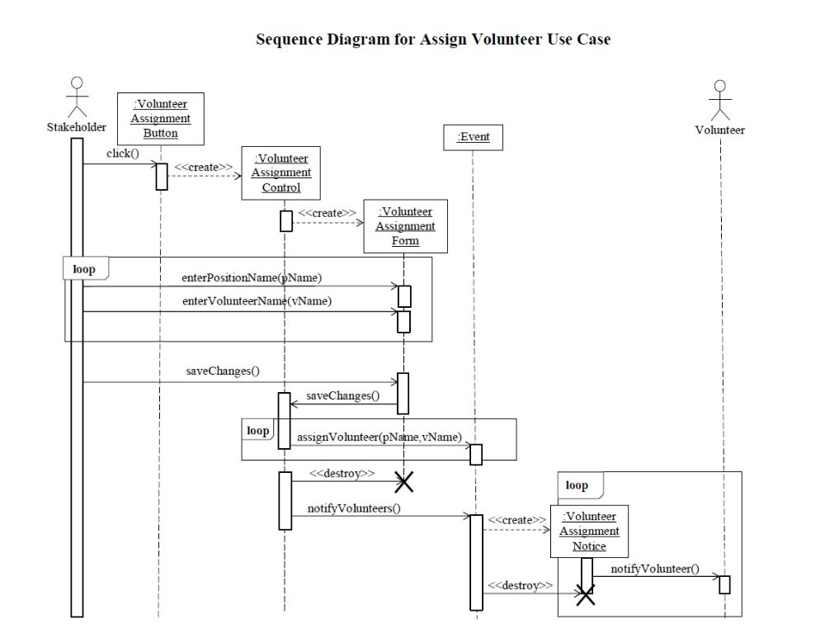
One sequence diagram for each use case of the system appears below. Each sequence diagram is followed by a description of the interaction behavior between the classes of the system involved in the use case.

Assign Volunteer Use Case:
- The Stakeholder class invokes the click operation of the VolunteerAssignmentButton class.
- The click operation of the VolunteerAssignmentButton class calls the constructor of the VolutneerAssignmentControl class.
- The VolunteerAssignmentControl class calls the constructor of the VolunteerAssignmentForm class.
- The Stakeholder class invokes the enterPositionName and enterVolunteerName operations of the VolunteerAssignmentForm class once for each volunteer the stakeholder wants to assign to a specific volunteer position.
- The Stakeholder class invokes the saveChanges operation of the VolunteerAssignmentForm class once the stakeholder is done assigning volunteers to positions. This causes the VolunteerAssignmentForm class to invoke the saveChanges operation of the VolunteerAssignmentControl class.
- The VolunteerAssignmentControl class invokes the assignVolunteer operation of the Event class using the position name and volunteer name as parameters.
- The VolunteerAssignmentControl class calls the destructor of the VolunteerAssignmentForm class.
- The VolunteerAssignmentControl class calls the notifyVolunteers operation of the Event class, which in turn calls the constructor of the VolunteerAssignentNotice class.
- The VolunteerAssignmentNotice class invokes the notifyVolunteer operation of the Volunteer class, once for each Volunteer object having a volunteer name attribute value that was specified as a parameter in the enterVolunteerName operation invocations.
- The Event class calls the destructor of the VolutneerAssignmentNotice class.

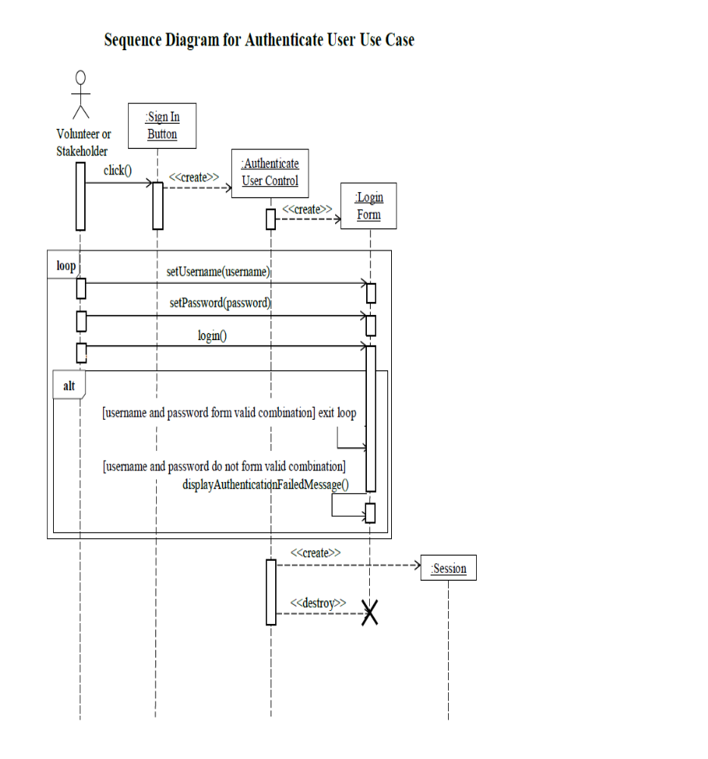

Authenticate User Use Case:
- Either the Volunteer class or the Stakeholder class invokes the click operation on the SignInButton class depending on whether a volunteer or stakeholder user initiates the use case.
- The SignInButton class calls the constructor of the AuthenticateUseControl class, which calls the constructor of the LoginForm class.
- The Volunteer or Stakeholder class invokes the setUsername operation of the LoginForm class with the username entered by the user passed as an argument.
- The Volunteer or Stakeholder class invokes the setPassword operation of the LoginForm class passing the password entered by the user as an argument.
- The Volunteer or Stakeholder class invokes the login operation of the LoginForm class.
- If the username and password entered by the user form a valid combination then the above steps are not repeated. If they do not form a valid combination the LoginForm class invokes the displayAuthenticationFailedMessage operation of the LoginForm class and the above steps are repeated.
- The AuthenticateUserControl class calls the constructor of the Session class and then calls the destructor of the LoginForm class.

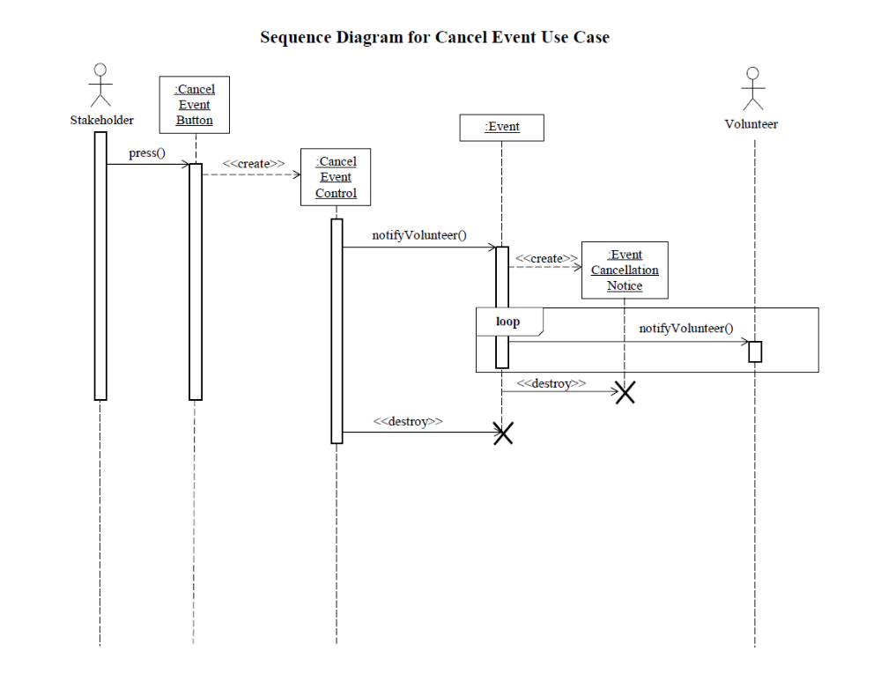

Cancel Event Use Case:
- The Stakeholder class invokes the press operation of the CancelEventButton class.
- The CancelEventButton class invokes the constructor of the CancelEventControl class.
- The CancelEventCotnrol class invokes the notifyvolunteer operation of the Event class.
- The Event class invokes the constructor of the EventCancellationNotice class.
- The Event class invokes the notifyVolunteer operation of the Volunteer class once for each Volunteer object associated with the Event object for the event that is being cancelled.
- The Event class calls the destructor of the EventCancellationNotice class.
- The CancelEventControl class calls the destructor fo the Event class.
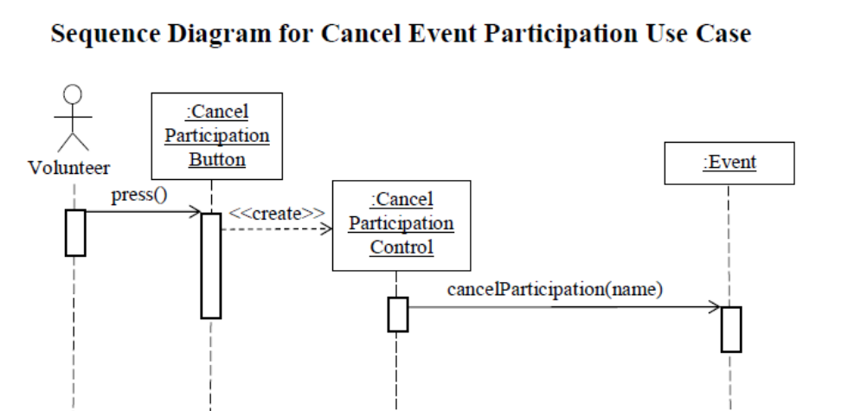

Cancel Event Participation Use Case:
- The Volunteer class invokes the press operation of the CancelParticipationButton class.
- The CancelParticipationButton class invokes the constructor fo the CancelparticipationControl.
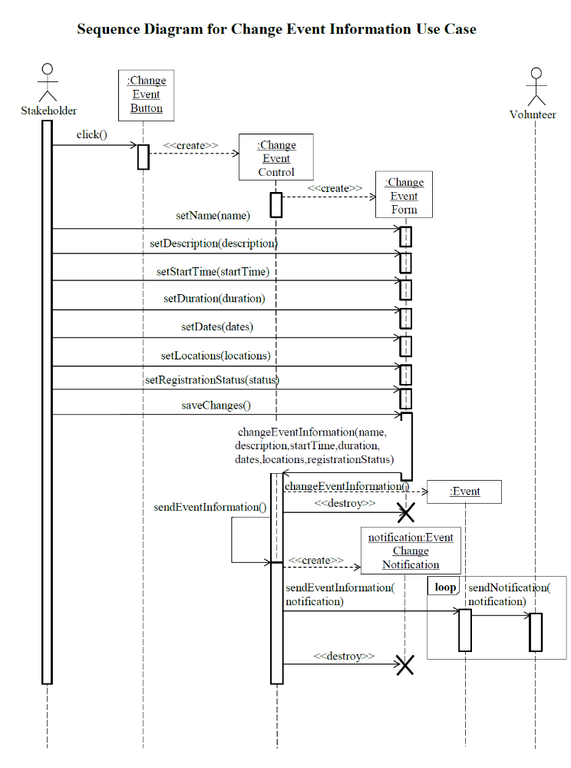
- The CancelParticpationCotnrol class invokes the cancelParticipation operation of the Event class passing the name of the Volunteer whose event participation is being cancelled as an argument.
Change Event Information Use Case:
- The Stakeholder class invokes the click operation of the ChangeEventButton class.
- The ChangeEventButton class invokes the constructor of the ChangeEventControl class.
- The ChangeEventControl class invokes the constructor fo the ChangEventForm class.
- The Stakeholder class invokes some or all of the following operations of the ChangeEventForm class depending on which information the stakeholder wants to change: the setName operation with the new name of the event as an argument, the setDescription operation with the new description of the event as an argument, the setStartTime operation with the new start time as an argument, the setDuration operation with the new duration as an argument, the setDates operation with the new dates for the event as an argument, the setLocations operation with the new event locations as an argument, and the setRegistrationStatus operation with the new registration status as an argument (either open for registration or view only).
- When the stakeholder is done changing the event information the Stakeholder class invokes the saveChanges operation of the ChangeEventForm class.
- The ChangeEventForm class invokes the changeEventInformation operation with the arguments passed in step 4 (or with some values set before the initiation of this use case) of the ChangeEventControl class.
- The ChangeEventControl class invokes the changeEventInformation operation of the Event class.
- The ChangeEventControl invokes the destructor of the ChangeEventForm class.
- The ChangeEventControl class invokes the sendEventInformation operation of its own class.
- The ChangeEventControl class invokes the constructor of the EventChangeNotification class.
- The ChangeEventControl class invokes the sendEventInformation operation of the Event class passing the notification object created in step 10 as an argument.
- The Event class invokes the sendNotification operation with the notification object created in step 10 as an argument once for each Volunteer object associated with the Event.
- The ChangeEventControl class invokes the destructor of the ChangeEventForm class.
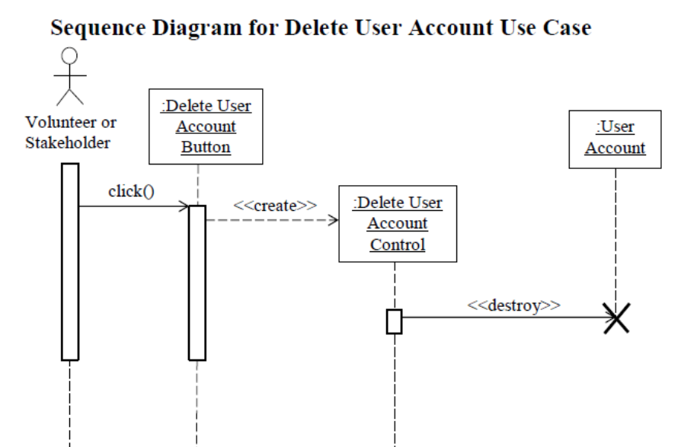

Delete User Account Use Case:
- Either the Volunteer or Stakeholder class invokes the click operation of the DeleteUserAccountButton class, depending on whether a volunteer or stakeholder user initiated the use case.
- The DeleteUserAccountButton class invokes the constructor of the DeleteUserAccountControl class.
- The DeleteUserAccountControl class invokes the destructor of the UserAccount object which has the username of the user initiating the use case as the value of the username attribute.

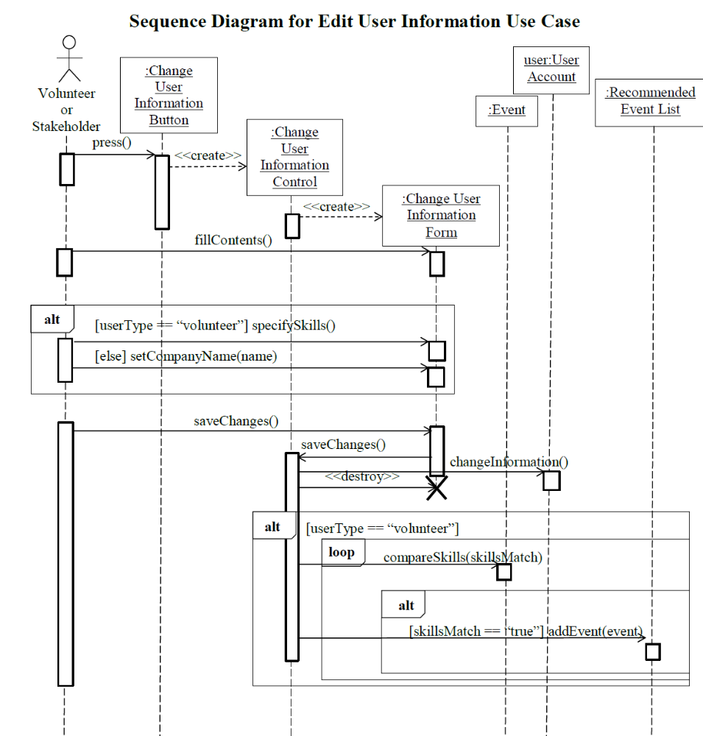

Edit User Information Use Case:
- Either the Volunteer or Stakeholder class invokes the press operation of the ChangeUserInformationButton class, depending on whether a volunteer or stakeholder user initiates the use case.
- The ChangeUserInformationButton class inokes the constructor of the ChangeUserInformationControl class.
- The ChangeUserInformationControl class invokes the constructor fo the the ChangeUserInformationForm class
- The Volunteer or Stakeholder class invokes the fillContents operation of the ChangeUserInformationForm class.
- If the user who initiated the use case is a volunteer and if they choose to provide a list of their skills, the Volunteer class invokes the specifySkills operation of the ChangeUserInformationForm class. If the user who initiated the use case is a stakeholder and if they choose to provide their company name, the Stakeholder class invokes the setCompanyName operation with the name of their company as an argument of the ChangeUserInformationForm class.
- The ChangeuserInformationForm class invokes the saveChanges operation of the ChangeUserInformationControl class.
- The ChangeUserInformationControl class invokes the changeInformation operation of the UserAccount object of the user who initiated the use case.
- The ChangeUserInformationControl class invokes the destructor of the ChangeUserInformationForm class.
- If the user who initiated the use case is a volunteer the ChangeUserInformationControl class invokes the compareSkills operation repetitively, once for each open event which has not already passed. The compareSkills operation compares the skills supplied by the volunteer with the skills required for every position associated with every event. When the skills required for the current event position match the skills provided by the volunteer the ChangeUserInformationControl operation invokes the addEvent operation of the RecommendedEventList object associated with the volunteer, passing the event identifier as an argument.

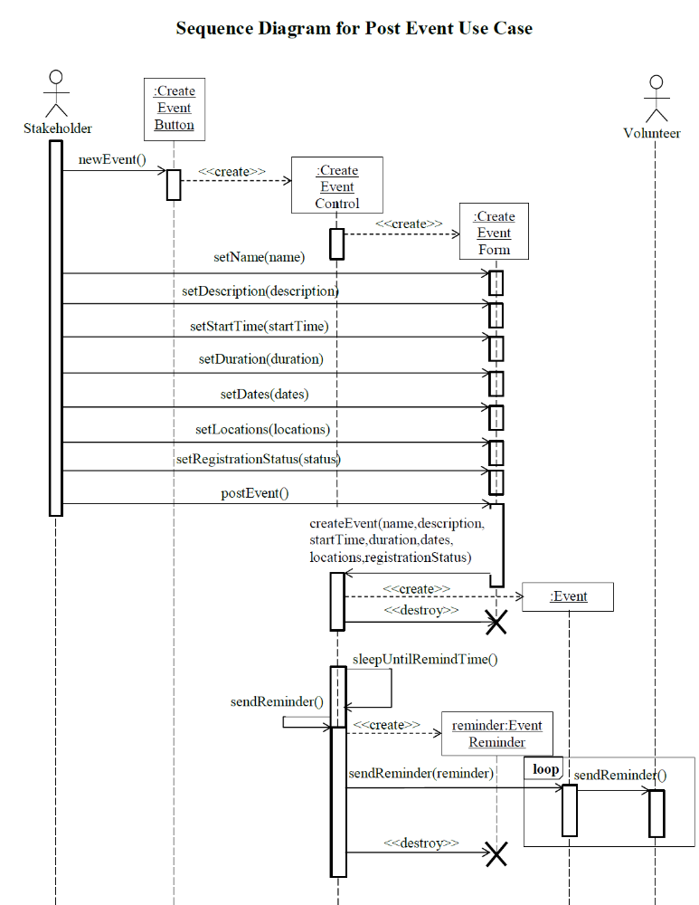

Post Event Use Case:
- The Stakeholder class invokes the newEvent operation of the CreateEventButton class.
- the CreateEventButton class invokes the constructor of the CreateEventControl class.
- The CreateEventControl class invokes the constructor of the CreateEventForm class.
- The stakeholder invokes the following operations of the CreateEventForm class: the setName operation with the name of the event as an argument, the setDescription operation with the description of the event as an argument, the setStartTime operation with the start time of the event as an operation, the setDuration operation with the duration of the event as an argument, the setDates operation with the dates the event will occur on as an argument, the setLocations operation with the locations of the event as an argument, and the setRegistrationStatus operation with the registration status of the event as an argument (either open for registration or view only).
- When the stakeholder is finished specifying the event information the postEvent operation of the CreateEventForm class is invoked.
- The CreateEventForm class invokes the createEvent operation of the CreateEventControl class with the values passed as arguments in step 4 passed as arguments in this operation invocation.
- The CreateEventControl class invokes the constructor of the Event class.
- The CreateEventControl class invokes the destructor fo the CreateEventForm class.
- The CreateEventControl class invokes the sleepUntilRemindTime operation of its own class which causes the execution of the control flow of this use case to freeze until it is three days before the start date of the event.
- When it is three days before the start date of the event the CreateEventControl class invokes the sendReminder operation of its own class which invokes the constructor fo the EventReminder class.
- The CreateEventControl class invokes the sendReminder operation of the Event class with the reminder object created in step 10 as an argument.
- The Event class invokes the sendReminder operation of the Volunteer class once for each Volunteer object who is associated with the event (the Volunteer object for each volunteer who has registered for the event).
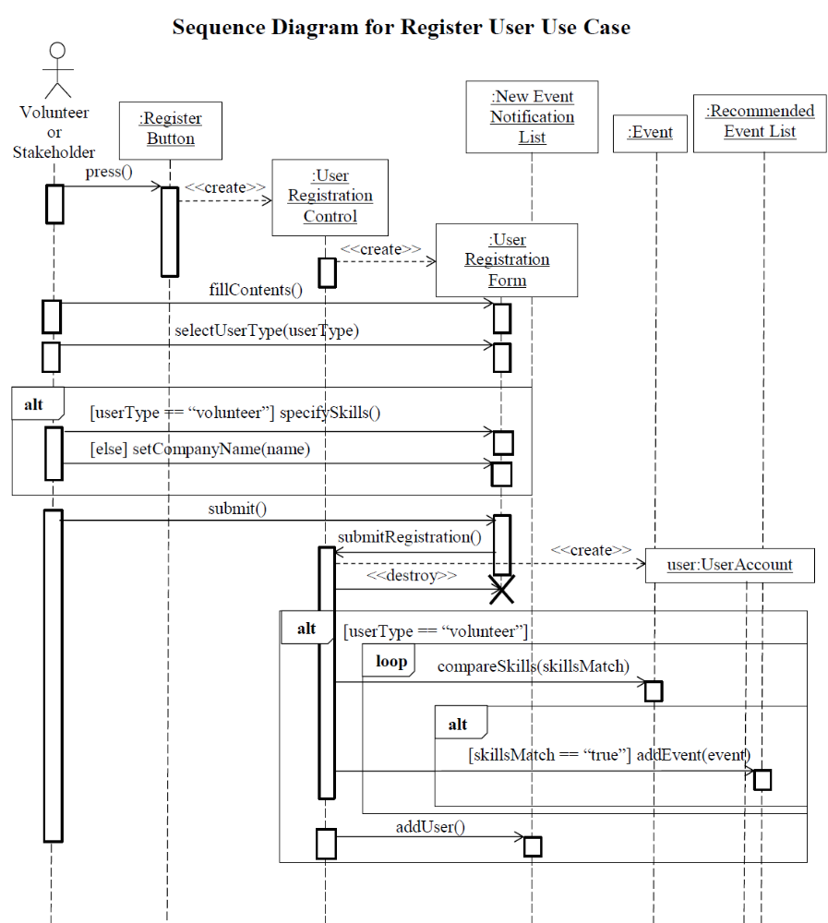
- The CreateEventControl class invokes the destructor of the CreateEventForm class.

Register User Use Case:
- Either the Volunteer or Stakeholder class invokes the press operation of the RegisterButton class, depending on whether a volunteer or stakeholder user initiated the use case.
- The RegisterButton class invokes the constructor fo the UserRegistrationControl class.
- The UserRegistrationControl class invokes the constructor of the UserRegistrationForm class.
- Either the Volunteer or Stakeholder class invokes the fillContents and selectUserType operations of the UserRegistrationForm class. The user type specified by the user, either volunteer or stakeholder, is passed as an argument of the selectUserType operation call.
- If the user is a volunteer the Volunteer class invokes the specifySkills operation of the UserRegistrationForm class. If the user is a stakeholder the Stakeholder class invokes the setCompanyName operation of the UserRegistrationForm class with the name of the stakeholder’s company as an argument.
- The Volunteer or Stakeholder class invokes the submit operation of the UserRegistrationForm class.
- The UserRegistrationForm class invokes the submitRegistration operation of the UserRegistrationControl class.
- The UserRegistrationControl class invokes the constructor of the UserAccount class.
- The UserRegistrationControl class invokes the destructor of the UserRegistrationFrom class.
- If the user is a volunteer the UserRegistrationControl class invokes the compareSkills operation of the Event class for each open event in the system which has not already passed. If the skills specified by the volunteer match the skills required for a volunteer position at an event the addEvent operation of the RecommendedEventList object associated with the volunteer is invoked with the event identifier and volunteer position identifier as an argument.
- If the user is a volunteer the UserRegistrationControl class invokes the addUser operation of the NewEventNotificationList class.

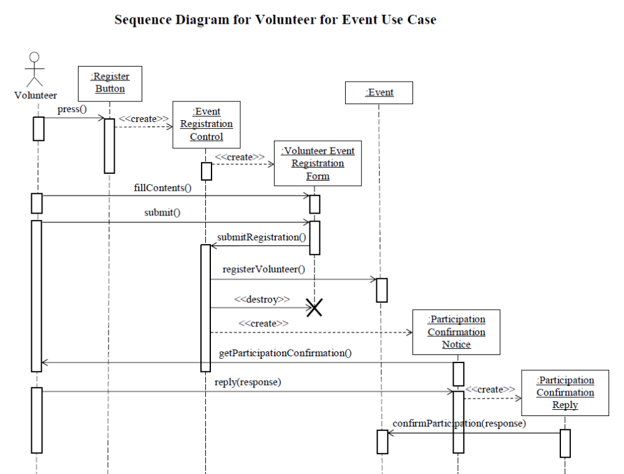

Volunteer for Event Use Case:
- The Volunteer class invokes the press operation of the RegisterButton class.
- The RegisterButton class invokes the constructor of the EventRegistrationControl class.
- The EventRegistrationContorl class invokes the constructor fo the VolunteerEventRegistrationForm class.
- The Volutneer class invokes the fillContents operation of the VolutneerEventRegistrationForm class.
- The Volunteer class invokes the submit operation of the VolutneerEventRegistrationForm class.
- The VolunteerEventRegistrationForm class invokes the submitRegistration operation of the EventRegistrationControl class.
- The EventRegistrationControl class invokes the registerVolutneer operation of the Event class.
- The EventRegistationControl class invokes the destructor of the VolunteerEventRegistrationForm class.
- The EventRegistrationControl class invokes the constructor of the PaticipationCofnirmationNotice class.
- The ParticpationConfirmationNotice class invokes the getParticipationConfirmation operation of the Volunteer class.
- The Volunteer class invokes the reply operation of the ParticipationConfirmationNotice class with the response made by the volunteer, either participation confirmed or participation cancelled.
- The ParticipationConfirmationNotice class invokes the constructor of the ParticipationConfirmationReply class.
- The ParticipationConfirmationReply class invokes the confirmParticipation operation of the Event class passing the response made by the volunteer as an argument.

Low Level Design

Stakeholder Interface Subsystem
The command design pattern is demonstrated in the below diagram. The diagram contains an EventManagementMenu invoker class which exclusively owns commands. This class is used to instantiate a menu used by a stakeholder to perform event management tasks. The EventMenuCommand class has several subclasses which represent the various commands that can be invoked upon the selection of a menu item by a stakeholder. The UserInterfaceBuilder is a client class that binds the Event receiver class to the concrete command classes, such as AddStakeholderCommand, ChangeEventInformationCommand, etc.
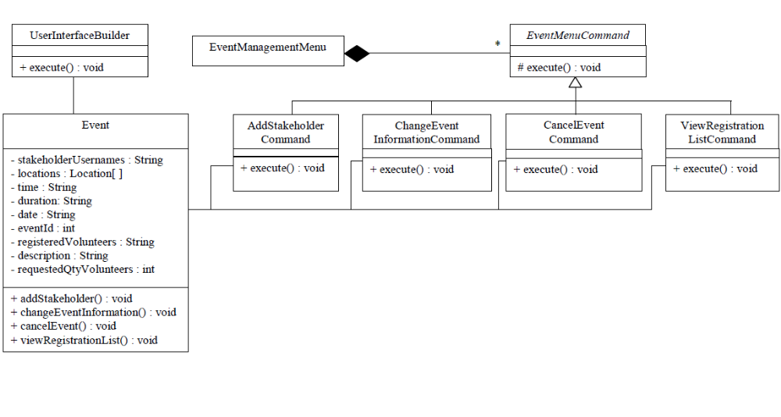

Volunteer Interface Subsystem
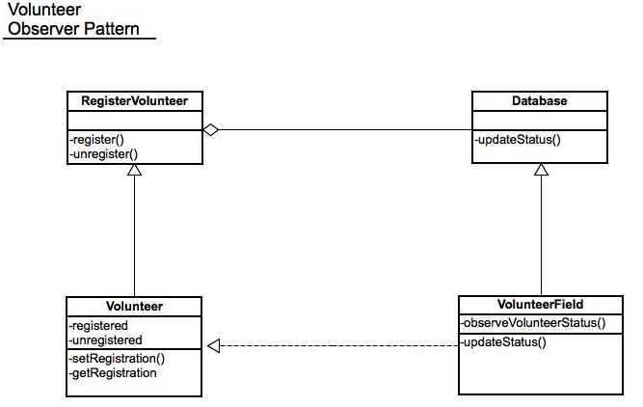

5.3 Notification Subsystem
The builder design pattern is demonstrated in the class diagram below. The MailboxConstructionDirector class specifies a construction algorithm. This class aggregates two different concrete builders. The ConcreteMenuMailboxBuilder class and the ConcreteDropdownMailboxBuilder class both contain a buildMailbox method which is a concrete implementation of the interface specified in the MailboxBuilder abstract class. The MailboxBuilder abstract class specifies the abstract steps of the algorithm for creating a mailbox. The creation of a mailbox is hidden from the user. One type of mailbox is navigated by end users through the use of menus, whereas the other variety is navigated through a drop-down list. There are menu items/list items for viewing the inbox, sent items, etc.
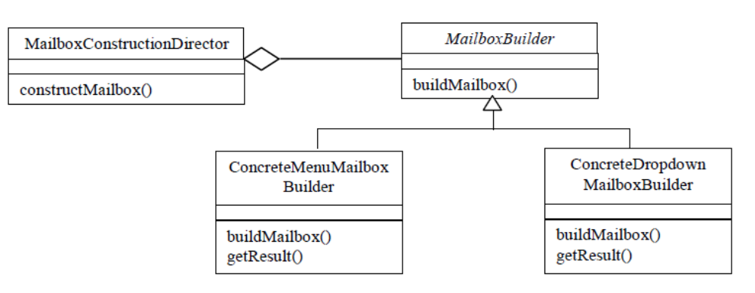

5.4 Volunteer Matcher Subsystem
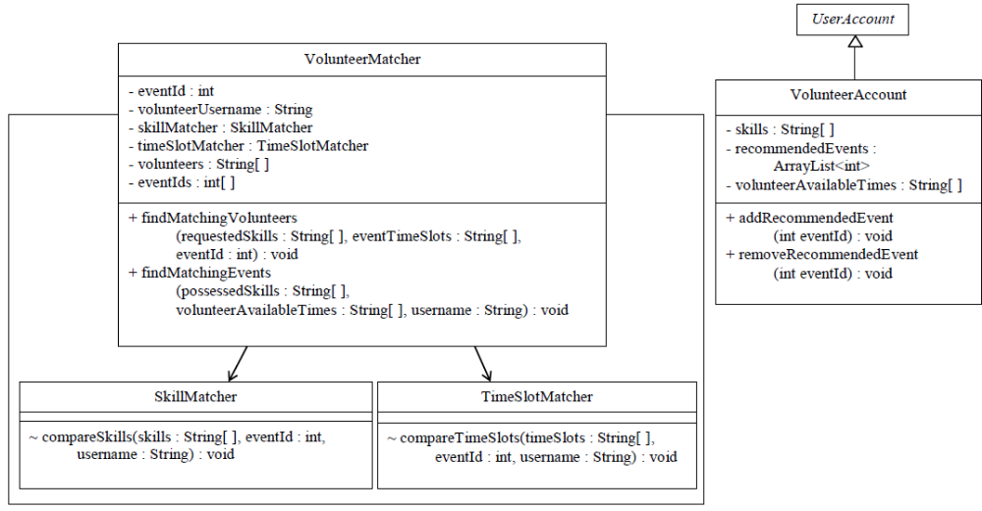

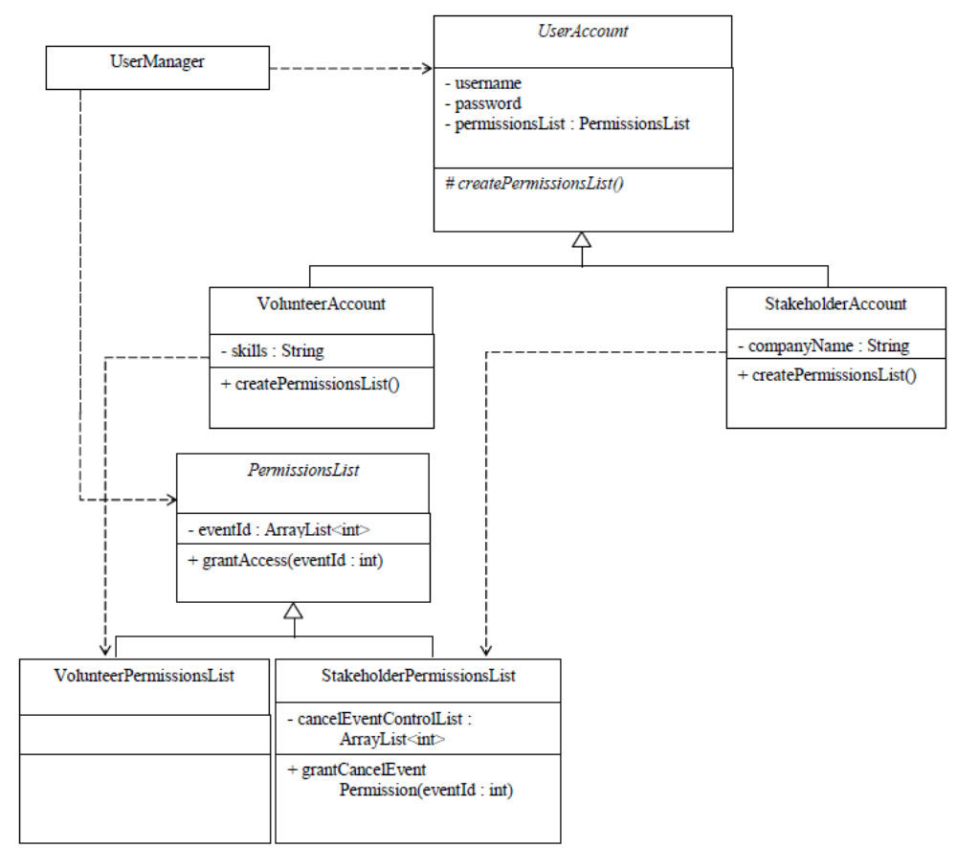
5.5 User Management Subsystem

5.6 Event Registration Subsystem
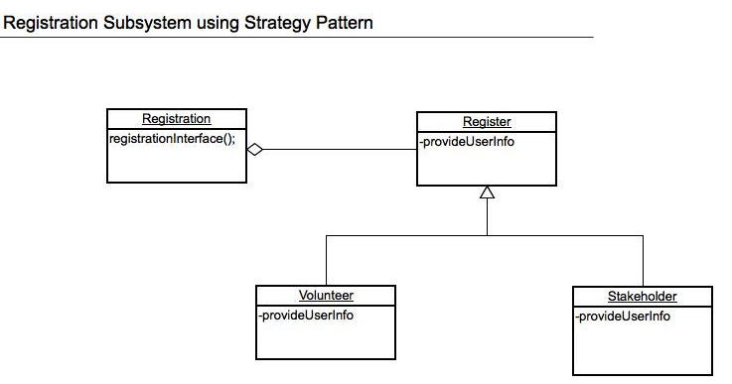

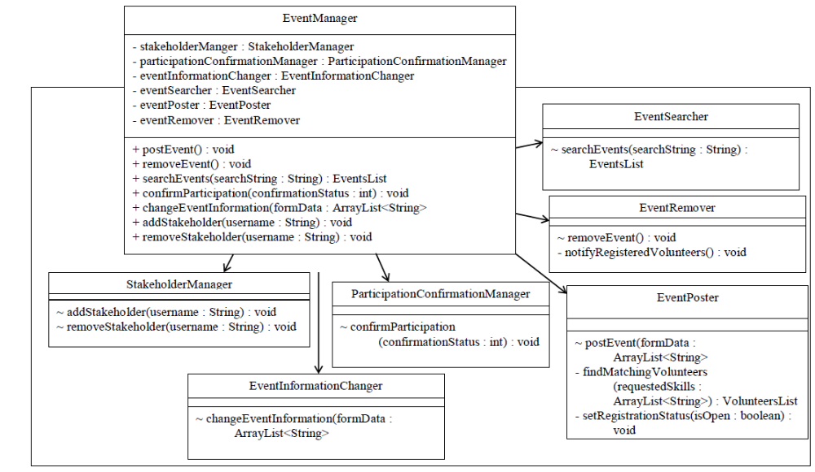
5.7 Event Management Subsystem

5.8 Storage and Database Subsystems
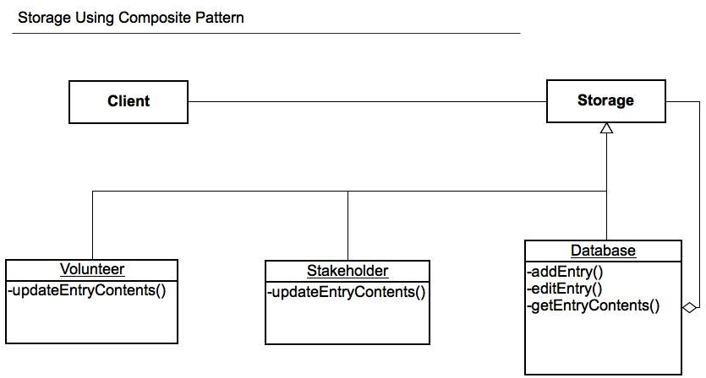

User Interface Design

User Interface Design Overview
The first page of the system is the login page. This page will have to editable textboxes labeled ‘Username:’ and ‘Password:’ with a link reading ‘New User Registration’. Text input into the textbox labeled ‘Password:’ should only read on the screen as asterisks.
The ‘New User Registration’ link will redirect the user to the New User Registration page. This will include editable textboxes labeled with all relevant user contact information, the option to select Volunteer or Stakeholder, and a grayed-out, unusable group of checkboxes labeled with skills-needed keywords near the bottom. If the user selects ‘Volunteer’, the group of checkboxes will be accessible, allowing the user to select abilities that would be applicable to the user. At the bottom of the New User Registration page, two buttons labeled ‘Save’ and ‘Cancel’ will allow the user to save his/her profile or jump back to the login page, respectively.
Once logged in as a Volunteer, the Volunteer Home Page will be displayed. The page will have two listboxes, one labeled ‘Upcoming Events’ and the other labeled ‘Notifications’. The elements in the ‘Upcoming Events’, when selected, will display tooltips that display additional event information and a button labeled ‘Cancel Event Participation’. The ‘Notifications’ list will have elements that, when selected, will display a full notification message, along with the sender and the date sent and an option to close the tooltip. Once read, the element will be deleted from the ‘Notifications’ list. Next to the list, there will be three Radiobuttons labeled ‘New’, ‘Read’, and ‘Sent’. The ‘New’ RadioButton will be selected by default. If the user selects ‘Read’, the list will display notifications that had previously been removed from the default ‘Notifications’ list when opened. At the bottom of the page will be three buttons labeled ‘Search for events’, ‘Edit User Information’, and ‘Delete Account’. The ‘Search for events’ button will redirect to the Event Search page. The ‘Edit User Information’ will redirect to the Register New User page, will all pre-existing information already filled in the appropriate textboxes. The ‘Delete Account’ will display a tooltip asking ‘Are you sure?’ with two buttons labeled ‘yes’ and ‘no’. ‘no’ will go back to the Volunteer Home Page. ‘yes’ will redirect to the login page, after deleting all user information out of the system.
The Event Search page will have a textbox labeled ‘Search:’ and two RadioButtons labeled ‘Recommended’ and ‘All’ with ‘Recommended’ selected by default, followed by a button labeled ‘Search’. The results will be displayed in a listbox below. When an element of the list is selected, the page will display a tooltip displaying all event information with two buttons labeled ‘Volunteer for Event’ and ‘Cancel’. If ‘Volunteer for Event’ is selected, the event is added to the Volunteer’s ‘Upcoming Events’ list on the home page. Selecting ‘Cancel’ will just close the tooltip. At the bottom of the Event Search page, there will be a button labeled ‘Back’ that, when pressed, redirects the user back to the Volunteer Home Page.
Once logged in a Stakeholder, the Stakeholder Home Page will be displayed. The page will look very similar to the Volunteer Home Page. The page will contain the same labeled listboxes as the Volunteer Home Page. In the Stakeholder’s ‘Upcoming Events’ listbox, when an event is selected from the list, the tooltips will also display all event information, and will have three buttons labeled ‘View Participants’, ‘Edit Event Information’, and ‘Cancel Event’. If ‘View Participants’ is selected, the Stakeholder will be redirected toe the Event Participants page, which contains all the participating volunteers and their contact information in a list box, with a button at the bottom labeled ‘Back’, which will redirect the Stakeholder back to the Stakeholder Home Page. If ‘Edit Event Information’ is selected, the Stakeholder will be redirected to the ‘Post New Event’ screen, which will be described later. If the Stakeholder chooses ‘Cancel Event’, the Stakeholder will be redirected to the Stakeholder home page and the event will no longer be displayed on the ‘Upcoming Events’ list. The Stakeholder’s ‘Notification’ list is identical in display and functionality as the Volunteer’s. The bottom of the screen will display three buttons, ‘Edit User Information’ and ‘Delete User Account’, both identical to their Volunteer Home Page counterparts, and ‘Post New Event’.
If the Stakeholder selects ‘Post New Event’, he/she will be redirected to the Post New Event page, which will contain textboxes corresponding to all pertinent event information, as well as a group of checkboxes labeled with different skills-needed keywords the Stakeholder may select to attract more specialized volunteers. At the bottom of this page, there will be two buttons labeled ‘Save’ and ‘Cancel’. If ‘Save’ is selected, the page will double-check to make sure all forms are filled out, and if not, will display a Messagebox that states ‘Form not complete’ and returns to the Post New Event page. If the forms are filled out when ‘Save’ is selected, the page will redirect to the Stakeholder Home Page, with the saved event added to the ‘Upcoming Events’ list. If the Stakeholder selects ‘Cancel’, he/she will be redirected to the Stakeholder Home Page and will not save any input information.

User Interface Navigation Hierarchy
The navigation hierarchy diagram appears at the end of this section.
The first page the user will see is the login screen. Here the user can either log in with an existing profile or create a new profile.
If the user selects ‘Create New Profile’, a form will open with textboxes corresponding to name, gender, phone number, mailing address, and email address. There will be a listbox that allows the user to select whether he/she will be operating the account as a Volunteer or Stakeholder. There will be a column of checkboxes corresponding to various skills that are applicable to the user. If the user selected Stakeholder from the above listbox, this area will be grayed out and will not accept input. Last, the user will be able to use textboxes to choose a username, a password, and an additional textbox to re-enter the password. The password must be at least 8 alphanumeric characters with at least 1 numeral character. Once all available inputs have been filled, the user may press a ‘Submit’ button at the bottom of the form. The system will verify that the username is available and all inputs are valid. If the system detects an error, the erroneous input field will reset, allowing the user to re-input the information. If the system detects no errors, the user will be sent back to the login page, where he/she can use the chosen username and password to login.
If the login is unsuccessful, the system will display an error message and reset the username and password forms. If login is successful and the user logged in as a Volunteer, the user will be brought to the Volunteer Homepage. Here the user will find a list labeled ‘Upcoming Events’ that shows all events the user has volunteered to participate in. The user may select any event on the list, which will bring up a page showing complete event information including event owner’s contact information. The page will also give the user the option to cancel participation in this event. If the user selects this option, a pop up message will confirm the decision.
Next to the ‘Upcoming Events’ list will be another list labeled ‘Notifications’ which will show all unread notifications with the name of its senders. The user may select any notification on the list, which will open the message contained in the notification. Below the ‘Notifications’ list, there will be RadioButtons labeled ‘Read’ and ‘New’. If the user selects any of these buttons, the ‘Notifications’ list will show messages corresponding to the button pressed.
Below the ‘Upcoming Events’ and ‘Notifications’ lists, there will be three buttons. The first button will be labeled ‘Edit User Information’. If the Volunteer selects this, a page identical to the new user registration form will be shown already displaying all previously input the information. The Volunteer can then edit the necessary fields and, when finished, can click the ‘Save’ button at the bottom of the screen, which will redirect the user back to the Volunteer Homepage. The second button will be labeled ‘Delete Account’. If the user selects this, a MessageBox will be displayed asking ‘Are you sure?’. The user may select no, which will redirect to the Volunteer Homepage, or the user may select yes, which will remove all saved information about the user from the system’s storage. The third button will be labeled ‘Search for more events’. If the user selects this, he/she will be redirected to the Event search page. At the top of the page, there will be a TextBox labeled ‘Search:’. Next to the Search field, there will be two RadioButtons, one labeled ‘Recommended’, the other labeled ‘All’. Last, there will be a button labeled ‘Search’. When the page loads, the RadioButton ‘Recommended’ will be activated by default. The user may choose to input text in the input box, and click ‘Search’. If the user has no text input in the search field, the ‘Search’ button will display a list showing all events with skills-needed keywords matching those chosen by the user during New User Registration. If the user does choose to input a search keyword, then the ‘Search’ button will display all events that either contain the search keyword in the title or in the skills-needed keywords. If the user selects the RadioButton ‘All’, the ‘Search’ button will show all upcoming events. If a search keyword is used, the functionality remains the same whether ‘Recommended’ or ‘All’ is selected. The search results will display the name and date of the event in list format. The Volunteer may select any event from the search results, which will bring up all event information, including event Stakeholder’s name and contact info, as well as skills-needed keywords. The user will also be given the option of volunteering for the selected event. If the Volunteer wishes to participate in an event, the Volunteer will be added to the list of participants for the Event, and the event will be added to the Volunteer’s list of upcoming events.
If the user logs in as a Stakeholder, they will be redirected to the Stakeholder homepage. The page set up will be nearly identical to the Volunteer homepage, with a few key differences. The Stakeholder’s ‘Upcoming Events’ list will show events that the Stakeholder currently has planned. Next to the ‘Upcoming Events’ list will be a button labeled ‘Post New Event’. If the Stakeholder selects this, he/she will be redirected to the ‘Post New Event’ page. This page is similar to the ‘Register New User’ form, with TextBoxes corresponding to all the relevant event information. Once all the fields have been filled out, the Stakeholder may select the ‘Post Event’ button at the bottom of the form. This will add the event to the Stakeholder’s ‘Upcoming Events’ list. When the Stakeholder selects one of these events, the complete event information will be displayed, along with options to view the list of participants, change event information, and cancel the event. If the user wished to view a list of participants for an event, a list will be displayed showing the names of all participants. If the user selects a participant, the participant’s full contact information will be displayed. If the Stakeholder selects ‘Change Event Information’, this will redirect him/her back to the ‘Post New Event’ page, with all the TextBoxes filled out with the currently saved information. Here the Stakeholder may change the relevant fields and select the ‘Save’ button at the bottom of the form. If the Stakeholder selects ‘Cancel Event’, this will remove the event from his/her ‘Upcoming Event’ list as well as all the participating volunteer’s ‘Upcoming Event’ lists. The Stakeholder’s ‘Edit User Information’ and ‘Delete Account’ buttons worked identically to the Volunteer’s.

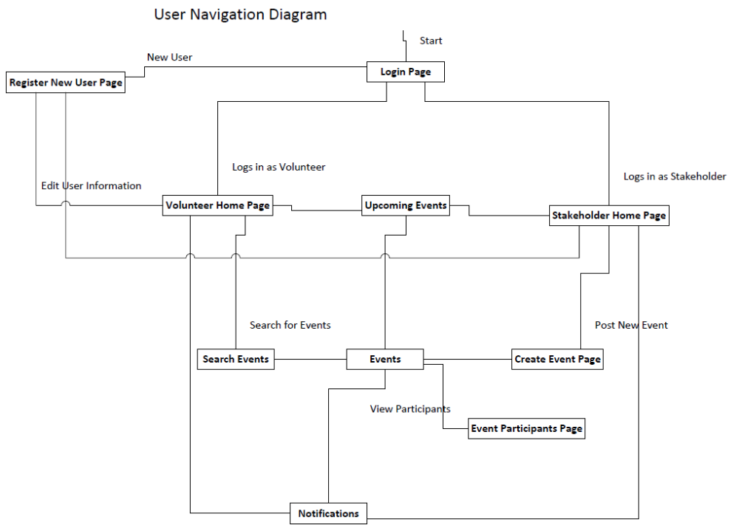

Requirements Traceability Matrix
Please refer to “TeamQuartzRequirementsTraceabilityMatrix.docx”, to be provided on a CD-ROM disk during the system delivery. This document indicates traceability from the software requirements document titled “TeamQuartz.docx” to the design elements documented.

Appendices
8.1 Subsystem Services Component Diagrams
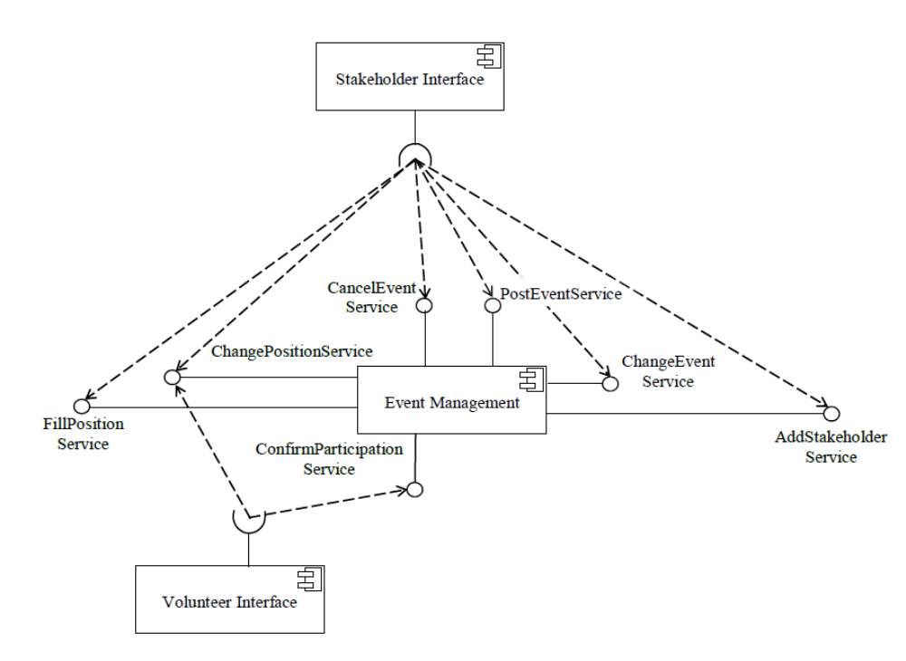
Event Management Subsystem Services Component Diagram

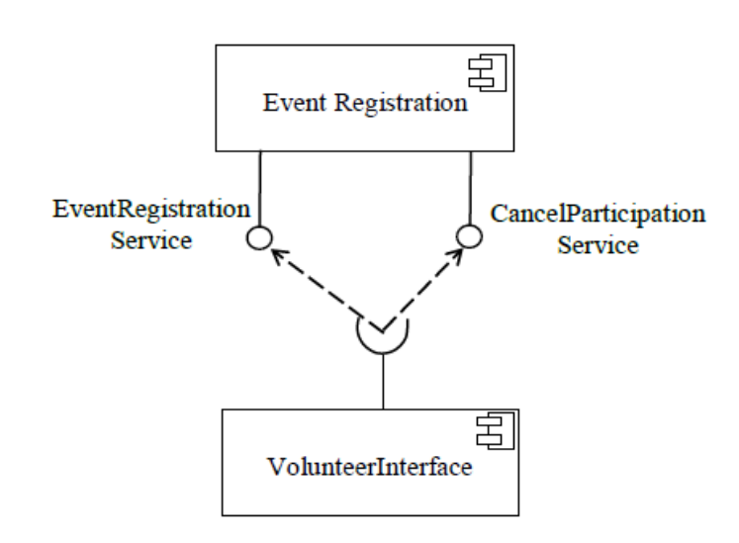
Event Registration Subsystem Services Component Diagram

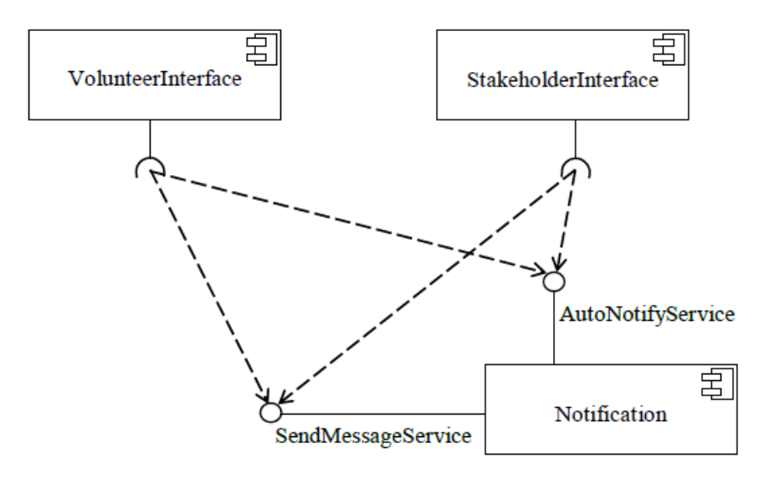
Notification Subsystem Services Component Diagram

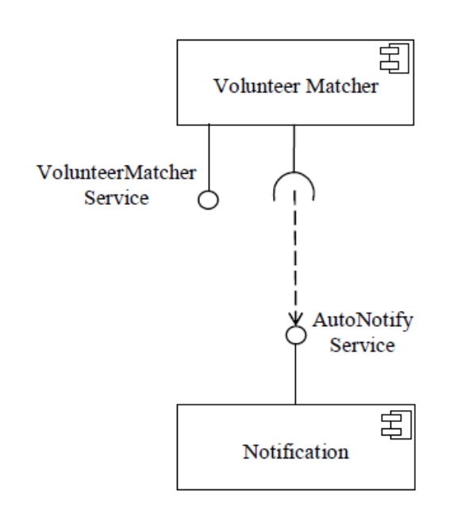
Volunteer Matcher Subsystem Services Component Diagram

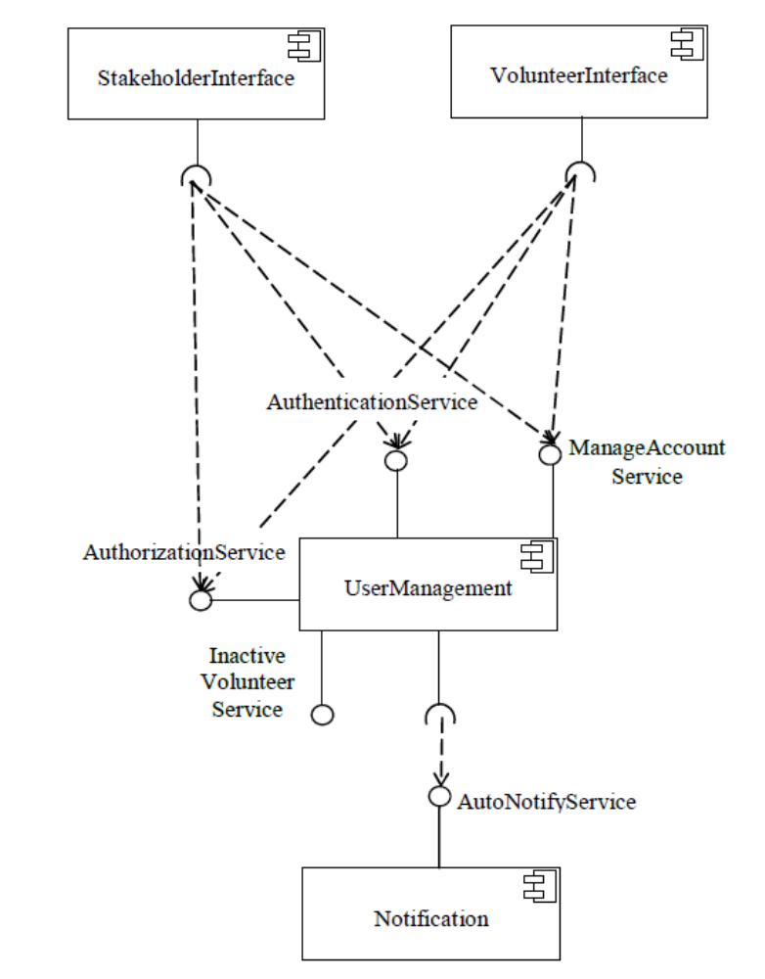
User Management Subsystem Services Component Diagram

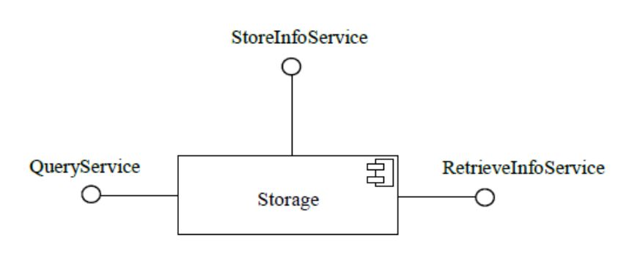
Storage Subsystem Services Component Diagram

8.2 Volunteer Management System Database EER Diagram
