Final Project Proposal

Group 3

Final Project Proposal

Group 3

Lakshmi M, Sahar M, Pouria M, Manjinder S, Alireza O, Alireza T, Parsa N, Suteash S, Toby H, Tony T

# Physical Topology

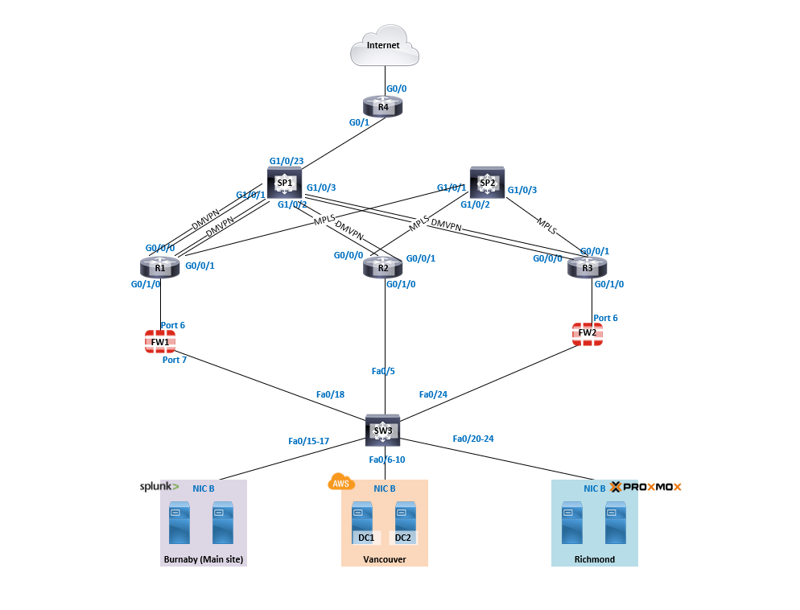

# Logical Topology

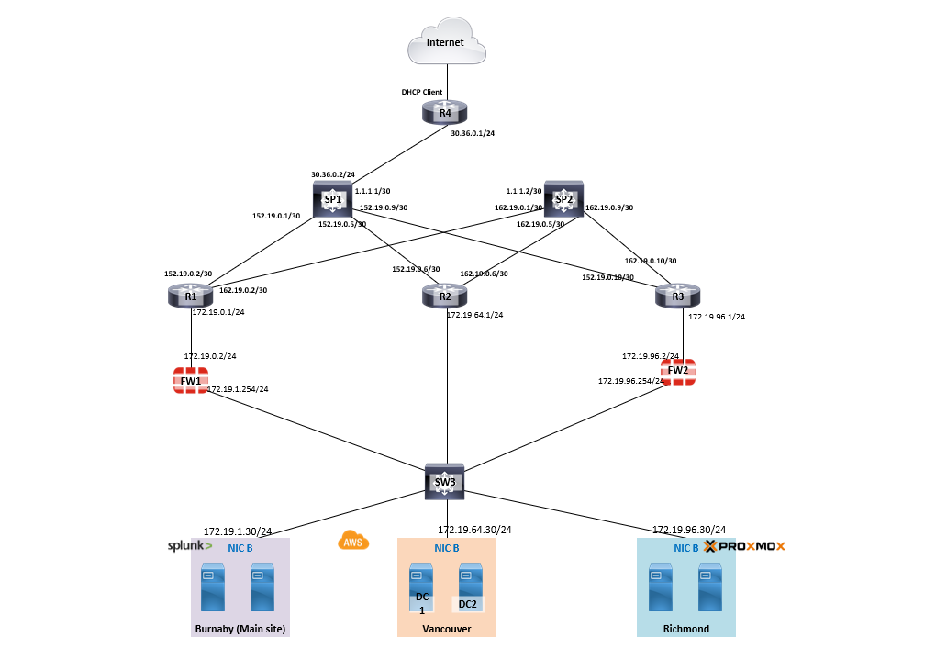

# Equipment Used

|  |  |
| --- | --- |
| **Devices** | **Equipment** |
| G3-R4 | B1P3 - 2085 |
| G3-SP1 | B1P3 - 2087 |
| G3-SP2 | B1P3 - 2088 |
| G3-R1-Bur | B1P3 - 2082 |
| G3-R2-Van | B1P3 - 2083 |
| G3-R3-Ric | B1P3 - 2084 |
| G3-FW1 | FW9 |
| G3-FW2 | FW10 |
| G3-SW3 | B1P3 - 2089 |

# IP Addressing

### WAN IP and Interface Addressing

|  |  |
| --- | --- |
|  | **IPv4** |
| **Major WAN Network** |  |
| SP1 | 152.19.0.0/16 |
| Site1-WAN1 | 152.19.0.0/30 |
| Site2-WAN1 | 152.19.0.4/30 |
| Site3-WAN1 | 152.19.0.8/30 |
| SP2 | 162.19.0.0/16 |
| Site1-WAN2 | 162.19.0.0/30 |
| Site2-WAN2 | 162.19.0.4/30 |
| Site3-WAN2 | 162.19.0.8/30 |

|  |  |
| --- | --- |
|  | **IPv4** |
| **SP1** | 152.19.0.0/16 |
| Site1-WAN1 |  |
| → SP1 (S1 – Gig1/0/1) | 152.19.0.1/30 |
| → Site1 (R1 – Gig0/0/0) | 152.19.0.2/30 |
| Site2-WAN1 |  |
| → SP1 (S1 – Gig1/0/2) | 152.19.0.5/30 |
| → Site2 (R2 – Gig0/0/0) | 152.19.0.6/30 |
| Site3-WAN1 |  |
| → SP1 (S1 – Gig1/0/3) | 152.19.0.9/30 |
| → Site3 (R3 – Gig0/0/0) | 152.19.0.10/30 |

|  |  |
| --- | --- |
|  | **IPv4** |
| **SP2** | 162.19.0.0/16 |
| Site1-WAN2 |  |
| → SP2 (S2 – Gig1/0/1) | 162.19.0.1/30 |
| → Site1 (R1 – Gig0/0/1) | 162.19.0.2/30 |
| → Site1 (R1 Loopback0) | 162.19.255.1 |
| Site2-WAN2 |  |
| → SP2 (S2 – Gig1/0/2) | 162.19.0.5/30 |
| → Site2 (R2 – Gig0/0/1) | 162.19.0.6/30 |
| → Site2 (R2 Loopback0) | 162.19.255.2 |
| Site3-WAN2 |  |
| → SP2 (S2 – Gig1/0/3) | 162.19.0.9/30 |
| → Site3 (R3 – Gig0/0/1) | 162.19.0.10/30 |
| → Site3 (R3 Loopback0) | 162.19.255.3 |

|  |  |  |  |
| --- | --- | --- | --- |
| **Site** | **IPv4 Overlay Address** | **IPv4 Loopback (for MPLS)** | **IPv6 Overlay Address** |
| **Site 1 (R1)** | 10.3.1.1/32 | 162.19.255.1/32 | 2001:10:3:1::1/128 |
| **Site 2 (R2)** | 10.3.1.2/32 | 162.19.255.2/32 | 2001:10:3:1::2/128 |
| **Site 3 (R3)** | 10.3.1.3/32 | 162.19.255.3/32 | 2001:10:3:1::3/128 |

### LAN IP and Interface Addressing

|  |  |  |  |
| --- | --- | --- | --- |
| **Site** | **Assigned IPv4 Range** | **Assigned IPv6 Range** | **Subnet Mask** |
| Burnaby | 172.19.0.0/18 | FD00:DB8:19:1::/64 | /24 |
| Vancouver | 172.19.64.0/19 | FD00:DB8:19:40::/64 | /24 |
| Richmond | 172.19.96.0/20 | FD00:DB8:19:61::/64 | /24 |

|  |  |  |
| --- | --- | --- |
| **Interface** -Burnaby | **IPv4** | **IPv6** |
| R1 – Gig 0/1/0  - Int vlan 1 | 172.19.0.1/24 | FD00:DB8:19:0::1/64 |
| Fortigate -Port6 | 172.19.0.2/24 | FD00:DB8:19:0::2/64 |
| Fortigate– port7 | 172.19.1.254/24 | FD00:DB8:19:1::FE/64 |

|  |  |  |
| --- | --- | --- |
| **Interface** - Vancouver | **IPv4** | **IPv6** |
| R2 – Gig 0/1/0  - Int Vlan 2 | 172.19.64.1/24 | FD00:DB8:19:40::1/64 |

|  |  |  |
| --- | --- | --- |
| **Interface** -Richmond | **IPv4** | **IPv6** |
| R3 – Gig 0/1/0  - Int vlan 3 | 172.19.96.1/24 | FD00:DB8:19:60::1/64 |
| Fortigate -Port6 | 172.19.96.2/24 | FD00:DB8:19:60::2/64 |
| Fortigate– port7 | 172.19.3.254/24 | FD00:DB8:19:61::FE/64 |

|  |  |  |
| --- | --- | --- |
| **Site** | **IPv6 Prefix (/64)** | **SLAAC Address Range** |
| **Burnaby** | FD00:DB8:19:1::/64 | FD00:DB8:19:1::100 → FD00:DB8:19:1::1FFF |
| **Vancouver** | FD00:DB8:19:40::/64 | FD00:DB8:19:40::100 → FD00:DB8:19:40::1FFF |
| **Richmond** | FD00:DB8:19:61::/64 | FD00:DB8:19:61::100 → FD00:DB8:19:61::1FFF |

### Host Addressing

|  |  |
| --- | --- |
| **Host Device** | **IP** |
| G3-DC1-Bur | 172.19.1.30/24 |
| G3-DC2-Bur | 172.19.1.29/24 |
| G3-PC-Bur | DHCP |
| G3-DC1-Van | 172.19.64.30/24 |
| G3-DC2-Van | 172.19.64.29/24 |
| G3-PC-Van | DHCP |
| G3-DC1-Ric | 172.19.3.30/24 |
| G3-DC2-Ric | 172.19.3.29/24 |
| G3-PC-Ric | DHCP |

# Testing Metric

**UNDERLAY TESTING**

tclsh

foreach X {

152.19.0.2

152.19.0.6

152.19.0.10

162.19.0.2

162.19.0.6

162.19.0.10

8.8.8.8

} {ping $X rep 3}

**OVERLAY TESTING**

tclsh

foreach X {

10.3.1.1

10.3.1.2

10.3.1.3

162.19.255.1

162.19.255.2

162.19.255.3

2001:10:3:1::1

2001:10:3:1::2

2001:10:3:1::3

8.8.8.8

} {ping $X rep 3}

**LAN-to-LAN TESTING**

tclsh

foreach X {

172.19.0.1

172.19.64.1

172.19.96.1

8.8.8.8

} {ping $X rep 3 source lo1}