assignement 2 integretion
yann
2025-02-26

Question 1
Write I = R 1 0 x 2 e x 2 dx as E[g(U)] with g a suitable function and U a uniform random variable on [0, 1]. Prove that I = 1 3 E[h(V )], V having a β(3, 1) distribution with density and h a function (that you need to figure out!).
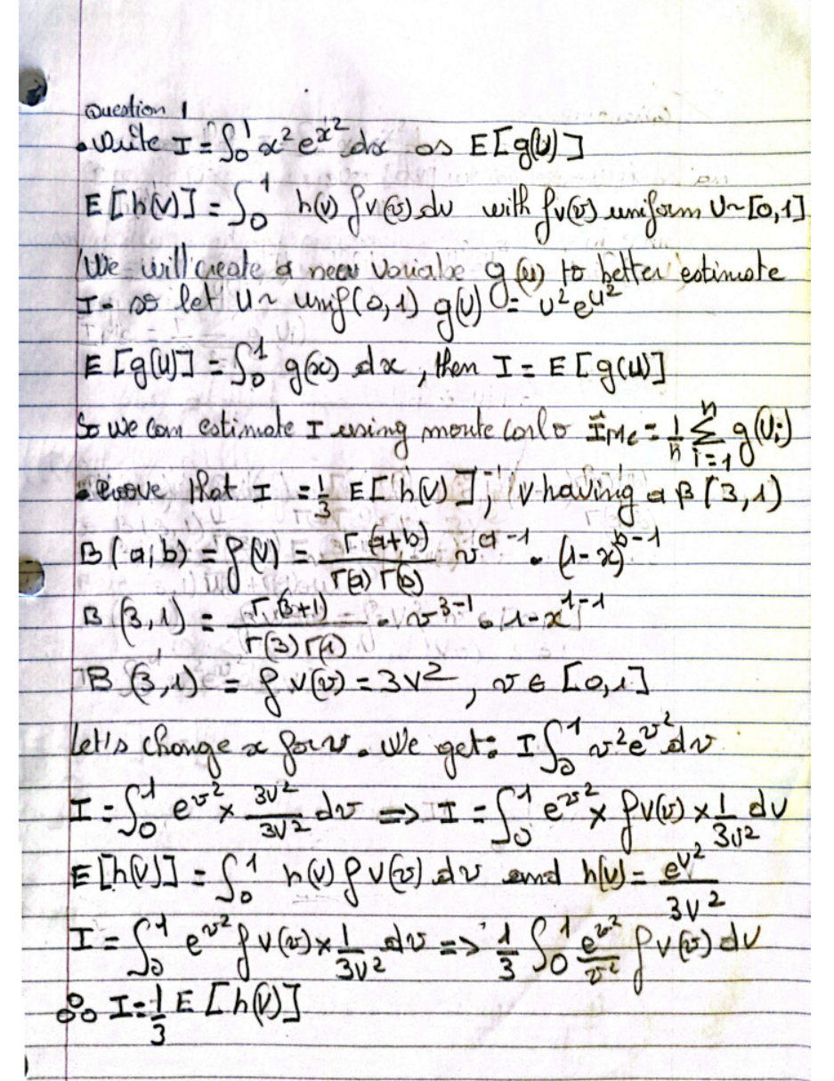
set.seed(123)
# Define sample sizes for our simulation: 10^3, 10^4, and 10^5 samples.
n_values <- c(1e3, 1e4, 1e5)
Crude Monte Carlo
# Define sample sizes as a vector.
n <- c(10^3, 10^4, 10^5)
# Define the function g(x) = x^2 * exp(x^2) which, when averaged over Uniform(0,1) samples,
# gives an unbiased estimator for the integral I = ∫0^1 x^2 * exp(x^2) dx.
g <- function(x) x^2 * exp(x^2)
# For each sample size, generate 'n' uniform random numbers and compute the average of g(x).
mc_estimates <- sapply(n, function(n) mean(g(runif(n))))
# Display the crude Monte Carlo estimates.
mc_estimates
## [1] 0.6187158 0.6173007 0.6274209
## [1] 0.6187158 0.6173007 0.6274209
Control Variate Method
# Define the control function h(x) = x^2.
cv_function <- function(x) x^2
# Estimate the expected value of the control function h(x) under Uniform(0,1).
mu_cv <- mean(cv_function(runif(100000)))
# Estimate the covariance between g(x) and h(x) using independent samples.
covariance <- cov(g(runif(10000)), cv_function(runif(10000)))
# Estimate the variance of h(x) using a large sample.
variance <- var(cv_function(runif(10000)))
# Compute the optimal control variate coefficient gamma.
# This coefficient minimizes the variance of the adjusted estimator.
gamma <- -covariance / variance
# For each sample size, compute the control variate estimator.
# The adjustment is: g(x) + gamma * (h(x) - mu_cv)
cv_estimates <- sapply(n, function(n)
mean(g(runif(n)) + gamma * (cv_function(runif(n)) - mu_cv))
)
# Display the control variate estimates.
cv_estimates
## [1] 0.6646270 0.6356376 0.6272932
## [1] 0.6646270 0.6356376 0.6272932
Antithetic Variates
# Define a function to compute the antithetic estimator.
# We generate n/2 uniform samples, and for each sample u, we also consider its antithetic pair (1-u).
antithetic_estimate <- function(n) {
u <- runif(n/2) # Generate half as many samples
# Compute the average of g(u) and g(1-u) and then average them to obtain the estimator.
(mean(g(u)) + mean(g(1 - u))) / 2
}
# Apply the antithetic estimator for each sample size.
antithetic_estimates <- sapply(n, antithetic_estimate)
# Display the antithetic variates estimates.
antithetic_estimates
## [1] 0.6444586 0.6226092 0.6265897
Comparison of variances:
# Calculate and compare the variances of the estimates obtained by each method.
# Here we compute the variance of the estimates across the different sample sizes.
var_table <- data.frame(
n,
Crude = var(mc_estimates),
ControlVar = var(cv_estimates),
Antithetic = var(antithetic_estimates)
)
print(var_table)
## n Crude ControlVar Antithetic
## 1 1e+03 3.003344e-05 0.0003839702 0.0001354233
## 2 1e+04 3.003344e-05 0.0003839702 0.0001354233
## 3 1e+05 3.003344e-05 0.0003839702 0.0001354233
Use the Beta representation for I to obtain new estimators
#Crude Monte Carlo using Beta samples: I = (1/3)*E(exp(V^2))
beta_crude_mc <- function(n) {
V <- rbeta(n, 3, 1)
estimates <- exp(V^2)
I_hat <- mean(estimates) / 3
I_var <- var(estimates) / (n * 9)
return(c(I_hat, I_var))
}
# Control Variate using Beta samples (using h(V) = V^2 with E[V^2]=0.6)
beta_control_mc <- function(n) {
V <- rbeta(n, 3, 1)
f_V <- exp(V^2)
h_V <- V^2 # and E[V^2]= 3*4/(4*5)=0.6
beta_hat <- - cov(f_V, h_V) / var(h_V)
adjusted_estimates <- f_V + beta_hat * (h_V - 0.6)
I_hat <- mean(adjusted_estimates) / 3
I_var <- var(adjusted_estimates) / (n * 9)
return(c(I_hat, I_var))
}
# Antithetic Variates using Beta samples
beta_antithetic_mc <- function(n) {
n <- ceiling(n / 2) * 2 # Ensures n is even
U <- runif(n / 2) # Generate uniform random numbers
V1 <- U^(1/3) # Inverse transform to get Beta(3,1)
V2 <- (1 - U)^(1/3)
estimates <- (exp(V1^2) + exp(V2^2)) / 2
I_hat <- mean(estimates) / 3
I_var <- var(estimates) / (n * 9)
return(c(I_hat, I_var))
}
# Run simulations for sample sizes 10^3, 10^4, 10^5
n_values <- c(1e3, 1e4, 1e5)
beta_crude_results <- t(sapply(n_values, beta_crude_mc))
beta_control_results <- t(sapply(n_values, beta_control_mc))
beta_antithetic_results <- t(sapply(n_values, beta_antithetic_mc))
results_estimators <- data.frame(
"Sample Size" = n_values,
"Crude MC (Beta)" = round(beta_crude_results[, 1], 6),
"Antithetic MC (Beta)" = round(beta_antithetic_results[, 1], 6),
"CV (Beta)" = round(beta_control_results[, 1], 6),
"True Value" = 0.6278151
)
print(results_estimators, caption = "Estimator Comparison using beta", digits = 6)
## Sample.Size Crude.MC..Beta. Antithetic.MC..Beta. CV..Beta. True.Value
## 1 1e+03 0.619362 0.627835 0.628361 0.627815
## 2 1e+04 0.626626 0.627803 0.627811 0.627815
## 3 1e+05 0.627424 0.627813 0.627843 0.627815

question2
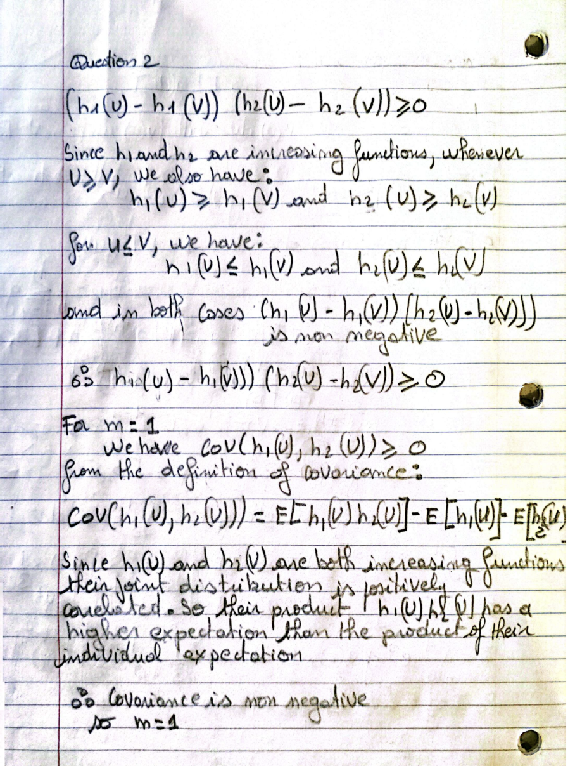

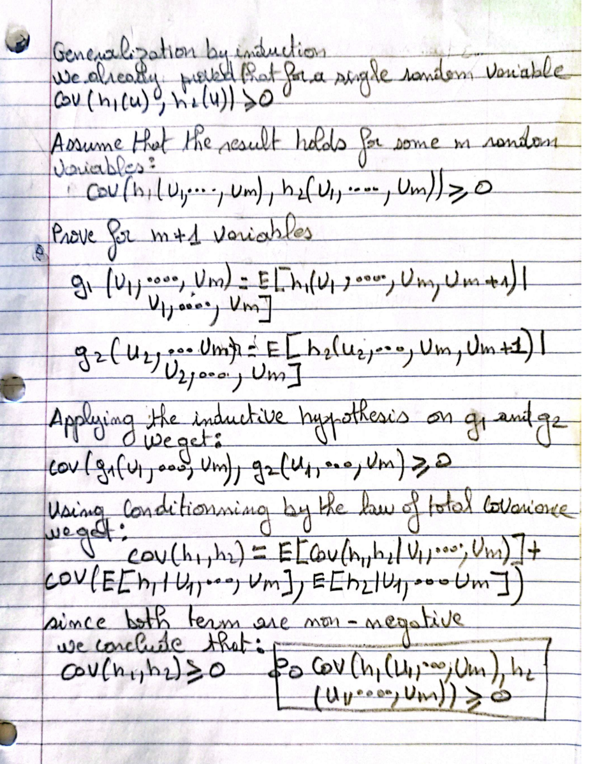

question 3
# Set Parameters
set.seed(123)
n <- 100
c <- 1
beta <- 1.5
# Step 2: Generate Uniform Samples and Transform
U <- runif(n)
X <- c * (-log(U))^(1 / beta) # Weibull samples via inverse CDF

Crude Monte Carlo for $β>1$
Objective: Estimate $P\left(X>q\right)$ for $p=0.001,0.005$, $β=1.5$.
# Crude Monte Carlo for beta > 1
# Step 1: Set Parameters
n_mc <- 10000
beta <- 1.5 #
c <- 1
p_values <- c(0.001, 0.005)
# Step 2: Loop Over p Values
for (p in p_values) {
q <- c * (-log(p))^(1 / beta) # Compute threshold q
X_mc <- c * (-log(runif(n_mc)))^(1 / beta) # Simulate Weibull samples
indicator <- X_mc > q
# Step 3: Estimate Probability and Variance
p_hat <- mean(indicator)
var_hat <- var(indicator) / n_mc
ci_lower <- p_hat - 1.96 * sqrt(var_hat) # Lower bound of 95% CI
ci_upper <- p_hat + 1.96 * sqrt(var_hat) # Upper bound of 95% CI
# Step 4: Display Results
cat("p =", p, ": p_hat =", p_hat, "Variance =", var_hat,
"CI = [", ci_lower, ",", ci_upper, "]\n")
}
## p = 0.001 : p_hat = 8e-04 Variance = 7.994399e-08 CI = [ 0.0002458224 , 0.001354178 ]
## p = 0.005 : p_hat = 0.005 Variance = 4.975498e-07 CI = [ 0.003617471 , 0.006382529 ]

Crude Monte Carlo for ( beta < 1 )
# Crude Monte Carlo for beta < 1
# Step 1: Set Parameters
beta <- 0.5
# Step 2: Loop Over p Values
for (p in p_values) {
q <- c * (-log(p))^(1 / beta) # Compute threshold q
X_mc <- c * (-log(runif(n_mc)))^(1 / beta) # Simulate Weibull samples
indicator <- X_mc > q # Check exceedance
# Step 3: Estimate Probability and Variance
p_hat <- mean(indicator)
var_hat <- var(indicator) / n_mc
ci_lower <- p_hat - 1.96 * sqrt(var_hat) # Lower bound of 95% CI
ci_upper <- p_hat + 1.96 * sqrt(var_hat) # Upper bound of 95% CI
# Step 4: Display Results
cat("p =", p, ": p_hat =", p_hat, "Variance =", var_hat,
"CI = [", ci_lower, ",", ci_upper, "]\n")
}
## p = 0.001 : p_hat = 0.0012 Variance = 1.19868e-07 CI = [ 0.0005214097 , 0.00187859 ]
## p = 0.005 : p_hat = 0.0043 Variance = 4.281938e-07 CI = [ 0.003017444 , 0.005582556 ]

Importance Sampling for beta > 2
For β > 2, show that we can reduce the variance by applying importance sampling with instrumental distribution Γ(β, 1/c).


# Importance Sampling for beta > 2
# Step 1: Set Parameters
beta <- 3 # beta > 2
# Step 2: Loop Over p Values
for (p in p_values) {
q <- c * (-log(p))^(1 / beta) # Compute threshold q
Y <- rgamma(n_mc, shape = beta, scale = c) # Simulate from Gamma
w <- (beta * gamma(beta) / c) * exp(-(Y / c)^beta + Y / c) # Compute weights
indicator <- Y > q
# Step 3: Importance Sampling Estimate
p_hat_is <- mean(indicator * w)
var_hat_is <- var(indicator * w) / n_mc
ci_lower_is <- p_hat_is - 1.96 * sqrt(var_hat_is)
ci_upper_is <- p_hat_is + 1.96 * sqrt(var_hat_is)
# Step 4: Crude MC for Comparison
X_mc <- c * (-log(runif(n_mc)))^(1 / beta)
p_hat_mc <- mean(X_mc > q)
var_hat_mc <- var(X_mc > q) / n_mc
rel_eff <- ifelse(var_hat_mc > 0, var_hat_mc / var_hat_is, NA)
# Step 5: Display Results
cat("p =", p, ": IS p_hat =", p_hat_is, "Var =", var_hat_is,
"CI = [", ci_lower_is, ",", ci_upper_is, "], Rel Eff =", rel_eff, "\n")
}
## p = 0.001 : IS p_hat = 0.001035038 Var = 2.021812e-09 CI = [ 0.0009469078 , 0.001123169 ], Rel Eff = 29.6615
## p = 0.005 : IS p_hat = 0.004734837 Var = 4.114014e-08 CI = [ 0.004337289 , 0.005132384 ], Rel Eff = 15.69853

Importance Sampling for beta <1
For β < 1, explain why the Gamma distribution is no longer suitable. Apply importance sampling with the log-normal distribution.



# Importance Sampling for beta < 1
# Step 1: Set Parameters
beta <- 0.5 # beta < 1
# Step 2: Loop Over p Values
for (p in p_values) {
q <- c * (-log(p))^(1 / beta) # Compute threshold q
mu <- log(q) # Center log-normal at q
sigma <- 1
Y <- rlnorm(n_mc, meanlog = mu, sdlog = sigma) # Simulate log-normal
f_X <- (beta / c) * (Y / c)^(beta - 1) * exp(-(Y / c)^beta) # Weibull PDF
f_Y <- dlnorm(Y, meanlog = mu, sdlog = sigma) # Log-normal PDF
w <- f_X / f_Y # Compute weights
indicator <- Y > q
# Step 3: Importance Sampling Estimate
p_hat_is <- mean(indicator * w)
var_hat_is <- var(indicator * w) / n_mc
ci_lower_is <- p_hat_is - 1.96 * sqrt(var_hat_is)
ci_upper_is <- p_hat_is + 1.96 * sqrt(var_hat_is)
# Step 4: Display Results
cat("p =", p, ": IS p_hat =", p_hat_is, "Var =", var_hat_is,
"CI = [", ci_lower_is, ",", ci_upper_is, "]\n")
}
## p = 0.001 : IS p_hat = 0.0009906009 Var = 3.692509e-10 CI = [ 0.0009529377 , 0.001028264 ]
## p = 0.005 : IS p_hat = 0.005054143 Var = 6.994995e-09 CI = [ 0.004890216 , 0.00521807 ]

question4
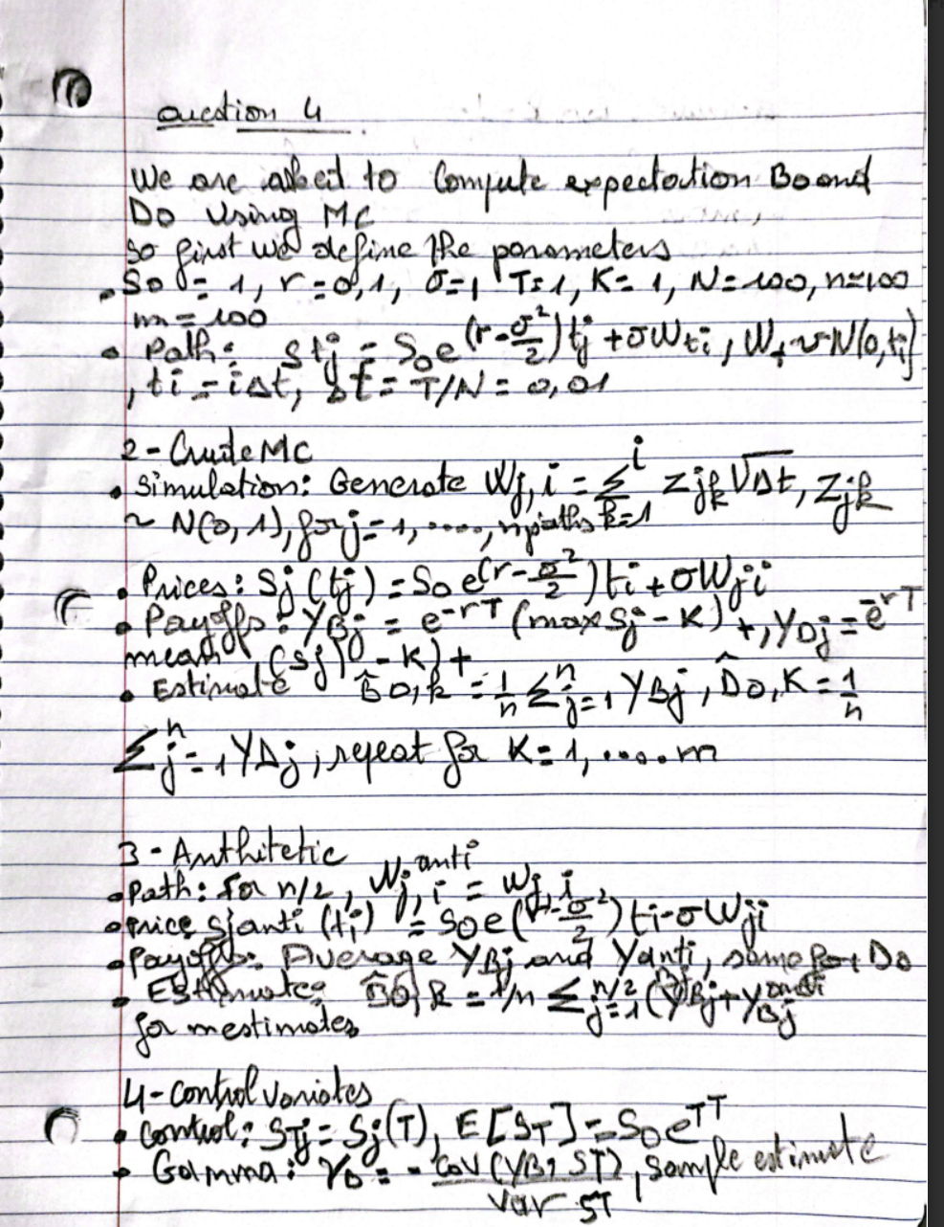
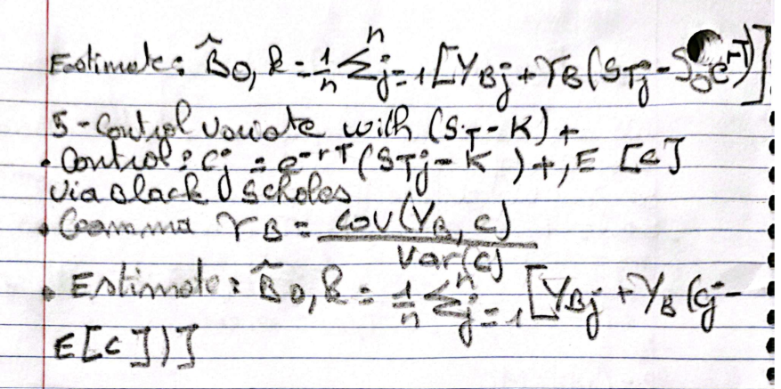
library(ggplot2)
# Load required libraries (already loaded in setup)
set.seed(123)
asian_option_estimator <- function(sigma, r, T, S0, K, N, n, m) {
dt <- T / N
# Compute European call option price (Black-Scholes formula)
d1 <- (log(S0/K) + (r + sigma^2 / 2) * T) / (sigma * sqrt(T))
d2 <- d1 - sigma * sqrt(T)
european_price <- S0 * pnorm(d1) - K * exp(-r * T) * pnorm(d2)
# Function to simulate GBM paths
simulate_gbm <- function(n_paths, antithetic = FALSE) {
dW <- matrix(rnorm(n_paths * N, 0, sqrt(dt)), nrow = n_paths, ncol = N)
if (antithetic) dW <- -dW
W <- t(apply(dW, 1, cumsum))
t_grid <- matrix(seq(dt, T, by = dt), nrow = n_paths, ncol = N, byrow = TRUE)
S <- S0 * exp((r - sigma^2 / 2) * t_grid + sigma * W)
return(S)
}
# Pre-allocate matrices for m estimates (each column corresponds to a method)
results_B <- matrix(0, nrow = m, ncol = 4)
results_D <- matrix(0, nrow = m, ncol = 4)
colnames(results_B) <- colnames(results_D) <- c("Crude MC", "Antithetic", "CV_S", "CV_Option")
for (k in 1:m) {
S <- simulate_gbm(n, antithetic = FALSE)
S_antithetic <- simulate_gbm(n, antithetic = TRUE)
# For B0: maximum of the path
max_S <- apply(S, 1, max)
payoff_B <- exp(-r * T) * pmax(max_S - K, 0)
max_S_anti <- apply(S_antithetic, 1, max)
payoff_B_anti <- exp(-r * T) * pmax(max_S_anti - K, 0)
B_antithetic <- (payoff_B + payoff_B_anti) / 2
# For D0: average of the path
avg_S <- rowMeans(S)
payoff_D <- exp(-r * T) * pmax(avg_S - K, 0)
avg_S_anti <- rowMeans(S_antithetic)
payoff_D_anti <- exp(-r * T) * pmax(avg_S_anti - K, 0)
D_antithetic <- (payoff_D + payoff_D_anti) / 2
# Control variate using S_T (terminal price)
S_T <- S[, N]
cov_B <- cov(payoff_B, S_T)
gamma_B <- - cov_B / var(S_T)
B_cv_S <- mean(payoff_B) + gamma_B * (mean(S_T) - S0 * exp(r * T))
cov_D <- cov(payoff_D, S_T)
gamma_D <- - cov_D / var(S_T)
D_cv_S <- mean(payoff_D) + gamma_D * (mean(S_T) - S0 * exp(r * T))
# Control variate using (S_T - K)^+ with European price
payoff_EU <- exp(-r * T) * pmax(S_T - K, 0)
cov_B_EU <- cov(payoff_B, payoff_EU)
gamma_B_EU <- - cov_B_EU / var(payoff_EU)
B_cv_EU <- mean(payoff_B) + gamma_B_EU * (mean(payoff_EU) - european_price)
cov_D_EU <- cov(payoff_D, payoff_EU)
gamma_D_EU <- - cov_D_EU / var(payoff_EU)
D_cv_EU <- mean(payoff_D) + gamma_D_EU * (mean(payoff_EU) - european_price)
results_B[k, ] <- c(mean(payoff_B), mean(B_antithetic), B_cv_S, B_cv_EU)
results_D[k, ] <- c(mean(payoff_D), mean(D_antithetic), D_cv_S, D_cv_EU)
}
return(list(B0 = results_B, D0 = results_D))
}
# Set parameters for the Asian option experiment
sigma <- 1
r <- 0.1
T <- 1
S0 <- 1
K <- 1
N <- 100
n <- 100
m <- 100
# Run the estimator
results <- asian_option_estimator(sigma, r, T, S0, K, N, n, m)
# Plotting the estimates for B0
df_B <- data.frame(
Estimate = c(results$B0),
Method = factor(rep(colnames(results$B0), each = m)),
Index = rep(1:m, times = 4)
)
ggplot(df_B, aes(x = Index, y = Estimate, color = Method)) +
geom_line() +
labs(title = "Estimates for B0 (Maximum-Based Asian Option)", y = "Estimate") +
theme_minimal()
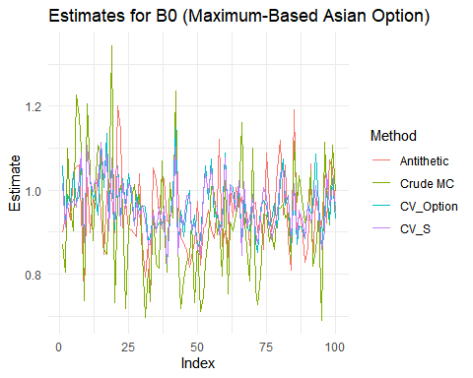
# Print variance comparisons for B0
var_B <- apply(results$B0, 2, var)
cat("Variances for B0:\nCrude MC:", var_B[1], "\nAntithetic:", var_B[2],
"\nCV with S_T:", var_B[3], "\nCV with EU Option:", var_B[4], "\n")
## Variances for B0:
## Crude MC: 0.01732895
## Antithetic: 0.008139353
## CV with S_T: 0.004177641
## CV with EU Option: 0.004498833
# Plotting the estimates for D0
df_D <- data.frame(
Estimate = c(results$D0),
Method = factor(rep(colnames(results$D0), each = m)),
Index = rep(1:m, times = 4)
)
ggplot(df_D, aes(x = Index, y = Estimate, color = Method)) +
geom_line() +
labs(title = "Estimates for D0 (Average-Based Asian Option)", y = "Estimate") +
theme_minimal()
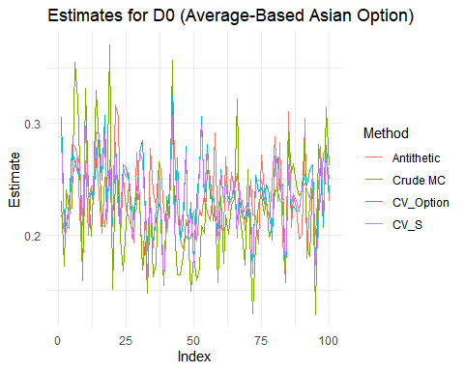
# Print variance comparisons for D0
var_D <- apply(results$D0, 2, var)
cat("\nVariances for D0:\nCrude MC:", var_D[1], "\nAntithetic:", var_D[2],
"\nCV with S_T:", var_D[3], "\nCV with EU Option:", var_D[4], "\n")
##
## Variances for D0:
## Crude MC: 0.002471226
## Antithetic: 0.001216017
## CV with S_T: 0.0009418998
## CV with EU Option: 0.00103126
#optional question1

set.seed(123)
# Parameters
p <- 0.01
n <- 10000
# Generate sample from N(0,1)
Z <- rnorm(n)
# Theoretical VaR at p = 0.01 (99th percentile)
q <- qnorm(1 - p)
# Filter values exceeding VaR and estimate ES
tail_Z <- Z[Z > q]
ES_hat <- mean(tail_Z)
# Standard error for confidence interval
se <- sd(tail_Z) / sqrt(length(tail_Z))
# 95% confidence interval
CI_lower <- ES_hat - qnorm(0.975) * se
CI_upper <- ES_hat + qnorm(0.975) * se
# Theoretical ES
true_ES <- dnorm(qnorm(1 - p)) / p
# Output results
cat("Estimated ES:", ES_hat, "\n")
## Estimated ES: 2.672539
cat("95% Confidence Interval:", CI_lower, "to", CI_upper, "\n")
## 95% Confidence Interval: 2.609354 to 2.735725
cat("Theoretical ES:", true_ES, "\n")
## Theoretical ES: 2.665214
With 10,000 samples, the Monte Carlo estimate ( 2.672539) closely matches the theoretical value (2.665214)

