Assignment 3 computational stat
yann
2025-03-20

Question 1 (graduate students only )
Although using a simple case k= 2 woul make the simpler case of the derivation and understanding much more straightforward, i did not use it to proove both expression (3)-(5)
Expression (3) proof
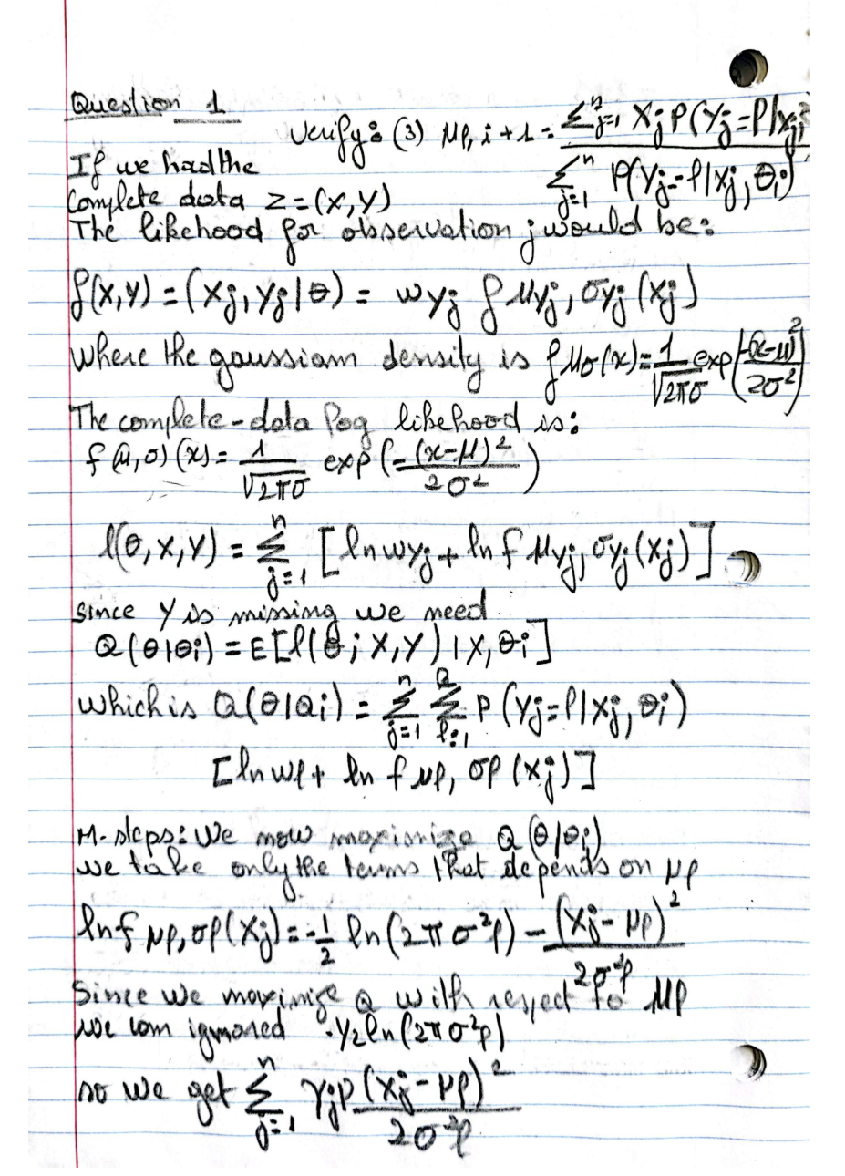
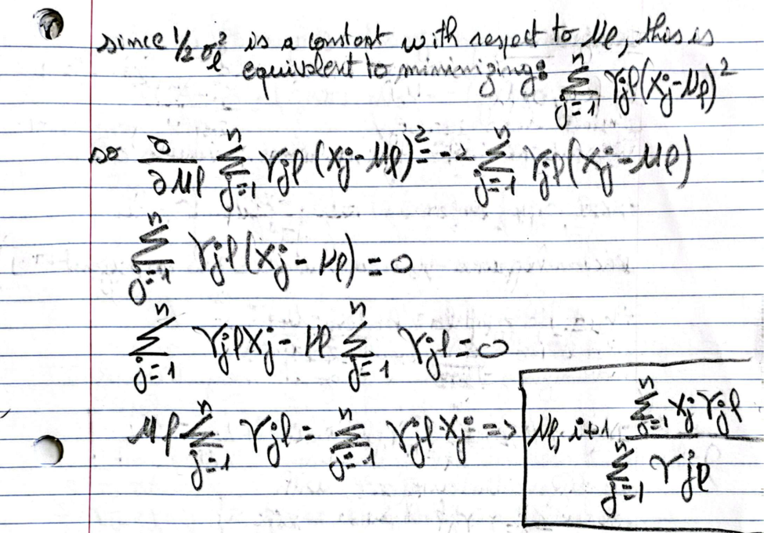
Expression (5) proof
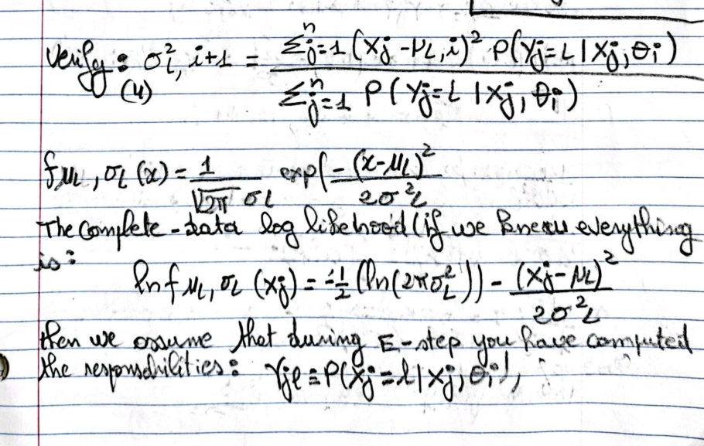

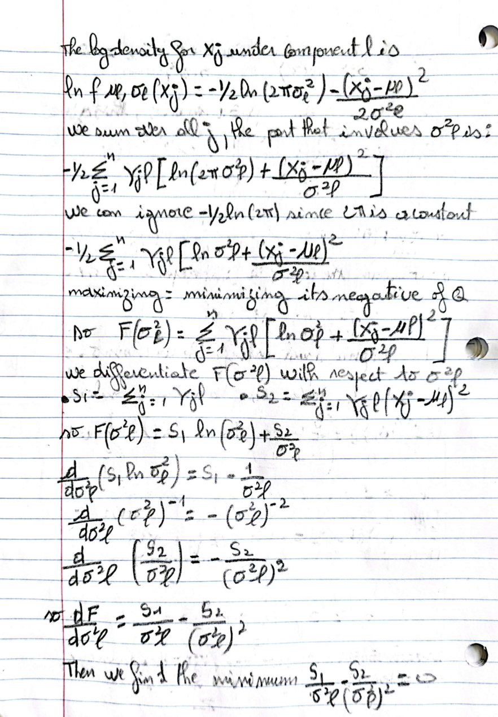

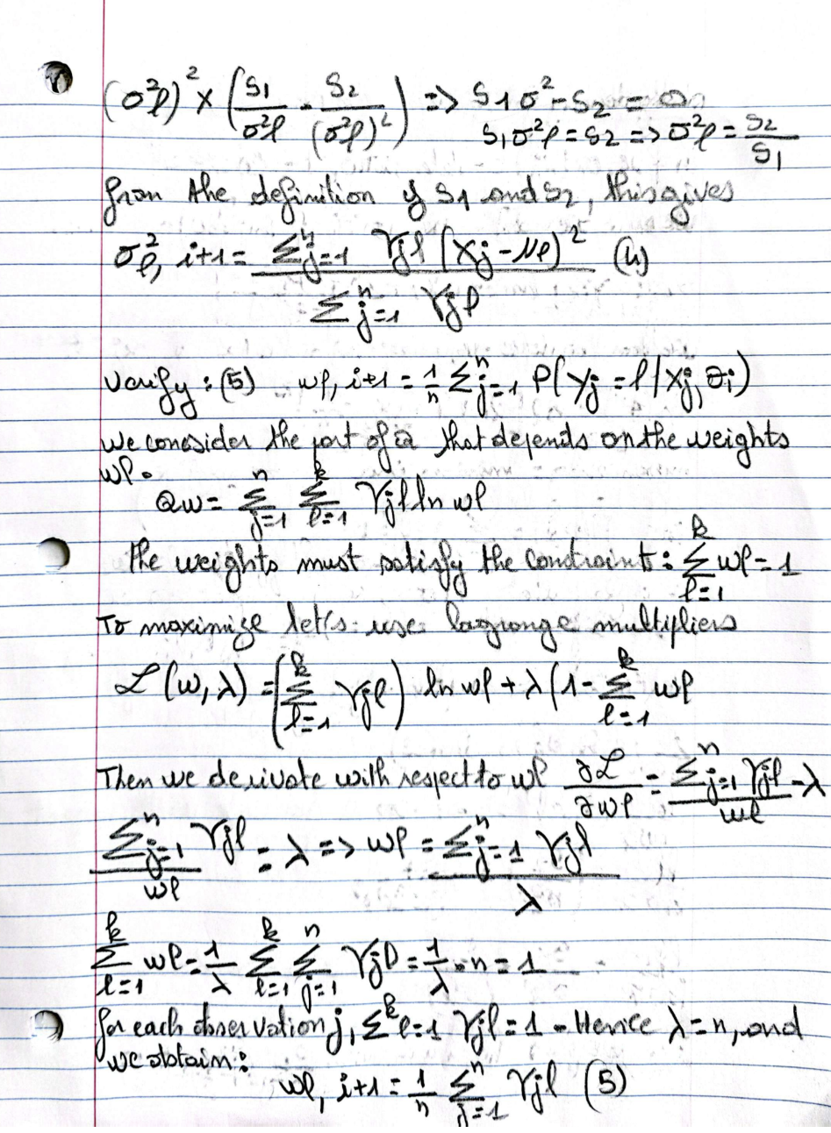

question 2

Grid search method
we don’t know if the function will lies between 0 to 1 which is the uniform parameters, so let’s plot a curve to define a large area where the maximum could be, we can take an initial area from 1 to 10 and see if the maximum is in there:
curve(log(x)/(1+x), from=0,to=10)
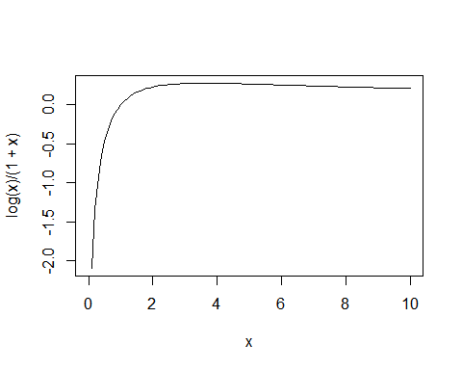 From the graph the maximun is indeed between 1 to 10 so let’s use a= 1 and b =10
# define grids and the parameters
gridS <- function(f, n, a, b) {
x_grid <- a + ((0:n)/n) * (b - a) # generates n+1 points between a and b
res <- rep(-1, n+1)
for(i in 1:(n+1)) {
res[i] <- f(x_grid[i])
}
return(list(M = max(res), argmax = x_grid[which.max(res)]))
}
ANalytically, after doing the derivative and set it equal to 0 we obtain:

# Define f(x) = ln(x)/(1+x)
f <- function(x) {
return(log(x)/(1+x))
}
# Apply grid search over [1, 10]
grid_result <- gridS(f, 10000, 1, 10)
cat("Grid Search:\n")
## Grid Search:
cat("Maximum found at x =", grid_result$argmax, "with f(x) =", grid_result$M, "\n")
## Maximum found at x = 3.5911 with f(x) = 0.2784645
we can see that the more a and b are far from the maximum point the more iteration we need to find the exact value of x. using the iterative version or bisection will generate the result faster with less iteration

Newton ransom method
# First derivative of f(x)
fprime <- function(x) {
return(((1 + x)/x - log(x)) / (1 + x)^2)
}
# Second derivative f''(x)
f2prime <- function(x) {
A <- (1 + x)/x - log(x)
Aprime <- -1/(x^2) - 1/x
return((Aprime*(1 + x)^2 - 2*A*(1 + x))/(1 + x)^4)
}
# Newton-Raphson algorithm
NR <- function(x0, tol = 1e-6, maxit = 1000) {
x <- x0
for(i in 1:maxit) {
x_new <- x - fprime(x) / f2prime(x)
if(abs(x_new - x) < tol) break
x <- x_new
}
return(x)
}
# Initial guess x0 = 3
x_nr <- NR(3)
cat("Newton-Raphson:\n")
## Newton-Raphson:
cat("Maximum found at x =", x_nr, "with f(x) =", f(x_nr), "\n\n")
## Maximum found at x = 3.591121 with f(x) = 0.2784645

Gradient descent Method
# Simple gradient ascent function:
SimpleGrad <- function(grad, n, gamma, x0) {
res <- rep(x0, n+1)
for(i in 1:n) {
res[i+1] <- res[i] + gamma[i] * grad(res[i])
}
return(res)
}
# First derivative of f(x)
fprime <- function(x) {
return(((1 + x)/x - log(x)) / (1 + x)^2)
}
# Use fprime as our gradient.
n_iter <- 100000
gamma_vec <- rep(0.01, n_iter)
x0 <- 3 # let's take x0=3 for exemple
x_values <- SimpleGrad(fprime, n_iter, gamma_vec, x0)
#The SimpleGrad function builds a vector that contains all the values obtained at each iteration. This allows us to #visualize the evolution of the value of x at each step. Then, to obtain the final result (the last value of x), we use #tail(x_values, 1), this will avoid plotting every iteration.
x_ga <- tail(x_values, 1)
cat("Gradient Ascent:\n")
## Gradient Ascent:
cat("Maximum found at x =", x_ga, "with f(x) =", f(x_ga), "\n")
## Maximum found at x = 3.591121 with f(x) = 0.2784645

question3

generate pareto observation
From pareto we transform the cdf into it’s inverse which is the quantile ( review in simulation)
# generate pareto using inverse transform
rpareto <- function(n, alpha, x_min = 1) {
U <- runif(n)
return(x_min / (1 - U)^(1/alpha))
}

calculate MLE analytically
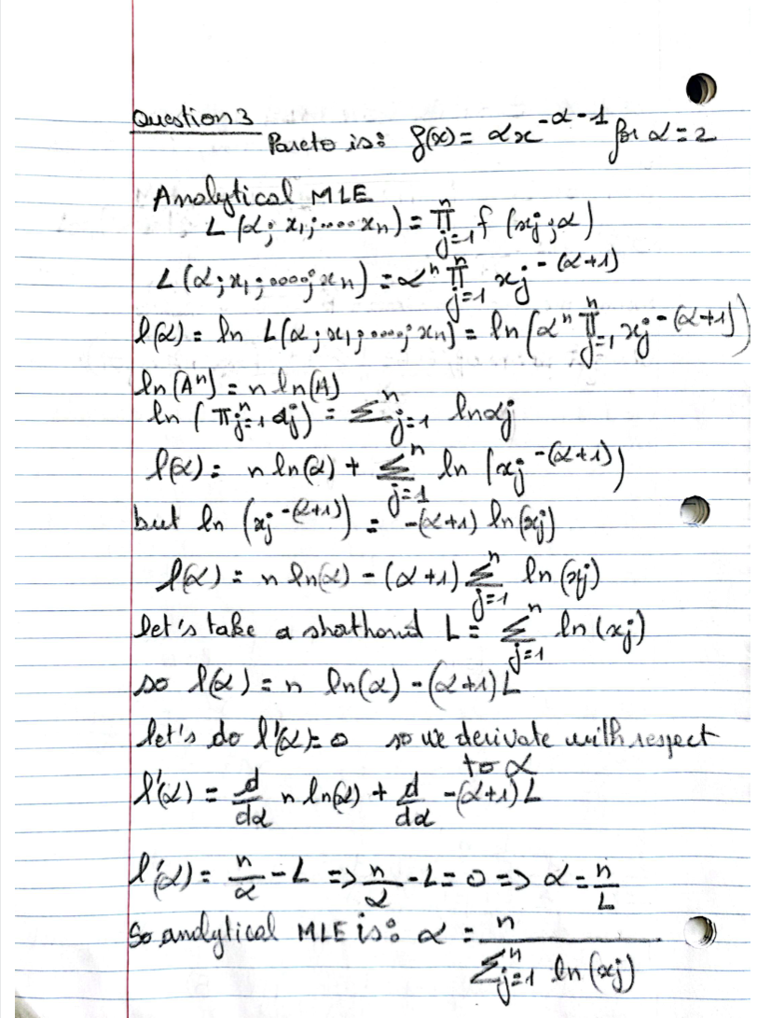
# Analytical MLE function for Pareto distribution.
analytical_MLE <- function(x) {
n <- length(x)
return(n / sum(log(x)))
}

calculate MLE using nr algorithm
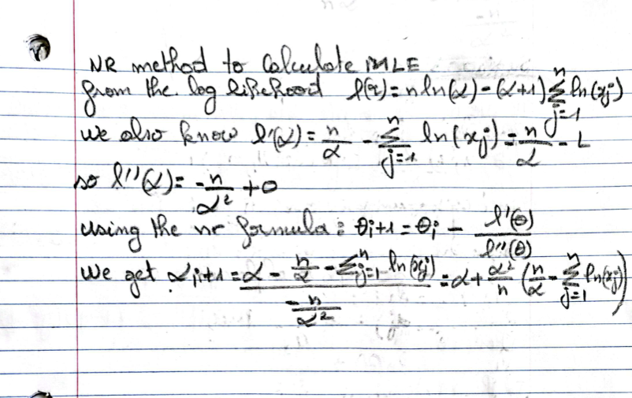# Newton-Raphson algorithm to find the root of l'(alpha)=0.
# x here represents the data vector.
NR <- function(x, theta0, tol = 1e-6, maxit = 1000) {
theta <- theta0
n <- length(x)
L <- sum(log(x)) # L = sum_{j=1}^n ln(x_j)
for (i in 1:maxit) {
# First derivative: l'(theta) = n/theta - L
lprime <- n/theta - L
# Second derivative: l''(theta) = -n/theta^2
lprime2 <- - n/theta^2
theta_new <- theta - lprime / lprime2
if (abs(theta_new - theta) < tol) break
theta <- theta_new
}
return(theta)
}

comparison
For the comparison i will use the mean and standart deviation
# Set seed for reproducibility
set.seed(123)
# Parameters
alpha_true <- 2
n <- 1000 # sample size
m <- 100 # number of replications
# Vectors to store estimates
analytical_estimates <- numeric(m)
NR_estimates <- numeric(m)
# Repeat the procedure m times
for (i in 1:m) {
x <- rpareto(n, alpha_true)
analytical_estimates[i] <- analytical_MLE(x)
# Apply Newton-Raphson to obtain MLE, using an initial guess, e.g., theta0 = 1
NR_estimates[i] <- NR(x, theta0 = 1)
}
# Compare the results
cat("Analytical MLE: Mean =", mean(analytical_estimates), "SD =", sd(analytical_estimates), "\n")
## Analytical MLE: Mean = 2.006097 SD = 0.05570272
cat("Newton-Raphson MLE: Mean =", mean(NR_estimates), "SD =", sd(NR_estimates), "\n")
## Newton-Raphson MLE: Mean = 2.006097 SD = 0.05570272
When we repeat the procedure 100 times, we obtain 100 estimates of α for each method. Taking the mean of these estimates provides a summary of the overall accuracy of the estimation procedure—ideally, the mean should be very close to the true value (α=2). In addition, computing the standard deviation (SD) of these estimates gives us an indication of the variability or dispersion of the estimates. A low SD means that the method produces similar estimates across different samples, indicating that it is stable and reliable.

question4
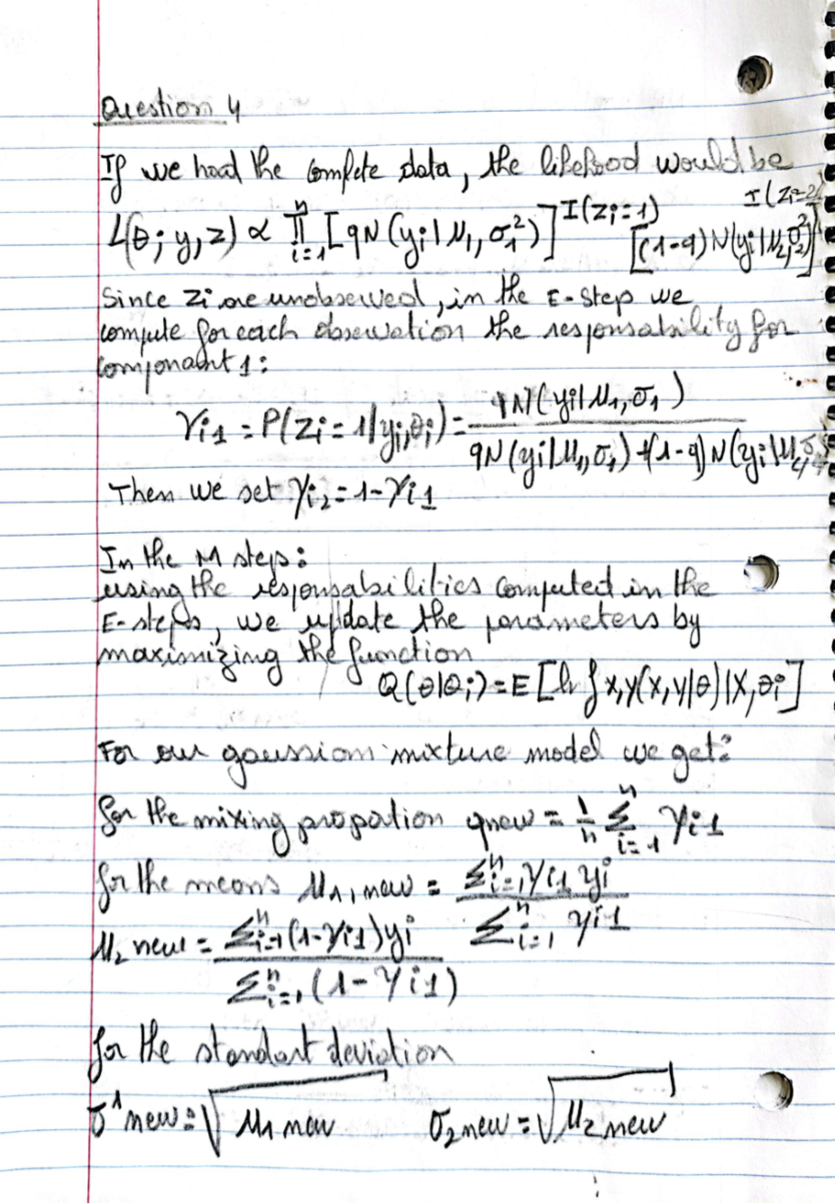

Part 1:
In this problem we know that zi is unobserved, so we will use EM algorithm to fit this model
# EM algorithm for a two-component Gaussian mixture model
EM_gauss_mix <- function(y, theta0, tol = 1e-6, maxit = 1000) {
# theta0: initial parameter vector (q, mu1, mu2, sigma1, sigma2)
theta <- theta0
iter <- 0
n <- length(y)
while (iter < maxit) {
# Extract current parameter estimates
q <- theta[1]
mu1 <- theta[2]
mu2 <- theta[3]
sigma1 <- theta[4]
sigma2 <- theta[5]
# E-step: compute responsibilities for each observation
# Use log-densities for numerical stability
log_tau1 <- log(q) + dnorm(y, mean = mu1, sd = sigma1, log = TRUE)
log_tau2 <- log(1 - q) + dnorm(y, mean = mu2, sd = sigma2, log = TRUE)
# Convert log-densities to densities and normalize:
gamma1 <- exp(log_tau1) / (exp(log_tau1) + exp(log_tau2))
gamma2 <- 1 - gamma1 # responsibility for component 2
# M-step: update the parameters using the responsibilities
q_new <- mean(gamma1)
mu1_new <- sum(gamma1 * y) / sum(gamma1)
mu2_new <- sum(gamma2 * y) / sum(gamma2)
sigma1_new <- sqrt(sum(gamma1 * (y - mu1_new)^2) / sum(gamma1))
sigma2_new <- sqrt(sum(gamma2 * (y - mu2_new)^2) / sum(gamma2))
theta_new <- c(q_new, mu1_new, mu2_new, sigma1_new, sigma2_new)
# Check for convergence: stop if the maximum change in parameters is below tol
if (max(abs(theta_new - theta)) < tol) break
theta <- theta_new
iter <- iter + 1
}
return(list(theta_hat = theta, iterations = iter))
}

Part 2:
We now run the algorithm from several different initializations and compare the results.
# Provided dataset from Houtot et al. 2002 (Geophysics)
y_data <- c(8.1, 8.2, 8.1, 8.2, 8.2, 7.4, 7.3, 7.4, 8.1, 8.1, 7.9, 7.8, 8.2, 7.9, 7.9, 8.1, 8.1)
# Different initializations for parameters
# Format: theta0 = (q, mu1, mu2, sigma1, sigma2)
init1 <- c(0.5, 7.5, 8.5, 0.5, 0.5)
init2 <- c(0.3, 7.8, 8.0, 0.3, 0.3)
init3 <- c(0.7, 7.2, 8.4, 0.7, 0.7)
# Run the EM algorithm for each initialization
result1 <- EM_gauss_mix(y_data, init1)
result2 <- EM_gauss_mix(y_data, init2)
result3 <- EM_gauss_mix(y_data, init3)
cat("EM Algorithm Results:\n")
## EM Algorithm Results:
cat("Initialization 1:\n")
## Initialization 1:
print(result1$theta_hat)
## [1] 0.44742083 7.69530202 8.14025989 0.27766802 0.04905319
cat("Number of iterations:", result1$iterations, "\n\n")
## Number of iterations: 18
cat("Initialization 2:\n")
## Initialization 2:
print(result2$theta_hat)
## [1] 0.17647015 7.36666659 8.06428536 0.04714048 0.12877056
cat("Number of iterations:", result2$iterations, "\n\n")
## Number of iterations: 16
cat("Initialization 3:\n")
## Initialization 3:
print(result3$theta_hat)
## [1] 0.44742325 7.69530445 8.14025988 0.27766925 0.04905319
cat("Number of iterations:", result3$iterations, "\n\n")
## Number of iterations: 14
These results show that the EM algorithm converged to different parameter estimates depending on the initial guess. Initializations 1 and 3 reached nearly the same solution, while Initialization 2 ended at a distinctly different set of parameters. This indicates the presence of multiple local maxima in the likelihood landscape. Consequently, the EM algorithm can produce different solutions unless one carefully chooses starting points or compares final likelihood values. That’s why we use multiple initialisation.

question 5

a-Calcul of the log likehood and it’s derivative

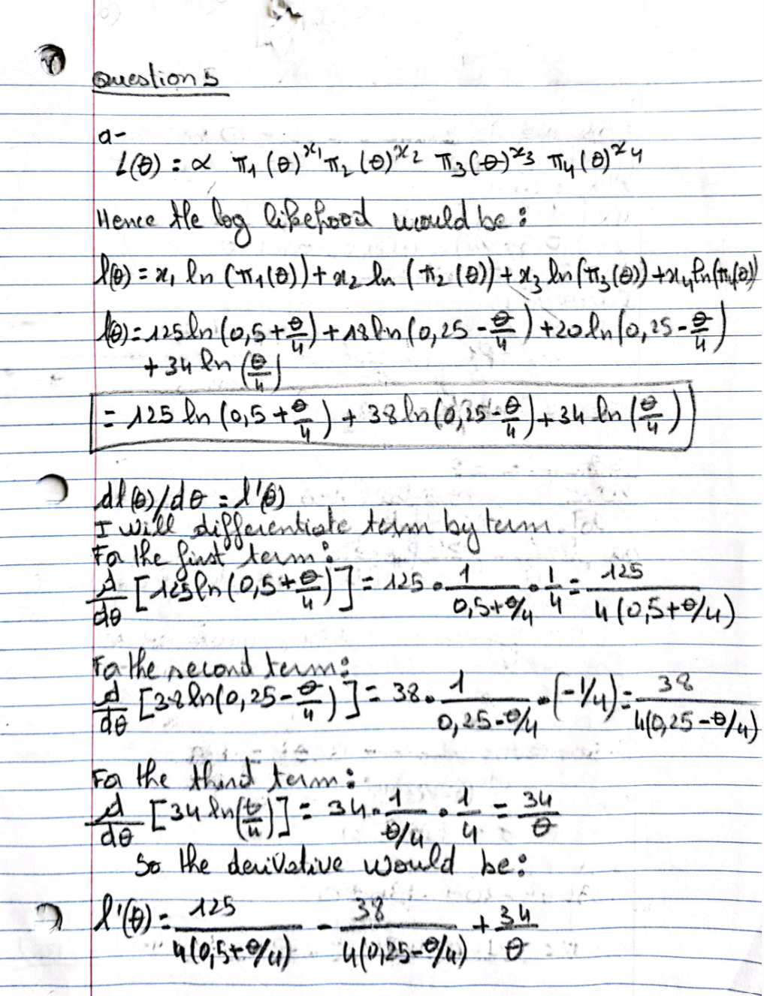

b- Find the MLE of theta

Finally yes i can confirm that the solution theta =0.626, indeed lies within the interval (0,1)

c- Plot the log-likelihood function and its derivative. Evaluate the estimate using the data provided.
x1 <- 125; x2 <- 18; x3 <- 20; x4 <- 34
n <- x1 + x2 + x3 + x4
# I define each pi to avoid writing to many times some terms:
pi1 <- function(th) 0.5 + th/4
pi2 <- function(th) 0.25 - th/4
pi3 <- function(th) 0.25 - th/4
pi4 <- function(th) 1 - (pi1(th) + pi2(th) + pi3(th))
# log-likelihood
ell <- function(th) {
return(x1*log(pi1(th)) + x2*log(pi2(th)) + x3*log(pi3(th)) + x4*log(pi4(th)))
}
# derivative
ell_prime <- function(th) {
return((125 / (4 * (0.5 + th/4)))- (38 / (4 * (0.25 - th/4)))+ (34 / th))
}
# Plot:
theta_seq <- seq(0.001, 0.999, length.out = 500)
ell_values <- unlist(sapply(theta_seq, ell))
plot(theta_seq, ell_values, type="l", main="Log-likelihood", xlab="theta", ylab="ell(theta)")
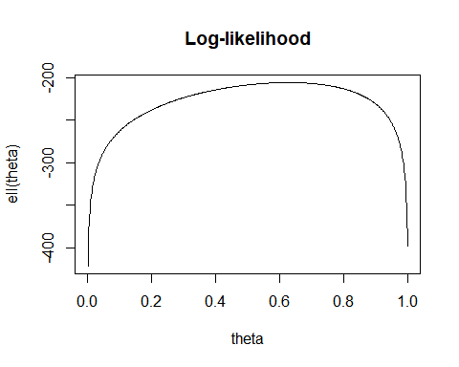
ellp_values <- unlist(sapply(theta_seq, ell_prime))
plot(theta_seq, ellp_values, type="l", main="Derivative of log-likelihood", xlab="theta", ylab="ell'(theta)")
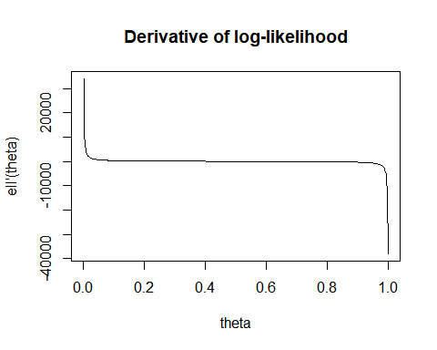

To evaluate the estimate, I first computed the log-likelihood function ℓ(θ) for a range of θ values (from 0.001 to 0.999) using the observed counts x=(125,18,20,34). Then, I plotted both ℓ(θ) and its derivative ℓ′(θ)to visually inspect where the log-likelihood reached its maximum and where the derivative crossed zero. By identifying the value of θ at which the derivative is nearly zero and the log-likelihood is highest, I found that the estimate is approximately θ≈0.626. Finally, I confirmed that this value satisfies the constraint θ∈(0,1) and represents the maximum likelihood estimate given the data.

d- Newton’s method
# Define the first derivative of the log-likelihood
ell_prime <- function(th) {
return((125 / (4 * (0.5 + th/4)))- (38 / (4 * (0.25 - th/4)))+ (34 / th))
}
# Define the second derivative of the log-likelihood
ell_second <- function(th) {
return((-125 / (16 * (0.5 + th/4)^2))+(-38 / (16 * (0.25 - th/4)^2))+(-34 / (th^2)))
}
# Newton-Raphson algorithm to solve ell'(theta)=0
NR <- function(theta0, tol=1e-6, maxit=1000) {
th <- theta0
for (i in 1:maxit) {
d1 <- ell_prime(th)
d2 <- ell_second(th)
th_new <- th - d1/d2
if (abs(th_new - th) < tol) break
th <- th_new
}
return(th)
}
theta_NR <- NR(0.5)
cat("Newton's method result:", theta_NR, "\n")
## Newton's method result: 0.6268215

Removed. The reason: since we have complete data, EM is not useful, but here is what i did
e- Em algorithm
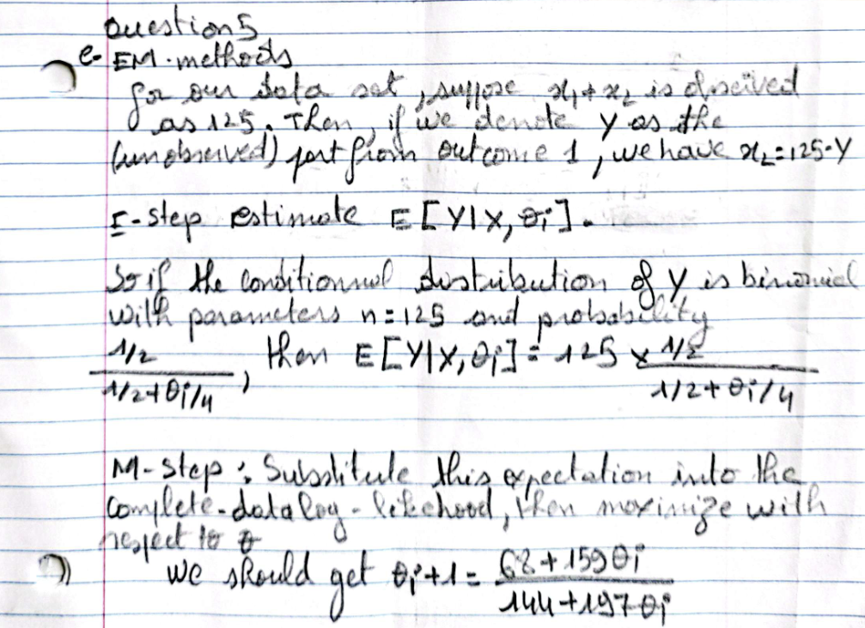
EM_multinomial <- function(theta0, tol = 1e-6, maxit = 1000) {
th <- theta0
iter <- 0
while (iter < maxit) {
p <- (0.5) / (0.5 + th/4)
E_Y <- 125 * p
# M-step: update theta using the closed-form update
th_new <- (68 + 159 * th) / (144 + 197 * th)
if (abs(th_new - th) < tol) break
th <- th_new
iter <- iter + 1
}
return(list(theta_hat = th, iterations = iter))
}
theta_EM <- EM_multinomial(0.5)
cat("EM Algorithm:\n")
## EM Algorithm:
cat("Solution by EM (theta) =", theta_EM$theta_hat, "after", theta_EM$iterations, "iterations.\n")
## Solution by EM (theta) = 0.6268207 after 6 iterations.

f- Gradient descent method (ascent)
we want to maximise here so instead of using the formula for gradient descent we will change the signs to plus to make it gradient ascent.

SimpleGrad <- function(grad, n, gamma, x0) {
res <- rep(x0, n+1)
for(i in 1:n) {
res[i+1] <- res[i] + gamma[i] * grad(res[i])
}
return(res)
}
n_iter <- 1000
gamma_vec <- rep(0.0001, n_iter)
theta_values <- SimpleGrad(ell_prime, n_iter, gamma_vec, 0.5)
theta_GA <- tail(theta_values, 1)
cat("Gradient Ascent:\n")
## Gradient Ascent:
cat("Solution by Gradient Ascent (theta) =", theta_GA, "\n")
## Solution by Gradient Ascent (theta) = 0.6268215
For the EM method I initially set the learning rate to 0.01 for the gradient ascent algorithm, but the result was far off (around –63.95), which indicated that the step size was too high and causing the updates to overshoot the optimum. Realizing this, I reduced the learning rate to 0.0001, which provided more gradual updates and allowed the algorithm to converge steadily to the correct value of approximately 0.626.

