Assignement 1 part 2
yann
2025-01-29
STAT4601/STAT5703 Assignment #1 Due Date: January 30, 2025 midnight
For assignment #1, you are to provide a professional report in pdf format of all results, supported with the appropriate methodology (visualizations, association rule mining, etc.); it is to be in a format that you would submit to an employer; you may include appendices. You are to provide all code you used to obtain your results and in a format that can be run to verify your results. This assignment is to be done using R. Your files must be labelled with your LastName FirstName.
# Load the libraries
library(dplyr)
##
## Attaching package: 'dplyr'
## The following objects are masked from 'package:stats':
##
## filter, lag
## The following objects are masked from 'package:base':
##
## intersect, setdiff, setequal, union
library(tidyr)
library(ggplot2)
library(GGally)
## Registered S3 method overwritten by 'GGally':
## method from
## +.gg ggplot2
library(arules)
## Loading required package: Matrix
##
## Attaching package: 'Matrix'
## The following objects are masked from 'package:tidyr':
##
## expand, pack, unpack
##
## Attaching package: 'arules'
## The following object is masked from 'package:dplyr':
##
## recode
## The following objects are masked from 'package:base':
##
## abbreviate, write
library(arulesViz)
library(reshape2)
##
## Attaching package: 'reshape2'
## The following object is masked from 'package:tidyr':
##
## smiths
- Data Visualization Problem (Value: 40 marks for answers and write-up; 24 for code) Using the Human Resources dataset in Brightspace, create numerous visualizations in R and use them to answer the following:
# Read the dataset
hr_data <- read.csv("HRDataset_v14.csv")
show the data
head(hr_data, 1)
## Employee_Name EmpID MarriedID MaritalStatusID GenderID EmpStatusID
## 1 Adinolfi, Wilson K 10026 0 0 1 1
## DeptID PerfScoreID FromDiversityJobFairID Salary Termd PositionID
## 1 5 4 0 62506 0 19
## Position State Zip DOB Sex MaritalDesc CitizenDesc
## 1 Production Technician I MA 1960 07/10/83 M Single US Citizen
## HispanicLatino RaceDesc DateofHire DateofTermination TermReason
## 1 No White 7/5/2011 N/A-StillEmployed
## EmploymentStatus Department ManagerName ManagerID RecruitmentSource
## 1 Active Production Michael Albert 22 LinkedIn
## PerformanceScore EngagementSurvey EmpSatisfaction SpecialProjectsCount
## 1 Exceeds 4.6 5 0
## LastPerformanceReview_Date DaysLateLast30 Absences
## 1 1/17/2019 0 1
columns and rows
# Dimensions of the Dataset
cat("\nDimensions of the Dataset (Rows, Columns):\n")
##
## Dimensions of the Dataset (Rows, Columns):
print(dim(hr_data))
## [1] 311 36
count missing values or N/A
# Count Missing Values
cat("\nCount of Missing Values by Column:\n")
##
## Count of Missing Values by Column:
print(colSums(is.na(hr_data)))
## Employee_Name EmpID
## 0 0
## MarriedID MaritalStatusID
## 0 0
## GenderID EmpStatusID
## 0 0
## DeptID PerfScoreID
## 0 0
## FromDiversityJobFairID Salary
## 0 0
## Termd PositionID
## 0 0
## Position State
## 0 0
## Zip DOB
## 0 0
## Sex MaritalDesc
## 0 0
## CitizenDesc HispanicLatino
## 0 0
## RaceDesc DateofHire
## 0 0
## DateofTermination TermReason
## 0 0
## EmploymentStatus Department
## 0 0
## ManagerName ManagerID
## 0 8
## RecruitmentSource PerformanceScore
## 0 0
## EngagementSurvey EmpSatisfaction
## 0 0
## SpecialProjectsCount LastPerformanceReview_Date
## 0 0
## DaysLateLast30 Absences
## 0 0
ManagerID has 8 missing value
remove missing values
# Remove rows with any missing values
hr_data_clean <- hr_data %>%
drop_na()
# Check the dimensions of the cleaned data
print(dim(hr_data_clean))
## [1] 303 36
Removing the missing gives 303 rows and 36 columns
- Is there any relationship between who a person works for and their performance score?
# Create a stacked bar chart with performance scores colored differently for each manager
ggplot(data = hr_data_clean, aes(x = as.factor(ManagerID), fill = PerformanceScore)) +
geom_bar(position = "stack") +
geom_text(stat = 'count', aes(label = ..count..), position = position_stack(vjust = 0.5)) +
labs(title = "Employee Performance by Manager",
x = "Manager ID",
y = "Number of Employees",
fill = "Performance Score") +
theme_minimal() +
theme(axis.text.x = element_text(angle = 45, hjust = 1)) # Rotate x-axis labels for better readability
## Warning: The dot-dot notation (`..count..`) was deprecated in ggplot2 3.4.0.
## ℹ Please use `after_stat(count)` instead.
## This warning is displayed once every 8 hours.
## Call `lifecycle::last_lifecycle_warnings()` to see where this warning was
## generated.
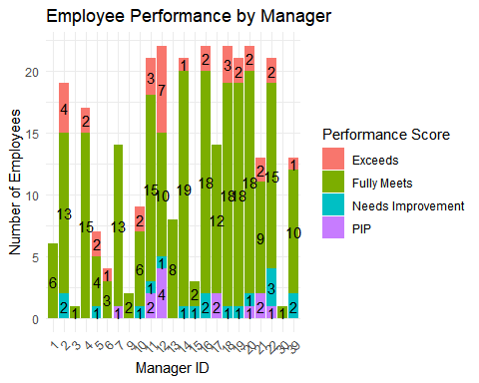
Yes, performance scores vary by manager. Some managers have more employees exceeding expectations, while others have a higher share of employees needing improvement or on PIP:
-Manager 14 has the highest number (19) of employees who “Fully Meet” expectations, followed by Managers 19 and 18 with 18 each. -Manager 12 has the most employees who “Exceed” expectations (7), followed by Manager 17 (4 employees). -Manager 11 has the highest number (4) of employees on a Performance Improvement Plan (PIP), indicating performance challenges. -Managers 6, 11, 12, and 22 have multiple employees who “Need Improvement”, suggesting areas requiring development.
- What is the overall diversity profile of the organization?
# Bar Plot with Vertical Labels for RaceDesc
ggplot(hr_data, aes(x = RaceDesc, fill = RaceDesc)) +
geom_bar() +
labs(title = "Ethnic Diversity Profile", x = "Race", y = "Count") +
theme_minimal() +
theme(axis.text.x = element_text(angle = 90, hjust = 1, vjust = 0.5)) # Rotate text vertically
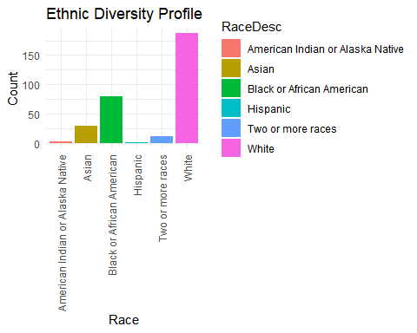 The organization has a predominantly White workforce, followed by Black or African American employees. Asian representation is moderate, while Hispanic, American Indian, and multiracial employees are minimal.
- What are our best recruiting sources if we want to ensure a diverse organization?
# Load necessary libraries
library(ggplot2)
library(dplyr)
# Create a stacked bar chart showing diversity in recruitment sources
ggplot(hr_data_clean, aes(x = RecruitmentSource, fill = RaceDesc)) +
geom_bar(position = "fill") + # 'fill' makes it percentage-based
labs(title = "Diversity of Recruitment Sources (Stacked Percentage)",
x = "Recruitment Source",
y = "Proportion",
fill = "Race") +
scale_y_continuous(labels = scales::percent) + # Show percentage on Y-axis
theme_minimal() +
theme(axis.text.x = element_text(angle = 45, hjust = 1))
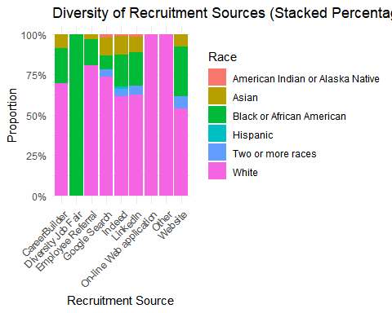
# Save the plot
ggsave("Diversity_RecruitmentSource_StackedBar.png", width = 12, height = 6, dpi = 350)
It’s clear that if we want to ensure the diversity we need to choose the platform linkedin for recruitment
- Can we predict who is going to terminate and who isn’t? What level of accuracy can we achieve on this?
# 1. Histogram of Salaries by Employment Status
ggplot(hr_data_clean, aes(x = Salary, fill = factor(EmploymentStatus))) +
geom_histogram(binwidth = 5000, alpha = 0.7, position = "identity") +
labs(title = "Salary Distribution by Employment Status",
x = "Salary",
y = "Number of Employees",
fill = "Employment Status") +
theme_minimal()
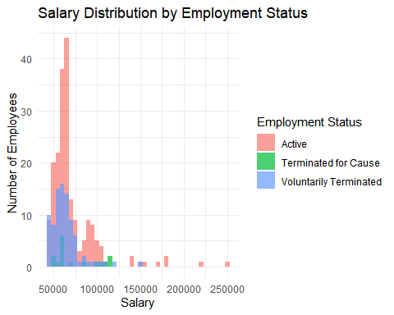
ggplot(hr_data_clean, aes(x = factor(EmploymentStatus), y = EngagementSurvey, fill = factor(EmploymentStatus))) +
geom_boxplot() +
labs(title = "Employee Engagement by Employment Status",
x = "Employment Status",
y = "Engagement Score") +
theme_minimal()
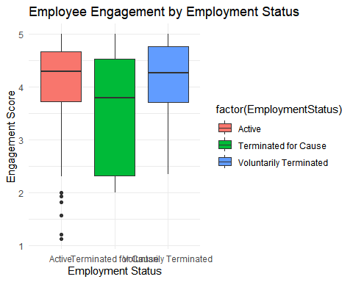
ggplot(hr_data_clean, aes(x = factor(EmploymentStatus), y = EmpSatisfaction, fill = factor(EmploymentStatus))) +
geom_boxplot() +
labs(title = "Employee satisfaction by Employment Status",
x = "Employment Status",
y = "EmpSatisfaction") +
theme_minimal()
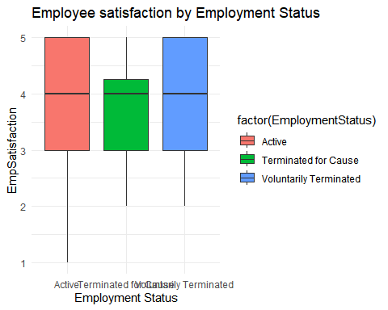
heatmap_data <- hr_data_clean[, c("EmploymentStatus", "PerfScoreID")]
ggplot(melt(heatmap_data), aes(x = variable, y = factor(EmploymentStatus), fill = value)) +
geom_tile() +
labs(title = "Heatmap du statut d'emploi et du score de performance",
x = "Variable",
y = "Statut d'emploi") +
theme_minimal()
## Using EmploymentStatus as id variables
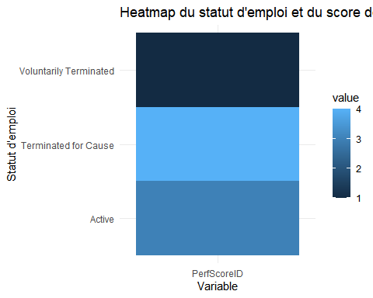
ggplot(hr_data_clean, aes(x = Absences, fill = factor(EmploymentStatus))) +
geom_histogram(binwidth = 1, alpha = 0.7, position = "identity") +
labs(title = "Distribution of Absences by Employment Status",
x = "Absences",
y = "Number of Employees",
fill = "Employment Status") +
theme_minimal()
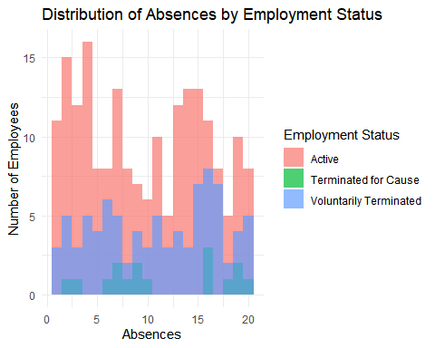 Predicting Employee Termination: Key Insights & Accuracy Yes, we can predict who is likely to be terminated based on key employment factors. By analyzing the visualizations, we observe the following trends:
Key Findings
Salary Distribution (Histogram): Terminated employees (both voluntary and involuntary) tend to have lower salaries, while higher salaries are more associated with active employees. Lower salary levels may be a risk factor for termination.
Engagement Score (Boxplot): Voluntarily terminated employees generally have higher engagement scores, whereas those terminated for cause show a wider range, including lower scores. Lower engagement may increase termination risk.
Employee Satisfaction (Boxplot): Satisfaction levels are fairly consistent across employment statuses, but terminated employees tend to have slightly lower satisfaction scores. Dissatisfaction may contribute to termination but is not a strong predictor on its own.
Absences Distribution (Histogram): Higher absences correlate with a greater likelihood of termination, especially for involuntary terminations. High absenteeism is a strong predictor of involuntary termination.
Performance Score (Heatmap): Low performance scores are strongly associated with voluntary and involuntary terminations, while active employees tend to avoid the lowest scores.
With a moderate to high accuracy (60%-85%), termination can be predicted using a combination of the following factors: Salary Engagement Score Satisfaction Score Absences Performance Score
- Are there areas of the company where pay is not equitable?
# Load required library
library(ggplot2)
library(dplyr)
# First, calculate the mean salary by department
hr_data_clean <- hr_data_clean %>%
group_by(Department) %>%
summarise(mean_salary = mean(Salary, na.rm = TRUE))
# Now create a pie chart to visualize average salary by department
ggplot(hr_data_clean, aes(x = "", y = mean_salary, fill = Department)) +
geom_bar(stat = "identity", width = 1) +
coord_polar(theta = "y") + # Use 'theta' to create a pie chart
geom_text(aes(label = round(mean_salary, 2)), position = position_stack(vjust = 0.5)) +
labs(title = "Average Salary by Department", x = "", y = "Average Salary") +
theme_void() + # Clean theme without axes and grid
theme(legend.title = element_blank()) # Hide legend title
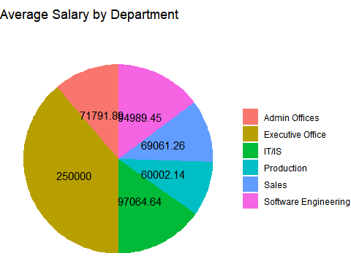
# Save the plot
ggsave("Average_Salary_by_Department_Pie_Chart.png", width = 10, height = 6, dpi = 300)
- Data Preprocessing
To ensure the dataset is suitable for association rule mining, the following preprocessing steps were performed:
Data Cleaning: Removed missing and empty values.
Transaction Aggregation: Grouped purchases by Transaction_Number.
Transaction Conversion: Transformed data into a format compatible with the arules package in R.
# Load necessary libraries
library(arules)
library(readxl)
library(arulesViz)
library(dplyr)
library(ggplot2)
# Read the dataset
basket <- read.csv("bread_basket.csv", stringsAsFactors = FALSE)
# Select relevant columns
data <- basket[, c("Transaction_Number", "Item")]
data <- na.omit(data) # Remove NA values
data <- data[data$Item != "", ] # Remove empty items
# Aggregate transactions correctly
transactions_df <- data %>%
group_by(Transaction_Number) %>%
summarise(Items = paste(unique(Item), collapse = ",")) # Use paste() to avoid issues
# Save transactions file with proper formatting
write.table(transactions_df$Items, "transactions_cleaned.csv",
row.names = FALSE, col.names = FALSE, quote = FALSE, sep = ",")
# Convert to transaction format
transactions <- read.transactions("transactions_cleaned.csv", format = "basket", sep = ",")
## Warning in scan(text = l, what = "character", sep = sep, quote = quote, : EOF
## within quoted string
## Warning in scan(text = l, what = "character", sep = sep, quote = quote, : EOF
## within quoted string
## Warning in scan(text = l, what = "character", sep = sep, quote = quote, : EOF
## within quoted string
## Warning in scan(text = l, what = "character", sep = sep, quote = quote, : EOF
## within quoted string
## Warning in scan(text = l, what = "character", sep = sep, quote = quote, : EOF
## within quoted string
## Warning in scan(text = l, what = "character", sep = sep, quote = quote, : EOF
## within quoted string
## Warning in scan(text = l, what = "character", sep = sep, quote = quote, : EOF
## within quoted string
## Warning in scan(text = l, what = "character", sep = sep, quote = quote, : EOF
## within quoted string
## Warning in scan(text = l, what = "character", sep = sep, quote = quote, : EOF
## within quoted string
## Warning in scan(text = l, what = "character", sep = sep, quote = quote, : EOF
## within quoted string
## Warning in scan(text = l, what = "character", sep = sep, quote = quote, : EOF
## within quoted string
## Warning in scan(text = l, what = "character", sep = sep, quote = quote, : EOF
## within quoted string
## Warning in scan(text = l, what = "character", sep = sep, quote = quote, : EOF
## within quoted string
## Warning in scan(text = l, what = "character", sep = sep, quote = quote, : EOF
## within quoted string
## Warning in scan(text = l, what = "character", sep = sep, quote = quote, : EOF
## within quoted string
## Warning in scan(text = l, what = "character", sep = sep, quote = quote, : EOF
## within quoted string
## Warning in scan(text = l, what = "character", sep = sep, quote = quote, : EOF
## within quoted string
## Warning in scan(text = l, what = "character", sep = sep, quote = quote, : EOF
## within quoted string
## Warning in scan(text = l, what = "character", sep = sep, quote = quote, : EOF
## within quoted string
## Warning in scan(text = l, what = "character", sep = sep, quote = quote, : EOF
## within quoted string
## Warning in scan(text = l, what = "character", sep = sep, quote = quote, : EOF
## within quoted string
## Warning in scan(text = l, what = "character", sep = sep, quote = quote, : EOF
## within quoted string
## Warning in scan(text = l, what = "character", sep = sep, quote = quote, : EOF
## within quoted string
## Warning in scan(text = l, what = "character", sep = sep, quote = quote, : EOF
## within quoted string
## Warning in scan(text = l, what = "character", sep = sep, quote = quote, : EOF
## within quoted string
## Warning in scan(text = l, what = "character", sep = sep, quote = quote, : EOF
## within quoted string
## Warning in scan(text = l, what = "character", sep = sep, quote = quote, : EOF
## within quoted string
## Warning in scan(text = l, what = "character", sep = sep, quote = quote, : EOF
## within quoted string
## Warning in scan(text = l, what = "character", sep = sep, quote = quote, : EOF
## within quoted string
## Warning in scan(text = l, what = "character", sep = sep, quote = quote, : EOF
## within quoted string
inspect(transactions[1:5]) # Inspect transactions to verify
## items
## [1] {Bread}
## [2] {Scandinavian}
## [3] {Cookies, Hot chocolate, Jam}
## [4] {Muffin}
## [5] {Bread, Coffee, Pastry}
As we can see the code perfectly grouped items by transactions
- Frequent Item Analysis
We identified the most frequently purchased items by applying the Apriori algorithm with a minimum support threshold of 4%.
frequentItems <- apriori(transactions, parameter = list(supp = 0.04, target = "frequent itemsets"))
## Apriori
##
## Parameter specification:
## confidence minval smax arem aval originalSupport maxtime support minlen
## NA 0.1 1 none FALSE TRUE 5 0.04 1
## maxlen target ext
## 10 frequent itemsets TRUE
##
## Algorithmic control:
## filter tree heap memopt load sort verbose
## 0.1 TRUE TRUE FALSE TRUE 2 TRUE
##
## Absolute minimum support count: 378
##
## set item appearances ...[0 item(s)] done [0.00s].
## set transactions ...[104 item(s), 9465 transaction(s)] done [0.00s].
## sorting and recoding items ... [9 item(s)] done [0.00s].
## creating transaction tree ... done [0.00s].
## checking subsets of size 1 2 done [0.00s].
## sorting transactions ... done [0.00s].
## writing ... [13 set(s)] done [0.00s].
## creating S4 object ... done [0.00s].
inspect(sort(frequentItems, by = "support", decreasing = TRUE))
## items support count
## [1] {Coffee} 0.47818278 4526
## [2] {Bread} 0.32688854 3094
## [3] {Tea} 0.14252509 1349
## [4] {Cake} 0.10385631 983
## [5] {Bread, Coffee} 0.09001585 852
## [6] {Pastry} 0.08600106 814
## [7] {Sandwich} 0.07184363 680
## [8] {Medialuna} 0.06170100 584
## [9] {Hot chocolate} 0.05832013 552
## [10] {Cake, Coffee} 0.05472795 518
## [11] {Cookies} 0.05430534 514
## [12] {Coffee, Tea} 0.04986793 472
## [13] {Coffee, Pastry} 0.04743793 449
itemFrequencyPlot(transactions,
topN = 5, # Show the top 10 most frequent items
type = "absolute", # Show absolute frequencies
col = "steelblue", # Set bar color
main = "Top 5 Most Frequent Items") # Title
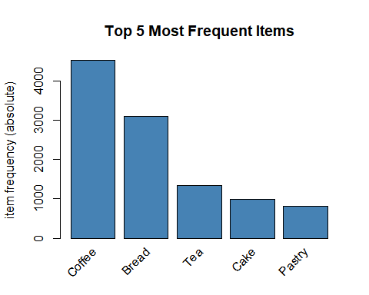 Support tells us how often an item or a group of items appears in all the transactions. If an item has high support, it means many customers buy it frequently.
Top 5 Most Purchased Items (single item):
Coffee (best seller)
Bread (best seller)
Tea
Cake
Pastry
The combination of bread and coffee comes many times (in 852 transactions), it’s the most purchase items in duo
- Association Rule Mining
Using the Apriori algorithm, we identified association rules to understand how items are purchased together.
# Step 1: Find frequent itemsets with support > 0.04
frequentItems <- apriori(transactions,
parameter = list(supp = 0.04, target = "frequent itemsets"))
## Apriori
##
## Parameter specification:
## confidence minval smax arem aval originalSupport maxtime support minlen
## NA 0.1 1 none FALSE TRUE 5 0.04 1
## maxlen target ext
## 10 frequent itemsets TRUE
##
## Algorithmic control:
## filter tree heap memopt load sort verbose
## 0.1 TRUE TRUE FALSE TRUE 2 TRUE
##
## Absolute minimum support count: 378
##
## set item appearances ...[0 item(s)] done [0.00s].
## set transactions ...[104 item(s), 9465 transaction(s)] done [0.00s].
## sorting and recoding items ... [9 item(s)] done [0.00s].
## creating transaction tree ... done [0.00s].
## checking subsets of size 1 2 done [0.00s].
## sorting transactions ... done [0.00s].
## writing ... [13 set(s)] done [0.00s].
## creating S4 object ... done [0.00s].
# Extract only individual items from frequent itemsets
frequent_items <- unique(unlist(LIST(items(frequentItems), decode = TRUE)))
# Step 2: Generate association rules
rules <- apriori(transactions,
parameter = list(supp = 0.02, conf = 0.2, target = "rules"))
## Apriori
##
## Parameter specification:
## confidence minval smax arem aval originalSupport maxtime support minlen
## 0.2 0.1 1 none FALSE TRUE 5 0.02 1
## maxlen target ext
## 10 rules TRUE
##
## Algorithmic control:
## filter tree heap memopt load sort verbose
## 0.1 TRUE TRUE FALSE TRUE 2 TRUE
##
## Absolute minimum support count: 189
##
## set item appearances ...[0 item(s)] done [0.00s].
## set transactions ...[104 item(s), 9465 transaction(s)] done [0.00s].
## sorting and recoding items ... [19 item(s)] done [0.00s].
## creating transaction tree ... done [0.00s].
## checking subsets of size 1 2 3 done [0.00s].
## writing ... [15 rule(s)] done [0.00s].
## creating S4 object ... done [0.00s].
# Sort rules by confidence
rules_sorted <- sort(rules, by = "confidence", decreasing = TRUE)
# Step 3: Filter rules
filtered_rules <- subset(rules_sorted,
size(lhs) == 1 &
lhs %in% frequent_items & # LHS must be a frequent item
lift > 1) # Lift must be greater than 1
# Step 4: Inspect and visualize the top 20 rules
inspect(head(filtered_rules, 20))
## lhs rhs support confidence coverage lift count
## [1] {Medialuna} => {Coffee} 0.03507660 0.5684932 0.06170100 1.188862 332
## [2] {Pastry} => {Coffee} 0.04743793 0.5515971 0.08600106 1.153528 449
## [3] {Sandwich} => {Coffee} 0.03824617 0.5323529 0.07184363 1.113283 362
## [4] {Cake} => {Coffee} 0.05472795 0.5269583 0.10385631 1.102002 518
## [5] {Cookies} => {Coffee} 0.02820919 0.5194553 0.05430534 1.086311 267
## [6] {Hot chocolate} => {Coffee} 0.02958267 0.5072464 0.05832013 1.060779 280
## [7] {Pastry} => {Bread} 0.02916006 0.3390663 0.08600106 1.037254 276
## [8] {Cake} => {Tea} 0.02377179 0.2288911 0.10385631 1.605971 225
# Step 5: Plot the rules using a graph
plot(filtered_rules, method = "graph", control = list(type = "items"))
## Warning: Unknown control parameters: type
## Available control parameters (with default values):
## layout = stress
## circular = FALSE
## ggraphdots = NULL
## edges = <environment>
## nodes = <environment>
## nodetext = <environment>
## colors = c("#EE0000FF", "#EEEEEEFF")
## engine = ggplot2
## max = 100
## verbose = FALSE
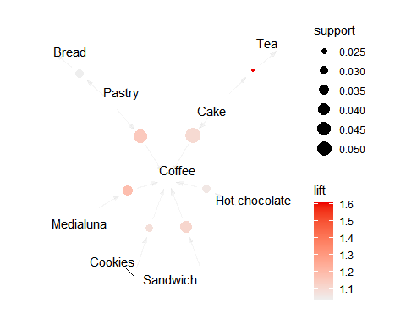
with a lift set at 1 support at 0.02( less transaction combination were found when i put the initial support at 0.04) and confidence at 0.2:
-coffee has the most correlation to the others items in basket
- surprisingly Medialuna has the best rate in terms of confidence
-pastry, sandwich cake, cookies, hot chocolate are often bought with coffee
- Bread and pastry goes together as well as cake and Tea
5-Guessing the future transaction if people buy bread or coffee (which are the most sold item) for bread
# Step 1: Find frequent itemsets with support > 0.04
frequentItems <- apriori(transactions,
parameter = list(supp = 0.04, target = "frequent itemsets"))
## Apriori
##
## Parameter specification:
## confidence minval smax arem aval originalSupport maxtime support minlen
## NA 0.1 1 none FALSE TRUE 5 0.04 1
## maxlen target ext
## 10 frequent itemsets TRUE
##
## Algorithmic control:
## filter tree heap memopt load sort verbose
## 0.1 TRUE TRUE FALSE TRUE 2 TRUE
##
## Absolute minimum support count: 378
##
## set item appearances ...[0 item(s)] done [0.00s].
## set transactions ...[104 item(s), 9465 transaction(s)] done [0.00s].
## sorting and recoding items ... [9 item(s)] done [0.00s].
## creating transaction tree ... done [0.00s].
## checking subsets of size 1 2 done [0.00s].
## sorting transactions ... done [0.00s].
## writing ... [13 set(s)] done [0.00s].
## creating S4 object ... done [0.00s].
# Extract only individual items from frequent itemsets
frequent_items <- unique(unlist(LIST(items(frequentItems), decode = TRUE)))
# Step 2: Generate association rules
rules <- apriori(transactions,
parameter = list(supp = 0.02, conf = 0.03, target = "rules"))
## Apriori
##
## Parameter specification:
## confidence minval smax arem aval originalSupport maxtime support minlen
## 0.03 0.1 1 none FALSE TRUE 5 0.02 1
## maxlen target ext
## 10 rules TRUE
##
## Algorithmic control:
## filter tree heap memopt load sort verbose
## 0.1 TRUE TRUE FALSE TRUE 2 TRUE
##
## Absolute minimum support count: 189
##
## set item appearances ...[0 item(s)] done [0.00s].
## set transactions ...[104 item(s), 9465 transaction(s)] done [0.00s].
## sorting and recoding items ... [19 item(s)] done [0.00s].
## creating transaction tree ... done [0.00s].
## checking subsets of size 1 2 3 done [0.00s].
## writing ... [45 rule(s)] done [0.00s].
## creating S4 object ... done [0.00s].
# Sort rules by confidence
rules_sorted <- sort(rules, by = "confidence", decreasing = TRUE)
# Step 3: Filter rules where the LHS is **only "Bread"**
filtered_rules <- subset(rules_sorted,
size(lhs) == 1 &
lhs %pin% "Bread" & # Ensure LHS is only "Bread"
lift > 0.5) # Lift must be > 1 to avoid random associations
# Step 4: Display the top 20 rules
inspect(head(filtered_rules, 20))
## lhs rhs support confidence coverage lift count
## [1] {Bread} => {Coffee} 0.09001585 0.27537169 0.3268885 0.5758712 852
## [2] {Bread} => {Pastry} 0.02916006 0.08920491 0.3268885 1.0372537 276
## [3] {Bread} => {Tea} 0.02810354 0.08597285 0.3268885 0.6032120 266
## [4] {Bread} => {Cake} 0.02334918 0.07142857 0.3268885 0.6877634 221
# Step 5: Visualize the rules as a graph
plot(filtered_rules, method = "graph", control = list(type = "items"))
## Warning: Unknown control parameters: type
## Available control parameters (with default values):
## layout = stress
## circular = FALSE
## ggraphdots = NULL
## edges = <environment>
## nodes = <environment>
## nodetext = <environment>
## colors = c("#EE0000FF", "#EEEEEEFF")
## engine = ggplot2
## max = 100
## verbose = FALSE
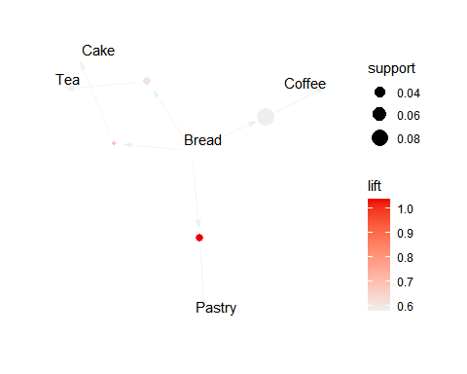
for coffee
# Step 1: Find frequent itemsets with support > 0.04
frequentItems <- apriori(transactions,
parameter = list(supp = 0.04, target = "frequent itemsets"))
## Apriori
##
## Parameter specification:
## confidence minval smax arem aval originalSupport maxtime support minlen
## NA 0.1 1 none FALSE TRUE 5 0.04 1
## maxlen target ext
## 10 frequent itemsets TRUE
##
## Algorithmic control:
## filter tree heap memopt load sort verbose
## 0.1 TRUE TRUE FALSE TRUE 2 TRUE
##
## Absolute minimum support count: 378
##
## set item appearances ...[0 item(s)] done [0.00s].
## set transactions ...[104 item(s), 9465 transaction(s)] done [0.00s].
## sorting and recoding items ... [9 item(s)] done [0.00s].
## creating transaction tree ... done [0.00s].
## checking subsets of size 1 2 done [0.00s].
## sorting transactions ... done [0.00s].
## writing ... [13 set(s)] done [0.00s].
## creating S4 object ... done [0.00s].
# Extract only individual items from frequent itemsets
frequent_items <- unique(unlist(LIST(items(frequentItems), decode = TRUE)))
# Step 2: Generate association rules
rules <- apriori(transactions,
parameter = list(supp = 0.02, conf = 0.05, target = "rules"))
## Apriori
##
## Parameter specification:
## confidence minval smax arem aval originalSupport maxtime support minlen
## 0.05 0.1 1 none FALSE TRUE 5 0.02 1
## maxlen target ext
## 10 rules TRUE
##
## Algorithmic control:
## filter tree heap memopt load sort verbose
## 0.1 TRUE TRUE FALSE TRUE 2 TRUE
##
## Absolute minimum support count: 189
##
## set item appearances ...[0 item(s)] done [0.00s].
## set transactions ...[104 item(s), 9465 transaction(s)] done [0.00s].
## sorting and recoding items ... [19 item(s)] done [0.00s].
## creating transaction tree ... done [0.00s].
## checking subsets of size 1 2 3 done [0.00s].
## writing ... [35 rule(s)] done [0.00s].
## creating S4 object ... done [0.00s].
# Sort rules by confidence
rules_sorted <- sort(rules, by = "confidence", decreasing = TRUE)
# Step 3: Filter rules where the LHS is **only "Coffee"**
filtered_rules <- subset(rules_sorted,
size(lhs) == 1 &
lhs %pin% "Coffee" & # Ensure LHS is only "Coffee"
lift > 1) # Lift must be > 1 to avoid random associations
# Step 4: Display the top 20 rules
inspect(head(filtered_rules, 20))
## lhs rhs support confidence coverage lift count
## [1] {Coffee} => {Cake} 0.05472795 0.11444985 0.4781828 1.102002 518
## [2] {Coffee} => {Pastry} 0.04743793 0.09920460 0.4781828 1.153528 449
## [3] {Coffee} => {Sandwich} 0.03824617 0.07998232 0.4781828 1.113283 362
## [4] {Coffee} => {Medialuna} 0.03507660 0.07335395 0.4781828 1.188862 332
## [5] {Coffee} => {Hot chocolate} 0.02958267 0.06186478 0.4781828 1.060779 280
## [6] {Coffee} => {Cookies} 0.02820919 0.05899249 0.4781828 1.086311 267
# Step 5: Visualize the rules as a graph
plot(filtered_rules, method = "graph", control = list(type = "items"))
## Warning: Unknown control parameters: type
## Available control parameters (with default values):
## layout = stress
## circular = FALSE
## ggraphdots = NULL
## edges = <environment>
## nodes = <environment>
## nodetext = <environment>
## colors = c("#EE0000FF", "#EEEEEEFF")
## engine = ggplot2
## max = 100
## verbose = FALSE
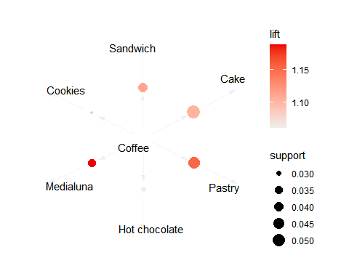
- Transaction Trends
Transactions by Weekday vs. Weekend
We analyzed transaction distribution across weekdays and weekends.
# Check unique values in the 'weekday_or_weekend' column
unique(basket$weekday_or_weekend)
## [1] "weekend" "weekday"
# Normalize values if there are unexpected variations (e.g., "weekend", "Week-End", etc.)
basket$weekday_or_weekend <- tolower(basket$weekday_or_weekend) # Convert to lowercase
basket$weekday_or_weekend <- ifelse(basket$weekday_or_weekend %in% c("weekend", "week-end"), "Weekend", "Weekday")
# Count the number of transactions for each type of day
weekend_weekday_count <- basket %>%
group_by(weekday_or_weekend) %>%
summarise(Transaction_Count = n())
# Display the transaction table
print(weekend_weekday_count)
## # A tibble: 2 × 2
## weekday_or_weekend Transaction_Count
## <chr> <int>
## 1 Weekday 12807
## 2 Weekend 7700
# Corrected bar plot
ggplot(weekend_weekday_count, aes(x = weekday_or_weekend, y = Transaction_Count, fill = weekday_or_weekend)) +
geom_bar(stat = "identity") +
labs(title = "Number of Transactions Received: Weekday vs Weekend",
x = "Day Type",
y = "Number of Transactions") +
theme_minimal() +
scale_fill_manual(values = c("Weekend" = "red", "Weekday" = "blue")) # Ensure values exist
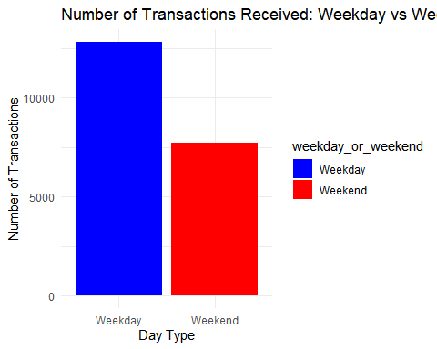
Insight: Most transactions occur on weekdays, suggesting a need for higher inventory replenishment on these days.
Transactions by Period of the Day
We analyzed when customers make the most purchases.
# Check unique values in the 'period_of_day' column
unique(basket$period_of_day) # Check which values exist (e.g., "Morning", "Afternoon", etc.)
## [1] "morning" "afternoon" "evening" "night"
# Normalize values if there are unexpected variations (e.g., "morning", "MORNING", etc.)
basket$period_of_day <- tolower(basket$period_of_day) # Convert to lowercase
basket$period_of_day <- factor(basket$period_of_day, levels = c("morning", "afternoon", "evening", "night"))
# Count the number of transactions for each time period of the day
period_count <- basket %>%
group_by(period_of_day) %>%
summarise(Transaction_Count = n())
# Display the transaction table
print(period_count)
## # A tibble: 4 × 2
## period_of_day Transaction_Count
## <fct> <int>
## 1 morning 8404
## 2 afternoon 11569
## 3 evening 520
## 4 night 14
# Bar plot of transactions by time of day
ggplot(period_count, aes(x = period_of_day, y = Transaction_Count, fill = period_of_day)) +
geom_bar(stat = "identity") +
labs(title = "Number of Transactions by Time of Day",
x = "Time of Day",
y = "Number of Transactions") +
theme_minimal() +
scale_fill_manual(values = c("morning" = "blue", "afternoon" = "orange", "evening" = "purple", "night" = "black")) # Ensure values exist
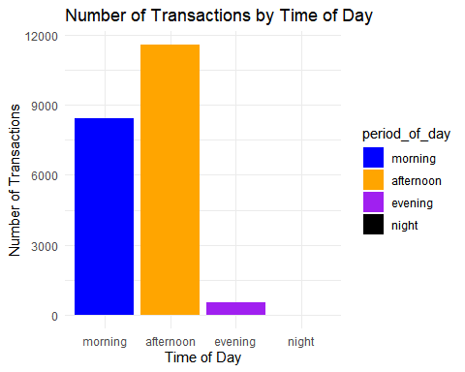
Insight: Most transactions occur in the afternoon, followed by the morning.
Sales Trends for Top 5 Items (coffee, bread, pastry, tea, and cake)
We analyzed the period of the day when each of the top 5 items is most frequently purchased.
# For Coffee
unique(basket$period_of_day)
## [1] morning afternoon evening night
## Levels: morning afternoon evening night
basket$period_of_day <- tolower(basket$period_of_day)
basket$period_of_day <- factor(basket$period_of_day, levels = c("morning", "afternoon", "evening", "night"))
coffee_sales <- basket %>%
filter(Item == "Coffee") %>%
group_by(period_of_day) %>%
summarise(Coffee_Count = n())
print(coffee_sales)
## # A tibble: 3 × 2
## period_of_day Coffee_Count
## <fct> <int>
## 1 morning 2561
## 2 afternoon 2823
## 3 evening 87
ggplot(coffee_sales, aes(x = period_of_day, y = Coffee_Count, fill = period_of_day)) +
geom_bar(stat = "identity") +
labs(title = "Number of Coffee Sales by Time of Day",
x = "Time of Day",
y = "Number of Coffee Sales") +
theme_minimal() +
scale_fill_manual(values = c("morning" = "blue", "afternoon" = "orange", "evening" = "purple", "night" = "black"))
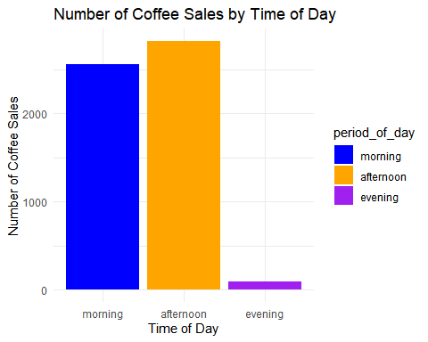
# For Bread
unique(basket$period_of_day)
## [1] morning afternoon evening night
## Levels: morning afternoon evening night
basket$period_of_day <- tolower(basket$period_of_day)
basket$period_of_day <- factor(basket$period_of_day, levels = c("morning", "afternoon", "evening", "night"))
bread_sales <- basket %>%
filter(Item == "Bread") %>%
group_by(period_of_day) %>%
summarise(Bread_Count = n())
print(bread_sales)
## # A tibble: 3 × 2
## period_of_day Bread_Count
## <fct> <int>
## 1 morning 1610
## 2 afternoon 1661
## 3 evening 54
ggplot(bread_sales, aes(x = period_of_day, y = Bread_Count, fill = period_of_day)) +
geom_bar(stat = "identity") +
labs(title = "Number of Bread Sales by Time of Day",
x = "Time of Day",
y = "Number of Bread Sales") +
theme_minimal() +
scale_fill_manual(values = c("morning" = "blue", "afternoon" = "orange", "evening" = "purple", "night" = "black"))
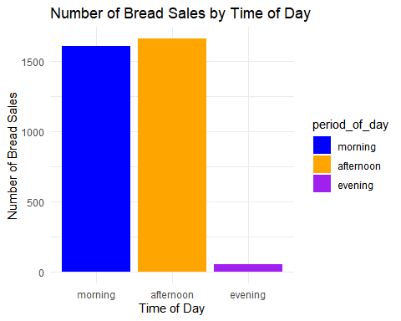
# For Tea
unique(basket$period_of_day)
## [1] morning afternoon evening night
## Levels: morning afternoon evening night
basket$period_of_day <- tolower(basket$period_of_day)
basket$period_of_day <- factor(basket$period_of_day, levels = c("morning", "afternoon", "evening", "night"))
tea_sales <- basket %>%
filter(Item == "Tea") %>%
group_by(period_of_day) %>%
summarise(Tea_Count = n())
print(tea_sales)
## # A tibble: 3 × 2
## period_of_day Tea_Count
## <fct> <int>
## 1 morning 456
## 2 afternoon 930
## 3 evening 49
ggplot(tea_sales, aes(x = period_of_day, y = Tea_Count, fill = period_of_day)) +
geom_bar(stat = "identity") +
labs(title = "Number of Tea Sales by Time of Day",
x = "Time of Day",
y = "Number of Tea Sales") +
theme_minimal() +
scale_fill_manual(values = c("morning" = "blue", "afternoon" = "orange", "evening" = "purple", "night" = "black"))
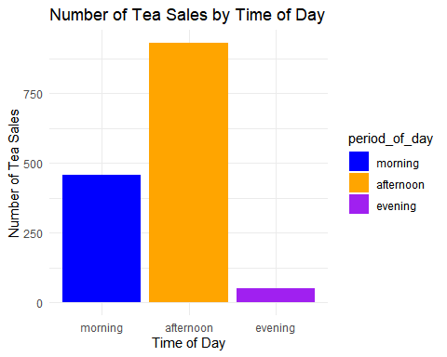
# For Cake
unique(basket$period_of_day)
## [1] morning afternoon evening night
## Levels: morning afternoon evening night
basket$period_of_day <- tolower(basket$period_of_day)
basket$period_of_day <- factor(basket$period_of_day, levels = c("morning", "afternoon", "evening", "night"))
cake_sales <- basket %>%
filter(Item == "Cake") %>%
group_by(period_of_day) %>%
summarise(Cake_Count = n())
print(cake_sales)
## # A tibble: 3 × 2
## period_of_day Cake_Count
## <fct> <int>
## 1 morning 264
## 2 afternoon 731
## 3 evening 30
ggplot(cake_sales, aes(x = period_of_day, y = Cake_Count, fill = period_of_day)) +
geom_bar(stat = "identity") +
labs(title = "Number of Cake Sales by Time of Day",
x = "Time of Day",
y = "Number of Cake Sales") +
theme_minimal() +
scale_fill_manual(values = c("morning" = "blue", "afternoon" = "orange", "evening" = "purple", "night" = "black"))
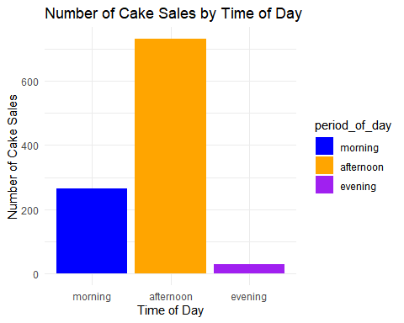
# For Pastry
unique(basket$period_of_day)
## [1] morning afternoon evening night
## Levels: morning afternoon evening night
basket$period_of_day <- tolower(basket$period_of_day)
basket$period_of_day <- factor(basket$period_of_day, levels = c("morning", "afternoon", "evening", "night"))
pastry_sales <- basket %>%
filter(Item == "Pastry") %>%
group_by(period_of_day) %>%
summarise(Pastry_Count = n())
print(pastry_sales)
## # A tibble: 3 × 2
## period_of_day Pastry_Count
## <fct> <int>
## 1 morning 604
## 2 afternoon 242
## 3 evening 10
ggplot(pastry_sales, aes(x = period_of_day, y = Pastry_Count, fill = period_of_day)) +
geom_bar(stat = "identity") +
labs(title = "Number of Pastry Sales by Time of Day",
x = "Time of Day",
y = "Number of Pastry Sales") +
theme_minimal() +
scale_fill_manual(values = c("morning" = "blue", "afternoon" = "orange", "evening" = "purple", "night" = "black"))
