Carleton University

Report: Automobile car predictions

Submitted to Dr Shirley Mills
From Yann-Emmanuel Obrou

2025-04-06



Summary
In today’s competitive automotive market, accurate price prediction is crucial for manufacturers, dealers, and market analysts. Our project was designed to address this need by developing a comprehensive data mining framework that not only predicts automobile prices using supervised learning techniques but also uncovers natural groupings within the data through unsupervised learning. The goal was to provide actionable insights that can drive strategic decision-making in automotive pricing and market segmentation.
Objective of the analysis
The goal was to provide actionable insights that can drive strategic decision-making in automotive pricing and market segmentation, to be able to do that :
- Visualizes key data characteristics and model outcomes in a clear, actionable format for stakeholders.
- Reduces data dimensions to simplify the modeling process while preserving key information.
- Discovers natural groupings (clusters) in the data through unsupervised learning
- Predicts automobile prices using various supervised learning models.

Data cleaning
The data set was taken from UCI Automobile Data Repository, originally comprised 205 observations and 26 features (including engine specifications, body style, and price). we checked the data info and found 10 categorical variables, and the rest are numerical Given the messy nature of real-world data, our initial steps focused on ensuring data quality:
- Missing Value Treatment:
We replaced all “?” symbols with NA and then imputed missing values. For numeric features (e.g., normalized losses), we substituted missing values with the mean of all values present in this variable. For categorical variables (such as num_of_doors), missing values were replaced with the mode ("four"), why four? it’s because most of the car in our data set have four door which also match what happens in real life . This step was crucial to avoid biased model estimates and to ensure consistency across our analysis.
- Data Type Conversion:
We explicitly converted numerical fields from character to numeric types and transformed categorical fields into factors. This conversion is necessary for both proper statistical analysis and for enabling algorithms to process the data accurately.
- Verification:
Post-cleaning, our dataset (data_cleaned) showed no missing values or duplicates, maintaining its original shape of 205×26. This thorough cleaning process ensured a reliable foundation for subsequent analysis.

Data visualization and interpretation
Our data visualization efforts played a critical role in understanding the structure and relationships within the automobile dataset, ultimately guiding our predictive and clustering analyses. Through a series of thoughtfully constructed graphs, we uncovered several key insights that directly inform our pricing strategy and market segmentation. We will talk only about the major findings ; the rest of the visualization can be found by running the code.

Univariate analysis
For numerical data
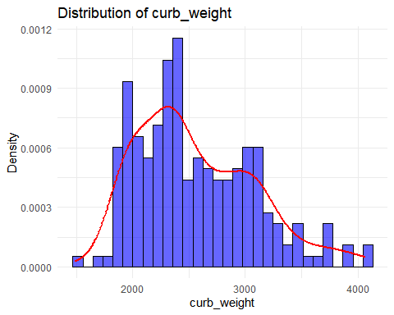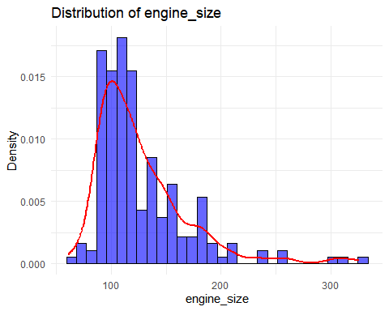
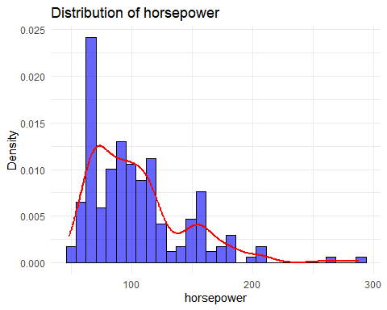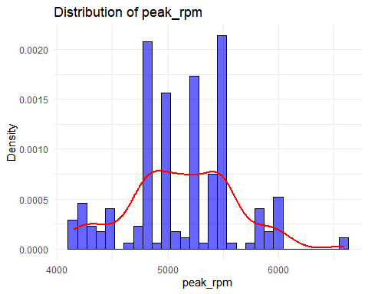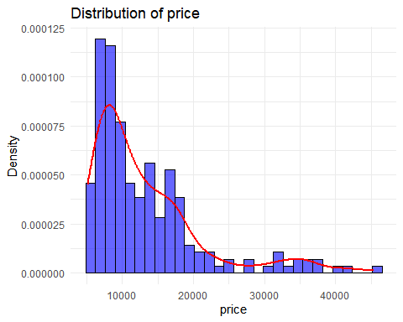

Findings
- Most of the car has a Curb Weight is in range 1900 to 3100
- The Engine Size is in range 60 to 190
- Most vehicle has horsepower 50 to 125
- Most Vehicle are in price range 5000 to 18000
- peak rpm is mostly distributed between 4600 to 5700

For categorical data

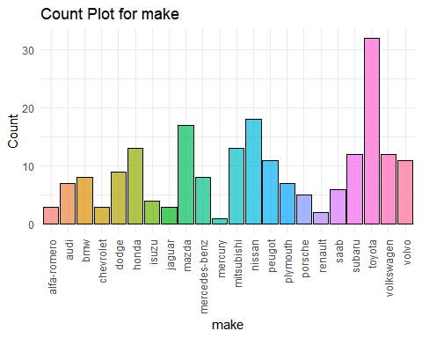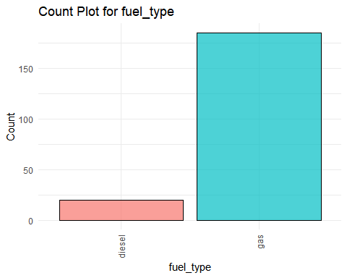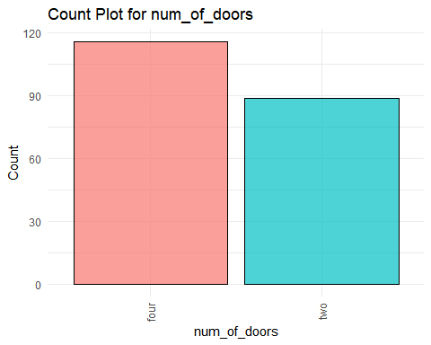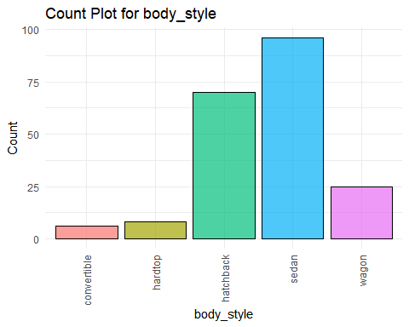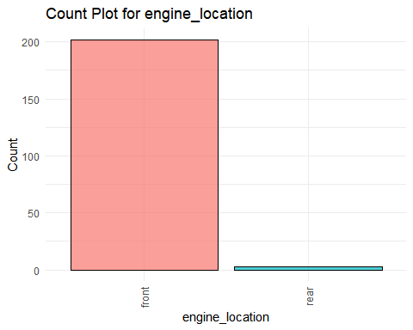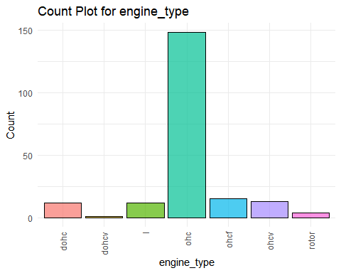

- More than 70 % of the vehicle has Ohc type of Engine
- 57% of the cars has 4 doors
- Gas is preferred by 85 % of the vehicles
- Most produced vehicle are of body style sedan around 48% followed by hatchback 32%
- Without surprise most vehicles have the engine located at the front

Bivariate analysis
For the bivariate analysis I principally focus on correlating the categorical and numerical variable to price , since price is the output variable that we will try to predict, I decide to use it to visually check the key factor that can influence price.
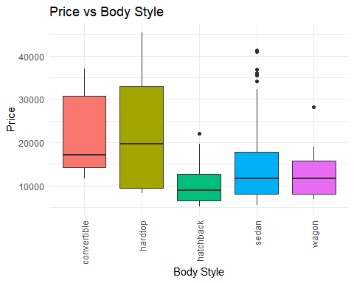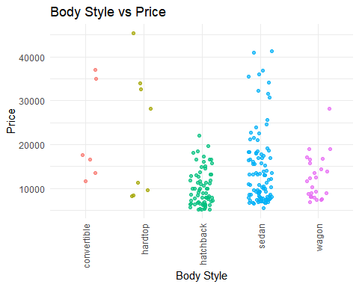

- Hardtop model are expensive in prices followed by convertible and sedan body style
- Turbo models have higher prices than for the standard model
- Convertible has only standard edition with expensive cars
- hatchback and sedan turbo models are available below 20000

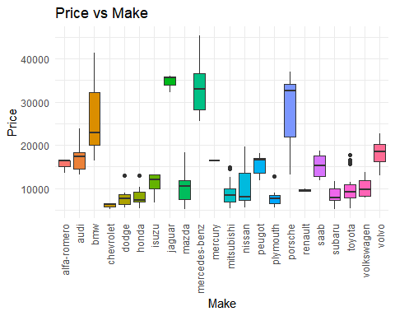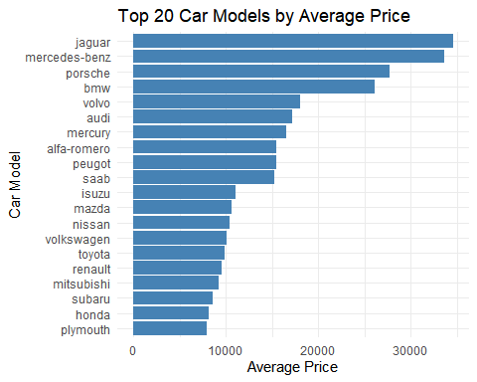

- Mercedez-Benz ,BMW, Jaguar, Porshe produces expensive cars more than 25000
- Cheverolet , Dodge, Honda,Mitbushi, Nissan,Plymouth Subaru,Toyata produces budget models with lower prices
- most of the cars comapany produces car in range below 2500

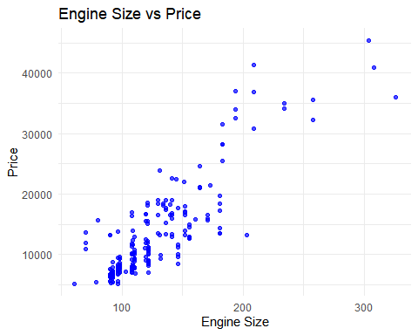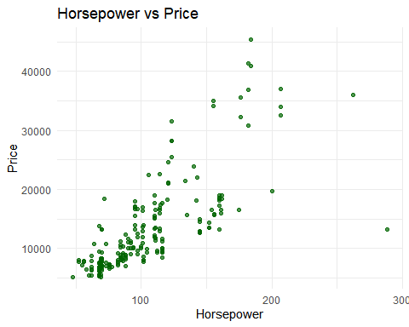
- Price increases when the engine size increases
- For horsepower below 100 the price is around 10000, the more the horsepower increase the more the price go up as well
- Engine size and horsepower are positively correlated to price

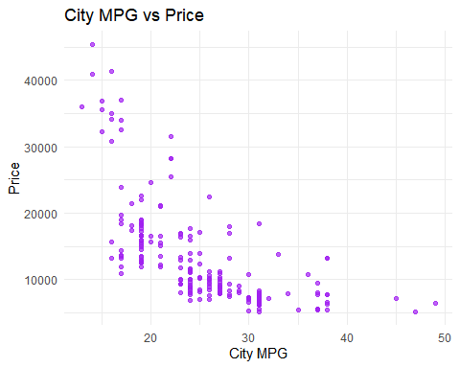
- Less value in City Miles Per Gallon yields to a higher price , so the more you have the less the price would be
- This indicates that CityMpg is negatively correlated to Price , which means It tends to decrease the price value

Correlation for numerical data
The bivariate analysis was more focused on the categorical variables , here is a correlation analysis for numerical variables. It will show the key variables to pay attention to for price prediction
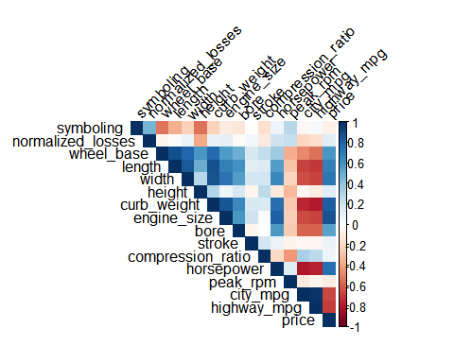
Findings:
- curb-size, engine-size, horsepower are positively corelated
- city-mpg,highway-mpg are negatively corelated

Partial conclusion for Data visualisation
Our data visualizations revealed critical patterns: most vehicles fall within defined ranges for attributes like curb weight, engine size, horsepower, and price, while key categorical factors—such as engine type, door count, and body style—significantly influence price levels, with premium brands commanding higher prices. These insights not only confirm the importance of performance and efficiency metrics in pricing decisions but also provide a solid foundation for our predictive models and market segmentation strategies.

Data Preprocessing and Encoding
We began by transforming our cleaned automobile dataset to prepare it for robust analysis. First, we created a working copy (Mle_data) and identified the categorical variables—such as make, fuel type, aspiration, and others—which were then encoded into numeric values using label encoding. This conversion was crucial for enabling distance-based clustering and predictive modeling. Next, we standardized the entire dataset via Z-score normalization to generate auto_norm, ensuring all features are on a comparable scale and preventing any single variable from dominating the analysis. Finally, we performed outlier detection using the Interquartile Range (IQR) method, which quantified potential anomalies in key features.
In simple word this preprocessing steps is to enhance data quality for our statistical models but also to ensure that our results are both accurate and actionable for strategic decision-making in the automotive market.

MLA
Unsupervised learning
In this phase, we applied unsupervised learning techniques to uncover natural groupings within the automobile dataset, a critical step for understanding market segmentation and refining our pricing strategy. Our approach involved data reduction through normalization and dimension reduction, followed by clustering using both K-Means and CLARA algorithms.
Clustering analysis
First here we evaluated the clusterability of the data by computing the Hopkins statistic, which confirmed that the dataset had a significant tendency to cluster (Hopkins statistic ≈ 0.84). In other words ,it indicates that the data naturally forms distinct groups rather than being randomly distributed. This means there are clear, inherent market segments within the data that we can leverage for targeted pricing and marketing strategies.
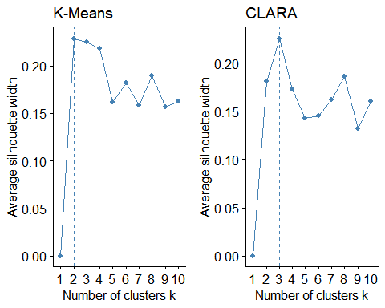
Using the silhouette and elbow methods, we determined that the optimal number of clusters ranged between 2 and 3. This can potentially mean that we have 2 to 3 grouping

Kmean clustering
The variance explained confirmed the optimal cluster of 2
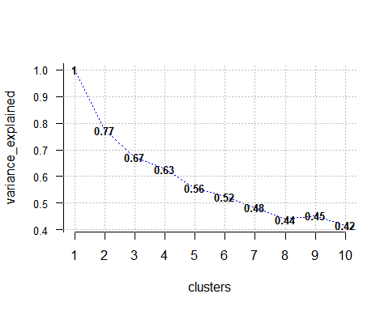

Visualization through cluster plots and silhouette plots revealed that one cluster was notably more compact (with an average silhouette width of 0.32) compared to the other (0.10). This suggests differentiated groupings in terms of key features that drive price or it can simply be the group for expensive car , and low cost car.

cluster | size | ave.sil.width
1 | 119 | 0.32
2 | 86 | 0.1

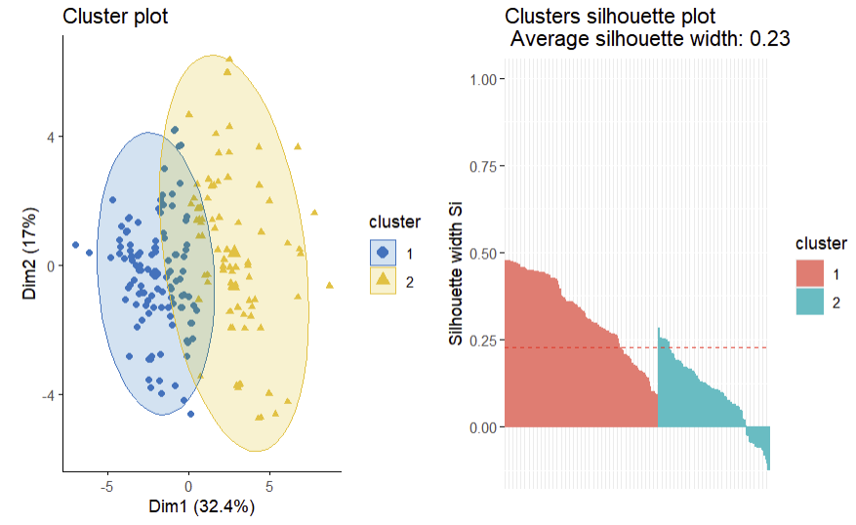
The rest of the plot for kmeans can be found by running the code .

Clara

cluster | size | ave.sil.width
1 | 46 | 0.08
2 | 107 | 0.31
3 | 52 | 0.17

To provide an alternative perspective, we applied CLARA, an algorithm suited for larger datasets, which partitioned the data into 3 clusters. The resulting visualizations confirmed moderate separation among clusters, highlighting the existence of additional nuances in the dataset.

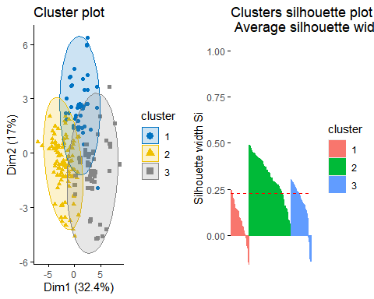

Partial conclusion for clustering analysis
These clustering analyses are highly impactful for our overall objective. The distinct segments uncovered suggest that the market can be divided into groups (also 3) with unique characteristics—for instance, one cluster may represent high-performance, premium vehicles (with larger engine sizes and higher horsepower), while another may consist of more economical models. Next, we will perform PCA

Principal Component Analysis (PCA)
In order to reduce the dimensional complexity of our dataset and highlight the features most relevant to price prediction and market segmentation, we applied Principal Component Analysis (PCA) to the normalized data (auto_norm). By transforming the original features into a set of uncorrelated principal components, PCA enables us to focus on the core drivers of variance in the dataset without losing crucial information.
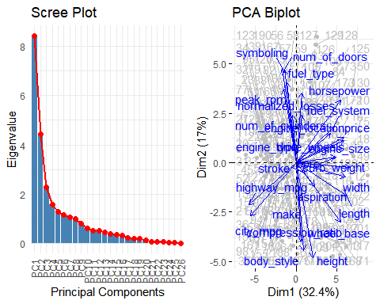

The scree plot shows that the first few principal components capture a large portion of the total variance. This indicates that focusing on a subset of these components can significantly reduce the dataset’s complexity while retaining its essential patterns.
The PCA biplot provides a visual map of both observations and features in the reduced space. Observations that cluster together in this space share similar overall profiles, while features that point in similar directions correlate with one another.

The PCA table was very long but here are the takeaway. It reveal how each feature contributes to the principal components. For example, higher loadings for variables like curb_weight, engine_size, and horsepower on certain components suggest these performance-related attributes strongly influence the dataset’s variance. Meanwhile, price itself loads significantly on components that capture high-performance or premium vehicle characteristics.

Supervised learning
To achieve our primary objective of accurately predicting automobile prices, we developed several predictive models using supervised learning techniques. The dataset was first split into a training set (70%) and a test set (30%) to ensure that our models could generalize well to unseen data. We built three models—linear regression, decision tree regression, and random forest regression—and evaluated their performance using key metrics such as Mean Absolute Error (MAE)( which is the absolute value of the difference between the actual price and predicted) price and R-squared.
Linear regression
Linear regression is a statistical technique that models the relationship between a dependent variable (such as automobile price) and one or more independent variables by fitting a linear equation to the observed data

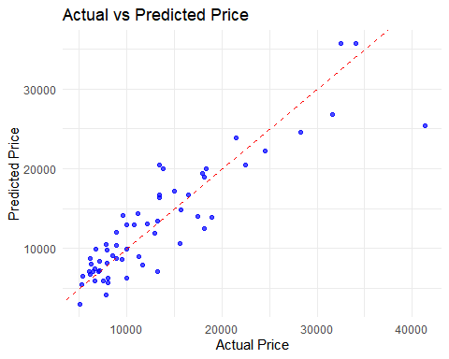

This model served as our baseline. It achieved an MAE of approximately 2477.75 and a cross-validation R-squared of around 0.82, meaning that 82% of the variance in automobile prices was explained by the predictors. While effective, this model was limited in capturing non-linear relationships.
This simply means that Linear regression predicts prices with an average error of about $2,478 and explain 82% of the variation in car prices. However, because it assumes a simple straight-line relationship, it may not capture some of the more complex factors that affect pricing.

Decision Tree
A decision tree splits the data into branches based on simple, intuitive rules, visually showing how different factors lead to variations in automobile prices.

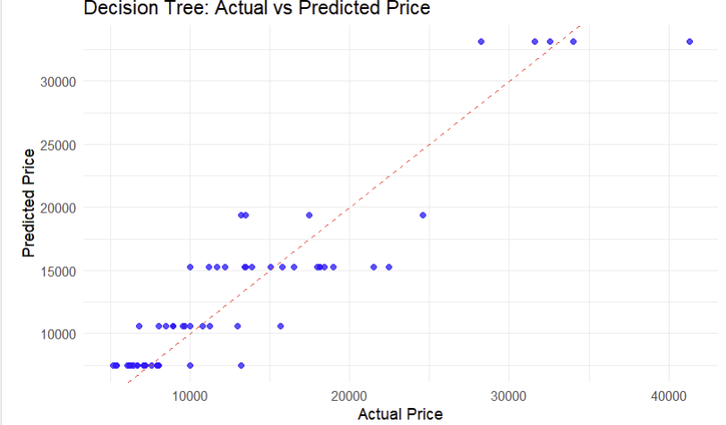

By incorporating non-linear splits, the decision tree improved the prediction accuracy, with an MAE of about 2289 and an R-squared of 0.85. This suggests that decision trees can better model complex interactions among vehicle attributes.

Random forest
A random forest builds multiple decision trees and averages their predictions, resulting in a more accurate and robust model that reduces the risk of overfitting.

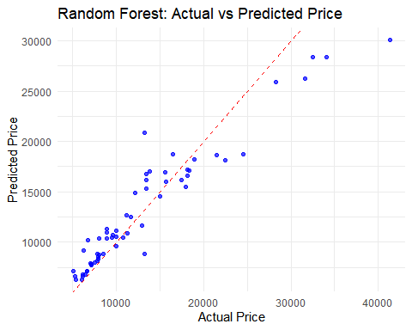
Leveraging an ensemble of decision trees, the random forest model provided the most robust predictions, with an MAE of approximately 1909.65 and an R-squared of 0.87. These metrics indicate that the random forest model explains 87% of the variability in prices, making it the most reliable tool for forecasting.

Visualizations such as scatter plots of actual versus predicted prices further confirmed the models' performance. The random forest model’s predictions closely followed the line of actual price, highlighting its superior ability to capture the underlying relationships in the data.

Table of the supervised learning result
Column1 | Decision tree | Linear regression | random forest
Percentage | 0.85 | 0.82 | 0.87
MAE | 2289 | 2477.75 | 1909.9

Key business takes away
After performing the report here are the business improvement, we can have :
- Enhanced Pricing Strategy: Our random forest model provides a reliable tool for setting competitive prices, as it captures the underlying complexity of the market.
- Market Segmentation: The clusters identified through unsupervised learning enable tailored marketing campaigns and resource allocation based on distinct vehicle groups.
- Data-Driven Decision Making: The integration of dimension reduction, clustering, and predictive modeling supports strategic decisions that drive profitability and market responsiveness.

Conclusion
In summary, our comprehensive analysis successfully addresses the business objective of predicting automobile prices and identifying distinct market segments. By rigorously cleaning and preprocessing the data, we ensured a reliable foundation for our analysis. The application of dimension reduction techniques such as PCA helped us distill complex, high-dimensional data into its most informative components, while unsupervised clustering methods (K-Means, CLARA, and Hierarchical Clustering) revealed clear market segments that can be leveraged for targeted marketing and pricing strategies.
On the supervised learning front, our predictive models—especially the random forest regression—demonstrated high accuracy (MAE ≈ 1909.65, R-squared ≈ 0.87). These results confirm that we can effectively forecast automobile prices, enabling manufacturers and dealers to make informed, competitive pricing decisions.

Appendix
The appendix was long so for report quality I removed it . A separate file with all the codes has been submitted

THANK YOU !

