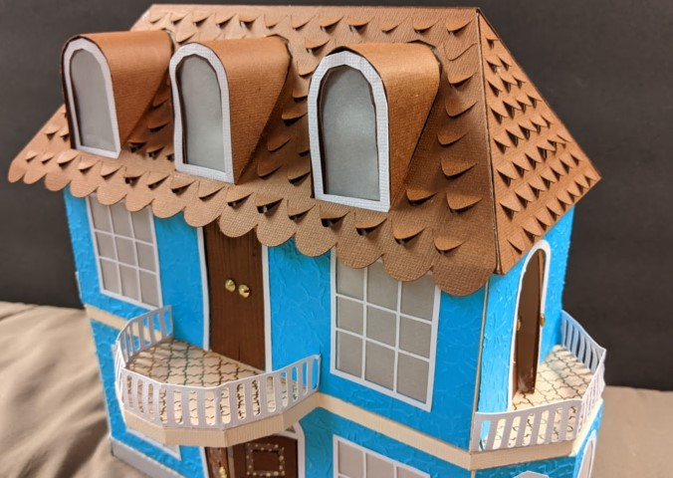
Roof Maker extension for Inkscape 1.1

This extension is designed to help make roof pieces for 3D papercraft designs. It also designs the pieces for dormer windows of several types. Designed for Inkscape 1.1. This version, updated in August 2022 changes the way the dormers are specified, allowing more flexibility in the height and shape. The files for this extension are at https://github.com/obzerving/roofmaker

The Options Panel: The most common parameters are in the Settings tab. Some advanced settings are under the Advanced tab.

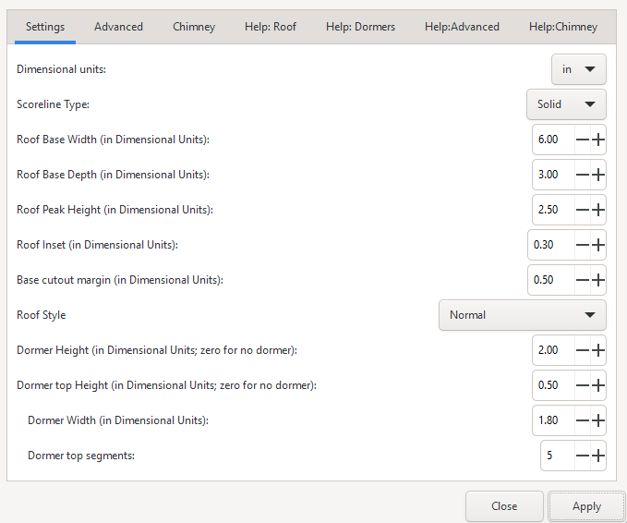

Dimensional units: This parameter is the units that the user is using when entering the values below

Scoreline Type: Choose if you want solid scorelines or dashed/cut scorelines. If Solid, then the scorelines will be grouped with each piece. If dash-cut, then the scorelines will be part of the piece path. Groups are always used for the two main roof pieces to make it easier to add holes for the dormers.
Scorelines on groups will be green. Scorelines that are part of paths will be black.

Basic Roof Settings

Roof Base Width: From a front view, this is the left to right width of the roof
Roof Base Depth: From front to back at the base of the roof
Roof Peak Height: The vertical measure from the base of the roof to the peak
Roof Inset: If used, this will make your roof narrower at the top than the bottom . The inset refers to how much this is on each side. E.g. if you use .5", the top of the roof will be a total of 1" shorter than the base. This is ignored if the roof style is set to Barn
Roof Cutout Margin: The base of the roof can have a cutout to allow ease of construction. This option allows you to vary the width of the cutout margin.
Roof Style:
Normal: One angle from base to peak.
Barn: The angle at near the top will change to tilt in more

Dormer Window Settings:

Dormer Height: The height of the dormer window. If zero, then no dormer windows will be drawn.
Dormer Top Height: A typical dormer will have a rectangular base and a top formed from a polygonal shape. This option allows you to determine how much of the total Dormer Height is used to form the top . If 0 then there will be only a rectangular base. If equal to the Dormer Height, then there will be no rectangular base.
Dormer Width: The width of the dormer (from a front view)

Dormer top segments: Use this option to specify how many segments should be used to form the top of the dormer. If 2, there will two segments joined at a single peak. If a larger number, then it will be more “rounded”. Note that each segment will have a tab for construction, so don’t go crazy with the number here – 12 to 16 should be sufficient for making a rounded top in most cases.

Advanced Settings:
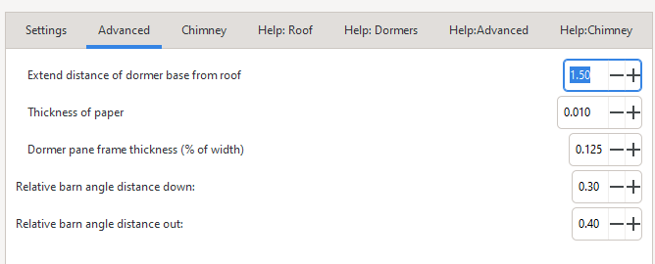

Extend distance of dormer base from roof: Normally the bottom of the dormer will be flush to the roof. This setting can be used to allow your dormer base to be outset from the roof.

Omit base: If using a dormer type other than Just the Base, then you can opt to use only the top shape of the window. This will limit your dormer height to the shape of the top of the dormer. (The calculated height of the dormer top is normally equal to half the width of your dormer.) Note: if you omit the base and have a dormer type of "Just the Base" no dormers will be constructed, because I have no idea what that would look like.

Dormer pane frame thickness % : This is how thick you want the "frame" area around the dormer window "glass" pane. Increase this to have more room for trim, for instance.

Relative barn angle distance down: On barn type roofs, this affects where the change in the roof angle occurs, as a percentage (downward) of the roof peak height. Smaller numbers will result in the roof angle change occurring higher. *
Relative barn angle distance out: On barn type roofs, this affects where the change in the roof angle occurs, as a percentage (outward from center) of the roof depth/2. Smaller numbers will result in the roof angle change occurring closer to the middle. *
*To more easily preview the shape of the resulting settings, look at the roof side decorative piece.

CHIMNEY
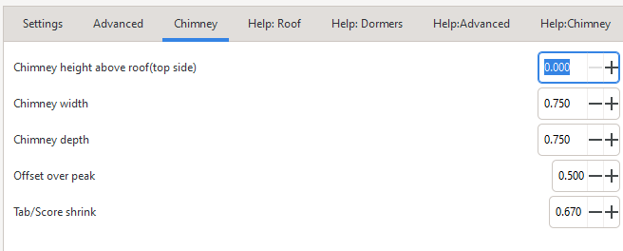
Added an option to construct an on-roof chimney.
Specify the width (l-r) and depth (front-back) and height (distance above roof at highest point of intersection) for the chimney.
RoofMaker will construct a side piece and decorative piece that form a box that fits onto the roof.
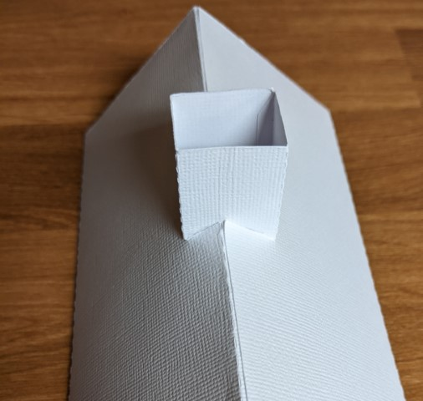
You can also specify and off-peak adjustment. If you want to center the chimney on the peak, it will be 0.5. If you want it all on the front, this should be 1.0.
A hole template is also provided which you can use to “cut a hole” in the roof decorative (and optionally structure) paper to secure the chimney and hide the tabs. This is not done by the extension.

Usage and notes:

The files for this extension are at GitHub - obzerving/roofmaker: Inkscape extension to help make roof pieces for 3D papercraft designs.

You may want to view this video: https://www.youtube.com/watch?v=RSFQnMGN3Q0
(part of the House Design Tutorial by TheSerialCrafter)

After installing, the extension can be found in "Extensions->Papercraft"

Basic usage: Just fill out the setting options and apply. Your pieces will be created.

Some of the pieces created will be positioned on top of each other. Just move them apart. If you are using a dash-cut scoreline, most will be part the one path that makes the piece. Main roof pieces, which are grouped with their scorelines. This was done to make it a little easier to add the dormers (explained below). Following is an example of the pieces created. Yours will likely look different depending on the parameters you use.
Figure 1: Pieces that the extension creates
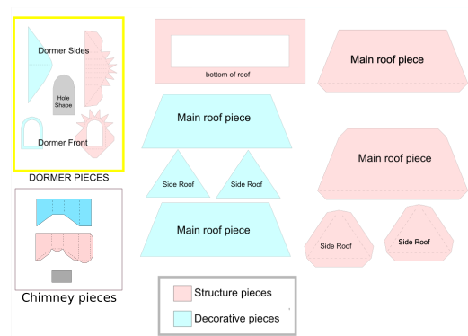
Dormers Placement:

You will need to decide how many dormer windows you want, and where to position them in your roof, if using them. Duplicate the dormer pieces as needed.

Here are the steps for doing that (this will go very quickly once you've done it a couple of times):

- Move the decorative roof main piece over the roof piece. You will want to cut holes in the decorative piece in exactly the same place as on the structure piece. If you are putting windows on the backside as well, you can stack all the roof pieces and decorative pieces at this point.
- Ungroup the decorative piece if it is grouped with scorelines (barn style)
- Drag one or more duplicates of your hole shape onto the decorative piece.
- Once you have your hole shape(s) in position, select them all and combine (ctl k) into a single hole path
- DUPLICATE (ctl-d) THIS PATH and leave the duplicate selected (if doing both sides of the roof duplicate 3x)
- If the decorative piece is grouped with scorelines, ungroup it. (ctl shift g)
- Shift-click decorative piece and difference with the holes (ctl shift - ) to make a new roof path
- Select the scorelines (if present) and roof piece and combine (ctl-k) You will now have a single path that incorporates your decorative roof panel and the roof.
- Move the decorative roof piece aside. You should still have the a holes path and the structure piece in place. Follow the same steps as above to place holes into the structure piece. If you are doing both sides of the roof, just repeat steps 6-8.
- Be sure to duplicate the four dormer pieces so you have the pieces you need for any additional dormers.
- You can delete the hole piece once you are finished.

Other changes you might want to make:
Roof decorative pieces: you might want to extend the height and/or width of these so they will overhang your roof a bit, or you might want to create shingle cuts in them for interest.
Suggestion: Use this Roof Maker extension in conjunction with the extruderz and stairrails extensions to make the basic parts for a house. All are available at obzerving (obzerving) / Repositories · GitHub
Issues? Let me know Email theserialcraftercom@gmail.com
About the extension: The guts of the extension were written by me (Obzerving's wife a.k.a. The Serial Crafter) with a whole giant heap of Obzerving's routines for adding tabs and scorelines, as well as his much needed assistance with turning it into an extension. Hopefully, it will be helpful to anyone trying to make houses and buildings in 3D papercraft. I'll post links to any videos on TheSerialCrafter.com If you encounter problems please email theserialcraftercom@gmail.com

