7COM1079-0901-2025 - Team Research and Development Project

Final report title:

Difference in the Mean Daily Precipitation Among the Seasons in London
from 1979 to 2020

Group ID: A 199

Dataset number: DS134

Prepared by:

Danial Zafaranchizadeh Moghaddam - 24085891
Ouassim Ahmed Ramy Chelghoum - 24089816
Farbod Chit Saz - 24098583
Jayakumar Mahesh - 24175965
David Oloke - 24178815

University of Hertfordshire
Hatfield, 2025

Table of Contents

- Introduction
  - Problem statement and research motivation ................................................... 2
  - The data set ..................................................................................................... 2
  - Research question ........................................................................................... 2
  - Null hypothesis and alternative hypothesis (H₀/H₁) ....................................... 2

- Background research
  - Research papers .............................................................................................. 3
  - Why RQ is of interest ..................................................................................... 3
- Visualisation
  - Appropriate plot for the RQ output of an R script .......................................... 4
  - Additional information relating to understanding the data ............................. 6
  - Useful information for data understanding ..................................................... 6

- Analysis
  - Statistical test used to test the hypotheses and output .................................... 6
  - The null hypothesis is rejected /not rejected .................................................. 6
- Evaluation – group’s experience at 7COM1079
  - What went well ............................................................................................... 7
  - Points for improvement .................................................................................. 7
  - Group’s time management .............................................................................. 7
  - Project’s overall judgement ............................................................................ 7
  - Comment on GitHub log output ..................................................................... 7

- Conclusions
  - Results explained. ........................................................................................... 8
  - Interpretation of the results ............................................................................. 8
  - Reasons and/or implications for future work, limitations .............................. 8

- Reference list ............................................................................................................... 9
- Appendices
- R code used for analysis and visualisation .......................................................... 10
- GitHub log output ................................................................................................ 11

1. Introduction
1.1. Problem statement and research motivation
Understanding local weather patterns is crucial for UK urban planning and agriculture. In London, variable precipitation significantly affects drainage systems, infrastructure and daily routines. Recent research indicates that although total annual rainfall figures may remain relatively consistent, there is a noticeable increase in seasonal instability and the frequency of extreme weather events across the UK (Osborn and Hulme, 2002; Kendon et al., 2023).
Hence, this project examines whether daily precipitation statistics are statistically affected by seasonal variations. Our goal is to identify significant differences in mean rainfall between seasons. This information can then be used to predict future climate trends and improve flood risk management, specifically for urban resilience.
1.2. The data set
The dataset used in this research is the "London Weather Data" dataset provided by the European Climate Assessment (ECA) (Werr, 2021). It contains daily weather observations for London from 1979 to 2020. The dataset consists of 15,341 rows and 10 columns. For this analysis, we focused on the dependent variable precipitation (measured in mm, ratio data) and the independent variable date used to derive the nominal independent variable season. We identified and removed 6 missing values (NAs) from the precipitation.
1.3. Research question
Is there a difference in the mean daily precipitation among the seasons in London from 1979 to 2020?
1.4. Null hypothesis and alternative hypothesis (H0/H1)
- Null Hypothesis (H₀): There is no difference in the mean of daily precipitation among the seasons in London from 1979 to 2020.
- Alternative Hypothesis (H₁): There is a difference in the mean of daily precipitation among the seasons in London from 1979 to 2020.

2. Background research

2.1. Research papers (at least 3 relevant to your topic / DS)

- Klein Tank et al. (2002) established the reliability of the European Climate Assessment (ECA), which is the source of our project's data. Their work confirms that these daily records are reliable enough to analyse long-term climate variability across the United Kingdom.

- Kendon et al. (2023) provided a comprehensive update on the UK's climate, noting a clear trend towards wetter winters and summers. This supports our hypothesis that seasonal means are diverging and confirms an increase in the risk of both floods and droughts

- Osborn and Hulme (2002) identified that while total annual rainfall has remained stable, the pattern of precipitation is changing. They found that heavy rainfall events are becoming more frequent in winter; on the other hand, summers are seeing a decrease in overall rainfall but occasional intense storms.

- Fowler and Kilsby (2007) projected that these seasonal extremes will continue to get stronger. Their research suggests that future water management strategies must be specific for each season and focusing on drainage in winter and saving water in summer, rather than relying on a uniform annual approach.
2.2. Why RQ is of interest (research gap and future directions according to the literature)

This research is critical because recent papers, such as Kendon et al. (2023), indicate a major change in UK climate patterns towards the seasons. While Klein Tank et al. (2002) established the reliability of European weather data, a specific research gap exists in applying these general national trends to London's daily precipitation at a detailed level. Validating these seasonal differences fills this gap. Future directions suggested by Fowler and Kilsby (2007) imply that confirming these trends must lead to specifying seasonal planning for city infrastructure. Prioritising winter flood defences and summer water saving rather than uniform annual strategies.

3. Visualisation

3.1. Appropriate graphs for the RQ

We first visualised the data distribution using a histogram (Figure 1). This plot reveals a strong right skewness, confirming that daily precipitation is not normally distributed. To answer our research question, we chose a boxplot (Figure 2). Boxplots allow us to compare the median, interquartile range and outliers of the ratio variable precipitation across seasons.

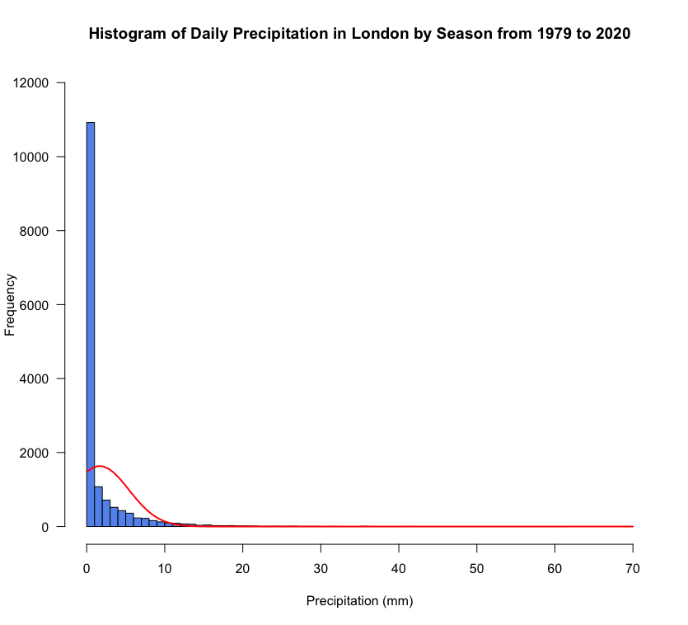
(Figure 1: Histogram of Daily Precipitation with Normal Curve)
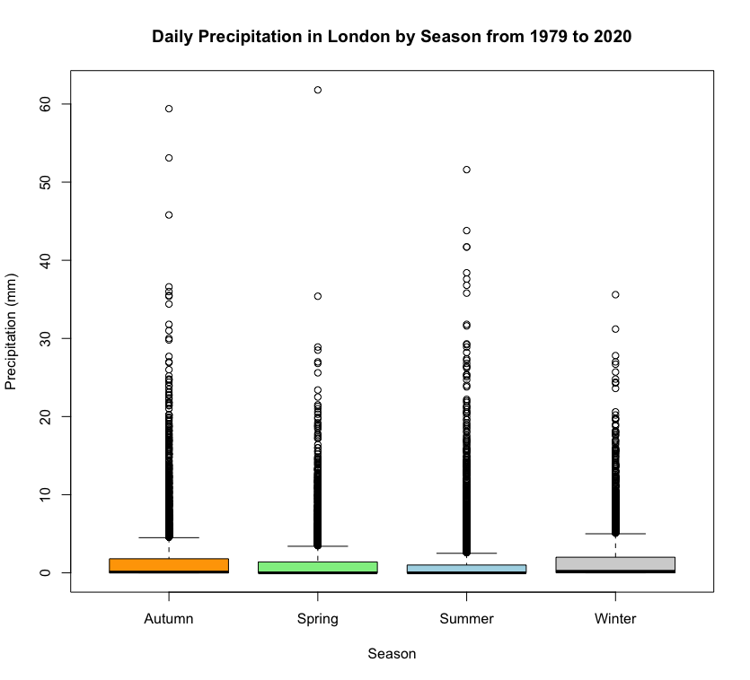
(Figure 2: Boxplot of Daily Precipitation by Season)

 | min. | 1st Qu. | Median | Mean | 3rd Qu. | Max.
Autumn | 0.000 | 0.000 | 0.100 | 1.901 | 1.800 | 59.400
Spring | 0.000 | 0.000 | 0.000 | 1.462 | 1.400 | 61.800
Summer | 0.000 | 0.000 | 0.000 | 1.573 | 1.000 | 51.600
Winter | 0.000 | 0.000 | 0.200 | 1.742 | 2.000 | 35.600

(Table 1: Summary Statistics of Daily Precipitation by Season)

3.2. Additional information relating to understanding the data

Before visualisation, we performed necessary data cleaning by removing 6 missing values (NAs) from the precipitation column to avoid calculation errors. We also transformed the date variable into a nominal season variable. This step was essential to group daily observations into Winter, Spring, Summer, and Autumn for our analysis.

3.3. Useful information for the data understanding

To support our graph (Figure 2), we calculated summary statistics for each season (Table 1). The dataset comprises precipitation (ratio data) grouped by season (nominal data). The table shows that while median precipitation is usually low (often 0 mm) due to many dry days, mean values vary significantly. This is caused by the rare heavy rain events called outliers, shown in our graphs.

4. Analysis

4.1. Statistical test used to test the hypotheses and output

We used the pairwise Wilcoxon rank sum test to analyse the data, as the output shown in Table 2. This non-parametric test was selected because our research question compares a ratio variable, precipitation, with four independent seasons. As visualised in the section 3 graph (Figure 1), the precipitation data are strongly right-skewed, so we could not use a standard parametric test. According to the module's statistical decision tree, the pairwise Wilcoxon rank sum test is the appropriate method for comparing means when the data is not normally distributed across more than two groups.

Winter | 1
Spring | 8.0e-07  Very significant difference | 1
Summer | 2.8e-16  Very significant difference | 0.0021  significant difference | 1
Autumn | 0.0021  significant difference | 2.8e-16  Very significant difference | < 2e-16  Very significant difference | 1
 | Winter | Spring | Summer | Autumn

(Table 2: Pairwise Wilcoxon Rank Sum Test Results)

4.2. The null hypothesis is rejected /not rejected (select one) based on the p-value

The statistical results in Table 2 show that p-values are significantly lower than the standard level of 0.05. For instance, even between seasons that might seem similar, like Winter vs. Autumn (p = 0.0021) and Autumn vs. Spring (p = 2.8e-16), the test shows they are different. Since these values are below 0.05, we have strong statistical evidence to reject the null hypothesis (H₀). This means we accept the alternative hypothesis (H₁), concluding that there is a statistically significant difference in the mean daily precipitation among the seasons in London.

5. Evaluation – group’s experience at 7COM107
5.1. What went well

We used GitHub branches for version control, ensuring organised project management. Our team collaborated closely through frequent meetings, starting early to thoroughly understand the problem together. Presenting our Research Question and initial analysis to professors for feedback was incredibly helpful, allowing us to refine our approach before the final submission. Starting early and working together helped us handle the complex seasonal data. Although selecting the pairwise statistical test was challenging, we overcame the challenge and produced a strong analysis
5.2. Points for improvement
Some team members were unfamiliar with Git branching, leading to extra coordination challenges that we had to resolve. We could have improved our study by looking only at rainy days to fix the problem of having too many zeros. Also, checking how seasonal patterns change year by year would help us find long-term climate trends.
5.3. Group’s time management

We set up a weekly schedule, starting from the research question and moving all the way to visualisation. We met at every stage to split up the work and keep on schedule. Using WhatsApp and GitHub kept everyone updated and helped us meet our deadlines efficiently.
5.4. Project’s overall judgement
Overall, this project successfully answered the hypothesis. We effectively answered our research question by proving a statistically significant difference in London's seasonal precipitation. Despite technical challenges with Git and statistical selection, our teamwork and early preparation resulted in a strong analysis. The final report confirms that seasonal climate patterns are shifting.
5.5. Comment on GitHub log output

The log (Appendix B) uses the graph method to visualise our workflow across three branches. 1_intro_background managed the research question presentation PDF. 2_visualisation handled the second presentation for visual findings. Finally, 3_report_document_preparation consolidated the report, where all members contributed. This graph structure confirms our effective version control and parallel file management.

1. Commit Message: [feat: Every members folder crearted with the files which they need for Visualization and Analysis Demo]
Establishes individual folders for each member, a crucial step that enabled parallel work and file management without merge conflicts.

2. Commit Message: [Merge branch '2_visualisation': Added R scripts and generated plots for Research Question from each team member]
Merges the 2_visualisation branch, bringing together everyone's R scripts, charts, and the second presentation file.

3. Commit Message: [- Finalised the R analysis script (Danial-Analysis2.R). - Rephrased and updated content in the final report documents. - Created and added the bibliography reference file (.bib). - Added final visualisation outputs]
Merges the 3_report_document_preparation branch, combining all team parts into the final report and completing the analysis scripts for submission.

6. Conclusions

6.1. Results explained

The analysis successfully answered the research question regarding seasonal precipitation differences. The Wilcoxon Rank Sum Test showed p-values well below the 0.05 limit, leading us to reject the null hypothesis (H₀). This statistical evidence, supported by the boxplots in Figure 2, confirms that rainfall does not follow the same pattern in the years. Specifically, there is a difference in the mean of daily precipitation among the seasons in London from 1979 to 2020.

6.2. Interpretation of the results

Rejecting the null hypothesis confirms that London's rainfall patterns are distinctly seasonal. For urban planners and the public, this means that planning cannot rely on simple yearly averages. The significant variation requires strategies for each season: better drainage systems are needed to manage heavy rain in Winter (flood risk), while strict water saving measures are needed for Summer. This matches national climate research (Kendon et al., 2023), highlighting the need to prepare for changing weather extremes.

6.3. Reasons and/or implications for future work, limitations

A major limitation is that the dataset ends in 2020, so it misses the climate patterns from the last five years (up to 2025). Also, the study was limited because we had to choose from a fixed list of questions and types of variables. From a scientific view, the many days with zero rain skewed our results. Future work should use newer data and look specifically at rainy days to better analyse.

7. Reference List

- Werr, E.F. (2021) London Weather Data. Available at: https://www.kaggle.com/datasets/emmanuelfwerr/london-weather-data (Accessed: 10 December 2025).

- Kendon, M. et al. (2023) 'State of the UK climate 2022', International Journal of Climatology, 43, pp. 1–83.
- Fowler, H.J. and Kilsby, C.G. (2007) 'Using regional climate model data to simulate historical and future river flows in northwest England', Climatic Change, 80(3-4), pp. 337–367.

- Klein Tank, A.M.G. et al. (2002) 'Daily dataset of 20th-century surface air temperature and precipitation series for the European Climate Assessment', International Journal of Climatology, 22(12), pp. 1441–1453.

- Osborn, T.J. and Hulme, M. (2002) 'Evidence for trends in heavy rainfall events over the UK', Philosophical Transactions of the Royal Society of London. Series A: Mathematical, Physical and Engineering Sciences, 360(1796), pp. 1313–1325.

8. Appendices
A. R code used for analysis and visualisation

# R codes used for analysis and visualization
library(readr)
df <- read_csv("london_weather.csv")

# create year and month column
df$year <- as.numeric(substr(as.character(df$date), 1, 4))
df$month <- as.numeric(substr(as.character(df$date), 5, 6))
df$season <- "Autumn"
df$season[df$month %in% c(12, 1, 2)] <- "Winter"
df$season[df$month %in% c(3, 4, 5)] <- "Spring"
df$season[df$month %in% c(6, 7, 8)] <- "Summer"

# Clear NA from the data
sum(is.na(df$date))
sum(is.na(df$precipitation)) #We have 6 NA
df <- df[!is.na(df$date) & !is.na(df$precipitation), ]
sum(is.na(df$precipitation))

# histogram with curve Figure 1
png("seasonal_precipitation_histogram_with_curves.png",width = 800, height = 600)
h <- hist(df$precipitation,
main = "Histogram of Daily Precipitation in London by Season from 1979 to 2020",
xlab = "Precipitation (mm)",
ylab = "Frequency",
col = "cornflowerblue",
breaks = 50,
xlim = c(0, 70),
ylim = c(0, 12000),
las = 1)
# Normal Curve with proper scale
x_lines <- seq(min(df$precipitation), 70, length = 100)
y_lines <- dnorm(x_lines, mean = mean(df$precipitation), sd = sd(df$precipitation))
bin_width <- h$breaks[2] - h$breaks[1]
y_scaled <- y_lines * length(df$precipitation) * bin_width
lines(x_lines, y_scaled, col = "red", lwd = 2)
dev.off()

# box plot Figure 2
png("box_plot.png",width = 800, height = 600)
boxplot(precipitation ~ season, data = df,
main = "Daily Precipitation in London by Season from 1979 to 2020",
xlab = "Season",
ylab = "Precipitation (mm)",
col = c("orange", "lightgreen", "lightblue", "lightgray"),
border = "black")
dev.off()

# Table 1
tapply(df$precipitation, df$season, summary)
# Pairwise Wilcoxon Test
pairwise.wilcox.test(df$precipitation, df$season, p.adjust.method = "holm")

B. GitHub log output.
* commit 8736069c611402f9d5e772fb883ede2f80c02994 (HEAD -> main,
| origin/main, origin/HEAD)
| Author: danialza <dz24aaf@herts.ac.uk>
| Date: Fri Dec 12 00:29:01 2025 +0000
|
| Clean up file structure, update analysis script, and draft final
| report
|
| - Organized and moved project files for better structure.
| - Integrated team member code into the main R analysis script.
| - Updated the final document with conclusions from supporting
| files.
| - Removed unnecessary temporary files.
|
* commit 73c3c17d5187b2a9bf7d1485ce33f9b3c88e0dc3
| (origin/3_report_document_preparation, 3_report_document_preparation)
| Author: danialza <dz24aaf@herts.ac.uk>
| Date: Thu Dec 11 23:33:35 2025 +0000
|
| - Finalised the R analysis script (Danial-Analysis2.R).
| - Rephrased and updated content in the final report documents.
| - Created and added the bibliography reference file (.bib).
| - Added final visualization outputs
|
* commit 572ce20f82664a6c0750fbcc677d3d1034d019a9
| Author: Jayakumar Mahesh <jm25acy@herts.ac.uk>
| Date: Thu Dec 11 21:51:29 2025 +0000
|
| Completed my final Report
|
* commit 2425f0162ed03c8b32232f76cb3f3f8cb82b4d54
| Author: fc24aax <fc24aax@herts.ac.uk>
| Date: Thu Dec 11 01:16:55 2025 +0000
|
| Added full Sections 6, 7, and 8 to final report + minor clean-ups
|
| Added full Conclusions section (6.1–6.3)
|
| Added updated and corrected Reference List (Harvard format)
|
| Added all Appendix content including R code
|
* commit 18cfeebb7099c022fc4e359068d23962d689d6c8
| Author: fc24aax <fc24aax@herts.ac.uk>
| Date: Wed Dec 10 01:33:42 2025 +0000
|
| Major update to the final project report with expanded analysis,
| added evaluation sections, and overall refinement of structure
|
| Added Analysis (4.1 & 4.2)
|
| Completed Evaluation parts (5.1–5.6)
|
| Refined wording and structure
|
| Added draft notes for GitHub log section
|
| Fixed small formatting and fonts issues
|
* commit 83f964746ab1c8c0a7e8be1f8761e6512360413e
| Author: Jayakumar Mahesh <jm25acy@herts.ac.uk>
| Date: Wed Dec 10 00:38:04 2025 +0000
|
| "Edited my report file"
|
* commit d3eb42b17cf0423fa3aa890981a8e74b0954b92a
| Author: unknown <oc24aan@herts.ac.uk>
| Date: Tue Dec 9 18:03:23 2025 +0100
|
| Ouassim's final analysis
|
* commit c1c4f619207a197001e4a8ef13a99e0b40f5b372
| Author: do25ab <do25abe@herts.ac.uk>
| Date: Tue Dec 9 14:57:59 2025 +0000
|
| Contribution to the conclusion part of the final report documents.
| Here we see how the the visualization and test both agree with the
| research question.
|
* commit d41341fc0f93a608f92b478b40ce6f4e3fce8791
| Author: fc24aax <fc24aax@herts.ac.uk>
| Date: Tue Dec 9 00:11:54 2025 +0000
|
| Expand visualisation section in final report
|
| - Added seasonal precipitation boxplot
| - Added histogram with density line for daily rainfall
| - Updated narrative in sections 3.1–3.3 to reflect new visuals
| - Improved clarity of explanations for seasonal weather patterns
| - Added drafts for next section ( Analysis )
|
* commit 6019776d87853f917a4df0434c1a97d39ffa029a
| Author: fc24aax <fc24aax@herts.ac.uk>
| Date: Tue Dec 9 00:04:49 2025 +0000
|
| Expand visualisation section in final report
|
| - Added seasonal precipitation boxplot
| - Added histogram with density line for daily rainfall
| - Updated narrative in sections 3.1–3.3 to reflect new visuals
| - Improved clarity of explanations for seasonal weather patterns
| - Added drafts for next section ( Analysis )
|
* commit 664844d0e433cd4b3de2010fd0b388ddc6b412db
| Author: fc24aax <fc24aax@herts.ac.uk>
| Date: Tue Dec 9 00:02:24 2025 +0000
|
| Expand visualisation section in final report
|
| - Added seasonal precipitation boxplot
| - Added histogram with density line for daily rainfall
| - Updated narrative in sections 3.1–3.3 to reflect new visuals
| - Improved clarity of explanations for seasonal weather patterns
| - adding drafts for next section ( Analysis )
|
* commit 49e9af7ce99310b196086948ab1306f3c797738c
| Author: do25ab <do25abe@herts.ac.uk>
| Date: Mon Dec 8 19:22:42 2025 +0000
|
| My contribution to the word document towards the final project
| documentation. In it is updated to the visualisation part of the
| documents.
|
* commit 3175fc61883d68d36270eeaf01f5b8aca95050b0
| Author: do25ab <do25abe@herts.ac.uk>
| Date: Mon Dec 8 11:49:22 2025 +0000
|
| my first contribution to final word documents for team presentation
|
* commit 8089e3d3588dc65fd219f73520e5c72005545bd5
| Author: fc24aax <fc24aax@herts.ac.uk>
| Date: Sun Dec 7 02:01:53 2025 +0000
|
| Add complete Background Research and initial Visualisation draft
|
| - Background Research section fully updated with three relevant
| references and literature analysis.
| - 3.1 Visualization section added as a draft.
|
* commit 62a4b677d8787a9043c05914626698871253d019
| Author: fc24aax <fc24aax@herts.ac.uk>
| Date: Sat Dec 6 01:02:36 2025 +0000
|
| Update sections: Introduction and Data Set with latest details
|
* commit 960778d9ef66f360011fd83dfa773410420b77e4
| Author: fc24aax <fc24aax@herts.ac.uk>
| Date: Fri Dec 5 02:55:29 2025 +0000
|
| Add full draft of Introduction section (1.1–1.4)
|
* commit c05a61c10b8821e8026801ece681590f0d1c2807
| Author: fc24aax <fc24aax@herts.ac.uk>
| Date: Thu Dec 4 18:51:34 2025 +0000
|
| Update farbod_Analysis2.R code and add p_values_seasons.csv and
| p_values_years.csv to new branch
|
* commit 94736c2ac74f329356fb59dd39369534a7628e90
| Author: danialza <dz24aaf@herts.ac.uk>
| Date: Wed Dec 3 21:12:39 2025 +0000
|
| - Majur important problems added with Red color which needs to
| check before submition.
|
* commit 1f32ae23068c22a5852854b86bedd86f5f456670
| Author: danialza <dz24aaf@herts.ac.uk>
| Date: Wed Dec 3 21:10:59 2025 +0000
|
| - Completed up to section 3
| Added 'paper links.txt' with paper citations and links
|
* commit bb4581db778a61ef9963ad2315f5265d9ffd3768
| Author: danialza <dz24aaf@herts.ac.uk>
| Date: Sat Nov 29 18:42:46 2025 +0000
|
| feat: Every member DOC file created.
|
* commit af1d9b5cfb74bc1fd521b0cdc28395fdec174245
|\ Merge: e249afc 0a0235e
| | Author: danialza <dz24aaf@herts.ac.uk>
| | Date: Sat Nov 29 18:12:58 2025 +0000
| |
| | Merge branch '2_visualisation': Added R scripts and generated
| | plots for Research Question from each team member
| |
| | Merge branch '2_visualisation'
| | # Please enter a commit message to explain why this merge is
| | necessary,
| | # especially if it merges an updated upstream into a topic
| | branch.
| | #
| | # Lines starting with '#' will be ignored, and an empty message
| | aborts
| | # the commit.
| |
| * commit 0a0235e22fbc7f7d6b92c816a6b239fb3fcf17cb
| | (origin/2_visualisation, 2_visualisation)
| | Author: do25ab <do25abe@herts.ac.uk>
| | Date: Fri Nov 28 13:03:57 2025 +0000
| |
| | R codes for data visualisation: this include codes for boxplot
| | and histogram with distribution curve overlay
| |
| * commit ff979464bf42b37de97656c7b4a7803b3dac8475
| | Author: Jayakumar Mahesh <jm25acy@herts.ac.uk>
| | Date: Fri Nov 28 01:14:40 2025 +0000
| |
| | "Added mean perception of an season"
| |
| * commit 25dec3b679a055605ed7826b4bd06d6f6b0307c6
| | Author: fc24aax <fc24aax@herts.ac.uk>
| | Date: Thu Nov 27 20:16:24 2025 +0000
| |
| | adding visualization about mean precipitation between seasons of | | year
| | Kruskal Wallis test, Pairwise Wilcoxon test, Boxplots, histogram
| | with density curves and bar plots
| |
| * commit 3c14e4ee26c81df82a10079e36bed0a1c473d8e0
| | Author: oc24aan <oc24aan@herts.ac.uk>
| | Date: Wed Nov 26 19:21:14 2025 +0100
| |
| | Move results folder to Ouassim's directory
| |
| * commit 56f63e94f2aeeb1acca6910fa5edcba5a0c9b159
| | Author: oc24aan <oc24aan@herts.ac.uk>
| | Date: Wed Nov 26 19:19:08 2025 +0100
| |
| | Add analysis results (plots and CSVs) to results folder inside
| | Ouassim's directory
| |
| * commit 604d61729f014a69743f7f58cdc954d705ad4d0f
| | Author: Ouassim Ahmed Ramy Chelghoum <oc24aan@herts.ac.uk>
| | Date: Wed Nov 26 18:57:45 2025 +0100
| |
| | Delete Ouassim/Oassim directory
| |
| * commit 9cb5f20ddbf6288b247af26c78aff0da69a02b77
| | Author: oc24aan <oc24aan@herts.ac.uk>
| | Date: Wed Nov 26 18:53:18 2025 +0100
| |
| | Remove old results folder
| |
| * commit 0f95ced9e2b5ba566cdf24016b6e8597841a3605
| | Author: oc24aan <oc24aan@herts.ac.uk>
| | Date: Wed Nov 26 18:49:39 2025 +0100
| |
| | Move all results files into Ouassim's repo
| |
| * commit 48dd2c7e9aa97f1cd28bb4145fd5e58e4140b5ee
| | Author: oc24aan <oc24aan@herts.ac.uk>
| | Date: Wed Nov 26 18:36:33 2025 +0100
| |
| | Moved results folder ins Oassim's directory
| |
| * commit d1c9f50fab0e4d1d863f8339ac868be86dc5062b
| | Author: oc24aan <oc24aan@herts.ac.uk>
| | Date: Wed Nov 26 18:32:37 2025 +0100
| |
| | Move results folder inside Ouassim's directory
| |
| * commit 2b317fdccd1cffac2950072374b82d96e633fbe2
| | Author: oc24aan <oc24aan@herts.ac.uk>
| | Date: Wed Nov 26 18:16:37 2025 +0100
| |
| | Add visualizations and p-value CSVs for precipitation analysis
| |
| * commit 9b9fc0a6ebf49302943a6e69f34cebbc91ca764b
| | Author: danialza <dz24aaf@herts.ac.uk>
| | Date: Wed Nov 26 16:00:41 2025 +0000
| |
| | refactor: Normal line added to the Histogram graph - PPTX and PDF
| | file updated
| |
| * commit 3aaddfe7b1381f4cd5a18f6ec4f10a7e819f5be1
| | Author: danialza <dz24aaf@herts.ac.uk>
| | Date: Wed Nov 26 13:11:00 2025 +0000
| |
| | feat: Final PPTX and PDF version of presentation created.
| |
| * commit 1d4a42d29bb72846041a8f9720cb3d42c2c2a04a
| | Author: danialza <dz24aaf@herts.ac.uk>
| | Date: Wed Nov 26 13:06:25 2025 +0000
| |
| | refactor: move csv files to 'danial' directory
| |
| * commit 0fa04996be2cd9053d2818f2d697ee71c9819133
| | Author: danialza <dz24aaf@herts.ac.uk>
| | Date: Wed Nov 26 13:02:48 2025 +0000
| |
| | feat: add precipitation analysis script, visualizations, and
| | final vwesion of second presentation
| |
| | This commit introduces the analysis for the London Weather from
| | 1979 to 2020. Changes included: Added R script for statistical
| | testing, generated Histogram and Boxplot visualizations, and
| | included the final PowerPoint presentation.
| |
| * commit 6576732fc4069d3919c61fb09f75474ca6eaee9e
| | Author: danialza <dz24aaf@herts.ac.uk>
| | Date: Sun Nov 23 15:34:52 2025 +0000
| |
| | feat: Every members folder crearted with the files which they
| | need for Visualization and Analysis Demo
| | The question file and hypoteses pdf created
| |
* | commit e249afcb74c7c831022163db95539ec87417a701
| | Author: danialza <dz24aaf@herts.ac.uk>
| | Date: Sun Nov 23 15:13:59 2025 +0000
| |
| | feat: Project Question updated with the Professors advices
| |
* | commit 0b40720420c64795dfabdc971ada7b76dc1d3194
| | (origin/1_intro_background)
| | Author: do25ab <do25abe@herts.ac.uk>
| | Date: Fri Nov 21 13:54:01 2025 +0000
| |
| | final intro
| |
* | commit 4d6d73f2100fea50b7906b9163d9cee89057790a
| | Author: do25ab <do25abe@herts.ac.uk>
| | Date: Fri Nov 21 13:48:22 2025 +0000
| |
| | 2 test line added
| |
* | commit ef4794d63b60999f16438090e0ed90a1cf58f823
| | Author: do25ab <do25abe@herts.ac.uk>
| | Date: Fri Nov 21 13:45:55 2025 +0000
| |
| | David File Created.
| |
* | commit 78bc1b98e925ecc3f724993229fc6acfaea64cb2
| | Author: danialza <dz24aaf@herts.ac.uk>
| | Date: Wed Nov 19 16:00:25 2025 +0000
| |
| | Question Presentation Done - Question Confirmed
| |
* | commit d7533c1ea4a2e45d339189d4dc297311505095e1
| | Author: fc24aax <fc24aax@herts.ac.uk>
| | Date: Wed Nov 19 14:26:41 2025 +0000
| |
| | Farbod's questions have been pushed.
| |
* | commit 9a079fe174ce5f2856bac1abe002107b9596e623
| | Author: danialza <dz24aaf@herts.ac.uk>
| | Date: Wed Nov 19 13:55:41 2025 +0000
| |
| | Test file removed
| |
* | commit d2cdfd6565659084d75b9269ac225b3c17e45834
| | Author: Danial Zafaranchizadeh Moghaddam |
| | <33610543+danialza@users.noreply.github.com>
| | Date: Wed Nov 19 13:54:44 2025 +0000
| |
| | file upload from github website file check
| |
* | commit 81dfa2b9ba035e5d7a833c832ea9796e9bc23bc0
| | Author: Ouassim Ahmed Ramy Chelghoum <oc24aan@herts.ac.uk>
| | Date: Wed Nov 19 13:19:35 2025 +0000
| |
| | Update Ouassim-Questions.txt
| |
* | commit a09f001c62a680e02a00baf888b0d6cffe678161
| | Author: Ouassim Ahmed Ramy Chelghoum <oc24aan@herts.ac.uk>
| | Date: Wed Nov 19 13:12:07 2025 +0000
| |
| | Create Ouassim-Questions.txt
| |
* | commit e1c18d7b10036a4d0e498f7f469acf8d123bc5f0
| | Author: danialza <dz24aaf@herts.ac.uk>
| | Date: Wed Nov 19 12:47:09 2025 +0000
| |
| | Research Question selected and Presentation created.
| |
* | commit 58232897c4c84eef84a28e2d66b20e5008fea672
| | Author: danialza <dz24aaf@herts.ac.uk>
| | Date: Wed Nov 19 11:40:40 2025 +0000
| |
| | Among selected!
| |
* | commit de5f74fdac7414c6ffb06f7020fab87cdc727286
| | Author: danialza <dz24aaf@herts.ac.uk>
| | Date: Wed Nov 19 11:36:32 2025 +0000
| |
| | Question 4.1 Added !!
| |
* | commit 7feb206d83f85c56c221dde1baba44baa1bbf070
| | Author: danialza <dz24aaf@herts.ac.uk>
| | Date: Wed Nov 19 10:27:30 2025 +0000
| |
| | Presentation template added
| |
* | commit 04575c01e93ee36b76bc13e3a4530293d6cd5ceb
| | Author: Jayakumar Mahesh <jm25acy@herts.ac.uk>
| | Date: Tue Nov 18 22:30:21 2025 +0000
| |
| | Jayakumar Question file
| |
* | commit c2309e683c61ba3a99b613fbbc0ba16fc0cab15c
| | Author: Jayakumar Mahesh <jm25acy@herts.ac.uk>
| | Date: Tue Nov 18 21:24:49 2025 +0000
| |
| | Jayakumar Question File
| |
* | commit 927d1e5599826fef6015bb1548707da1d503065c
| | Author: Jayakumar Mahesh <jm25acy@herts.ac.uk>
| | Date: Tue Nov 18 21:20:42 2025 +0000
| |
| | Jayakumar Question File
| |
* | commit 1dac8e87a456b74b7204cd156b5256952b3d55c1
| | Author: danialza <dz24aaf@herts.ac.uk>
| | Date: Mon Nov 17 11:19:03 2025 +0000
| |
| | revFarbod file Deleted
| |
* | commit 65abfd90126b6055d07469e8d519f77f1bb7b169
| | Author: danialza <dz24aaf@herts.ac.uk>
| | Date: Mon Nov 17 10:59:04 2025 +0000
| |
| | Farbod Question File Added
| |
* | commit 3e3563455a8db77ff58de5bf027948ef27732754
| | Author: danialza <dz24aaf@herts.ac.uk>
| | Date: Mon Nov 17 10:30:07 2025 +0000
| |
| | Add research questions and hypothesis template
| |
* | commit 8884d4b603b2ffd4f8c375fcb3d4b382aa1c6234
|/ Author: danialza <dz24aaf@herts.ac.uk>
| Date: Mon Nov 17 10:29:13 2025 +0000
|
| Add research questions Danial
|
* commit ef32508af84bd40eac67297fa95d3a66db7553ec
| Author: danialza <dz24aaf@herts.ac.uk>
| Date: Sun Nov 16 17:25:47 2025 +0000
|
| feat: Load 'london_weather.csv' dataset using readr
|
* commit 4155dcdc050eeb93fff3b1a53188a1fa79a06ec5
| Author: danialza <dz24aaf@herts.ac.uk>
| Date: Mon Nov 10 09:55:01 2025 +0000
|
| feat: Add initial project structure and data
|
| - Upload all raw project files
| - Add the group dataset
| - Initialize R project file (.Rproj)
|
* commit 8f7a2c58bb6085f15698b17f3b69c7ac84361bab
Author: Ouassim Ahmed Ramy Chelghoum <oc24aan@herts.ac.uk>
Date: Thu Oct 30 00:48:34 2025 +0100

Initial commit

