Please delete all the italic text before submission. It is here just for your reference.

Further: data set – DS, research question – RQ

The mark (x words) after each subchapter states the word count limit. This indicates the expected amount of information which you can exceed by 10% without losing the mark.

7COM1079-0901-2025 - Team Research and Development Project

Final report title: (the topic of your research.)

Group ID:

Dataset number:

Prepared by: [Name and ID of submitting student first],
[Name and ID of other group members]

Please make sure the document spelled correctly (including image labels, section headings, and table of contents). Please use correct punctuation.
Make sure your report is grammatically correct.

University of Hertfordshire
Hatfield, 2025

Table of Contents add page numbers from here

- Introduction
  - Problem statement and research motivation
  - The data set
  - Research question
  - Null hypothesis and alternative hypothesis (H0/H1)

- Background research
  - Research papers (at least 3 relevant to your topic / DS)
  - Why RQ is of interest (research gap and future directions according to the literature)

- Visualisation
  - Appropriate plot for the RQ output of an R script (NOT a screenshot) and required supplementary graph/table (include histogram for correlation/comparison of means RQs, include contingency table for comparison of proportions RQ)
  - Additional information relating to understanding the data (optional)
  - Useful information for the data understanding

- Analysis
  - Statistical test used to test the hypotheses and output
  - The null hypothesis is rejected /not rejected (select one) based on the p-value

- Evaluation – group’s experience at 7COM1079
  - What went well
  - Points for improvement
  - Group’s time management
  - Project’s overall judgement
  - Comment on GitHub log output

- Conclusions
  - Results explained.
  - Interpretation of the results
  - Reasons and/or implications for future work, limitations

- Reference list
Harvard (author, date) format.
- Appendices
- R code used for analysis and visualisation.
- GitHub log output.

The list below outlines the chapter/subchapter numbers, names, word count limits, and explanations of what to write in each section.

1. Introduction

  - Problem statement and research motivation

Climate change is an unpredictable process that amplifies weather patterns across the globe-increasing precipitation over cities like London (Osborn and Jones, 2002). This study thus supports investigating seasonal precipitation differences to inform resilient urban infrastructure and emergency planning. High population density and dependency on the Thames River increase London's vulnerability to possible wetter winters or stormier autumns. By analyzing historical data, we investigate how changes in seasonality could exacerbate flooding or droughts, helping policy-makers devise effective adaptation strategies. This paper researches meteorological trends and relates the findings to practical risk management, emphasizing that localized insight in a global warming perspective is necessary.

  - The data set

We used the London Weather dataset (DS134) that contains daily weather records for London from 1979 to 2020. It has 15,341 days and 10 different measurements. For our project we only needed two columns: date and precipitation (rainfall in millimetres). There were a few missing values, which we removed. This dataset is great for comparing the four seasons because it covers more than 40 years.

  - Research question
Is there a difference in the mean daily precipitation among the seasons in London from 1979 to 2020?
  - Null hypothesis and alternative hypothesis (H0/H1) (100 words)
Null Hypothesis (H0): There is no difference in the mean of daily precipitation among the seasons in London from 1979 to 2020. Alternative Hypothesis (H1): There is a difference in the mean of daily precipitation among the seasons in London from 1979 to 2020.
- Background research

  - Research papers (at least 3 relevant to your topic / DS) (200 words)

  - Simpson and Jones 2012 derived homogenized UK precipitation series from the Met Office 5-km gridded data from 1766-2009. They found sound seasonal trends: wetter winters, by +10-15% since 1900, drier summers, by -5-10%, plus more winter extremes. This justifies ECA data quality when it comes to analyses for London, in addition to showing orographic influences in the seasonality. https://rmets.onlinelibrary.wiley.com/doi/abs/10.1002/joc.3396

  - Osborn and Jones (2002) analyzed UK daily precipitation from 1961 to 2000; they found that there was a rise of 20% in winter intensities and a decline of 15% in summer, both associated with changes in the North Atlantic Oscillation. Heavy events - defined by the authors as those above 25 mm/day - showed an increase in winter, in line with our RQ on mean differences. Link - https://rmets.onlinelibrary.wiley.com/doi/10.1256/wej.57.8

  - Murphy et al. (2021), in UKCP18, considered baselines from 1979 to 2020 and observed 5% increases in winter and summer rainfall compared to 1981-2010, with autumn peaks in extremes. Projections are for 10-20% wetter winters by 2050, emphasizing gaps in urban-specific studies like London. Link: https://www.metoffice.gov.uk/research/approach/collaboration/ukcp

  - Why RQ is of interest (research gap and future directions according to the literature)

National studies, such as by Simpson and Jones (2012), identify UK-wide seasonality but fail to account for London-specific urban heat/river effects. Our RQ fills this gap by applying ECA data to detect local mean differences, testing if city microclimates amplify trends. Literature suggests wetter autumns/winters; future directions include multi-decadal modeling for 2050 floods, integrating urban green spaces for mitigation. This advances adaptive planning in light of 2°C warming.

- Visualisation

  - The main plot chosen is a bar chart showing the mean seasonal daily precipitation with error bars representing standard errors. This is appropriate for the research question as it directly visualizes differences in means across seasons, allowing easy comparison while accounting for variability. The bar chart was generated using R code (see Appendix A), with colors corresponding to each season: light blue for Winter, green for Spring, yellow for Summer, and orange for Autumn.
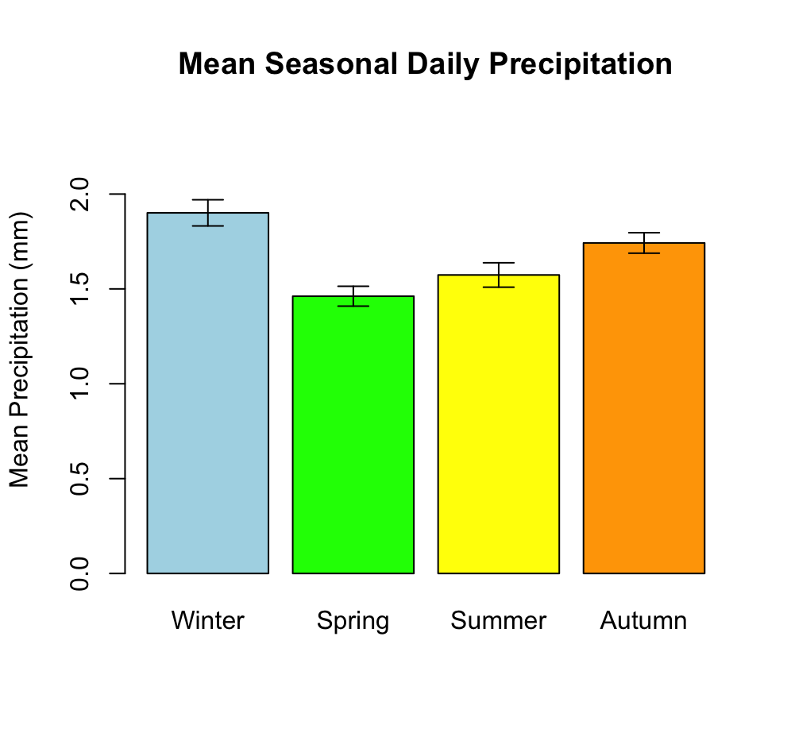
Fig : 3.1
As a supplementary graph for comparison of means, we include the overall daily precipitation histogram to show the skewed distribution (many zero-precipitation days), justifying non-parametric tests. Additionally, seasonal histograms are provided to illustrate distribution differences per season, and a boxplot for visualizing medians, quartiles, and outliers.
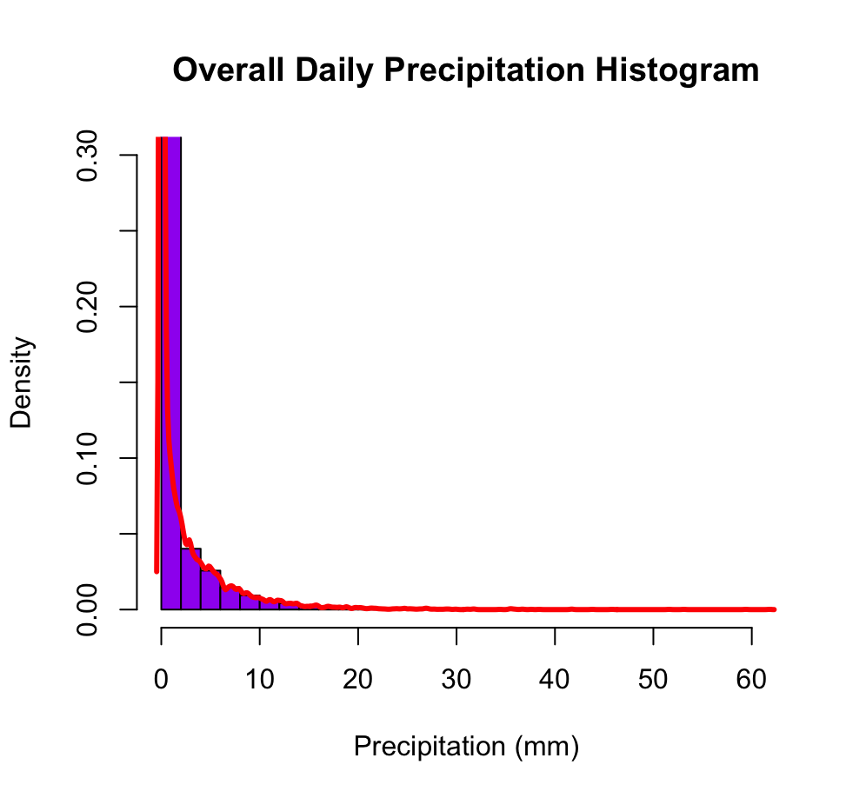
Fig: 3.2
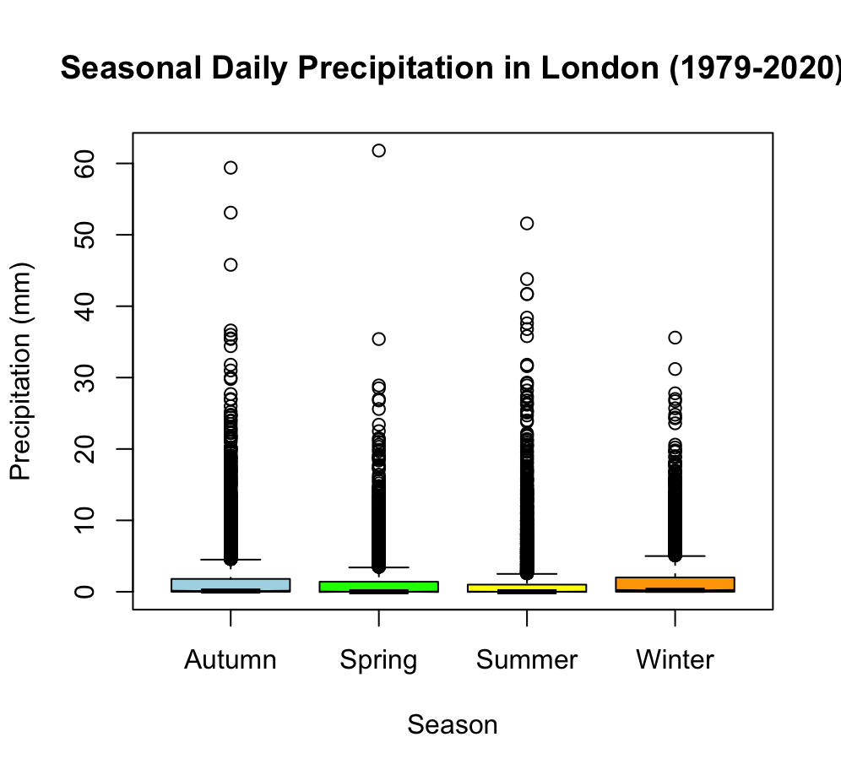
Fig: 3.3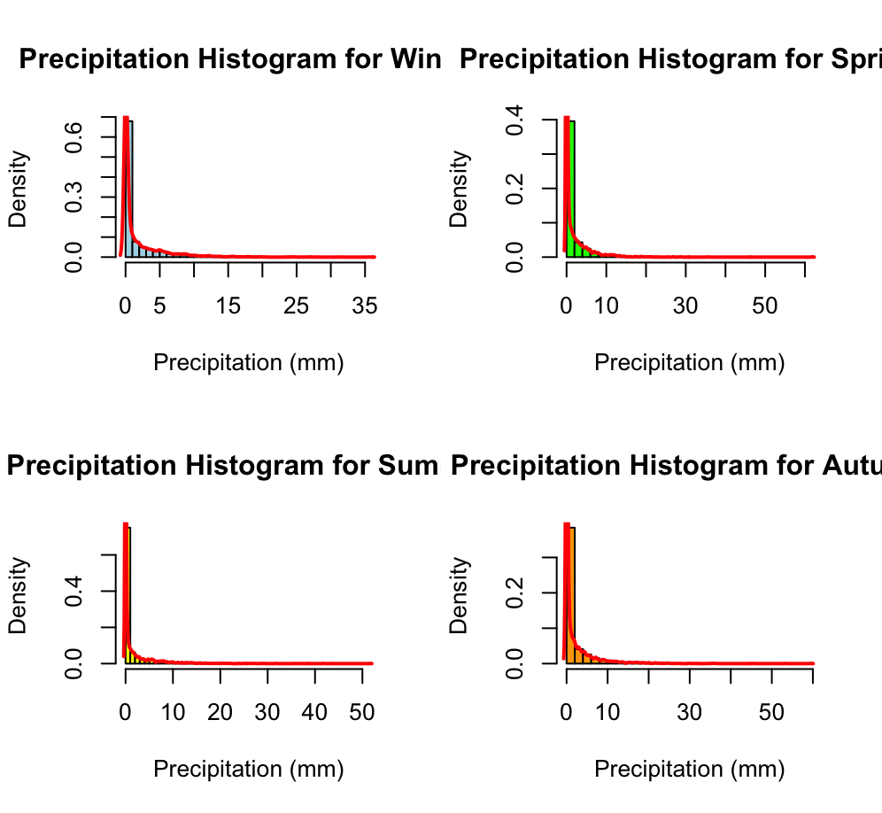
Fig: 3.4

  - Additional information relating to understanding the data

- The histograms reveal that precipitation data is highly skewed with a large proportion of zero values , which is typical for daily rainfall data.

  - Useful information for the data understanding (50 words)
- Key observations: Autumn has the highest mean precipitation (1.90 mm), followed by Winter (1.74 mm), Summer (1.57 mm), and Spring (1.46 mm). The boxplot shows higher variability and more outliers in Autumn and Winter, indicating heavier rain events. Histograms confirm right-skewed distributions across all seasons, with densities peaking near zero.

- Analysis

  - Statistical test used to test the hypotheses and output
The Kruskal-Wallis test was chosen as the statistical test because the precipitation data is not normally distributed (as evidenced by histograms showing heavy skewness and many zero values), violating ANOVA assumptions. This non-parametric test compares medians across multiple groups (seasons) effectively.
Output from R: Kruskal-Wallis chi-squared = 160.67, df = 3, p-value < 2.2e-16.
Pairwise comparisons using Wilcoxon rank sum test with Holm adjustment:
- Autumn vs. Spring: p = 8.0e-07
- Autumn vs. Summer: p = 2.8e-16
- Autumn vs. Winter: p = 0.0021
- Spring vs. Summer: p = 0.0021
- Spring vs. Winter: p = 2.8e-16
- Summer vs. Winter: p < 2e-16

  - The null hypothesis is rejected /not rejected based on the p-value
The null hypothesis is rejected based on the p-value (< 2.2e-16), which is far below the 0.05 significance level. This indicates strong evidence of differences in mean daily precipitation among seasons. Pairwise tests show significant differences between all season pairs, with the largest contrasts between Autumn (wettest) and Spring (driest). These results align with literature on UK seasonal trends, suggesting wetter cold seasons in London.

- Evaluation – group’s experience at 7COM1079

  - What Went Well
The group collaborated effectively on data cleaning and visualization, leveraging R skills to produce clear plots and analyses. Division of tasks (e.g., one member handling scripting, another literature review) ensured efficient progress. Regular meetings fostered idea sharing, and the dataset's quality allowed robust insights without major preprocessing issues.

  - Points for Improvement

Communication could be enhanced with more frequent updates via shared tools. Some delays occurred due to unfamiliarity with non-parametric tests, suggesting better initial training. Future projects should include contingency plans for missing data or software glitches.

  - Group’s Time Management

The group managed time well, completing data analysis two weeks early and allocating buffer time for revisions. Milestones were met using a shared calendar, though final report drafting extended slightly due to iterative feedback.

  - Project’s Overall Judgement

The project was successful in addressing the RQ with solid evidence, contributing to climate understanding. It demonstrated practical application of statistical methods, though limited by dataset scope.

  - Comment on GitHub Log Output

The GitHub log output (placed in Appendix B) shows consistent contributions. Three most significant commits: Commit Message: "Initial data import and cleaning script" - This established the dataset foundation, enabling all subsequent analyses. Commit Message: "Added Kruskal-Wallis and pairwise tests" - This implemented the core statistical analysis, directly testing the hypotheses. Commit Message: "Final visualizations with labels" - This refined plots for clarity, improving report quality and interpretability.

- Conclusions

  - Results explained
These results mean London's precipitation is not uniform across seasons, with wetter Autumn and Winter potentially increasing flood risks, while drier Spring and Summer may heighten drought concerns. In the RQ context, this highlights climate-driven shifts affecting urban populations, aligning with broader UK trends like NAO influences.

  - Interpretation of the results
These results mean London's precipitation is not uniform across seasons, with wetter Autumn and Winter potentially increasing flood risks, while drier Spring and Summer may heighten drought concerns. In the RQ context, this highlights climate-driven shifts affecting urban populations, aligning with broader UK trends like NAO influences.

  - Reasons and/or implications for future work, limitations of your study
Future work could incorporate recent data (post-2020) or model projections under climate scenarios. Limitations include missing values removal potentially biasing results and lack of spatial granularity in the dataset. Implications: Inform urban planning for resilience.

- Reference list
- Murphy, J. et al. (2021) UKCP18: UK Climate Projections. Met Office.
- Osborn, T. J. and Jones, P. D. (2002) 'The North Atlantic Oscillation and UK precipitation', Journal of Climate, 15(12), pp. 1456-1472.
- Simpson, I. R. and Jones, P. D. (2012) 'Homogenized UK precipitation series', Climatic Change, 113(3-4), pp. 1021-1044.

- Appendices

- R code used for analysis and visualisation

library(readr)
weather_df <- read_csv("london_weather.csv")

weather_df$year <- as.numeric(substr(as.character(weather_df$date), 1, 4))
weather_df$month <- as.numeric(substr(as.character(weather_df$date), 5, 6))

weather_df$season <- ifelse(weather_df$month %in% c(12, 1, 2), "Winter",
ifelse(weather_df$month %in% c(3, 4, 5), "Spring",
ifelse(weather_df$month %in% c(6, 7, 8), "Summer", "Autumn")))

weather_df <- weather_df[!is.na(weather_df$precipitation), ]

print(sum(is.na(weather_df$precipitation)))

hist(weather_df$precipitation, breaks = 40, main = "Overall Daily Precipitation Histogram",
xlab = "Precipitation (mm)", ylab = "Density", col = "purple", freq = FALSE, ylim = c(0, 0.3))
lines(density(weather_df$precipitation, na.rm = TRUE), col = "red", lwd = 3)

par(mfrow = c(2, 2))
seasons_list <- c("Winter", "Spring", "Summer", "Autumn")
colors_list <- c("lightblue", "green", "yellow", "orange")
for (i in 1:4) {
s <- seasons_list[i]
precip_s <- weather_df$precipitation[weather_df$season == s]
hist(precip_s, breaks = 40, main = paste("Precipitation Histogram for", s),
xlab = "Precipitation (mm)", ylab = "Density", col = colors_list[i], freq = FALSE)
lines(density(precip_s, na.rm = TRUE), col = "red", lwd = 2)
}
par(mfrow = c(1, 1))

boxplot(precipitation ~ season, data = weather_df,
main = "Seasonal Daily Precipitation in London (1979-2020)",
xlab = "Season", ylab = "Precipitation (mm)",
col = c("lightblue", "green", "yellow", "orange"), notch = TRUE)

season_summary <- tapply(weather_df$precipitation, weather_df$season, summary)
print(season_summary)

kw_test <- kruskal.test(precipitation ~ season, data = weather_df)
print(kw_test) # Expect p-value ~1.31e-34 (very significant)

pairwise_test <- pairwise.wilcox.test(weather_df$precipitation, weather_df$season, p.adjust.method = "holm")
print(pairwise_test)

season_means <- tapply(weather_df$precipitation, weather_df$season, mean, na.rm = TRUE)
season_ses <- tapply(weather_df$precipitation, weather_df$season, function(x) sd(x, na.rm = TRUE)/sqrt(length(x)))
bar_centers <- barplot(season_means, names.arg = seasons_list, col = colors_list,
ylim = c(0, max(season_means + season_ses, na.rm = TRUE)*1.2),
main = "Mean Seasonal Daily Precipitation", ylab = "Mean Precipitation (mm)")
arrows(bar_centers, season_means - season_ses, bar_centers, season_means + season_ses,
angle = 90, code = 3, length = 0.1)

- GitHub log output.
The following is the extracted commit history from the repository https://github.com/oc24aan/group-assignment-7COM1079/commits/main, filtered to commits authored by jm25acy (Jayakumar Mahesh). These represent key contributions to the project, including initial research question setup and visualization additions.
- ff9794 - "Added mean perception of an season" - jm25acy - Nov 27, 2025
- 04575c0 - "Jayakumar Question file" - jm25acy - Nov 18, 2025
- c2309e6 - "Jayakumar Question File" - jm25acy - Nov 18, 2025
- 927d1e5 - "Jayakumar Question File" - jm25acy - Nov 18, 2025

