Please delete all the italic text before submission. It is here just for your reference.

Further: data set – DS, research question – RQ

The mark (x words) after each subchapter states the word count limit. This indicates the expected amount of information which you can exceed by 10% without losing the mark.

7COM1079-0901-2025 - Team Research and Development Project

Final report title: (the topic of your research.)

Group ID:

Dataset number:

Prepared by: [Name and ID of submitting student first],
[Name and ID of other group members]

Please make sure the document spelled correctly (including image labels, section headings, and table of contents). Please use correct punctuation.
Make sure your report is grammatically correct.

University of Hertfordshire
Hatfield, 2025

Table of Contents add page numbers from here

- Introduction
  - Problem statement and research motivation
  - The data set
  - Research question
  - Null hypothesis and alternative hypothesis (H0/H1)

- Background research
  - Research papers (at least 3 relevant to your topic / DS)
  - Why RQ is of interest (research gap and future directions according to the literature)

- Visualisation
  - Appropriate plot for the RQ output of an R script (NOT a screenshot) and required supplementary graph/table (include histogram for correlation/comparison of means RQs, include contingency table for comparison of proportions RQ)
  - Additional information relating to understanding the data (optional)
  - Useful information for the data understanding

- Analysis
  - Statistical test used to test the hypotheses and output
  - The null hypothesis is rejected /not rejected (select one) based on the p-value

- Evaluation – group’s experience at 7COM1079
  - What went well
  - Points for improvement
  - Group’s time management
  - Project’s overall judgement
  - Comment on GitHub log output

- Conclusions
  - Results explained.
  - Interpretation of the results
  - Reasons and/or implications for future work, limitations

- Reference list
Harvard (author, date) format.
- Appendices
- R code used for analysis and visualisation.
- GitHub log output.

- Introduction
  - Problem statement and research motivation
Understanding local weather patterns is crucial for UK urban planning and agriculture. In London, variable precipitation significantly affects drainage systems, infrastructure and daily routines. Recent research indicates that although total annual rainfall figures may remain relatively consistent, there is a noticeable increase in seasonal instability and the frequency of extreme weather events across the UK (Osborn and Hulme, 2002; Kendon et al., 2023).
Hence, this project examines whether daily precipitation statistics are statistically affected by seasonal variations. Our goal is to identify significant differences in mean rainfall between seasons. This information can then be used to predict future climate trends and improve flood risk management, specifically for urban resilience.
  - The data set
The dataset used in this research is the "London Weather Data" dataset provided by the European Climate Assessment (ECA) (Werr, 2021). It contains daily weather observations for London from 1979 to 2020. The dataset consists of 15,341 rows and 10 columns. For this analysis, we focused on the dependent variable precipitation (measured in mm, interval data) and the independent variable date used to derive the nominal independent variable season. We identified and removed 6 missing values (NAs) from the precipitation.
  - Research question
Is there a difference in the mean daily precipitation among the seasons in London from 1979 to 2020?
  - Null hypothesis and alternative hypothesis (H0/H1)
- Null Hypothesis (H₀): There is no difference in the mean of daily precipitation among the seasons in London from 1979 to 2020.
- Alternative Hypothesis (H₁): There is a difference in the mean of daily precipitation among the seasons in London from 1979 to 2020.
2. Background research

2.1. Research papers (at least 3 relevant to your topic / DS)
- Klein Tank et al. (2002) established the reliability of the European Climate Assessment (ECA), which is the source of our project's data. Their work confirms that these daily records are reliable enough to analyse long-term climate variability across the United Kingdom.
- Kendon et al. (2023) provided a comprehensive update on the UK's climate, noting a clear trend towards wetter winters and summers. This supports our hypothesis that seasonal means are diverging and confirms an increase in the risk of both floods and droughts.
- Osborn and Hulme (2002) identified that while total annual rainfall has remained stable, the pattern of precipitation is changing. They found that heavy rainfall events are becoming more frequent in winter; on the other hand, summers are seeing a decrease in overall rainfall but occasional intense storms.
- Fowler and Kilsby (2007) projected that these seasonal extremes will continue to get stronger. Their research suggests that future water management strategies must be specific for each season and focusing on drainage in winter and saving water in summer, rather than relying on a uniform annual approach.
2.2. Why RQ is of interest (research gap and future directions according to the literature)

This research is critical because recent papers, such as Kendon et al. (2023) and Arnell et al. (2021), indicate a major change in UK climate patterns towards the seasons. While Klein Tank et al. (2002) established the reliability of European weather data, a specific research gap exists in applying these general national trends to London's daily precipitation at a detailed level. Validating these seasonal differences fills this gap. Future directions suggested by Fowler and Kilsby (2007) imply that confirming these trends must lead to specifying seasonal planning for city infrastructure. Prioritising winter flood defences and summer water saving rather than uniform annual strategies.
3. Visualisation

3.1. Appropriate graphs for the RQ

We first visualised the data distribution using a histogram (Figure 1). This plot reveals a strong right skewness, confirming that daily precipitation is not normally distributed. To answer our research question, we chose a boxplot (Figure 2). Boxplots allow us to compare the median, interquartile range and outliers of the ratio precipitation across seasons.

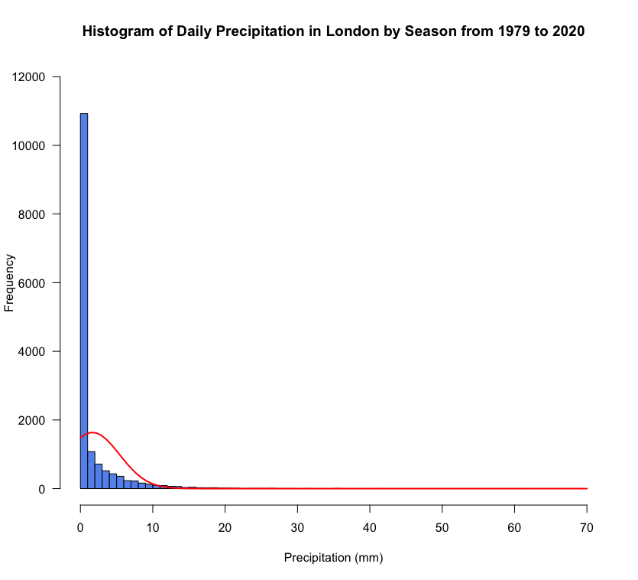
(Figure 1: Histogram of Daily Precipitation with Normal Curve)
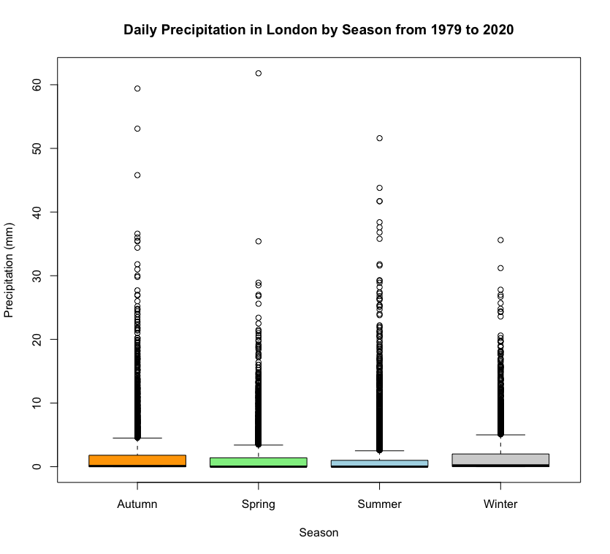
(Figure 2: Boxplot of Daily Precipitation by Season)

 | min. | 1st Qu. | Median | Mean | 3rd Qu. | Max.
Autumn | 0.000 | 0.000 | 0.100 | 1.901 | 1.800 | 59.400
Spring | 0.000 | 0.000 | 0.000 | 1.462 | 1.400 | 61.800
Summer | 0.000 | 0.000 | 0.000 | 1.573 | 1.000 | 51.600
Winter | 0.000 | 0.000 | 0.200 | 1.742 | 2.000 | 35.600

(Table 1: Summary Statistics of Daily Precipitation by Season)

3.2. Additional information relating to understanding the data

Before visualisation, we performed necessary data cleaning by removing 6 missing values (NAs) from the precipitation column to avoid calculation errors. We also transformed the date variable into a nominal season variable. This step was essential to group daily observations into Winter, Spring, Summer, and Autumn for our analysis.

3.3. Useful information for the data understanding

To support our graph (Figure 2), we calculated summary statistics for each season (Table 1). The dataset comprises precipitation (ratio data) grouped by season (nominal data). The table shows that while median precipitation is usually low (often 0 mm) due to many dry days, mean values vary significantly. This is caused by the rare heavy rain events called outliers, shown in our graphs.

4. Analysis

4.1. Statistical test used to test the hypotheses and output

We used the pairwise Wilcoxon rank sum test to analyse the data, as the output shown in Table 2. This non-parametric test was selected because our research question compares a ratio variable, precipitation, with four independent seasons. As visualised in the section 3 graph (Figure 1), the precipitation data are strongly right-skewed, so we could not use a standard parametric test. According to the module's statistical decision tree, the pairwise Wilcoxon rank sum test is the appropriate method for comparing means when the data is not normally distributed across more than two groups.

Winter | 1
Spring | 8.0e-07  Very significant difference | 1
Summer | 2.8e-16  Very significant difference | 0.0021  significant difference | 1
Autumn | 0.0021  significant difference | 2.8e-16  Very significant difference | < 2e-16  Very significant difference | 1
 | Winter | Spring | Summer | Autumn

(Table 2: Pairwise Wilcoxon Rank Sum Test Results)

4.2. The null hypothesis is rejected /not rejected (select one) based on the p-value

The statistical results in Table 2 show that p-values are significantly lower than the standard level of 0.05. For instance, even between seasons that might seem similar, like Winter vs. Autumn (p = 0.0021) and Autumn vs. Spring (p = 2.8e-16), the test shows they are different. Since these values are below 0.05, we have strong statistical evidence to reject the null hypothesis (H₀). This means we accept the alternative hypothesis (H₁), concluding that there is a statistically significant difference in the mean daily precipitation among the seasons in London.

5. Evaluation – group’s experience at 7COM107
5.1. What went well

We used GitHub branches for version control, ensuring organised project management. Our team collaborated closely through frequent meetings, starting early to thoroughly understand the problem together. Presenting our Research Question and initial analysis to professors for feedback was incredibly helpful, allowing us to refine our approach before the final submission. Starting early and working together helped us handle the complex seasonal data. Although selecting the pairwise statistical test was challenging, we overcame the challenge and produced a strong analysis
5.2. Points for improvement
Some team members were unfamiliar with Git branching, leading to extra coordination challenges that we had to resolve. We could have improved our study by looking only at rainy days to fix the problem of having too many zeros. Also, checking how seasonal patterns change year by year would help us find long-term climate trends.
5.3. Group’s time management

We set up a weekly schedule, starting from the research question and moving all the way to visualisation. We met at every stage to split up the work and keep on schedule. Using WhatsApp and GitHub kept everyone updated and helped us meet our deadlines efficiently.
5.4. Project’s overall judgement
Overall, this project successfully answered the hypothesis. We effectively answered our research question by proving a statistically significant difference in London's seasonal precipitation. Despite technical challenges with Git and statistical selection, our teamwork and early preparation resulted in a strong analysis. The final report confirms that seasonal climate patterns are shifting.
5.6. Comment on GitHub log output

6. Conclusions

6.1. Results explained

The analysis successfully answered the research question regarding seasonal precipitation differences. The Wilcoxon Rank Sum Test showed p-values well below the 0.05 limit, leading us to reject the null hypothesis (H₀). This statistical evidence, supported by the boxplots in Figure 2, confirms that rainfall does not follow the same pattern in the years. Specifically, there is a difference in the mean of daily precipitation among the seasons in London from 1979 to 2020.

6.2. Interpretation of the results

Rejecting the null hypothesis confirms that London's rainfall patterns are distinctly seasonal. For urban planners and the public, this means that planning cannot rely on simple yearly averages. The significant variation requires strategies for each season: better drainage systems are needed to manage heavy rain in Winter (flood risk), while strict water saving measures are needed for Summer. This matches national climate research (Kendon et al., 2023), highlighting the need to prepare for changing weather extremes.

6.3. Reasons and/or implications for future work, limitations

A major limitation is that the dataset ends in 2020, so it misses the climate patterns from the last five years (up to 2025). Also, the study was limited because we had to choose from a fixed list of questions and types of variables. From a scientific view, the many days with zero rain skewed our results. Future work should use newer data and look specifically at rainy days to better analyse.

7. Reference List

Kendon, M. et al. (2023) ‘State of the UK climate 2022’, International journal of climatology, 43, pp. 1–83.
Osborn, T.J. and Hulme, M. (2002) ‘Evidence for trends in heavy rainfall events over the UK’, Philosophical Transactions of the Royal Society of London. Series A: Mathematical, Physical and Engineering Sciences, 360(1796), pp. 1313–1325.
Werr, E.F. (2021) ‘London Weather Data’. Kaggle.

