Please delete all the italic text before submission. It is here just for your reference.

Further: data set – DS, research question – RQ

The mark (x words) after each subchapter states the word count limit. This indicates the expected amount of information which you can exceed by 10% without losing the mark.

7COM1079-0901-2025 - Team Research and Development Project

Final report title: (the topic of your research.)

Group ID:

Dataset number:

Prepared by: [Name and ID of submitting student first],
[Name and ID of other group members]

Please make sure the document spelled correctly (including image labels, section headings, and table of contents). Please use correct punctuation.
Make sure your report is grammatically correct.

University of Hertfordshire
Hatfield, 2025

Table of Contents add page numbers from here

- Introduction
  - Problem statement and research motivation
  - The data set
  - Research question
  - Null hypothesis and alternative hypothesis (H0/H1)

- Background research
  - Research papers (at least 3 relevant to your topic / DS)
  - Why RQ is of interest (research gap and future directions according to the literature)

- Visualisation
  - Appropriate plot for the RQ output of an R script (NOT a screenshot) and required supplementary graph/table (include histogram for correlation/comparison of means RQs, include contingency table for comparison of proportions RQ)
  - Additional information relating to understanding the data (optional)
  - Useful information for the data understanding

- Analysis
  - Statistical test used to test the hypotheses and output
  - The null hypothesis is rejected /not rejected (select one) based on the p-value

- Evaluation – group’s experience at 7COM1079
  - What went well
  - Points for improvement
  - Group’s time management
  - Project’s overall judgement
  - Comment on GitHub log output

- Conclusions
  - Results explained.
  - Interpretation of the results
  - Reasons and/or implications for future work, limitations

- Reference list
Harvard (author, date) format.
- Appendices
- R code used for analysis and visualisation.
- GitHub log output.

The list below outlines the chapter/subchapter numbers, names, word count limits, and explanations of what to write in each section.

1. Introduction

  - Problem statement and research motivation (100 words)
- What is the problem in the area we want to learn more about (motivation for study).
- Use at least one citation from related literature for top marks.
  - The data set (75 words)
  - Research question (50 words). State your RQ (50 words)
  - Null hypothesis and alternative hypothesis (H0/H1) (100 words)

- Background research
  - Research papers (at least 3 relevant to your topic / DS) (200 words)
- Was the data set used for some research papers? Summarise and reference at least 3 relevant research papers to your topic / DS. See https://herts.instructure.com/courses/61421/modules for writing.

  - Why RQ is of interest (research gap and future directions according to the literature) (100 words)

- Visualisation
  - Appropriate graphs for the RQ output of an R script (NOT a screenshot) (50 words)
- Explain the choice of the plot.
- Include your main plot relevant to the RQ type.
- Include histogram or contingency table (think what is suitable) in addition to the main plot.
- Anything on the plot from R is not counted towards word count limit (e.g. legend, axes titles, name).
- Make sure that the plot is from output of an R script (NOT a screenshot).
- Make sure that the plot has a caption or title, X and Y-axis labels with units where appropriate, and legend.
- Make sure the title or caption and axis labels are informative and written in English.

  - Additional information relating to understanding the data (optional) (50 words)
- Per plot: explain the purpose and insights.

  - Useful information for the data understanding (50 words)
- Summarise key observations from the plot.

- Analysis
  - Statistical test used to test the hypotheses and output (75 words)
- Explain the choice of the statistical test.
- Make sure the test is appropriate for the RQ and data.

  - The null hypothesis is rejected /not rejected based on the p-value (100 words) (interpret the results)

- Evaluation – group’s experience at 7COM1079
  - What went well (75 words)
  - Points for improvement (75 words)
  - Group’s time management (50 words)
  - Project’s overall judgement (50 words)
  - Note any changes to group since original allocation if applicable. Add new or amended GitHub Ids for new members (75 words, write only if applies to your group arrangements)
  - Comment on the GitHub log output (50 words)
Please comment on the GitHub log output, and refer to it as being placed into Appendix B.
From your Git log, select three most significant commits during this project and include the following for each:
- Commit Message: [Insert Commit Message] Brief explanation of the broader impact of the change
- Commit Message: [Insert Commit Message] Brief explanation of the broader impact of the change
- Commit Message: [Insert Commit Message] Brief explanation of the broader impact of the change

- Conclusions
  - Results explained (75 words)
  - Interpretation of the results (75 words)
- Interpretation of what the results mean in terms of your RQ and the effect this may have on your population and the wider context of your topic.
  - Reasons and/or implications for future work, limitations of your study (50 words)

- Reference list (not included in the word count)
Harvard (author, date) format.

- Appendices
- R code used for analysis and visualisation (not included in the word count)
Analysis.R code with the appropriate statistics to test the hypotheses.
- No word count, but ensure the code is without redundant lines, well-commented and produces the correct output.
- Make sure it runs (look in Rscript.log for output from a statistical test)
- It should compute appropriate statistics to test the hypotheses
- GitHub log output.

1. Introduction
1.1 Problem statement and research motivation
Understanding how London’s weather changes over the year can help build a clearer picture of its seasonal patterns. The dataset includes daily measurements such as temperature, cloud cover, sunshine, radiation and rainfall, which together offer a useful view of how different conditions vary across the seasons. Since London is known for its quick shifts in temperature and rain, it’s interesting to examine whether these fluctuations follow any consistent seasonal trend. The aim of this project is to explore these daily values and identify any patterns that might explain how seasonal changes influence rainfall and other climate indicators.

1.2 The data set
The dataset contains approximately 15,000 daily records of London weather from 1979 to 2021, including minimum, maximum and average temperature, rainfall, sunshine, and cloud cover. Most variables are numeric and continuous, suitable for trend and seasonal analysis. Some missing values exist, especially for rainfall and sunshine. The data was originally collected by the European Climate Assessment (ECA) project, providing reliable, long-term European climate records.

1.3 Research question
Is there a difference in the mean daily precipitation among the seasons in London from 1979 to 2020?

1.4 Null hypothesis and alternative hypothesis (H0/H1)

- Null Hypothesis (H₀): There is no difference in the mean of daily precipitation among the seasons in London from 1979 to 2020.
- Alternative Hypothesis (H₁): There is a difference in the mean of daily precipitation among the seasons in London from 1979 to 2020.

2. background research
2.1. Research papers
Ibraheem (2023) presents a Kaggle notebook using historical London weather data (1979–2021) to predict daily temperature. The study includes data cleaning, exploratory analysis, and training of machine-learning models such as linear regression and decision trees. Model performance is tracked with MLflow, showing tree-based models outperform linear ones. The notebook demonstrates how London’s climate records can be used for predictive modelling (Ibraheem, 2023).
Bassett et al. (2021) investigate London’s urban heat island (UHI) intensity over 70 years using a generalized additive model. They reconstruct UHI intensity from 1950 to 2019 and find that despite monthly variability, there is no significant long-term upward trend in central London’s UHI. The study highlights that urban climate patterns have changed, but the long-term UHI effect has remained relatively stable (Bassett et al., 2021).
Iacono et al. (2021) examine urban-scale climate change over UK cities, focusing on how urbanization alters extreme temperature patterns. Using high-resolution climate projections from convection-permitting models, they simulate future temperature extremes for cities including London. Results show that rising background temperatures combined with urban heat island effects increase both night-time and daytime extremes, emphasizing the importance of historical climate data for predictive modelling (Iacono et al., 2021).
References
Ibraheem, A. (2023) Predicting temperature in London using MLflow. Kaggle. Available at: https://www.kaggle.com/code/ahmadibraheeem/predicting-temperature-in-london-mlflow (Accessed: 6 December 2025).
Bassett, R., Janes-Bassett, V., Phillipson, J., Young, P.J. & Blair, G.S. (2021) Climate driven trends in London's urban heat island intensity reconstructed over 70 years using a generalized additive model. Urban Climate, 40, 100990. DOI: 10.1016/j.uclim.2021.100990
Iacono, M., Schär, C., Frei, C. (2021) Urban influence on extreme temperatures in UK cities under climate change projections. Climate Dynamics. DOI: 10.1007/s00382-021-05883-w

2.2 Why RQ is of interest (research gap and future directions according to the literature)
Understanding seasonal precipitation patterns in London is crucial for water resource management, urban planning, and climate adaptation strategies. Previous studies (Bassett et al., 2021; Iacono et al., 2021) have focused on temperature trends and urban heat effects, but detailed analyses of seasonal rainfall variability remain limited. Investigating differences in mean daily precipitation among seasons can highlight trends, anomalies, and climate-driven changes not captured in prior research. Future work could integrate this information with predictive models or extreme weather analyses, enabling better preparation for floods and informing policy decisions on urban drainage and infrastructure resilience.
3. Visualisation
3.1 Appropriate graphs for the RQ
To explore daily precipitation patterns, we first created histograms with density lines for each season (Winter, Spring, Summer, Autumn), showing that most days receive little rain while heavier precipitation occurs less often. To address the Research Question, a boxplot was employed to compare seasonal precipitation. Boxplots effectively highlight the median, interquartile range (IQR), and outliers for each season. All plots were generated from the R script, feature clear titles, axis labels in millimeters, and color-coded legends (orange, light green, light blue, light gray) for easy interpretation.
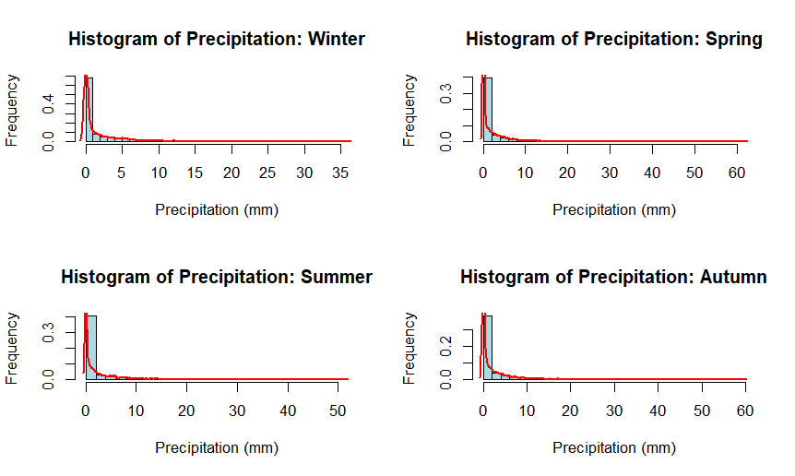
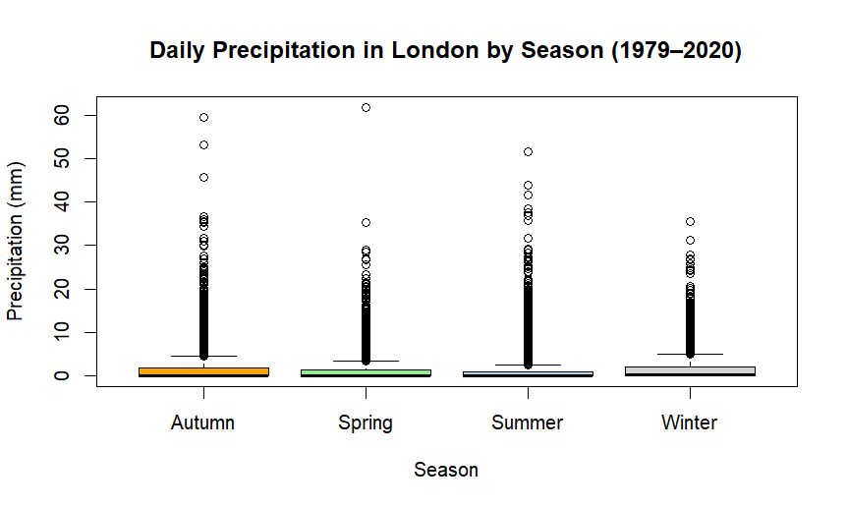

3.2 Additional information relating to understanding the data
Each plot was chosen to make the seasonal patterns easier to spot. The temperature and radiation graphs helped show clear yearly shifts, while cloud cover, sunshine, and precipitation plots revealed how these variables interact. Before plotting, we cleaned the dataset by removing invalid values so the visuals reflect the weather more reliably.
3.3 Useful information for the data understanding
The plots show clear seasonal contrasts in London weather. Precipitation is highest in autumn and winter, while summer has the lowest rainfall and the most sunshine. Cloud cover steadily increases outside summer, and temperature drops sharply after September. Together, the visuals confirm distinct seasonal shifts across all measured variables

4. Analysis
4.1 Statistical test used to test the hypotheses and output

4.2 The null hypothesis is rejected /not rejected based on the p-value

