Lognormal Return Distributions: META & ORCL
TAMID Fall 2026 · Oscar · Daily data Aug 31, 2021 – Sep 04, 2026 · source: Excel STOCKHISTORY via xlwings

1. Executive summary
We pulled five years of daily closing prices for Meta Platforms (META) and Oracle (ORCL) out of the club's StockDatabase.xlsx with Python (xlwings), converted them to logarithmic returns, fitted a normal distribution to those returns, and computed the 1σ, 2σ and 3σ bounds that theory says should contain 68.27%, 95.45% and 99.73% of daily moves. All tables and charts were written to a new Excel workbook as live formulas so the numbers can be audited in Excel.
 | META | ORCL
Return observations (days) | 1,258 | 1,258
Last close | $616.77 | $158.78
Daily σ (std. dev. of log returns) | 2.85% | 2.69%
Annualized volatility | 45.3% | 42.6%
Annualized drift (mean log return × 252) | 9.7% | 11.6%
1σ daily move (68.27%) | -2.77% / +2.93% | -2.61% / +2.77%
2σ daily move (95.45%) | -5.51% / +5.91% | -5.19% / +5.57%
3σ daily move (99.73%) | -8.16% / +8.97% | -7.70% / +8.44%
Actual days inside ±1σ / ±2σ / ±3σ | 82.0% / 96.3% / 98.8% | 81.4% / 95.4% / 98.4%
Skewness / excess kurtosis | -1.10 / 23.4 | +1.25 / 17.9

Key takeaways
- Both stocks are high-volatility names. A typical (1σ) day moves META about ±2.9% and ORCL about ±2.7%, i.e. roughly 43–45% annualized — about 2–3× the long-run volatility of the S&P 500.
- The normal model gets the middle wrong. About 82% of days fall inside ±1σ, not 68%: most days are quieter than σ suggests.
- …and the tails wrong. Moves beyond 3σ happened 15 times for META and 20 times for ORCL, versus ~3.4 expected. Excess kurtosis of 23 and 18 (normal = 0) and Jarque-Bera p-values of ≈0 formally reject normality.
- The tails are earnings days. META's −26% (Feb-2022) and −25% (Oct-2022) and ORCL's +36% (Sep-2025) are single scheduled events that σ-based bands cannot capture.
- Use the bands as a baseline, not a guarantee. ±2σ is a sensible 'normal-day' range; for risk limits, use empirical percentiles or a fat-tailed model and treat earnings dates separately.

2. The assignment and how the tooling is set up
The assignment: read the stock-price data from the Excel workbook into Python, calculate log returns, find the 68/95/99% (1, 2, 3 sigma) bounds, build a table and a chart, and output everything to a new Excel workbook. Oscar runs daily META and ORCL; Haas runs daily AAPL and MSFT with the same tool.
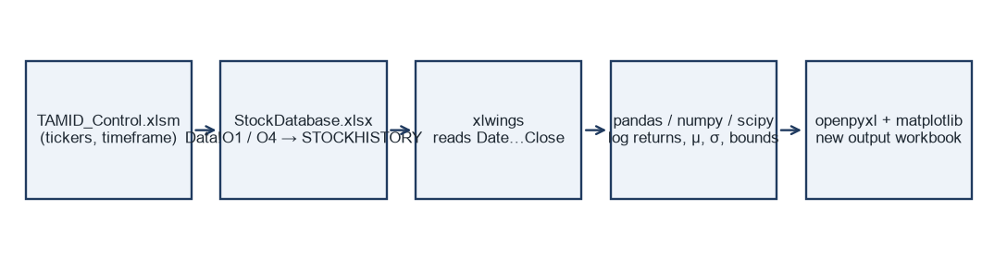
Figure 1 — Data flow. Excel remains the front end at both ends; Python does the computation.

2.1 Where the data comes from: STOCKHISTORY
StockDatabase.xlsx does not store prices: cell Data!A1 contains =STOCKHISTORY(O1, O2, O3, interval, 1, 0, 2, 3, 4, 1, 5), an Excel 365 function that downloads history from Microsoft's market-data provider and ‘spills’ Date, Open, High, Low, Close, Volume. The inputs are:
- O1 — ticker. Typing META there refreshes the whole table.
- O4 — timeframe dropdown (DAILY / WEEKLY / MONTHLY), mapped through the lookup table R1:S3 to STOCKHISTORY's interval argument 0 / 1 / 2.
- O2 / O3 — start and end date. O3 = TODAY(); O2 = EOMONTH(O3, −61 / −121 / −241), i.e. ≈5 years of daily, ≈10 years of weekly, or ≈20 years of monthly bars.
Because STOCKHISTORY refreshes asynchronously (Excel shows #BUSY! while downloading), the Python script cannot read a saved file — it must drive a running Excel, change O1/O4, and wait until the table is fully refreshed. That is exactly what xlwings is for.

2.2 The tools
- xlwings (desktop). A Python library that remote-controls an open Excel (AppleScript on Mac, COM on Windows). We use it to set Data!O1/O4, poll until the spill is stable, and read A:F straight into a pandas DataFrame. It also powers the Run button in TAMID_Control.xlsm (RunPython calls our script).
- xlwings Lite. The add-in visible in the Excel side-panel. It runs Python inside Excel itself (WebAssembly), so nothing needs to be installed, but it is sandboxed: it can only edit the workbook it lives in and cannot wait for STOCKHISTORY. We ship a Lite script for a quick single-ticker analysis on a new sheet.
- pandas / numpy / scipy. DataFrames, vectorised math, and the statistical functions (skewness, kurtosis, normal CDF, chi-square).
- openpyxl. Writes the new .xlsx file: formatted tables, live formulas, native Excel charts, and embedded images.
- matplotlib. Publication-quality charts (histogram with normal overlay, price/returns, Q-Q plot).

2.3 Design choices
- Control panel in Excel. Tickers and timeframe live in yellow cells in TAMID_Control.xlsm, so switching from META/ORCL to AAPL/MSFT weekly is an edit in Excel, not in code.
- Formulas, not pasted numbers. Every statistic in the output (e.g. σ = STDEV(G3:G1259)) is an Excel formula pointing at the raw prices. Python computes the same numbers independently and we verified they match to machine precision — a built-in audit trail.
- Non-destructive. The script remembers the ticker/timeframe that was in StockDatabase.xlsx and puts it back, and never saves that file.

3. Concepts, and why we use each one

3.1 Returns instead of prices
Prices are not comparable across stocks or over time (a $5 move means something different at $90 and at $790) and they trend, so their ‘distribution’ is meaningless. Returns are unit-free percentages and are roughly stationary — their behaviour is similar across time — which is what makes a distribution useful for forecasting ranges.

3.2 Simple vs. logarithmic returns
Simple return: R_t = P_t / P_(t−1) − 1 Log return: r_t = ln(P_t / P_(t−1)) = ln(1 + R_t)
For small moves they are almost identical (ln(1.01) = 0.995%). We use log returns because:
- They add up over time. The log return over n days is the sum of the daily log returns: ln(P_n/P_0) = r_1 + r_2 + … + r_n. Sums of random variables are what the Central Limit Theorem and the √t scaling rule are built on. Simple returns compound multiplicatively, which is messy.
- They are symmetric. +10% then −10% in simple terms leaves you down 1%; in log terms +0.0953 then −0.0953 brings you exactly back to zero.
- They imply prices that cannot go negative. If r is normal, P = P₀·e^r is lognormal: always positive and right-skewed. A normal model on simple returns would allow a −150% move.
- They are the standard in finance. Black-Scholes, geometric Brownian motion, and volatility quoted on option desks all assume normally distributed log returns.

3.3 The lognormal model
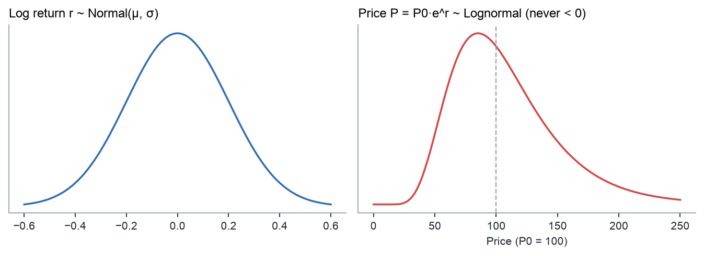
Figure 2 — If log returns are normal (left), prices are lognormal (right): bounded at zero, with a long right tail.
The model (geometric Brownian motion, in discrete form) says each period's log return is an independent draw from the same normal distribution:
r_t ~ N(μ, σ²) independently ⇒ P_T = P_0 · exp(r_1 + … + r_T), ln(P_T / P_0) ~ N(μT, σ²T)
Two parameters describe everything: the drift μ (average log return per bar) and the volatility σ (standard deviation per bar). We estimate them from history.

3.4 Estimating μ and σ
μ̂ = (1/n) Σ r_t σ̂ = √[ Σ (r_t − μ̂)² / (n − 1) ]
- Why n − 1 (sample standard deviation, Excel STDEV / STDEV.S). We are estimating a population parameter from a sample; dividing by n−1 (Bessel's correction) removes the downward bias.
- μ is small and noisy; σ is large and reliable. META's daily μ is 0.039% against σ of 2.85%. Over one day the drift barely matters, which is why the bounds are almost symmetric around zero. The standard error of μ̂ is σ/√n ≈ 0.080% — larger than μ itself — so the historical drift should not be read as a forecast.

3.5 Annualizing: the square-root-of-time rule
μ_annual = μ · N σ_annual = σ · √N (N = 252 trading days, 52 weeks, or 12 months)
Means add linearly over time, but for independent returns it is variances that add, so standard deviation grows with √time. This is how the tool compares daily, weekly and monthly runs on the same scale, and how the multi-horizon price table in the workbook is built. It relies on returns being independent; we check that in section 5.4.

3.6 Sigma bounds and the 68-95-99.7 rule
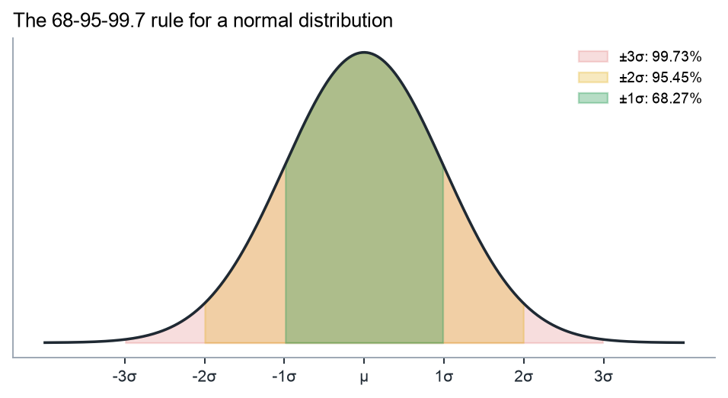
Figure 3 — For a normal variable, the probability of landing within k standard deviations of the mean is 68.27% (k=1), 95.45% (k=2), 99.73% (k=3).
The z-score z = (r − μ)/σ says how many standard deviations a move was. The bounds are computed in log space and then converted back to a percentage move and a price using the last close P₀:
log bounds: μ ± kσ % move: e^(μ ± kσ) − 1 price: P₀ · e^(μ ± kσ)
Note the asymmetry this creates: for META the 3σ band is -8.16% / +8.97%. The upside is larger than the downside because a lognormal price can rise without limit but can fall at most 100%. (The request mentioned ‘99%’; strictly, 3σ is 99.73% and the exact 99% band would be ±2.576σ.)

3.7 Longer horizons
Price range over h bars: P₀ · exp(μh ± kσ√h)
Because log returns add, the h-day distribution is N(μh, σ²h). The workbook tabulates 1-day, 1-week, 1-month, 1-quarter and 1-year ranges. The ‘median price’ P₀·e^(μh) is the 50th percentile; the mean of a lognormal is higher, P₀·e^(μh + σ²h/2), again because of the right skew.

3.8 Testing whether returns are actually normal
- Empirical coverage. Count the share of historical days that really fell inside ±kσ and compare with 68.27/95.45/99.73%. The simplest and most intuitive test.
- Histogram vs. normal curve. Overlay the fitted N(μ, σ²) density on the histogram. The workbook also tabulates actual vs. expected counts per bin.
- Skewness (third standardized moment) measures asymmetry: negative means the big moves are mostly down.
- Excess kurtosis (fourth moment − 3) measures tail heaviness. Normal = 0. Positive (‘leptokurtic’) means a taller, narrower peak AND fatter tails — more quiet days and more extreme days than a normal predicts.
- Jarque-Bera test. JB = n/6 · (S² + K²/4) combines skewness S and excess kurtosis K; under normality it follows a χ² distribution with 2 degrees of freedom. A p-value below 0.05 rejects normality.
- Q-Q plot. Plots sorted actual z-scores against the z-scores a normal distribution would produce. A normal sample lies on the 45° line; an S-shape bending away at both ends is the visual fingerprint of fat tails.

4. Methodology, step by step
# | Step | Implementation (Python → Excel formula in output)
1 | Select ticker & timeframe | TAMID_Control.xlsm → xlwings writes Data!O4 then Data!O1
2 | Wait for data | Poll A1:F2 and the last row every 1.5 s until the table has changed and is stable twice
3 | Read & clean | Read A1:F(last) into pandas; coerce types, drop blanks/non-positive prices, sort by date
4 | Log returns | np.log(Close / Close.shift(1)) → =LN(E3/E2)
5 | μ, σ, moments | mean, std(ddof=1), skew, kurtosis → =AVERAGE, =STDEV, =SKEW, =KURT
6 | Sigma bounds | μ ± kσ; e^x − 1; P₀·e^x → =EXP(D29)−1, =P₀*EXP(D29)
7 | Empirical coverage | share with lo ≤ r ≤ hi → =COUNTIFS(r, ">="&lo, r, "<="&hi)/n
8 | Normality | Jarque-Bera, percentiles vs NORMSINV, 32-bin histogram vs NORMDIST
9 | Output | openpyxl workbook (Summary, META, META_Data, ORCL, ORCL_Data) + charts; Excel recalculates
10 | Verify | Excel-computed μ, σ, skew, kurtosis, coverage compared with Python: identical

Data notes: STOCKHISTORY's Close is split-adjusted but not dividend-adjusted. Dividends are tiny for META and ORCL (<1.5% a year), so the effect on daily σ is negligible, but for high-yield stocks total-return data would be more accurate. The first bar has no return, so n = number of prices − 1.

5. Results
Run date September 14, 2026. Data: 1,259 daily closes from 08/31/2021 to 09/04/2026. Every figure below is reproduced as a live formula in output/LogReturns_DAILY_META_ORCL_2026-09-14.xlsx.

5.1 META
Statistic | Value | Statistic | Value
Mean log return μ (daily) | 0.0386% | Annualized drift | 9.73%
Std. deviation σ (daily) | 2.8505% | Annualized volatility | 45.25%
Worst day | -30.64% | Best day | 20.93%
Skewness | -1.096 | Excess kurtosis | 23.41
Jarque-Bera | 28,986 | p-value | 0.0e+00

Band | Normal prob. | Down move | Up move | Price low | Price high | Actual inside | Days outside
±1σ | 68.27% | -2.77% | +2.93% | $599.67 | $634.85 | 81.96% | 227 (exp. 399)
±2σ | 95.45% | -5.51% | +5.91% | $582.82 | $653.21 | 96.34% | 46 (exp. 57)
±3σ | 99.73% | -8.16% | +8.97% | $566.44 | $672.09 | 98.81% | 15 (exp. 3)

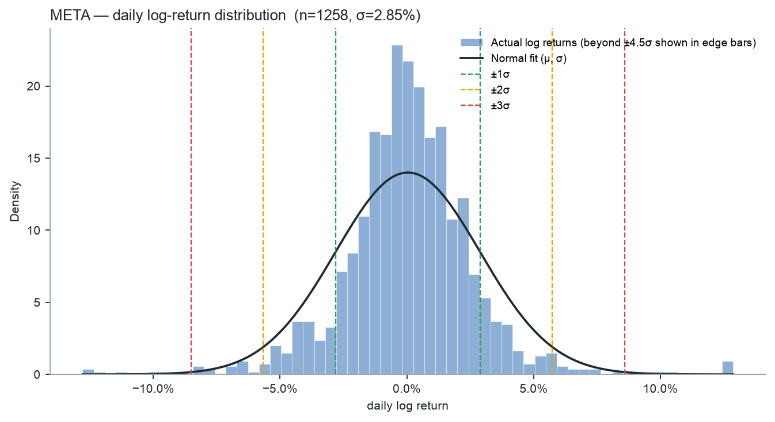
Figure — META daily log-return histogram with fitted normal curve and ±1/2/3σ lines.
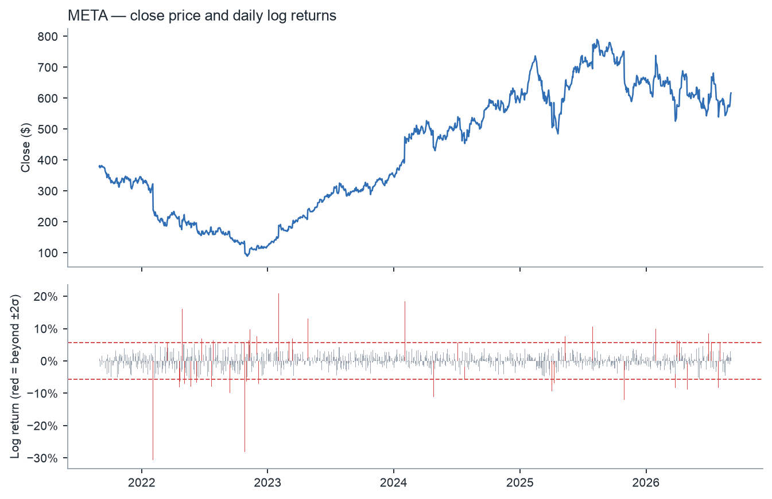
Figure — META close price and daily log returns; red bars are beyond ±2σ.
Largest moves | Close | Log return | Simple return | σ multiple
Feb 03, 2022 | $237.76 | -30.64% | -26.39% | -10.8σ
Oct 27, 2022 | $97.94 | -28.18% | -24.56% | -9.9σ
Feb 02, 2023 | $188.77 | +20.93% | +23.28% | +7.3σ
Feb 02, 2024 | $474.99 | +18.50% | +20.32% | +6.5σ
Apr 28, 2022 | $205.73 | +16.21% | +17.59% | +5.7σ

Horizon | Median | 1σ range (68%) | 2σ range (95%) | 3σ range (99.7%)
1 day | $617 | $600 – $635 | $583 – $653 | $566 – $672
1 week | $618 | $580 – $659 | $544 – $702 | $510 – $748
1 month | $622 | $546 – $709 | $479 – $807 | $420 – $920
1 quarter | $632 | $504 – $792 | $402 – $994 | $321 – $1,246
1 year | $680 | $432 – $1,069 | $275 – $1,681 | $175 – $2,642

5.2 ORCL
Statistic | Value | Statistic | Value
Mean log return μ (daily) | 0.0459% | Annualized drift | 11.57%
Std. deviation σ (daily) | 2.6864% | Annualized volatility | 42.65%
Worst day | -14.84% | Best day | 30.71%
Skewness | +1.250 | Excess kurtosis | 17.87
Jarque-Bera | 17,062 | p-value | 0.0e+00

Band | Normal prob. | Down move | Up move | Price low | Price high | Actual inside | Days outside
±1σ | 68.27% | -2.61% | +2.77% | $154.64 | $163.18 | 81.40% | 234 (exp. 399)
±2σ | 95.45% | -5.19% | +5.57% | $150.54 | $167.62 | 95.39% | 58 (exp. 57)
±3σ | 99.73% | -7.70% | +8.44% | $146.55 | $172.19 | 98.41% | 20 (exp. 3)

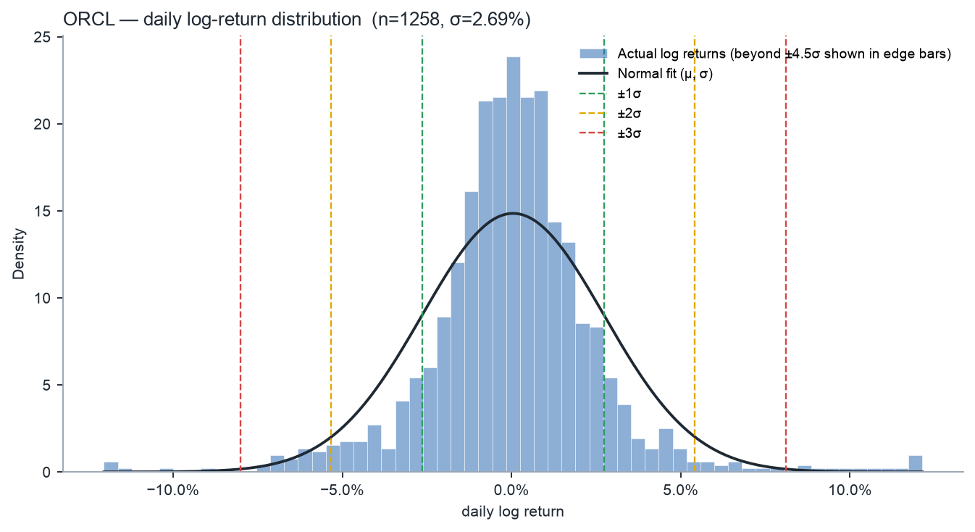
Figure — ORCL daily log-return histogram with fitted normal curve and ±1/2/3σ lines.
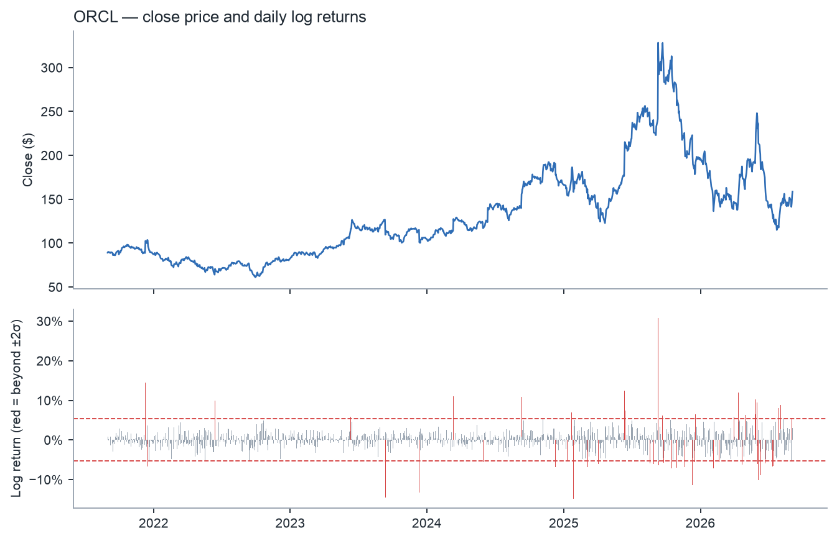
Figure — ORCL close price and daily log returns; red bars are beyond ±2σ.
Largest moves | Close | Log return | Simple return | σ multiple
Sep 10, 2025 | $328.33 | +30.71% | +35.95% | +11.4σ
Jan 27, 2025 | $158.28 | -14.84% | -13.79% | -5.5σ
Dec 10, 2021 | $102.63 | +14.51% | +15.61% | +5.4σ
Sep 12, 2023 | $109.61 | -14.50% | -13.50% | -5.4σ
Dec 12, 2023 | $100.81 | -13.28% | -12.44% | -5.0σ

Horizon | Median | 1σ range (68%) | 2σ range (95%) | 3σ range (99.7%)
1 day | $159 | $155 – $163 | $151 – $168 | $147 – $172
1 week | $159 | $150 – $169 | $141 – $179 | $133 – $191
1 month | $160 | $142 – $181 | $125 – $205 | $111 – $232
1 quarter | $163 | $132 – $202 | $107 – $250 | $86 – $310
1 year | $178 | $116 – $273 | $76 – $418 | $50 – $641

5.3 Is the normal model right? Comparing the two stocks
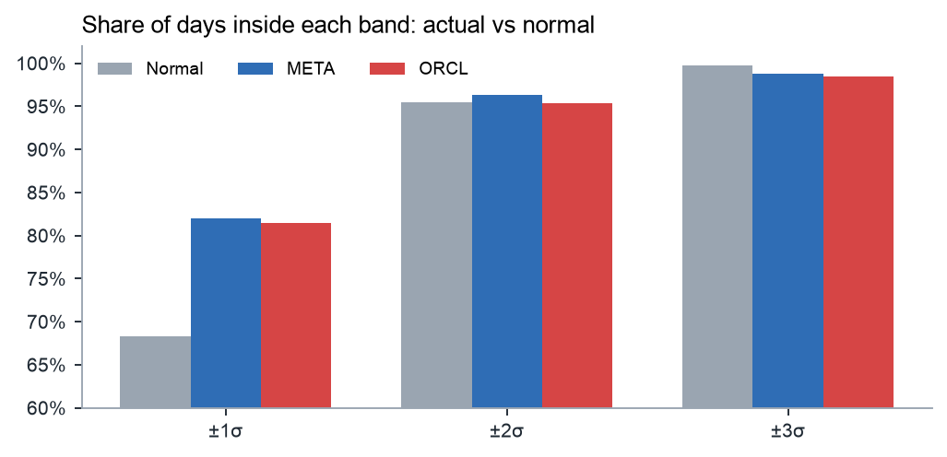
Figure — Actual share of days inside each sigma band versus the normal-distribution benchmark.
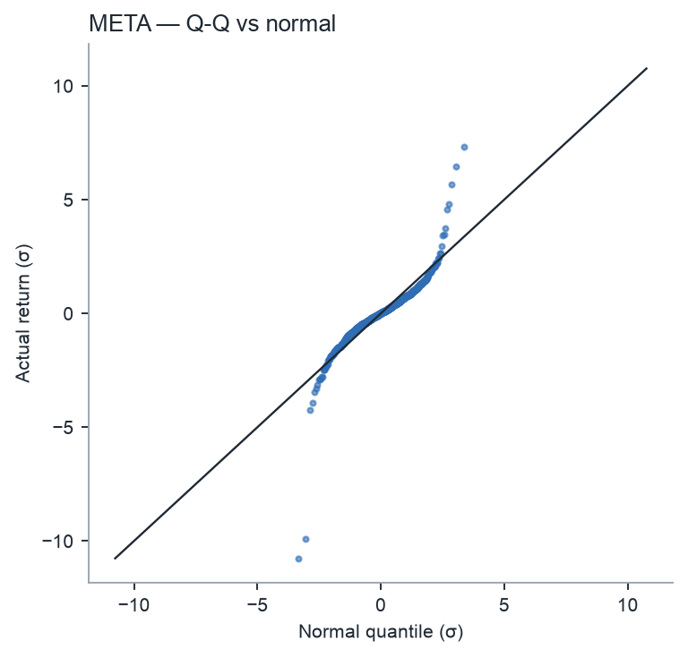 | 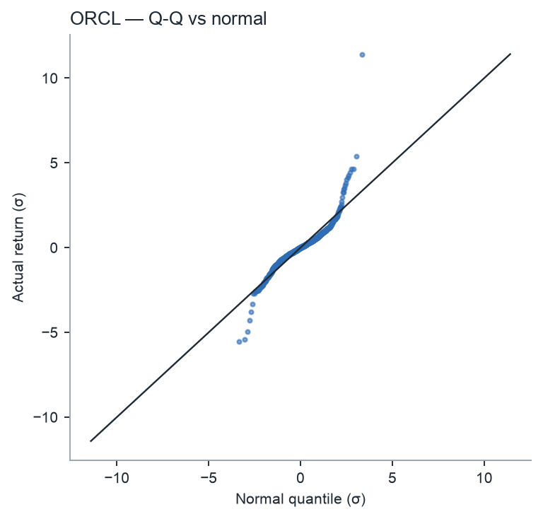
Figure — Q-Q plots. Points bend away from the line at both ends: the extreme days are far more extreme than a normal distribution allows.
- Too many quiet days (leptokurtosis). 82.0% (META) and 81.4% (ORCL) of days stayed within ±1σ, about 13–14 points more than the 68.3% benchmark. The histograms show a taller, narrower peak than the fitted curve.
- About right at 2σ — by coincidence. Coverage of 96.3% and 95.4% is close to 95.45%. Excess quiet days and excess extreme days offset each other here, which is why a 2σ range can look ‘validated’ even though the distribution is not normal.
- Too many extreme days (fat tails). At 3σ only 98.81% / 98.41% of days were inside the band, so extreme days happened roughly 4× (META) and 6× (ORCL) as often as the model predicts. META's worst day was a -10.7σ event; under normality a move that size should essentially never happen in the lifetime of the universe.
- Skew points in opposite directions. META is negatively skewed (-1.10): its biggest moves were crashes (2022 earnings). ORCL is positively skewed (+1.25), dominated by the +36% cloud-backlog surprise in September 2025.
- A handful of days drive the tails. Removing just the five largest days cuts META's excess kurtosis from 23 to about 3.5 and ORCL's from 18 to about 4. The fat tails are mostly earnings-announcement jumps; the rest of the distribution is still fatter than normal but far less so.

5.4 Volatility is not constant
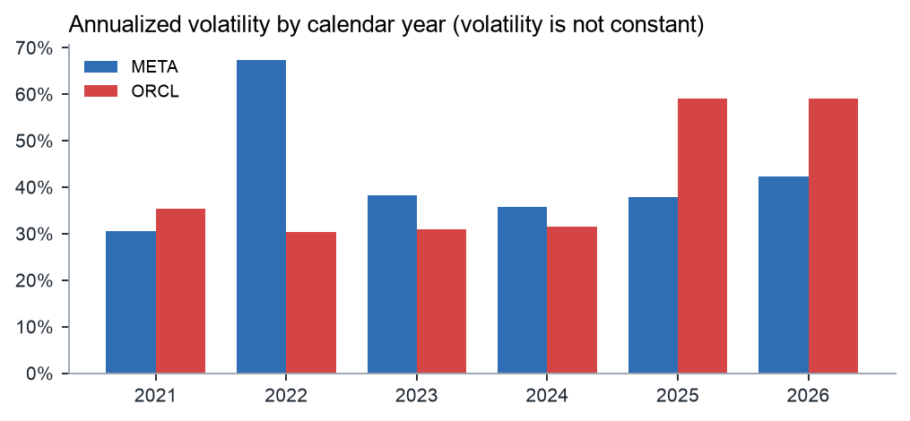
Figure — Realized annualized volatility by calendar year.
The model uses one σ for five years, but realized volatility moves a lot: META ran at ~67% in its 2022 drawdown and ~36% in 2024, while ORCL went from ~30–32% (2022–2024) to ~59% in 2025–2026 as it was re-rated as an AI-infrastructure name. This volatility clustering (calm periods and turbulent periods) is a second reason for the fat tails: mixing a low-σ regime and a high-σ regime produces a fat-tailed overall distribution. The day-to-day autocorrelation of returns themselves is close to zero for both stocks (META −0.01, ORCL +0.04), so the ‘independent returns’ assumption behind √t scaling is reasonable for the direction of moves, but not for their size. The correlation between META and ORCL daily returns is 0.27.

6. How to use these numbers
- Expected daily range. On a normal day, expect META within roughly $600–$635 and ORCL within $155–$163 (1σ from the last close). In practice this band holds about 4 days out of 5.
- Position sizing and stops. A stop placed inside the 1σ band will be hit by ordinary noise. Stops or risk limits are more robust at 2σ or beyond, sized so that a 3σ day — which happens a few times a year for these names, not once a lifetime — is survivable.
- Comparison with options. Realized σ can be compared with the implied volatility on META/ORCL options. If implied vol is well below the ~43–45% realized here, options look cheap relative to history, and vice versa. Around earnings, implied vol rises precisely because of the jump days identified above.
- Relative risk. Dividing the 1σ move by the S&P 500's gives a quick measure of how much more a stock moves than the market; running SPY through the same tool gives the benchmark.
- Don't treat 3σ as a worst case. The empirical 0.135% percentile was −16.9% for META and −13.7% for ORCL, about twice the normal-model 3σ bound. For risk work, quote empirical percentiles alongside σ bands.

7. Limitations and possible extensions
- Normality is rejected (section 5). Alternatives: a Student-t distribution (fits fat tails with one extra parameter), or historical simulation using the actual empirical distribution.
- Constant σ. Use EWMA volatility (RiskMetrics, λ = 0.94) or a GARCH(1,1) model so the bands widen in turbulent periods and shrink in calm ones.
- Event risk. Flag earnings dates and analyse ex-earnings returns separately; the bands are much more reliable away from announcements.
- Window choice. Five years mixes very different regimes (META's 2022 crash, ORCL's 2025 re-rating). Try the WEEKLY/MONTHLY settings, or a rolling 1-year window, and compare σ.
- Price data. Close is not dividend-adjusted and historical estimates say nothing about new information; past volatility is a guide, not a forecast.

Appendix A — Files
File | What it does
TAMID_Control.xlsm | Control panel: tickers, timeframe, Run button (xlwings RunPython)
run_analysis.py | Main script: drives StockDatabase.xlsx, computes, writes the output workbook
lognormal/excel_source.py | xlwings: set O1/O4, wait for STOCKHISTORY, read prices
lognormal/core.py | Math: cleaning, log returns, statistics, sigma bounds
lognormal/workbook.py | openpyxl: formatted tables, live formulas, native charts, images
lognormal/charts.py | matplotlib figures
xlwings_lite/main.py | Single-ticker version that runs inside Excel via the xlwings Lite add-in
output/LogReturns_*.xlsx | Results (one workbook per run)
SETUP_GUIDE.md | Step-by-step installation and usage guide

Appendix B — Glossary
Term | Meaning
Log return | ln(P_t/P_(t−1)); additive over time
μ (drift) | Average log return per bar
σ (volatility) | Standard deviation of log returns per bar
Annualized volatility | σ × √(bars per year)
z-score | (r − μ)/σ: how many σ a move was
Lognormal | Distribution of a variable whose logarithm is normal; used for prices
Skewness | Asymmetry of the distribution (0 for normal)
Excess kurtosis | Tail heaviness relative to normal (0 for normal)
Fat tails | Extreme moves occur more often than a normal distribution predicts
Jarque-Bera | Test of normality based on skewness and kurtosis
Q-Q plot | Actual vs. theoretical quantiles; straight line = normal
Volatility clustering | Big moves tend to follow big moves; σ changes over time
STOCKHISTORY | Excel 365 function that downloads historical prices
xlwings | Python library that reads/writes a running Excel

