Professional

Corporate Committee

- Contact companies to set up events and obtain sponsorships for IEEE
- Meet company representatives for luncheons and other events
- Attend Career Fairs throughout year to obtain more contacts and set up business relations

Email Rohit Kant at kant1@illinois.edu to get involved.

External Relations Committee

- Organize events with neighboring student branches and other IEEE branches
- Gain experience in planning conferences, alumni events, and social events with other schools
- Looking for students who love to plan events!

If you have ideas for exciting events this year, email Ekta Shah at shah47@illinois.edu to make them happen!

Membership Information
To join the international IEEE organization, one must visit ieee.org for instructions. There is a $32 fee for yearly student membership.

Membership benefits for students at UIUC include:
- 24 hrs a day lab access for the IEEE lab on the second floor of EL
- Discounts on IEEE workshops, sometimes deep enough to cover the membership fee
- Funding for projects
- Ability to run for positions on the board
- Subscription to IEEE’s Potentials and Spectrum magazines.

If you have any further questions regarding membership or any of our activities, feel free to email Suraj Malhotra at smalhotra@ieee.org.

Visit the IEEE at Illinois website at ieee.ece.uiuc.edu to read more about IEEE on campus or stop on by our office in 243 Everitt Lab.

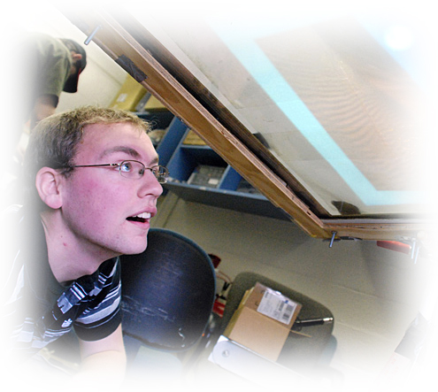

About IEEE

- IEEE is the world leading professional society for Electrical and Computer Engineers
- IEEE at Illinois, the local student branch, serves the students and faculty in ECE and related disciplines.
- IEEE at Illinois is not only a technical organization but also a very socially focused one as well.
- We break the stereotypical mold of being dull engineers.
- The outgoing and social executive board is representative of the talented individuals that participate in IEEE on campus.

Upcoming Events for IEEE - UIUC

- Quad Day
  - 8/21 all day on the Quad
- First General Meeting
  - 9/7 – Everitt Lab
  - Free Pizza!!
- First Workshop
  - TBD

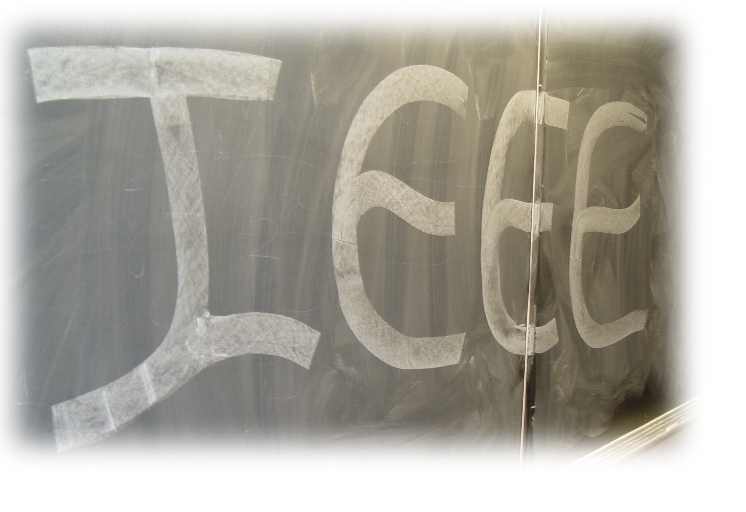

To get involved and see a whole new world with IEEE, email Suraj Malhotra at smalhotra@ieee.org to join the mailing list.

Technical

Workshops Committee

- Help ECE undergrads learn valuable technical skills not taught in the classroom
- The first workshop each semester is assembling a logic probe useful for ECE 110 and ECE 385
- Other workshops include speaker building, guitar distortion pedals, a fake Jar of LED fireflies, and more
- Looking for more students in not only hosting but also designing new fun and practical workshops!

Email Joseph Shim at shimyosup@gmail.com to join the committee to develop these workshops or to attend these workshops.

IEEE SEED Projects

- IEEE at U of I began the SEED initiative to prompt and support undergraduate lead and undergraduate initiated projects.
- Currently several SEED projects are underway and provide a multitude of opportunities for ECE majors.
- These SEED Projects range from six to fifteen people in size and are all in different stages of development.

To learn more about the current and potential projects email Andy Gong at andygongyb@gmail.com.

Internal Task Force

The ITF publishes The Spark, a student-written magazine about student-led projects on campus from all disciplines of engineering, interviews with professors, an engineering society spotlight, and general news about the engineering campus.

Email Wolfgang Rubrecht at ieee.spark@gmail.com to get involved or contribute articles.
Social

Publicity Committee

- Disseminate information about IEEE and encourage student involvement with IEEE on campus
- This committee is full of intrigue, scandal, mystery, suspense, and pure drama
- Looking for enthusiastic students to help us publicize our exciting events!

Email Derek Chen at chen376@illinois.edu to join the committee or to share your publicity ideas!

Social Events Committee

- We bring together engineers in a social context
- We come up with ideas to get engineers to befriend each other
- Help improve the image of IEEE in the eyes of fellow engineers

Email Andrew Grieve at andrewgrieve1@gmail.com if you are interested.

IEEE-UIUC Exec Board 2011

President: Suraj Malhotra
Internal Vice President: Wolfgang Rubrecht
External Relations Director: Ekta Shah
Secretary: DJ Carroll
Treasurer: Vignesh Hirudayakanth
Publicity Director: Derek Chen
Social Director: Andrew Grieve
Corporate Director: Rohit Kant
Director of Operations: Matt Tischer
Technical Director of Workshops: Joseph Shim
Technical Director of Projects (SEED): Andy Gong
Information Technology Director: Oliver Cai

