**Virus Outbreak**

**by:**

**Parallel games**

**Carlos Cabrera**

**Ariel Cabrera**

**Gustavo Ocampo**

**Aliyah Amy**

**Francisco Rodriguez**

Table of Contents

Genre 3

System Requirements 3

Game Mechanics 3

Game Story 3

Game Controls & User Interface 4

Replayability 4

Inspirations & Examples 5

Asset List 5

# Genre

* Survival
* Shooter
* Multi-directional shooter

# System Requirements

* PC

Potential ports:

* Mobile
* Console

# Game PLAY/Mechanics

* 2D
* Real time
* Top-down

# Game Story

You are playing as an antibiotic by the name Peni (Penicillin), who is eradicating foreign invaders such as bacteria and viruses in the human body. See how long you can survive without getting infected.

# Game Controls & User Interface

W – upward movement

S – downward movement

A – leftward movement

D – Rightward movement

Mouse cursor – Direction of fire

Left Click on Mouse – Fires projectiles from weapon

H.U.D – Includes players:

* HP – Health Points
* EXP – Experience Bar
* LVL – Player’s Current Level
* Score – Player’s Current Score
* Weapon Type/Inventory

# Replayability

Our game will have a level system, different scenes, high score ranking system, and take place inside the human body. Related virus can range from the common cold to the most dangerous of infections and diseases, such as cancer.

# Inspirations & Examples

* Geometry wars



* Asteroids

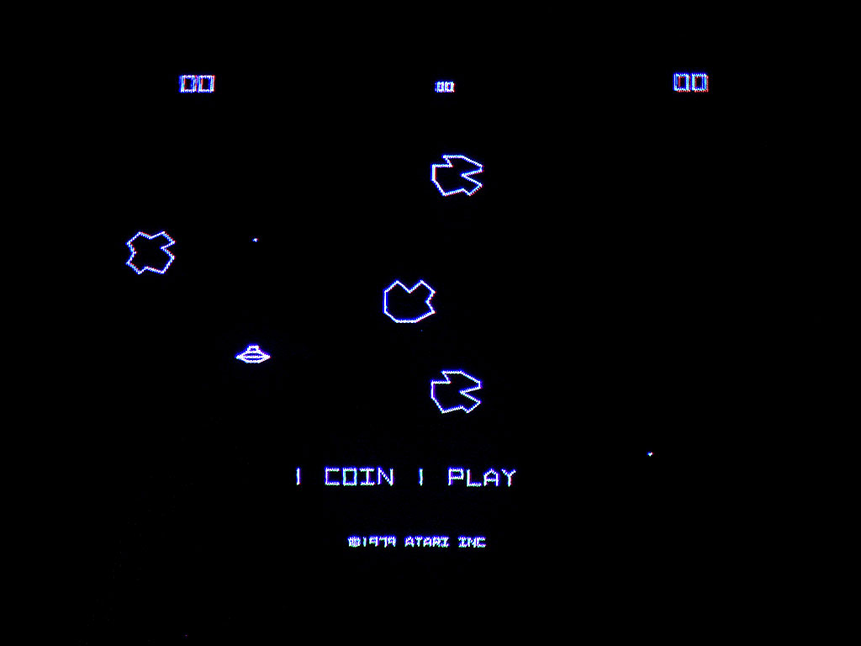

# Asset List (aRT & music)

* None at the moment