Jose Ocampo
Term Project Report
TABLE OF CONTENTS
1 Project Description 3
2 ER Diagram 3
3 Assumption and Limitations for the design 3
4 cardinality relationships 3
5 Data Dictionary 3
6 Team Contribution 3
7 Sample Data 3
8 SQL Queries 3
8.1 Table creation queries 3
8.2 Data Insertion Queries 3
8.3 Screenshot of DB tables and data instances 3
9 Own SQL queries 4

Project Description
This project will cover a recreational area that will combine characteristics of businesses like Main event and gaming lounges. Customers would be able to come in pay an entry fee based on the games they would like to play and have a food service as well.

ER Diagram
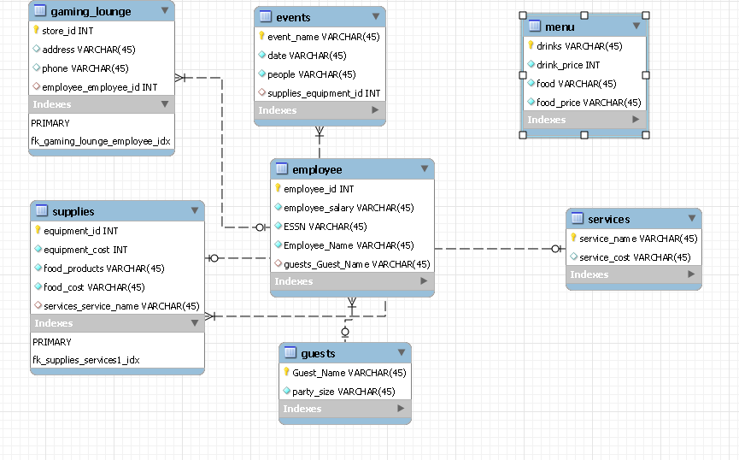

Assumption and Limitations for the design
- Limitation on how many guests to keep track of. Will have to place cap on reservations
- Limitation on drink name needing unique names for primary key
- Limitation on Guest_Name needing to be unique each time to be primary key
- Limitation on Service_name needing to be unique each time to be primary key

cardinality relationships

1->M Guest to employee

1->M services to supplies

1->M events to supplies

1->M gaming_lounge to employee

Data Dictionary
Table | Field Name | Data Type | Nullable | Field Size | Ref | Description
Services | Service_name | varchar | Not null | 45 | n/a | Primary key
Services | Service_cost | Varchar | Not null | 45 | n/a
Guests | Guest_Name | Varchar | Not Null | 45 | n/a | Primary Key
Guests | Party_size | Varchar | Not Null | 45 | n/a
Menu | Drinks | Varchar | Not Null | 45 | n/a | Primary Key
Menu | Drink_price | Int | Not Null | n/a | n/a
Menu | Food | Varchar | Not Null | 45 | n/a
Menu | Food_price | Varchar | Not Null | 45 | n/a
Events | Event_name | Varchar | Not Null | 45 | n/a | Primary Key
Events | Date | Date | Not Null | n/a | n/a
Events | People | Varchar | Not Null | 45 | n/a
Events | Supplies_equipment_id | Int | Null | n/a | supplies | Foreign Key
Employee | Employee_id | Int | Not Null | n/a | n/a | Primary Key
Employee | Employee_salary | Varchar | Not Null | 45 | n/a
Employee | ESSN | Varchar | Not Null | 45 | n/a
Employee | Employee_name | Varchar | Not Null | 45 | n/a
Employee | Guest_guest_name | Varchar | Null | 45 | Guest | Foreign Key
Gaming_Lounge | Store_id | Int | Not Null | n/a | n/a | Primary Key
Gaming_Lounge | Address | Varchar | Not Null | 45 | n/a
Gaming_Lounge | Phone | Varchar | Not Null | 45 | n/a
Gaming_Lounge | Employee_employee_id | Int | Null | n/a | employee | Foreign Key
Supplies | Equipment_id | Int | Not Null | n/a | n/a | Primary Key
Supplies | Equipment_cost | Int | Not Null | n/a | n/a
Supplies | Food_products | Varchar | Not Null | 45 | n/a
Supplies | Food Cost | Varchar | Not Null | 45 | n/a
supplies | Services_services_name | Varchar | Not null | 45 | services | Foreign Key

Team Contribution

Jose Ocampo no team

Sample Data
[Sample Employee Table]
Employee_id | Employee_salary | ESSN | Employee_Name
1 | 40000 | 278301111 | Kathleen Doty
2 | 32000 | 379262222 | Viola Garcia
3 | 60000 | 626183333 | Todd Mitchell

[Sample Events table]
Event_name | Date | People
Call of Duty Cup | 07-10-2021 | 500
Christmas Bash | 12-24-2021 | 700
Comic Con | 08-05-2021 | 300

[Sample Gaming_Lounge table]
Store_id | Address | Phone
1 | 2575 Pratum Ave, Hoffman Estates, IL 60192 | 8476451111
2 | 1035 W Huron St #304, Chicago, IL 60642 | 3124759970
3 | 28248 Diehl Rd. Warrenville, IL 60555 | 2626584477

[Sample guests table]
Guest_Name | Party_size
Alec Sandi | 2
Ava Girisha | 5
Church Grant | 8

[Sample menu table]
Drinks | Drink_price | Food | Food_price
Black Russian | 4 | House Salad | 2.99
Blue Lagoon | 5 | Fried Onion Rings | 3.99
Daiquiri | 6 | Chicken Wings | 5.99

[Sample services table]
Service_name | Service_cost
All you can play | 60
AR Games | 15/hour
Bowling | 10/3 Games

[Sample supplies table]
Equipment_id | Equipment_cost | Food_products | Food_cost
1 | 10000 | Liquor | 5000
2 | 15000 | Soda | 2000
3 | 20000 | Ice | 500
4 | 25000 | Cups | 700

SQL Queries

Table creation queries
-- MySQL Workbench Forward Engineering

SET @OLD_UNIQUE_CHECKS=@@UNIQUE_CHECKS, UNIQUE_CHECKS=0;
SET @OLD_FOREIGN_KEY_CHECKS=@@FOREIGN_KEY_CHECKS, FOREIGN_KEY_CHECKS=0;
SET @OLD_SQL_MODE=@@SQL_MODE, SQL_MODE='ONLY_FULL_GROUP_BY,STRICT_TRANS_TABLES,NO_ZERO_IN_DATE,NO_ZERO_DATE,ERROR_FOR_DIVISION_BY_ZERO,NO_ENGINE_SUBSTITUTION';

-- -----------------------------------------------------
-- Schema mydb
-- -----------------------------------------------------

-- -----------------------------------------------------
-- Schema mydb
-- -----------------------------------------------------
CREATE SCHEMA IF NOT EXISTS `mydb` DEFAULT CHARACTER SET utf8 ;
USE `mydb` ;

-- -----------------------------------------------------
-- Table `mydb`.`guests`
-- -----------------------------------------------------
CREATE TABLE IF NOT EXISTS `mydb`.`guests` (
`Guest_Name` VARCHAR(45) NOT NULL,
`party_size` VARCHAR(45) NOT NULL,
PRIMARY KEY (`Guest_Name`))
ENGINE = InnoDB
DEFAULT CHARACTER SET = utf8;

-- -----------------------------------------------------
-- Table `mydb`.`employee`
-- -----------------------------------------------------
CREATE TABLE IF NOT EXISTS `mydb`.`employee` (
`employee_id` INT NOT NULL,
`employee_salary` VARCHAR(45) NOT NULL,
`ESSN` VARCHAR(45) NOT NULL,
`Employee_Name` VARCHAR(45) NOT NULL,
`guests_Guest_Name` VARCHAR(45) NULL,
PRIMARY KEY (`employee_id`),
INDEX `fk_employee_guests1_idx` (`guests_Guest_Name` ASC) VISIBLE,
CONSTRAINT `fk_employee_guests1`
FOREIGN KEY (`guests_Guest_Name`)
REFERENCES `mydb`.`guests` (`Guest_Name`)
ON DELETE NO ACTION
ON UPDATE NO ACTION)
ENGINE = InnoDB
DEFAULT CHARACTER SET = utf8;

-- -----------------------------------------------------
-- Table `mydb`.`services`
-- -----------------------------------------------------
CREATE TABLE IF NOT EXISTS `mydb`.`services` (
`service_name` VARCHAR(45) NOT NULL,
`service_cost` VARCHAR(45) NULL DEFAULT NULL,
PRIMARY KEY (`service_name`))
ENGINE = InnoDB
DEFAULT CHARACTER SET = utf8;

-- -----------------------------------------------------
-- Table `mydb`.`supplies`
-- -----------------------------------------------------
CREATE TABLE IF NOT EXISTS `mydb`.`supplies` (
`equipment_id` INT NOT NULL,
`equipment_cost` INT NOT NULL,
`food_products` VARCHAR(45) NOT NULL,
`food_cost` VARCHAR(45) NOT NULL,
`services_service_name` VARCHAR(45) NULL,
PRIMARY KEY (`equipment_id`),
INDEX `fk_supplies_services1_idx` (`services_service_name` ASC) VISIBLE,
CONSTRAINT `fk_supplies_services1`
FOREIGN KEY (`services_service_name`)
REFERENCES `mydb`.`services` (`service_name`)
ON DELETE NO ACTION
ON UPDATE NO ACTION)
ENGINE = InnoDB
DEFAULT CHARACTER SET = utf8;

-- -----------------------------------------------------
-- Table `mydb`.`events`
-- -----------------------------------------------------
CREATE TABLE IF NOT EXISTS `mydb`.`events` (
`event_name` VARCHAR(45) NOT NULL,
`date` VARCHAR(45) NOT NULL,
`people` VARCHAR(45) NOT NULL,
`supplies_equipment_id` INT NULL,
PRIMARY KEY (`event_name`),
INDEX `fk_events_supplies1_idx` (`supplies_equipment_id` ASC) VISIBLE,
CONSTRAINT `fk_events_supplies1`
FOREIGN KEY (`supplies_equipment_id`)
REFERENCES `mydb`.`supplies` (`equipment_id`)
ON DELETE NO ACTION
ON UPDATE NO ACTION)
ENGINE = InnoDB
DEFAULT CHARACTER SET = utf8;

-- -----------------------------------------------------
-- Table `mydb`.`gaming_lounge`
-- -----------------------------------------------------
CREATE TABLE IF NOT EXISTS `mydb`.`gaming_lounge` (
`store_id` INT NOT NULL,
`address` VARCHAR(45) NULL DEFAULT NULL,
`phone` VARCHAR(45) NULL DEFAULT NULL,
`employee_employee_id` INT NULL,
PRIMARY KEY (`store_id`),
INDEX `fk_gaming_lounge_employee_idx` (`employee_employee_id` ASC) VISIBLE,
CONSTRAINT `fk_gaming_lounge_employee`
FOREIGN KEY (`employee_employee_id`)
REFERENCES `mydb`.`employee` (`employee_id`)
ON DELETE NO ACTION
ON UPDATE NO ACTION)
ENGINE = InnoDB
DEFAULT CHARACTER SET = utf8;

-- -----------------------------------------------------
-- Table `mydb`.`menu`
-- -----------------------------------------------------
CREATE TABLE IF NOT EXISTS `mydb`.`menu` (
`drinks` VARCHAR(45) NOT NULL,
`drink_price` INT NOT NULL,
`food` VARCHAR(45) NOT NULL,
`food_price` VARCHAR(45) NOT NULL,
PRIMARY KEY (`drinks`))
ENGINE = InnoDB
DEFAULT CHARACTER SET = utf8;

SET SQL_MODE=@OLD_SQL_MODE;
SET FOREIGN_KEY_CHECKS=@OLD_FOREIGN_KEY_CHECKS;
SET UNIQUE_CHECKS=@OLD_UNIQUE_CHECKS;

Data Insertion Queries
INSERT INTO `mydb`.`gaming_lounge` (`store_id`, `address`, `phone`) VALUES ('1', '2575 Pratum Ave, Hoffman Estates, IL 60192', '8476451111');
INSERT INTO `mydb`.`gaming_lounge` (`store_id`, `address`, `phone`) VALUES ('2', '1035 W Huron St #304, Chicago, IL 60642', '3124759970');
INSERT INTO `mydb`.`gaming_lounge` (`store_id`, `address`, `phone`) VALUES ('3', '28248 Diehl Rd, Warrenville, IL 60555', '6303939400');
INSERT INTO `mydb`.`gaming_lounge` (`store_id`, `address`, `phone`) VALUES ('4', '3100 14th Ave, Kenosha, WI 53140', '2626584477');

INSERT INTO `mydb`.`employee` (`employee_id`, `employee_salary`, `ESSN`, `Employee_Name`) VALUES ('1', '40000', '278301111', 'Kathleen Doty');
INSERT INTO `mydb`.`employee` (`employee_id`, `employee_salary`, `ESSN`, `Employee_Name`) VALUES ('2', '32000', '379262222', 'Viola Garcia');
INSERT INTO `mydb`.`employee` (`employee_id`, `employee_salary`, `ESSN`, `Employee_Name`) VALUES ('3', '60000', '626183333', 'Todd Mitchell');
INSERT INTO `mydb`.`employee` (`employee_id`, `employee_salary`, `ESSN`, `Employee_Name`) VALUES ('4', '30000', '251544444', 'Bonnie Hightower');
INSERT INTO `mydb`.`employee` (`employee_id`, `employee_salary`, `ESSN`, `Employee_Name`) VALUES ('5', '50000', '602395555', 'Rickie Klaus');
INSERT INTO `mydb`.`employee` (`employee_id`, `employee_salary`, `ESSN`, `Employee_Name`) VALUES ('6', '55000', '321886666', 'Brandon Lehman');
INSERT INTO `mydb`.`employee` (`employee_id`, `employee_salary`, `ESSN`, `Employee_Name`) VALUES ('7', '52000', '461017777', 'Margaret Smith');
INSERT INTO `mydb`.`employee` (`employee_id`, `employee_salary`, `ESSN`, `Employee_Name`) VALUES ('8', '38000', '106078888', 'Hilda Price');
INSERT INTO `mydb`.`employee` (`employee_id`, `employee_salary`, `ESSN`, `Employee_Name`) VALUES ('9', '36000', '036569999', 'Edgar Valenzuela');
INSERT INTO `mydb`.`employee` (`employee_id`, `employee_salary`, `ESSN`, `Employee_Name`) VALUES ('10', '42000', '345050101', 'Mary Munson');
INSERT INTO `mydb`.`employee` (`employee_id`, `employee_salary`, `ESSN`, `Employee_Name`) VALUES ('11', '40000', '263882323', 'Judith Givens');
INSERT INTO `mydb`.`employee` (`employee_id`, `employee_salary`, `ESSN`, `Employee_Name`) VALUES ('12', '45000', '232123434', 'Gary Morrison');

INSERT INTO `mydb`.`events` (`event_name`, `date`, `people`) VALUES ('Respawn Gaming Tournament', '05-10-2021', '200');
INSERT INTO `mydb`.`events` (`event_name`, `date`, `people`) VALUES ('Siege Gaming', '06-12-2021', '100');
INSERT INTO `mydb`.`events` (`event_name`, `date`, `people`) VALUES ('Call of Duty Cup', '07-10-2021', '500');
INSERT INTO `mydb`.`events` (`event_name`, `date`, `people`) VALUES ('Comic Con', '08-05-2021', '300');
INSERT INTO `mydb`.`events` (`event_name`, `date`, `people`) VALUES ('Crynchyroll Expo', '09-16-2021', '75');
INSERT INTO `mydb`.`events` (`event_name`, `date`, `people`) VALUES ('GameX', '10-1-2021', '50');
INSERT INTO `mydb`.`events` (`event_name`, `date`, `people`) VALUES ('E3', '11-25-2021', '125');
INSERT INTO `mydb`.`events` (`event_name`, `date`, `people`) VALUES ('Christmas Bash', '12-24-2021', '700');

INSERT INTO `mydb`.`guests` (`Guest_Name`, `party_size`) VALUES ('Daria Tatiana', '3');
INSERT INTO `mydb`.`guests` (`Guest_Name`, `party_size`) VALUES ('Ronald Raj', '6');
INSERT INTO `mydb`.`guests` (`Guest_Name`, `party_size`) VALUES ('Shani Annette', '2');
INSERT INTO `mydb`.`guests` (`Guest_Name`, `party_size`) VALUES ('Geraldo Vilmantas', '8');
INSERT INTO `mydb`.`guests` (`Guest_Name`, `party_size`) VALUES ('Kore Zayd', '4');
INSERT INTO `mydb`.`guests` (`Guest_Name`, `party_size`) VALUES ('Marta Santiago', '3');
INSERT INTO `mydb`.`guests` (`Guest_Name`, `party_size`) VALUES ('Ava Girisha', '5');
INSERT INTO `mydb`.`guests` (`Guest_Name`, `party_size`) VALUES ('Chuch Grant', '8');
INSERT INTO `mydb`.`guests` (`Guest_Name`, `party_size`) VALUES ('Katrina Olesya', '2');
INSERT INTO `mydb`.`guests` (`Guest_Name`, `party_size`) VALUES ('Natia Pooja', '3');
INSERT INTO `mydb`.`guests` (`Guest_Name`, `party_size`) VALUES ('Silvester Tatiana', '4');
INSERT INTO `mydb`.`guests` (`Guest_Name`, `party_size`) VALUES ('Sendoa Sushila', '4');
INSERT INTO `mydb`.`guests` (`Guest_Name`, `party_size`) VALUES ('Alec Sandi', '2');

INSERT INTO `mydb`.`menu` (`drinks`, `drink_price`, `food`, `food_price`) VALUES ('soda', '1', 'Beer Batter shrimp', '7.99');
INSERT INTO `mydb`.`menu` (`drinks`, `drink_price`, `food`, `food_price`) VALUES ('water', '0', 'build a burger', '8.99');
INSERT INTO `mydb`.`menu` (`drinks`, `drink_price`, `food`, `food_price`) VALUES ('Tequila Sunrise', '5', 'Tacos', '6.99');
INSERT INTO `mydb`.`menu` (`drinks`, `drink_price`, `food`, `food_price`) VALUES ('Sex on the beach', '6', 'Steak', '8.99');
INSERT INTO `mydb`.`menu` (`drinks`, `drink_price`, `food`, `food_price`) VALUES ('Mojito', '6', 'Pizza', '7.99');
INSERT INTO `mydb`.`menu` (`drinks`, `drink_price`, `food`, `food_price`) VALUES ('Daiquiri', '6', 'Chicken Wings', '5.99');
INSERT INTO `mydb`.`menu` (`drinks`, `drink_price`, `food`, `food_price`) VALUES ('Pina Colada', '5', 'Nachos', '5.99');
INSERT INTO `mydb`.`menu` (`drinks`, `drink_price`, `food`, `food_price`) VALUES ('Blue Lagoon', '5', 'Fried Onion Rings', '3.99');
INSERT INTO `mydb`.`menu` (`drinks`, `drink_price`, `food`, `food_price`) VALUES ('Pink Lady', '4', 'French Fries', '3.99');
INSERT INTO `mydb`.`menu` (`drinks`, `drink_price`, `food`, `food_price`) VALUES ('Black Russian', '4', 'House Salad', '2.99');
INSERT INTO `mydb`.`menu` (`drinks`, `drink_price`, `food`, `food_price`) VALUES ('Jack and Coke', '4', 'Calzone', '6.99');

INSERT INTO `mydb`.`services` (`service_name`, `service_cost`) VALUES ('VR Games', '25/hour');
INSERT INTO `mydb`.`services` (`service_name`, `service_cost`) VALUES ('AR Games', '15/hour');
INSERT INTO `mydb`.`services` (`service_name`, `service_cost`) VALUES ('Console Games', '20/hour');
INSERT INTO `mydb`.`services` (`service_name`, `service_cost`) VALUES ('PC Games', '20/hour');
INSERT INTO `mydb`.`services` (`service_name`, `service_cost`) VALUES ('TableTop Games', '15/hour');
INSERT INTO `mydb`.`services` (`service_name`, `service_cost`) VALUES ('Bowling', '10/3 games');
INSERT INTO `mydb`.`services` (`service_name`, `service_cost`) VALUES ('Pool', '15');
INSERT INTO `mydb`.`services` (`service_name`, `service_cost`) VALUES ('All you can play', '60');

INSERT INTO `mydb`.`supplies` (`equipment_id`, `equipment_cost`, `food_products`, `food_cost`) VALUES ('1', '10000', 'liquor', '5000');
INSERT INTO `mydb`.`supplies` (`equipment_id`, `equipment_cost`, `food_products`, `food_cost`) VALUES ('2', '15000', 'soda', '2000');
INSERT INTO `mydb`.`supplies` (`equipment_id`, `equipment_cost`, `food_products`, `food_cost`) VALUES ('3', '20000', 'ice', '500');
INSERT INTO `mydb`.`supplies` (`equipment_id`, `equipment_cost`, `food_products`, `food_cost`) VALUES ('4', '25000', 'cups', '700');
INSERT INTO `mydb`.`supplies` (`equipment_id`, `equipment_cost`, `food_products`, `food_cost`) VALUES ('5', '22000', 'dairy supplies', '1200');
INSERT INTO `mydb`.`supplies` (`equipment_id`, `equipment_cost`, `food_products`, `food_cost`) VALUES ('6', '20000', 'baking supplies', '1800');
INSERT INTO `mydb`.`supplies` (`equipment_id`, `equipment_cost`, `food_products`, `food_cost`) VALUES ('7', '18000', 'food supplies', '2200');

Screenshot of DB tables and data instances

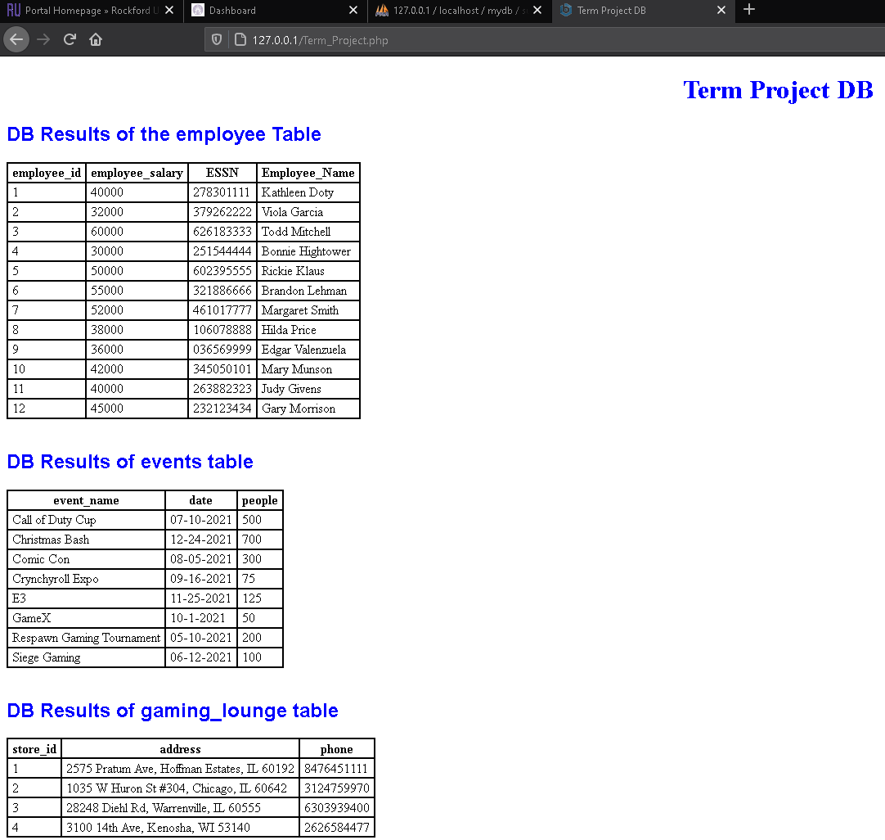

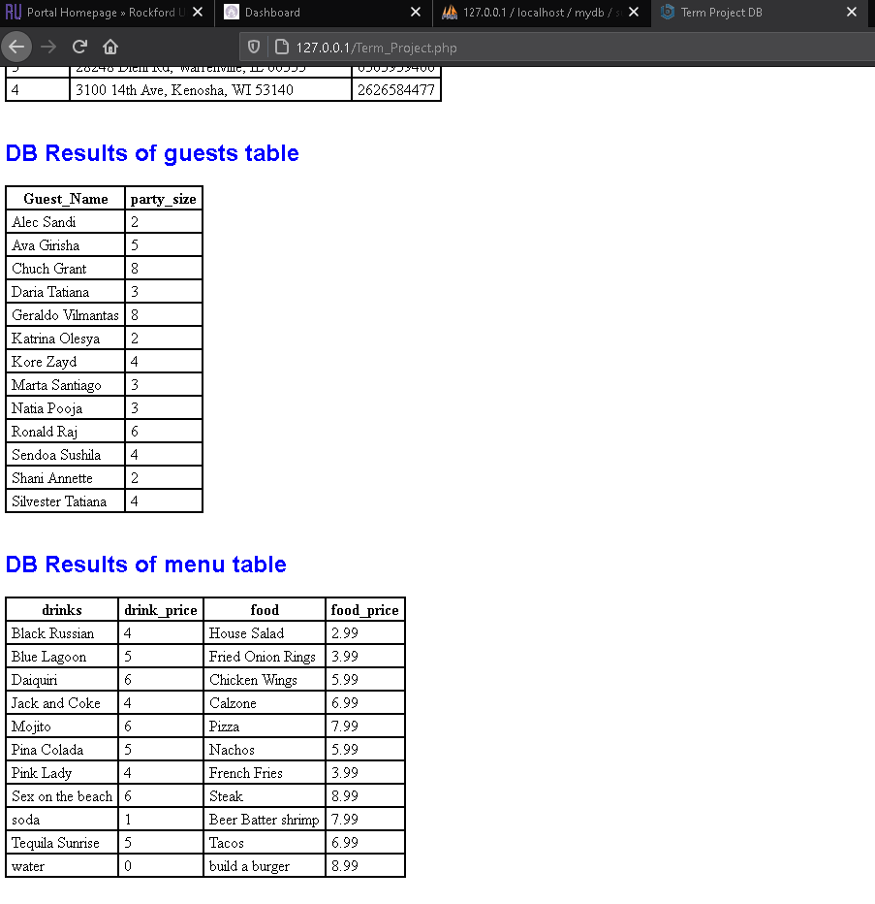

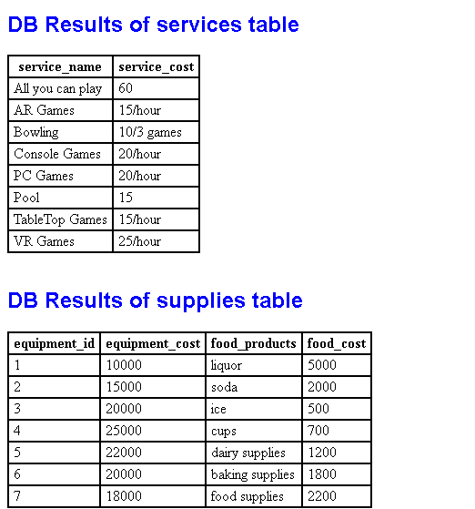

Own SQL queries
[Each team member should come up with 5 own queries and include them with screenshot of the outputs. For example, there are 4 team members, 12 queries has to be listed in this section]
- Pick out all the food product supplies from our inventory that cost between $2000 and $4000.

-- select food_products, food_cost
-- from supplies
-- where food_cost between 2000 and 4000
-- order by food_products
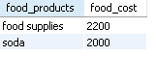

- Pick out the employees who make between $30,000 and $50,000 salary

-- select Employee_Name
-- from employee
-- where employee_salary between 30000 and 50000

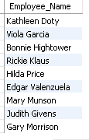

3. Pick the events we will be hosting after January 1st, 2021 that involve more than 150 people.

-- select event_name
-- from events
-- where date > 01-01-2021 and people >150

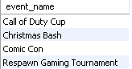

- Pick out all of our guests that came in with more than a group of more than 3 people whos name starts with an A.

-- select Guest_Name
-- from guests
-- where Guest_Name like 'A%'
-- and party_size > 3
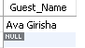

- Pick out all food items from our menu that have a minimum price of over $4.99 and order them by the cost.

-- select food, food_price
-- from menu
-- where food_price > 4.99
-- order by food_price
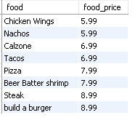

PHP Output of Queries
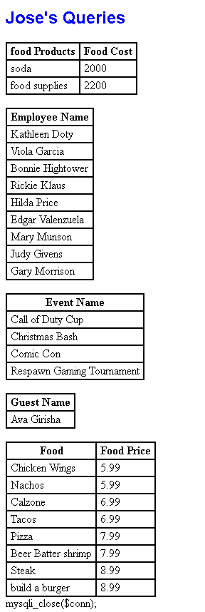

PHP Coding

<!DOCTYPE html>
<html>
<head>
<meta http-equiv="Content-Type" content="text/html; charset=UTF-8">
<title>Term Project DB</title>
<style type="text/css">
table {
border: 1;
border-collapse: collapse;
border-spacing: 0;
}
table td, table th {
border: 2px solid;
padding: 2px 5px 2px 5px;
}
h1 {text-align: center; color: blue}
h2 {font-family: Ariel, sans-serif; text-align: left; color: blue}
p.footer {text-align: center}
table.output {font-family: Ariel, sans-serif}
</style>
</head>

<body>
<h1>Term Project DB</br></h1>
<h2>DB Results of the employee Table</h2>

<?php
/* Load DB */
$conn = mysqli_connect("localhost:3307","root","csci354","mydb");
if ( !$conn ) die('DB Error');

/* Set to UTF-8 Encoding */
mysqli_query($conn, 'set session character_set_connection=utf8;');
mysqli_query($conn, 'set session character_set_results=utf8;');
mysqli_query($conn, 'set session character_set_client=utf8;');

/* Load data */
$query = 'SELECT * FROM employee';
$result = mysqli_query($conn, $query);

echo '<table class="text-center"><tr>' .
'<th>employee_id</th><th>employee_salary</th>
<th>ESSN</th><th>Employee_Name</th>'.
'</tr>';

while($row=mysqli_fetch_array($result)){
echo '<tr><td>'.$row['employee_id'].'</td>'.
'<td>'.$row['employee_salary'].'</td>'.
'<td>'.$row['ESSN'].'</td>'.
'<td>'.$row['Employee_Name'].'</td>'.
'</tr>';
}
echo '</table>';
?>

<br/>
<h2>DB Results of events table</h2>

<?php

$query = 'SELECT * FROM events';
$result2 = mysqli_query($conn, $query);

echo '<table class="text-center"><tr>' .
'<th>event_name</th><th>date</th>
<th>people</th>'.
'</tr>';

while($row=mysqli_fetch_array($result2)){
echo '<tr><td>'.$row['event_name'].'</td>'.
'<td>'.$row['date'].'</td>'.
'<td>'.$row['people'].'</td>'.
'</tr>';
}
echo '</table>';
?>

<br/>
<h2>DB Results of gaming_lounge table</h2>

<?php

$query = 'SELECT * FROM gaming_lounge';
$result3 = mysqli_query($conn, $query);

echo '<table class="text-center"><tr>' .
'<th>store_id</th><th>address</th>
<th>phone</th>'.
'</tr>';

while($row=mysqli_fetch_array($result3)){
echo '<tr><td>'.$row['store_id'].'</td>'.
'<td>'.$row['address'].'</td>'.
'<td>'.$row['phone'].'</td>'.
'</tr>';
}
echo '</table>';
?>

<br/>
<h2>DB Results of guests table</h2>

<?php

$query = 'SELECT * FROM guests';
$result4 = mysqli_query($conn, $query);

echo '<table class="text-center"><tr>' .
'<th>Guest_Name</th><th>party_size</th>'.
'</tr>';

while($row=mysqli_fetch_array($result4)){
echo '<tr><td>'.$row['Guest_Name'].'</td>'.
'<td>'.$row['party_size'].'</td>'.
'</tr>';
}
echo '</table>';
?>

<br/>
<h2>DB Results of menu table</h2>

<?php

$query = 'SELECT * FROM menu';
$result5 = mysqli_query($conn, $query);

echo '<table class="text-center"><tr>' .
'<th>drinks</th><th>drink_price</th>
<th>food</th><th>food_price</th>'.
'</tr>';

while($row=mysqli_fetch_array($result5)){
echo '<tr><td>'.$row['drinks'].'</td>'.
'<td>'.$row['drink_price'].'</td>'.
'<td>'.$row['food'].'</td>'.
'<td>'.$row['food_price'].'</td>'.
'</tr>';
}
echo '</table>';
?>

<br/>
<h2>DB Results of services table</h2>

<?php
$query = 'SELECT * FROM services';
$result6 = mysqli_query($conn, $query);

echo '<table class="text-center"><tr>' .
'<th>service_name</th><th>service_cost</th>'.
'</tr>';

while($row=mysqli_fetch_array($result6)){
echo '<tr><td>'.$row['service_name'].'</td>'.
'<td>'.$row['service_cost'].'</td>'.
'</tr>';
}
echo '</table>';
?>

<br/>
<h2>DB Results of supplies table</h2>

<?php

$query = 'SELECT * FROM supplies';
$result7 = mysqli_query($conn, $query);

echo '<table class="text-center"><tr>' .
'<th>equipment_id</th><th>equipment_cost</th>
<th>food_products</th><th>food_cost</th>'.
'</tr>';

while($row=mysqli_fetch_array($result7)){
echo '<tr><td>'.$row['equipment_id'].'</td>'.
'<td>'.$row['equipment_cost'].'</td>'.
'<td>'.$row['food_products'].'</td>'.
'<td>'.$row['food_cost'].'</td>'.
'</tr>';
}
echo '</table>';
?>

<br/>
<h2>Jose's Queries</h2>

<?php

$query = 'SELECT food_products, food_cost
FROM supplies
where food_cost between 2000 and 4000 ';

$result8 = mysqli_query($conn, $query);

echo '<table class="text-center"><tr>' .
'<th>food Products</th><th>Food Cost</th>'.
'</tr>';

while($row=mysqli_fetch_array($result8)){
echo '<tr><td>'.$row['food_products'].'</td>'.
'<td>'.$row['food_cost'].'</td>'.
'</tr>';
}
echo '</table>';
?>
<br>
<?php

$query = 'SELECT Employee_Name
FROM employee
where employee_salary between 30000 and 50000 ';

$result9 = mysqli_query($conn, $query);

echo '<table class="text-center"><tr>' .
'<th>Employee Name</th>'.
'</tr>';

while($row=mysqli_fetch_array($result9)){
echo '<tr><td>'.$row['Employee_Name'].'</td>'.
'</tr>';
}
echo '</table>';
?>

<br>
<?php

$query = 'SELECT event_name
FROM events
where date > 01-01-2021 and people > 150 ';

$result10 = mysqli_query($conn, $query);

echo '<table class="text-center"><tr>' .
'<th>Event Name</th>'.
'</tr>';

while($row=mysqli_fetch_array($result10)){
echo '<tr><td>'.$row['event_name'].'</td>'.
'</tr>';
}
echo '</table>';
?>

<br>
<?php

$query = 'SELECT Guest_Name
FROM guests
where Guest_Name like "A%" and party_size > 3 ';

$result11 = mysqli_query($conn, $query);

echo '<table class="text-center"><tr>' .
'<th>Guest Name</th>'.
'</tr>';

while($row=mysqli_fetch_array($result11)){
echo '<tr><td>'.$row['Guest_Name'].'</td>'.
'</tr>';
}
echo '</table>';
?>

<br>

<?php

$query = 'SELECT Food, food_price
from menu
where food_price > 4.99
order by food_price';

$result12 = mysqli_query($conn, $query);

echo '<table class="text-center"><tr>' .
'<th>Food</th><th>Food Price</th>'.
'</tr>';

while($row=mysqli_fetch_array($result12)){
echo '<tr><td>'.$row['Food'].'</td>'.
'<td>'.$row['food_price'].'</td>'.
'</tr>';
}
echo '</table>';
?>
mysqli_close($conn);
</body>
</html>

