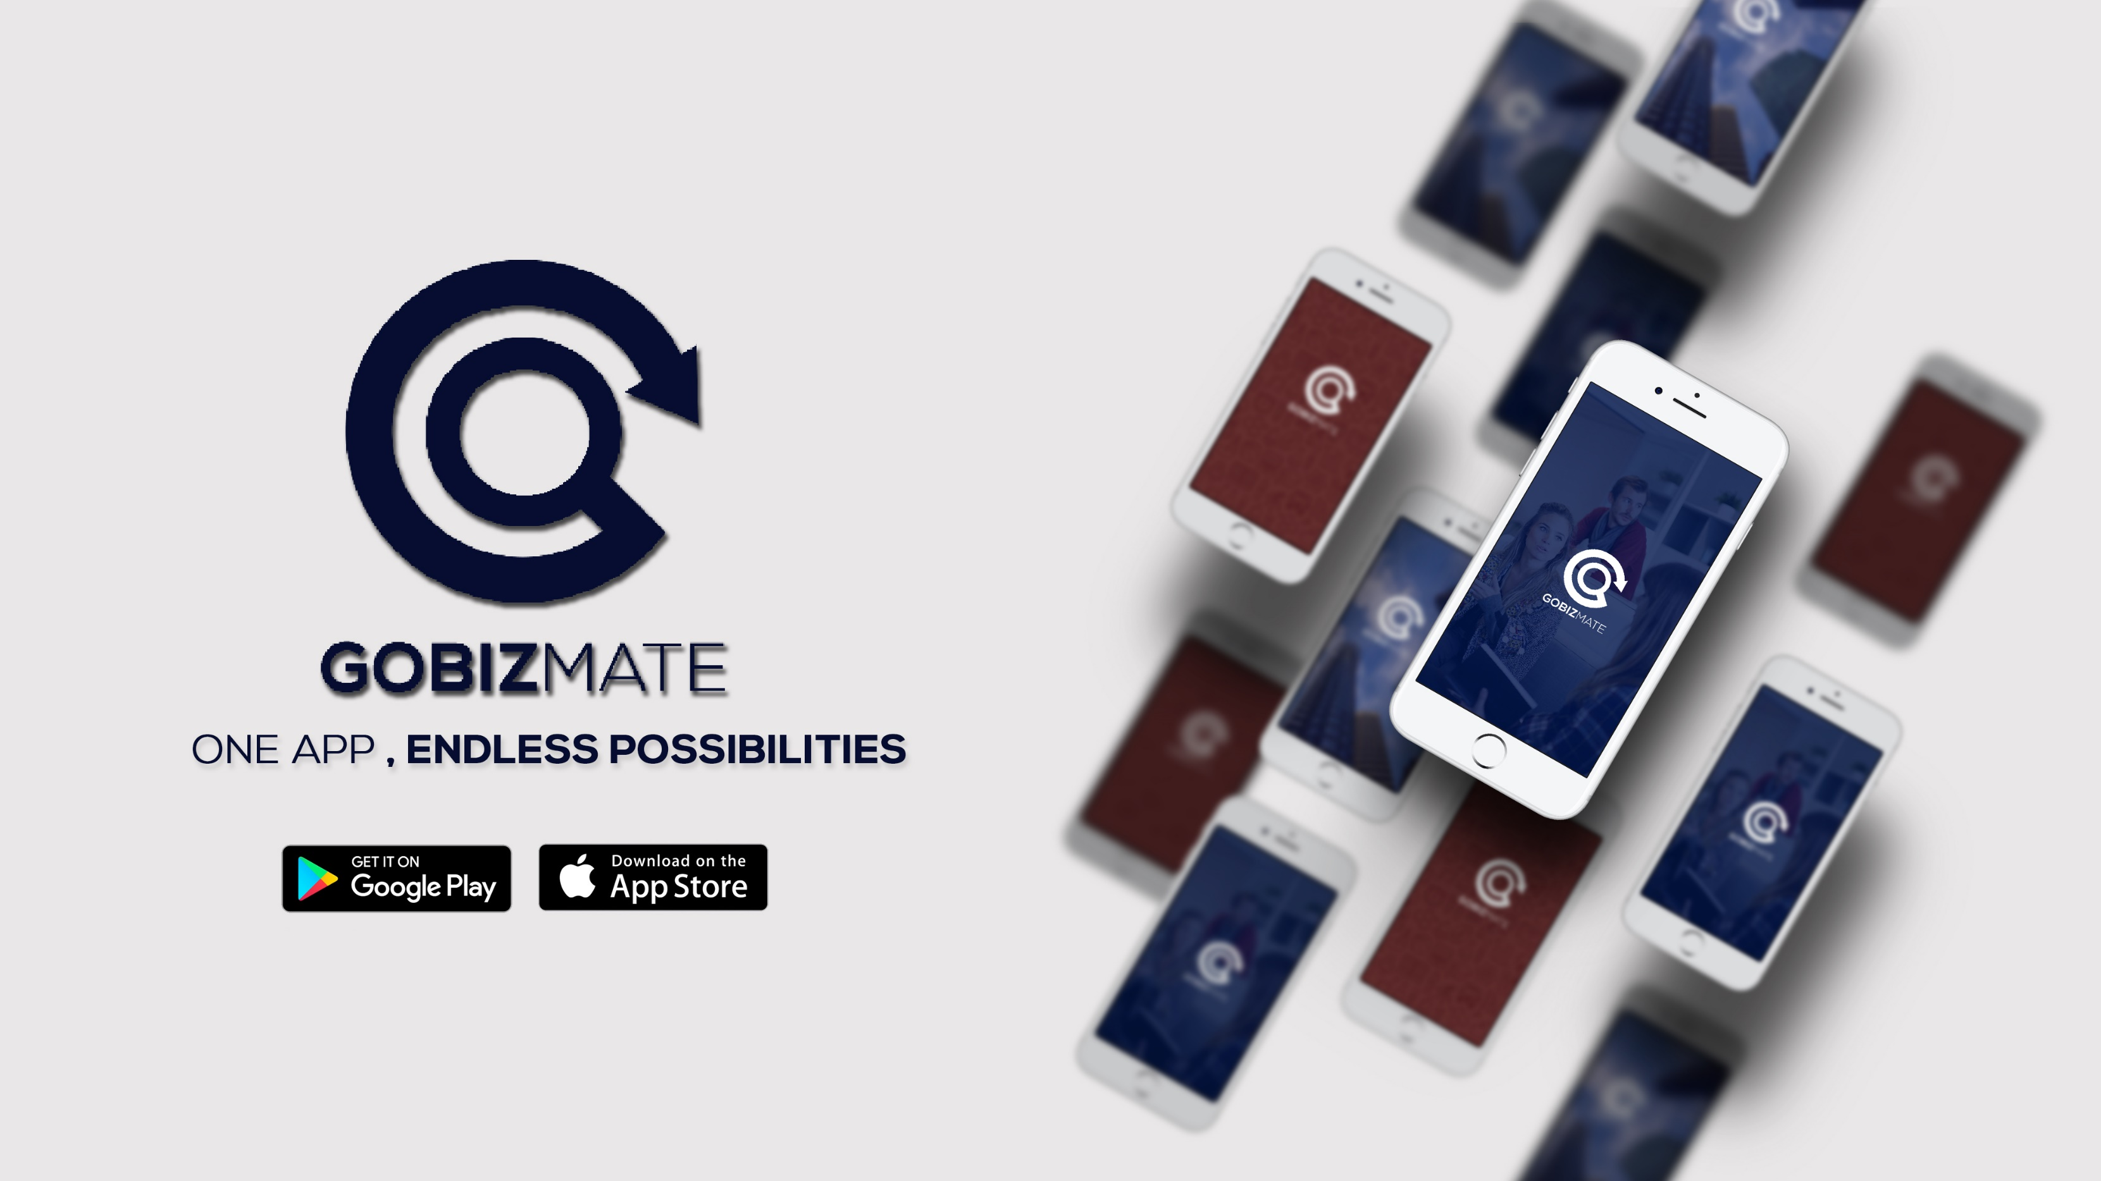

**A close up of a mans face

Description generated with high confidence**

GETTING AN ACCOUNT

* As part of promotional period for this new exciting app offering, we provide a community app to all interested companies and organizations which will allow you to share your information to public and maintain your mobile app presence.
* Other features will be explained when one of our customer support contacts you. If you are interested to have your own App in Appstore please inform us by filling up the form from the link below.
* It will only take within 24 hours to make your app in our community version to become available, after we verified and confirm your details submitted we will send you your account details as soon as your app is ready.

To get an account with appzmate simple Visit

<http://www.sysdatahub.com/customer-registration-for-new-app/>

Or visit

[www.appzmate.com](http://www.appzmate.com/)

And fill up the Customer Registration Form.