**Jacobs University**

**“GEO Informatics Lab Term Paper –**

**Network”**

**Student Name:**

**Otoniel José Campos Escobar** - o.camposescobar@jacobs-university.de

**Course:** Geo Informatics Lab

**Professor:** Prof. Dr. Vikram Unnithan

Wednesday, May 05, 2020

Contents

Abstract 3

Introduction 3

Possible Related Work 3

Tools Used 3

Data Sources and Preprocessing 4

Conclusions 4

Future work 4

Bibliography 5

Appendix 5

# Abstract

<https://www.realvnc.com/en/connect/download/viewer/>

Camera calibration: <https://www.youtube.com/watch?v=QV1a1G4lL3U>

# Introduction

# Possible Related Work

# Tools Used

We used several tools in this study; below is a list of them along with their purpose in this project.

# Data Sources and Preprocessing

We used the following instruments:

RaspberryPi 3x1: It served as the main server for collecting all the data.

RaspberryPi Zerox1: Infrared Camera was connected to it. We used it to stream the data to the Raspberry PI 3 (Server).

**Software Installation:**

1. Install raspberry
2. Install Jupyter Notebooks (<https://www.instructables.com/id/Jupyter-Notebook-on-Raspberry-Pi/>) in raspberry pi

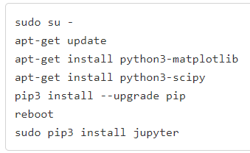

Figure 1: Install Jupyter code.

1. Install Epiphany browser. <https://pimylifeup.com/raspberry-pi-epiphany-browser/>
2. Run Jupyter Notebooks.
3. Connect to Jupyter Notebooks: ***ssh -N -f -L localhost:8888:localhost:8889*** [***pi@192.168.1.133***](mailto:pi@192.168.1.133)

# Conclusions

Under construction…

This a test (Voigt, 2007)

# Future work

Finally, we will try to extend it to perform machine learning distributed learning computations.

# Bibliography

Voigt, T. a. (2007). Sensor networking in aquatic environments-experiences and new challenges. *32nd IEEE Conference on Local Computer Networks (LCN 2007)* (pp. 793--798). IEEE.

# Appendix

## Appendix