Oscar Avina
04/05/2026
Module 2.3 Assignment

- ERD
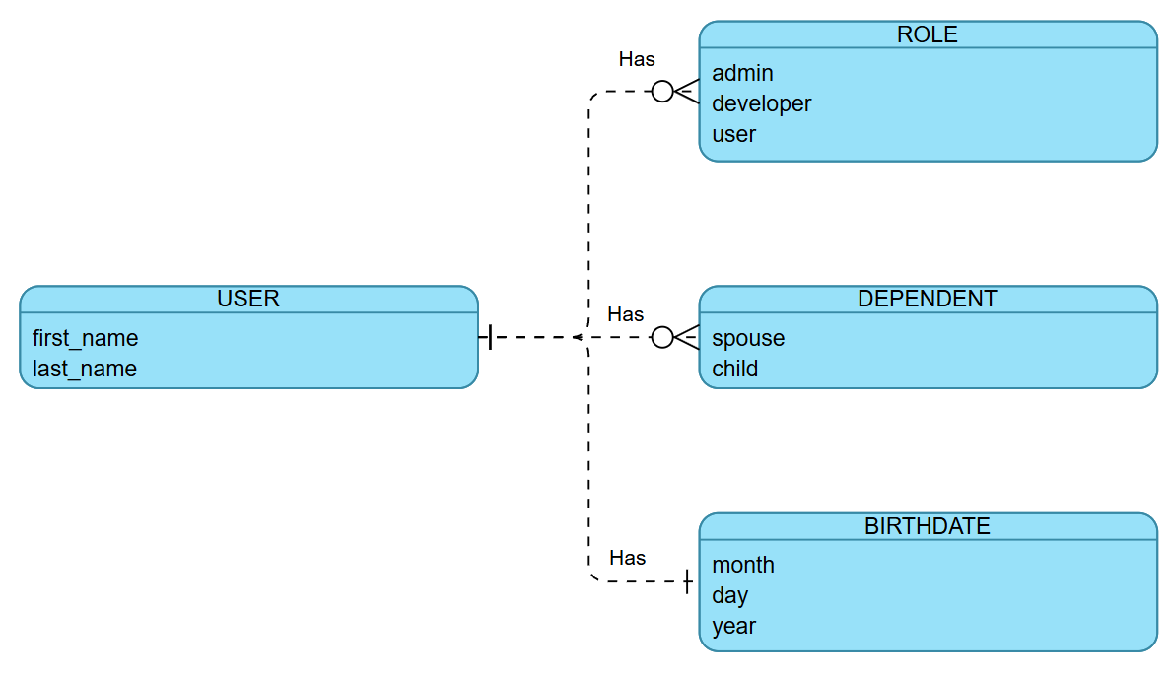
- NoSQL Data Structure Example
