Group Name: Green Team

CSD-310
May 17, 2026
Milestone #3

Team Members
- Maddison Montijo
- Fernando Contreras Corzo
- Oscar Avina
- Jordyn Rylander
- Desarai Lofton

ERD
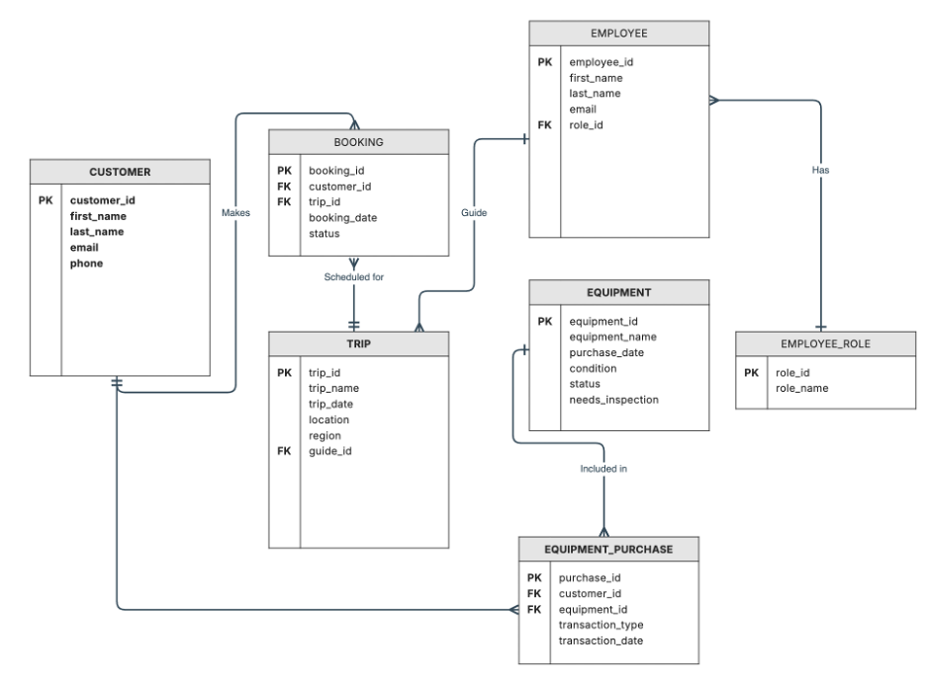

Case Study Selected
Outland Adventures — an outdoor adventure company that manages customer bookings, scheduled trips, employee roles, and equipment rentals and purchases.

Reports Overview
The following three reports were designed to answer the specific business questions identified in the Outland Adventures case study. Each report pulls data from the outland_adventures MySQL database using the reports_updated.py script.

Report 1: Equipment Purchases vs Rentals
Business Question: Do enough customers buy equipment to keep equipment sales?
The creation of tables like the Equipment table and the Equipment_Purchase table help identify Outland Adventures' business concerns, such as whether equipment sales are profitable. Economically, equipment that is in poor condition, has no sales, and is not being rented should be discontinued. This will ensure quality assurance for Outland Adventures customers and help boost reviews.
This report counts the total number of Buy vs Rent transactions from the Equipment_Purchase table, allowing management to compare sales against rentals and make an informed decision about whether to continue selling equipment outright.
Tables Used: Equipment_Purchase
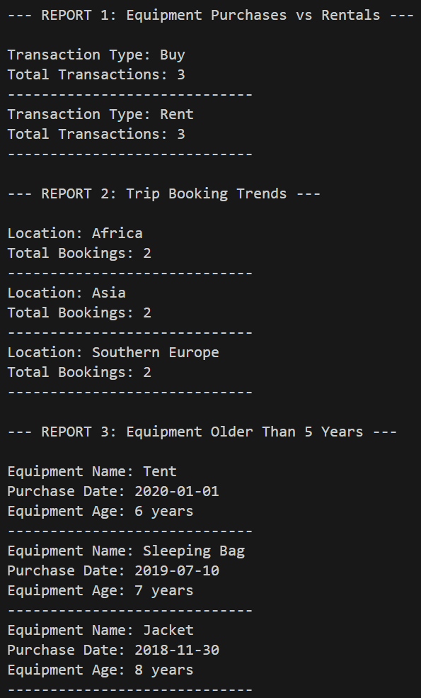

Report 2: Trip Booking Trends
Business Question: Is there any location that has a downward trend in bookings?
This report displays trip booking totals by location. The purpose of this report is to help Outland Adventures identify which locations may have lower booking trends. By joining the Trip and Booking tables and grouping by location, management can see which destinations — Africa, Asia, or Southern Europe — are receiving the fewest bookings and may need additional marketing attention or could be removed from the schedule.
Tables Used: Trip, Booking


Report 3: Equipment Older Than 5 Years
Business Question: Are there inventory items that are over five years old?
This report identifies equipment that is older than five years. The purpose of this report is to help management determine whether older inventory should be inspected, replaced, or tagged before being used on future trips. Equipment age is calculated from the purchase_date field in the Equipment table, and only items exceeding 5 years are returned in the results.
Tables Used: Equipment


Python Script
The reports_updated.py script connects to the outland_adventures MySQL database and generates all three reports using live SQL queries. The database is initialized using the create_outland_adventures_db.sql script. A .env file is required for database credentials. Both files are included in the zip file submitted with this deliverable.

