Oscar Avina
04/19/2026
Module 4.2 Assignment

Initial MySQL connection:
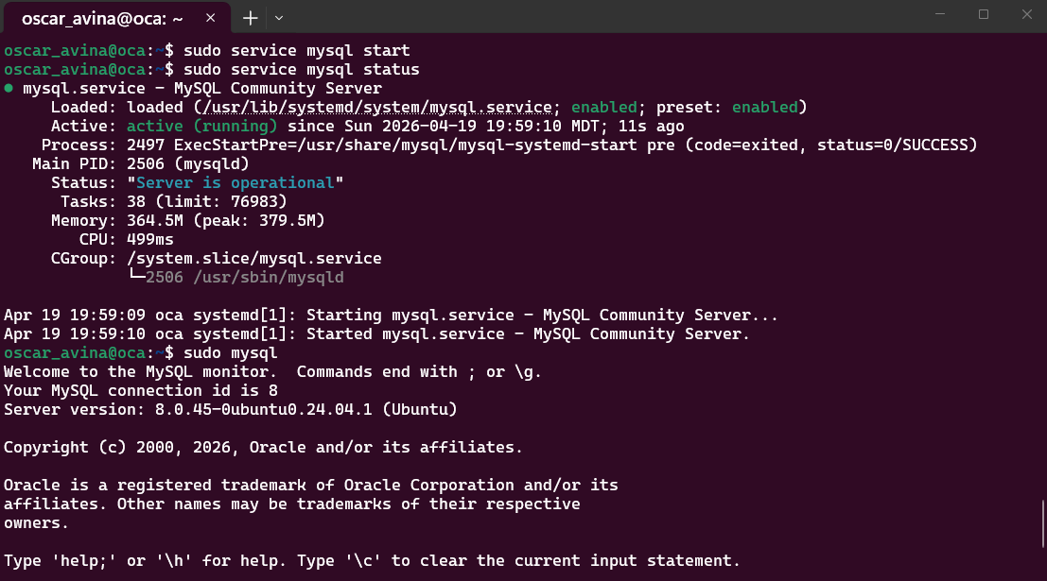

SHOW DATABASES screenshot:
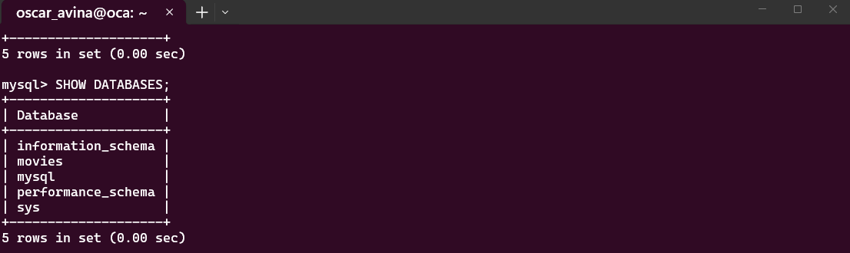

Function 1
The UPPER() function changes the text to all capital letters which could be used to display a movie title in uppercase.
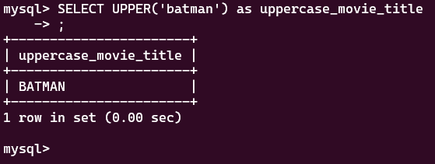

Function 2
The LENGTH() function counts how long a text value is which could be used to count the length of a movie title.
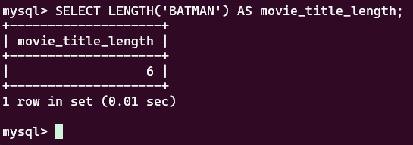

Function 3
The LOWER() function changes text to all lowercase letters which could be used to make text consistent, such as formatting movie titles or user input before storing or comparing data.
