Oscar Avina
05/02/2026
Module 7.2 Assignment

Initial output for `city_functions.py`
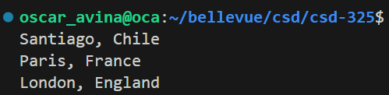

Initial output for `test_cities.py`:

Output after adding third parameter in `city_country` function
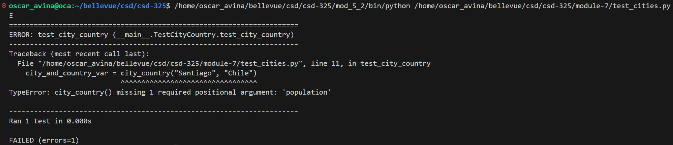

Output after making third parameter as optional:

Output after adding fourth parameter in `city_country` function
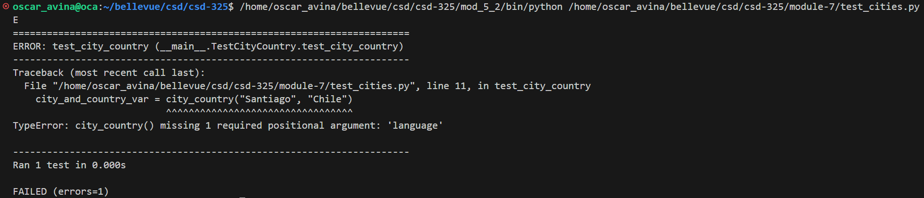

Output after making fourth parameter as optional:

Final output for `city_functions.py` output:

