Oscar Avina
05/03/2026
Module 8.2 Assignment

Flowchart:
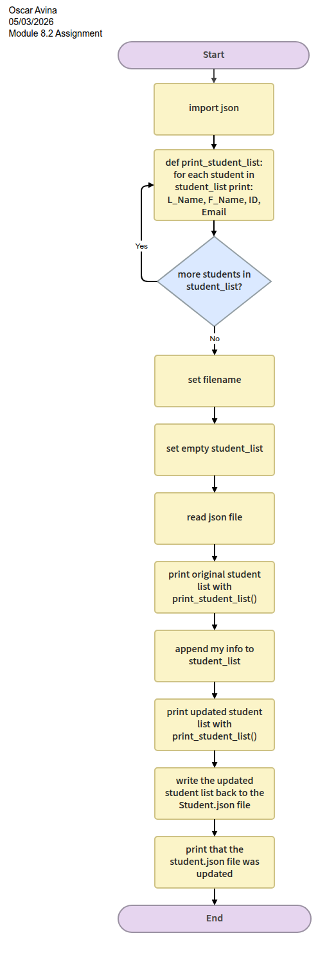

Output:
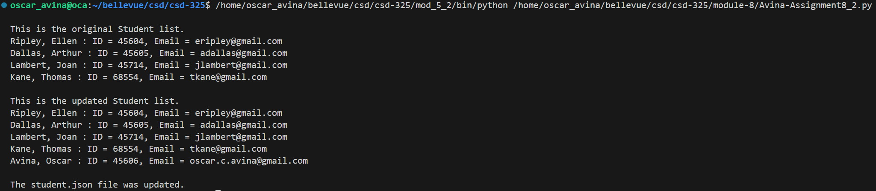

Notification:
I never received a notification that the student.json file changed. I even deleted my newly added info and ran it again a few times and never saw a notification.

JSON file contents:
[
{
"F_Name": "Ellen",
"L_Name": "Ripley",
"Student_ID": 45604,
"Email": "eripley@gmail.com"
},
{
"F_Name": "Arthur",
"L_Name": "Dallas",
"Student_ID": 45605,
"Email": "adallas@gmail.com"
},
{
"F_Name": "Joan",
"L_Name": "Lambert",
"Student_ID": 45714,
"Email": "jlambert@gmail.com"
},
{
"F_Name": "Thomas",
"L_Name": "Kane",
"Student_ID": 68554,
"Email": "tkane@gmail.com"
},
{
"F_Name": "Oscar",
"L_Name": "Avina",
"Student_ID": 45606,
"Email": "oscar.c.avina@gmail.com"
}
]

