Oscar Avina
04/19/2026
Module 4.2 Assignment

Original flowchart
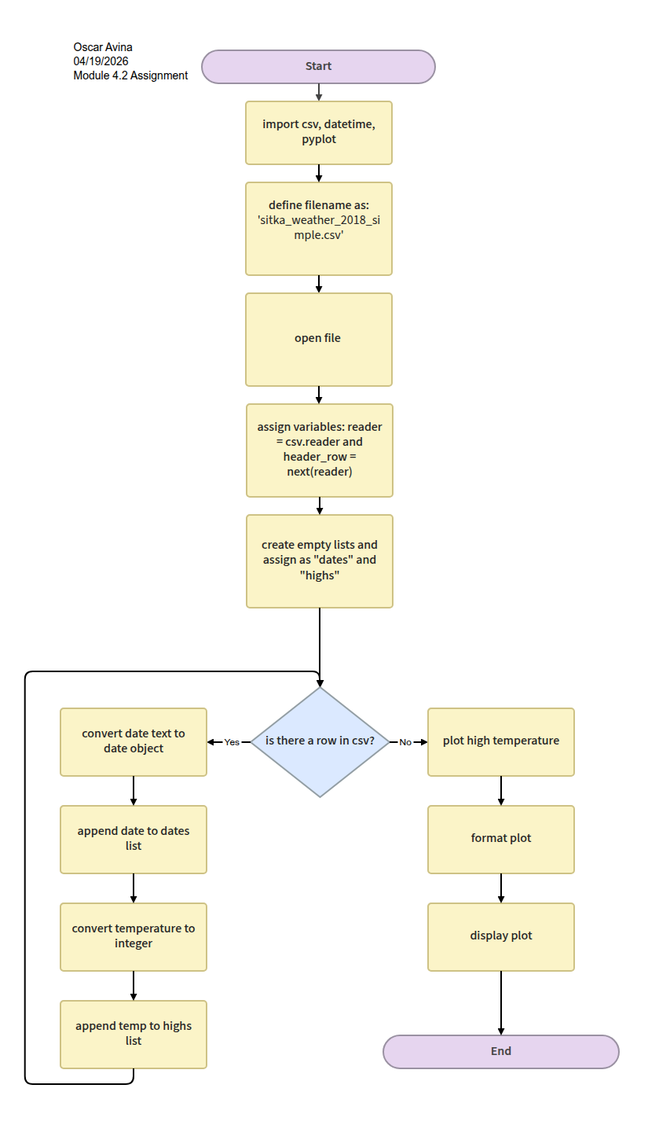
Revised flowchart
