Oscar Avina
06/14/2026
Module 3.2 Assignment

- Link to my Github repo:
  - https://github.com/ocavina/csd-340
- Link to my Github pages landing page:
- Screenshot of html check
  - 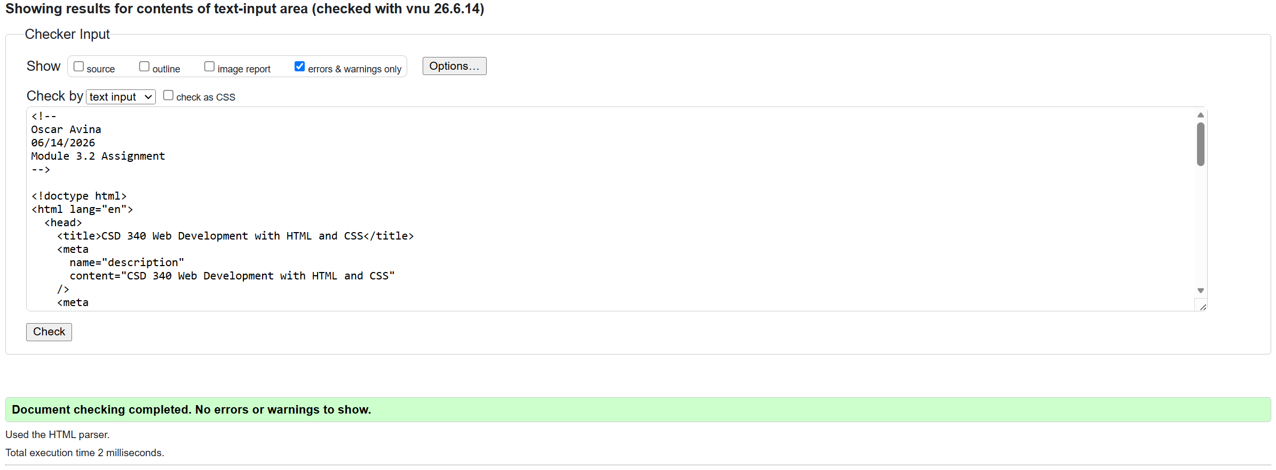

- Screenshot of css check

- Screenshot of webpage

  - 